16/10/2025
PL/25/1260
Catrin Davies
Address: 12-14 Kentwood Hill, Tilehurst, RG31 6DE
Proposal: Change of use from a social club to a church (place of worship), roof
extension to the existing rear extension and alterations to existing rear extension including fenestration alterations, insertion of Velux rooflights and provision of replacement slate roof to match existing

Application seeks to convert the existing social club into a place pf worship (F1 use). The existing and proposed size of the development is 513sqm

The site is located within Zone 3, Secondary Core Area, of the Council’s adopted Parking Standards and Design SPD. Typically, these areas are within 400m of a Reading Buses high frequency ‘Premier Route’, which provides high quality bus routes to and from Reading town centre and other local centre facilities. Double yellow lines are present on the opposite side of the carriageway preventing on street parking.
The submitted Design and Access Statement states that the activities of the church are as follows and proposed operational times:

Tuesday evening (approximately 30 adults)
Thursday evening (approximately 55 adults)
Friday evening (approximately 55 adults) as well as Sundays
60 seats will be provided to accommodate maximum demand.

Timings:
Tuesday (19:00-21:00)
Thursday (19:00-21:00)
Friday (19:00-21:00)
Saturdays 15:00h to 17:00h (Every other Saturday)
Sunday (10:00-16:00).

In accordance with the Council’s adopted Parking Standards and Design SPD, the proposed F1 use (Places of Worship) requires parking provision of 1 per 8 fixed seats and/or 1 per 16m² open hall. Based on the stated floor space of 513sqm, the development would require 32.06 parking spaces and 7.7 spaces for 60 seats(which the applicant has stated will be the anticipated maximum demand). Total provision would equate to 39 spaces.

However, it is noted that the submitted ground floor/site plan contradicts with the number of proposed seating as this plan shows 120 seats; Therefore, parking provision has been based on the number of seats illustrated. Based on 120 seats (15 parking spaces) and size of the hall (32 spaces) 47 spaces would be required for the proposed use.

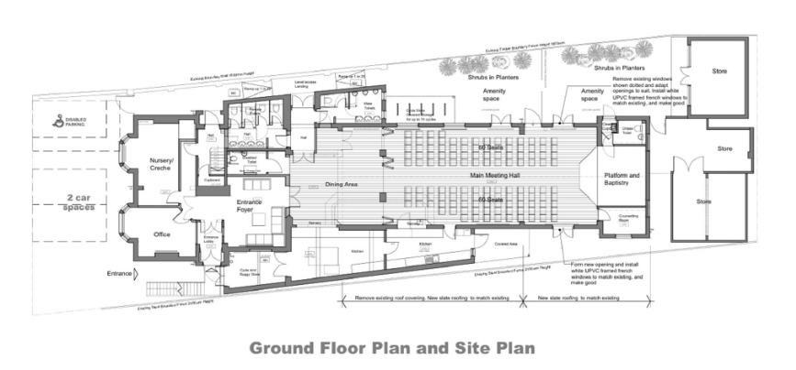

Existing parking provision for the Public House based on our current Parking Standards and Design SPD would have equated to 1 space per 5m2 which (102 parking spaces) this is considerably more than the proposed F1 use. The COU would result in a benefit to potential on street parking; Transport would not have any objections to the proposed provision for the place of worship only. Additional parking facilities are located close to the site in the form of a public pay and display car park. It should be noted that no assessment has been made in relation to any creche or day nursery facilities that would need a separate application as this would be a separate use class.

Cycle parking should be provided in accordance with our current Parking Standards and should be fully accessible without obstruction. Drawings should be updated to include a convenient access route to the cycle store on the northern elevation given this would be obstructed by parked vehicles.

The Councils refuse team should be contacted to ensure compliance with regards to bin storage and collection. A collection point will need to be illustrated on plans. This should not be located on any part of the Public Highway.

Please ask the applicant to address the points above.

N. Hussain
Transport Development Control Advisor

