Additional information for Roof Application.

Proposal – To remove tiles, replace rotten battens, add a breathable membrane and return tiles. Perished tiles will be replaced with like for like tiles. Tradition methods and materials will be used throughout.
The timber structure of the roof has historical significance, it is made from rafters, purlins, trusses and remains an important part of the fabric of the house. This application does not propose any changes to this timber structure. If any repairs are identified throughout, they will be carried out using traditional methods with like for like materials. We can report any repairs if they are to occur.
Throughout the works on the roof, it has been agreed that the timber structure will be protected from the elements if exposed.
All information regarding the proposed works have already been submitted, this document includes a roof plan and section drawing as requested.

Roof Plan.
Scale – 1 inch to 8 feet.

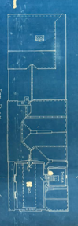

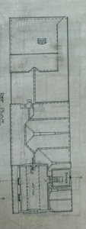

Section Drawings

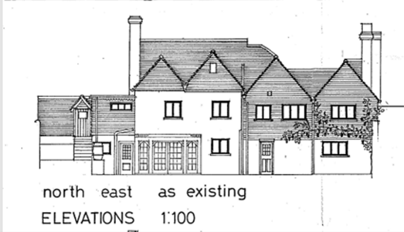
The section of roof that is visible without the removal of tiles is shown below,

These section drawings show the materials and parts of roof that are relevant to the application. We have not added the timber structure that has been shown in photos previously as we are not proposing any alterations to this structure or to these materials. This was advised from a local historical architect.

Existing Roof
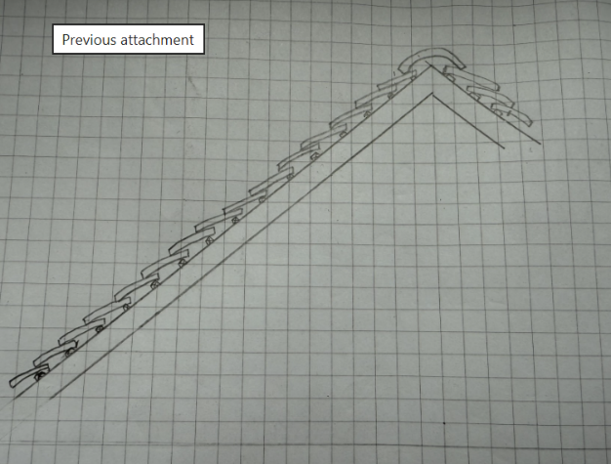
This is a cross section of the pitched roof showing the ridge at the centre.
Traditional clay tiles
Battens
Rafters
Ridge Tile

Proposed works
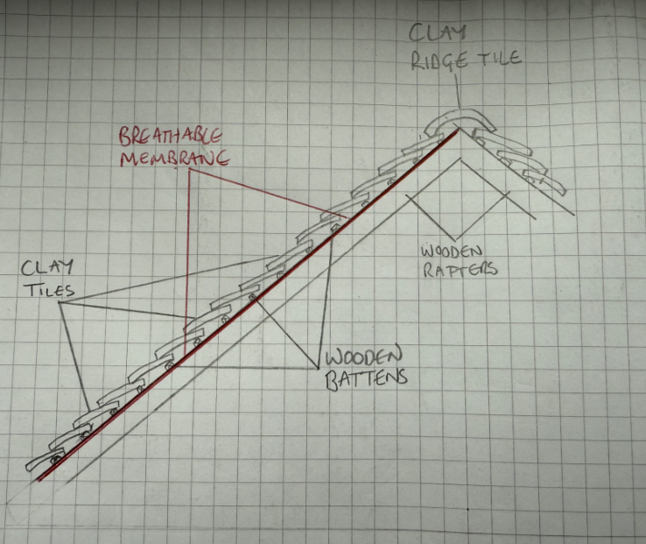
The breathable membrane would be added.
Any perished or broken tiles will be replaced with clay tiles of a similar colour
Any rotten battens will be replaced as necessary.
The wooden rafters will not be affected.

The reasons for these proposed work and all other details are in the other documents already sent.

