DELEGATED APPLICATION REPORT
Ward: Church
App Ref: PL/25/1193 Householder planning permission
Address: 22 HAZEL CRESCENT, READING, RG2 7ND
Proposal: Single storey rear extension and additional roof-lights to existing roof
Applicant: Mr Sudhir Adhakari
Received date: 25/08/2025
Target Decision date: 21/10/2025
Case Officer: Chukwudi Onwudinanti

- SITE DESCRIPTION

The application site consists of a mid-20th century two-storey semi-detached property, constructed from red brick, part pebble dashed render and tiled pitched and hipped roof. The property benefits from a larger westerly facing rear garden, along with a private frontage offering off-street parking. The property is largely original. Many properties nearby have been subject to single storey and two storey extensions of differing scale and design, including the adjoining neighbour at 20 Hazel Crescent. The property is not listed or within a conservation area.

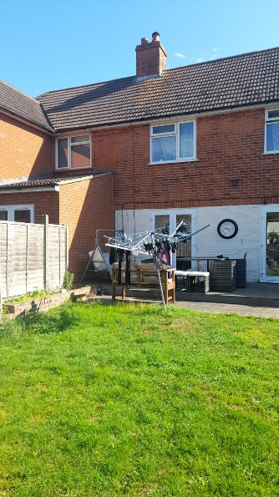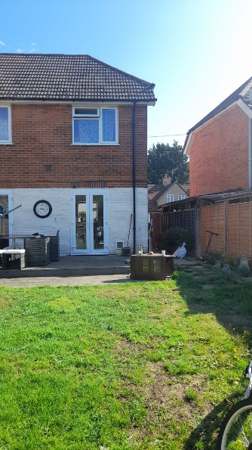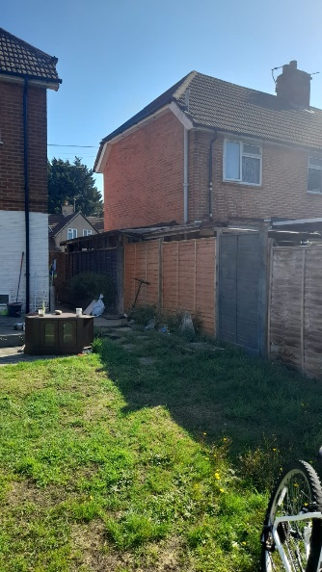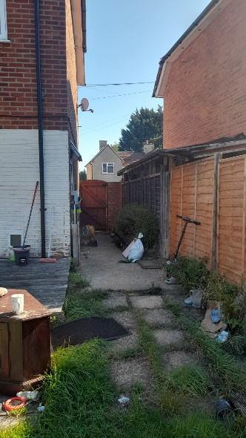

Site Photos (19/09/2025)

- PROPOSAL AND SUPPORTING INFORMATION
The proposal is for a single storey rear extension and addition of roof-lights to existing roof. The extension will be across the full width of the rear elevation and project 4.9m into the existing garden to the rear of the property. The roof will be a mono-pitch roof to the rear, with a ground to eave height of 2.4m and the highest point of 3.7m at the start of the slope, attached to the existing dwelling.
There will be three rooflights added to the front slope of the existing roof, two rooflights to the rear slope and one rooflight to the new single storey extension. Materials will match existing.

Plans Considered. dated August 2025 received 26/08/2025

Drawing No A-L-001 Rev B – Proposed Plans & Elevations
Drawing No E-X-001 Rev B – Existing Plans & Elevations

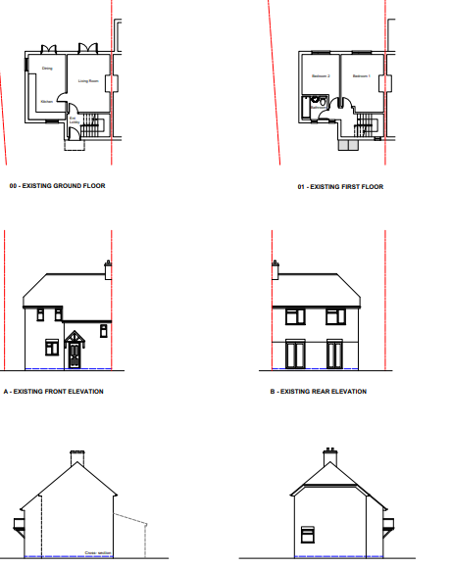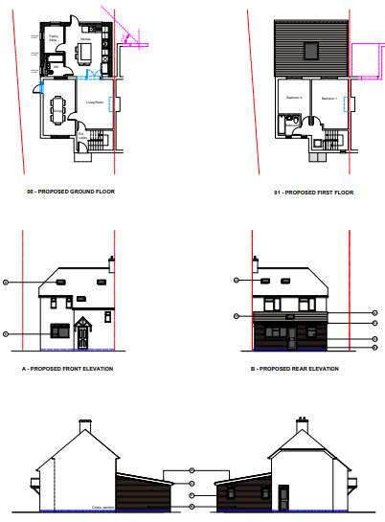
Existing Plans & Elevations Proposed Plans & Elevations

- CONSULTATIONS

A site notice was put up 07/09/2025.

No letters of representation have been received.

- RELEVANT PLANNING HISTORY
App Ref: PL/25/0772
Description: Proposed single and double storey rear extension including 3 no rooflights to the front roof slope.
Decision: Granted
Date: 17/07/2025

- Equality Act 2010:
In determining this application, the Council is required to have regard to its obligations under the Equality Act 2010. However, there is no indication or evidence (including from consultation on the application) that the protected groups identified by the Act have or will have different needs, experiences, issues and priorities in relation to this particular planning application. Therefore, in terms of the key equalities protected characteristics it is considered there would be no significant adverse impacts as a result of the development.

- LEGAL AND PLANNING POLICY CONTEXT
Section 38(6) of the Planning and Compulsory Purchase Act 2004 requires that proposals be determined in accordance with the development plan unless material considerations indicate otherwise. Material considerations include relevant policies in the National Planning Policy framework (NPPF) - among them the 'presumption in favour of sustainable development'. The following local and national planning policy and guidance is relevant to this application:

National Policy
National Planning Policy Framework
National Planning Practice Guidance

Reading Borough Local Plan (2019)
CC7 (Design and the Public Realm)
CC8 (Safeguarding Amenity)
H9 (House Extensions and Ancillary Accommodation)
H10 (Private and Communal Outdoor Space)

SPD
Design Guide to House Extensions SPD 2021

- APPRAISAL

Character and Appearance
Policy H9 states that an extension to a house will be acceptable where it respects the character of the house in terms of scale, location, materials and design and respects the character and pattern of neighbouring properties and the street as a whole in terms of scale, location, materials and design, and any important existing building line. Policy CC7 also sets out relevant considerations for design.

The proposed alterations would not cause significant changes to the character of the dwelling and would not significantly alter the appearance of the dwelling when viewed in the context of the street scene.

The single storey extension to the rear has a maximum height of 2.5m ground to eaves. The extension also does not extend to the sides or increase the width of the dwelling; therefore no aspect of the new development is visible from the street. The character to the rear of the existing dwelling is also not negatively impacted as the extension is modest and will be of same materials as existing on the host dwelling.

The alterations proposed therefore, are considered to be of acceptable scale and design, appropriately respectful to the scale, design and character of the proposal site and the neighbouring properties in close proximity.

Residential Amenity
Policy H9 states that an extension will be acceptable where it does not result in an overbearing impact on neighbours. Policy H10 seeks to ensure that the amenity of gardens and other outdoor areas are not compromised. Policy CC8 states an extension to a house will be acceptable where it will not cause a significant detrimental impact to the living environment of existing or new residential properties.

The extension will introduce a fresh blank wall on the side of the site, facing No 20. However, as the adjoining property on that side already has an existing extension, the development on No 22 will only be forward of the rear line by approximately 2m. The height of the proposed extension is also limited, lower than the existing extension on No 20. On the side of the adjoining property on No 24, there is a gap of at least 1.8m between the two properties and the property on that side also has an existing outrigger to the rear.

Therefore, it has been considered that the combination of the above-mentioned mitigating factors ensures that the impact on the adjoining properties is not negative overall. This has also been demonstrated by the 45-degree line analysis for the property on No 20.

- CONCLUSION
The proposed development has been assessed as set out above and is considered to be acceptable on that basis, subject to the following conditions.

- RECOMMENDATION: Grant
Recommended Conditions:
Approved Plans
Time Limit Standards
Materials to Match Existing
No New Openings

