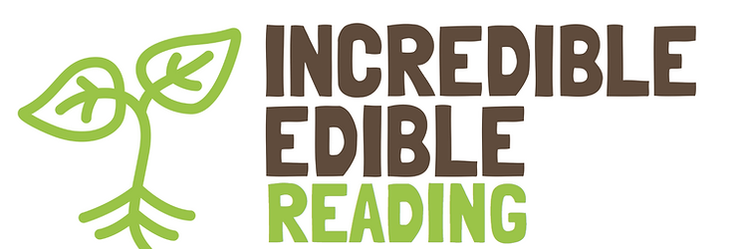

c/o RISC
35-39 London St
Reading
RG1 4PS
www.incredibleediblerdg.org

3 October 2025

For the attention of members of the Planning Applications Committee
Re: PL/24/1155 - John Lewis, Mill Lane
For the past 18 months I have been part of a group of voluntary sector groups in dialogue with John Lewis Partnership regarding their proposed re-development of the Mill Lane site. The main thrust of our discussions is how the project can fit with existing local initiatives maximise the long-term potential benefits for the wider communities.
We have been impressed by the JLP team’s commitment to long-term engagement with the community and its contribution to the developing the “thriving communities” we all aspire to. One indicator is the inclusion of a community garden within the development from its initial concept stages. We have had constructive discussion of how this space can integrate into the broader network of local groups which are promoting the public realm as a resource to support health and wellbeing, help raise awareness of sustainability, especially bio-diversity and RBC’s net zero strategy. It would provide an outdoor learning environment for Reading Community Learning Centre (based nearby) and opportunities for green social prescribing.
We would like to express our strong support for this application. The Incredible Edible Reading vision aims to bring together the experience of Reading’s vibrant community food growing network and to make the case for the inclusion of community gardens in the urban landscape, especially in the new developments which are going to transform the town centre. We believe this project will provide a blueprint for other future projects and a framework for forging a meaningful long-term partnership between local groups and the business community. It is a perfect example of how the aspirations of the Reading 2050 Vision can be realised in the challenging post-Covid.

Dave Richards
Incredible Edible Reading
lpvdave@gmail.com

