External Materials @ Elgar Road

Main brick: Ibstock Brunswick Wilton Yellow.
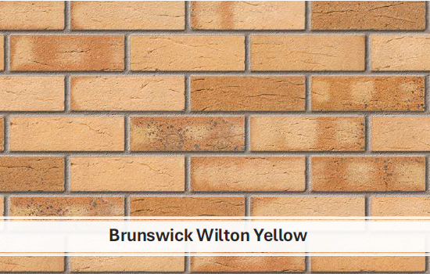

Feature brick: Ibstock Dorket Head – Sandringham
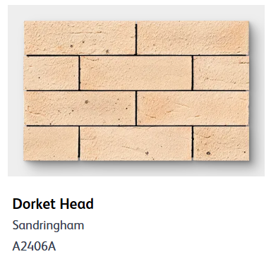

Roof tiles: Redland Renown Concrete Tiles in Slate Grey.
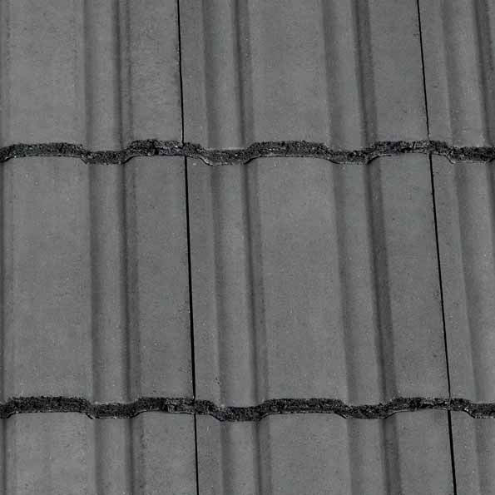

Marshalls Priora Permeable block paving Charcoal
