43 Church Road, Caversham, RG4 7AG

Official listing;
CHURCH ROAD 1. 5128 (North Side) Caversham No 43 (Banksfoot) SU 7074 11/264 22.3.57. II GV 2. Early and mid C18. 2 storeys, right hand art taller with attic. (Colourwashed brick. Old tile roof. Road front - 2 casement windows and 2 glazing bar sashes (4 in all) on 1st floor). Left part has central ½ glazed door with rectangular fanlight and flat hood. Tall chimney to right and modern garage extension with re-used beams. Interior: inglenook in room on ground floor to right. Flint garden wall to street.
Listing NGR: SU7097974890
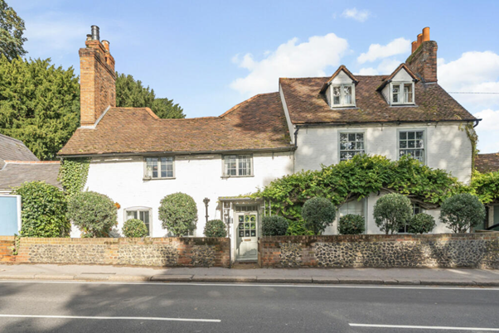

Application;

Rather than a re- roof it may be more accurate to request for lifting the tiles, adding felting and repair where necessary. Our aim is to protect the house, creating a weather proof roof, to stop damage to historical features still existing, to preserve the structural integrity of the house. This additional information is here to support the existing application as requested by Reading Borough Council.

POLICY CONTEXT
NPPF (Revised 2024 ) The National Planning Policy Framework (NPPF) sets out national planning policy relating to the conservation of the historic environment. It advises that in determining planning applications ‘local planning authorities should require an applicant to describe the significance of any heritage assets affected, including any contribution made to their setting. The level of detail should be proportionate to the assets’ importance and no more than is sufficient to understand the potential impact of the proposal on their significance (paragraph 207 .
Annex 2 of the NPPF defines a Heritage Asset as being ‘a building, monument, site, place area or landscape identified as having a degree of significance meriting consideration in planning decisions.’ Heritage assets are the valued components of the historic environment. They include designated heritage assets and non-designated heritage assets.
Draft Reading Borough Local Plan (2017) The Reading Borough Local Plan was issued as a draft in May 2017. The relevant historic environment policy for the proposed development is as follows:
Draft Policy EN1: Protection and Enhancement of the Historic Environment Reading Core Strategy (adopted January 2008 with alteration adopted 2015) The relevant historic environment policy contained within the Reading Core Strategy is as follows:
Policy CS33: Protection and Enhancement of the Historic Environment. Policy CS33 states that: Historic features and areas of historic importance and other elements of the historic environment, including their settings, will be protected and where appropriate enhanced.
This will include: - Listed Buildings; Conservation Areas; Other features with local or national designation, such as sites and features of archaeological importance, and historic parks and gardens. Planning permission will only be granted where development has no adverse impact on historic assets and their settings. All proposals will be expected to protect and where appropriate enhance the character and appearance of the area in which they are located.
Reading Central Area Action Plan (adopted January 2009) Policies contained within the Reading Central Area Action Plan relate to consideration of impacts on the settings of listed buildings and conservation areas.

The existing application includes our heritage findings, this document aims to provide more detail concerning the impact and therefore would be included as our heritage and access statement.

Description and assessment of significance
Existing Roof;
The roof is a complex structure with multi pitched roofing, it has a traditional aesthetic, expected within an older house. There are multiple sloping sections forming various peaks and valleys. It combines four prominent gable ends to the rear. The roof is covered with plain clay tiles in a warm reddish – brown hue, there appears to be areas that have been repaired at different points throughout history. There are two prominent, substantial chimney stacks constructed of brick, consistent with traditional English architecture. The stacks appear on either side of the roof, positioned to the centre of the roof line and contribute significantly to the character and historical appeal of the house. There is a flat roof and small pitched roof to the side of the property which is part of the 1960’s extension. These are in keeping with the traditional aesthetic of the rest of the house.
The front of the house presents a pitched roof with 2 small dormer windows, providing light into the attic room. As well as the clay roofing tiles, there are also hip and ridge tiles that cover the angles where different roof sections meet.
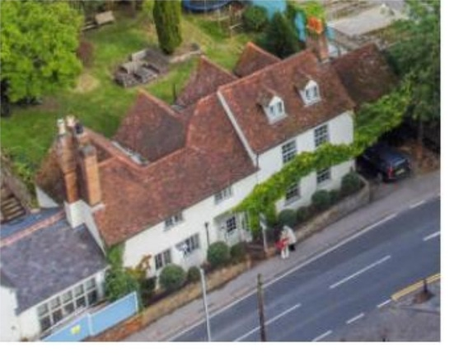
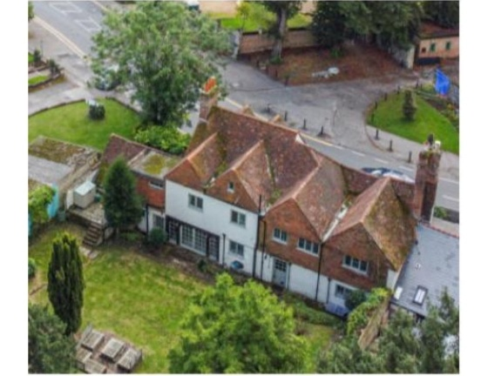

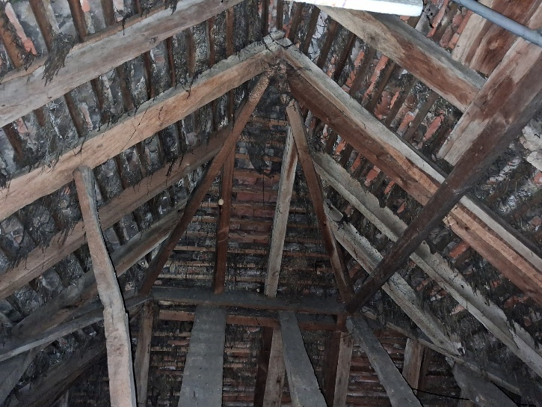
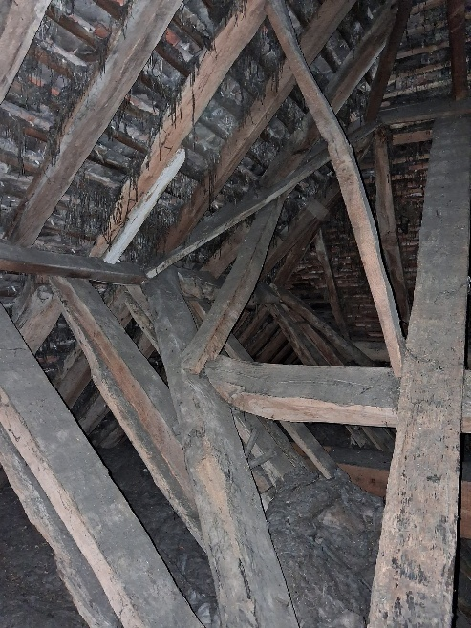

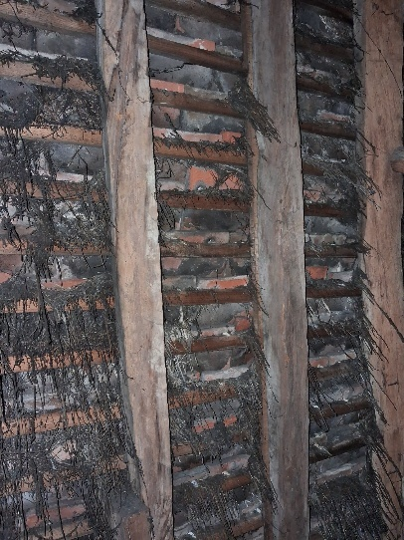

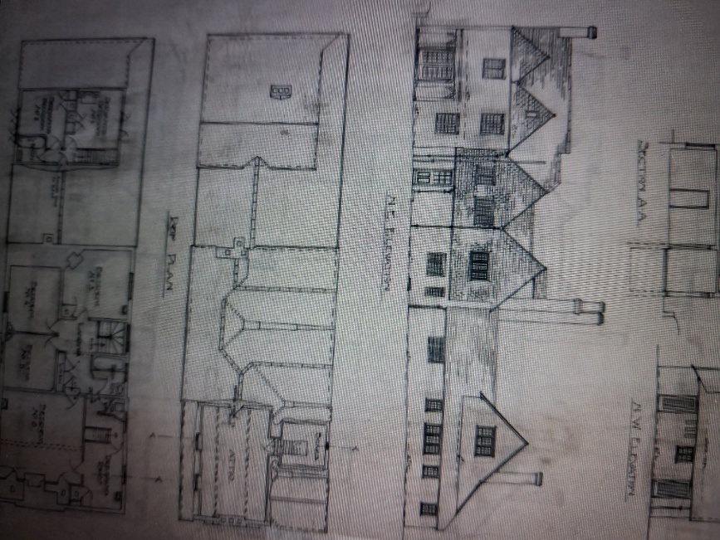
The Above photos are taken from this section of the roof, it is the only internal view of the roof and is accessed from the attic space.

As is shown in the photos, this is a pitched timber roof. The rafters are running parallel to each other, extending from the wall plate up to the ridge. These appear to be acceptable condition. The purlins which are running horizontally and perpendicular to the rafters are providing structural support and appear to be in acceptable condition. At the very apex of the roof, where the rafters meet, there’s a horizontal timber element which is the ridge board, serving as the highest point of the roof’s framework. The timbers appear to be individually cut on site as opposed to modern prefabricated truss systems.
The battens consist of strips of wood fixed across the rafters, supporting the tiles. These are in poor condition at parts. There is a stringy material hanging from the battens which we believed to be corked with horse hair and lime mortar but are now considering that the tiles were laid on hay, in an attempt to seal gaps from wind, rain and snow. These have deteriorated considerably and therefore the roof structure is now more vulnerable to the elements. This traditional method demonstrates that the original roof required protection under the tiles to preserve the condition of the house, as this no longer stands, adding a bat-safe breather membrane would meet these requirements without having any negative impacts on the house. The clay tiles are attached to the battens yet rusty nails can be seen and there are gaps where tiles are slipping, some tiles are also perished so need replacing.
The main structural timber will remain how they are which is necessary in compliance with heritage and conservation principles. This roofing structure adds to the fabric of the house and needs protecting. Any repairs that need to be carried out will be done so as a conservation repair, using traditional methods such as splicing with timber that is of the same species. The battens however do show need for repair, once the tiles are lifted, the irreparable battens will be replaced with a like for like material.

Reasons for our application;
The house has had a number of different owners over the last few years which appears to have led to lots of temporary repairs. The roof has been patched up in many different places as tiles have slipped and moved. The current roof is vulnerable in winds and rain and therefore may not protect the internal timber frame which is part of the historical fabric of the house. There is currently no roofing felt, which leaves no barrier beneath the tiles, leaving the roof vulnerable to moisture and leaks. Having no roofing felt may also be impacting the heat loss within the house which impacts our energy efficiency. Adding a bat-safe, breathable membrane , repairing or replacing broken elements and fixing tiles to working battens will hopefully add longevity to the entire roof system, preserving and protecting the future of the house. There have been a number of leaks caused by water entering the roof and traveling down into the house, although the leaks have been repaired, there is still damage to ceilings and walls within the house that we want to fix once the roof is fully repaired.

Proposed Roof Repairs;
We are using a restoration specialist who has provided a roofing report detailing the intended works alongside a schedule of works. He has also provided photos of his previous work.
In his report he states, ‘A re roof is recommended, so that roofing felt can be installed alongside replacing all broken and perished tiles as well as installing new lead flashings. Tile vents will be installed to allow full recommended ventilation.’
To preserve the historical appearance and integrity of the house, as many tiles as possible will re-laid, ones that need replacing will be placed within the valleys so they are not so easily seen. All tiles and ridge tiles will be clay tiles of the same colour and examples can be provided. The timber framed structure of the roof is an important part of the fabric of the house, there has not been any parts of this structure that has been identified as need repairing of replacing. If we were to come to across any repairs, they would be completed appropriately using traditional methods as mentioned above. The rotten battens will be replaced, the perished tiles will be replaced, most tiles will be re-laid and roof felting will be added. New lead flashings will be installed where these are failing and tile vents will be installed as recommended.
Scale – 1 inch to 8 feet.

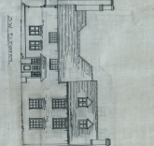
South west elevation. This does not include the garage which was added in the 1960s and is not part of this application.

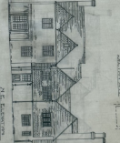
North west Elevation. This does not include the garage which was added in the 1960s and is not part of this application.

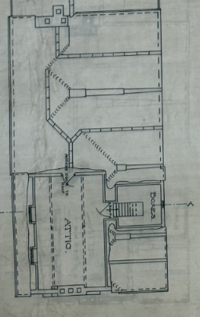

Roof plan.

These elevations remain the same for the proposed works.

Hanging Tiles
At the rear of the house there sections of hanging tiles with terracotta clay tiles. The tiles would have been added to the property as a method of cladding used to protect walls of the building from the elements. The handmade clay tiles have slight variations in colour and texture which gives the façade and unique and rustic appearance. The tiles are fixed to timber battens that are attached to the wall with nails. We feel that rather than changing these tiles for timber cladding, we are keen to retain the clay tiles to preserve the building’s traditional feel.
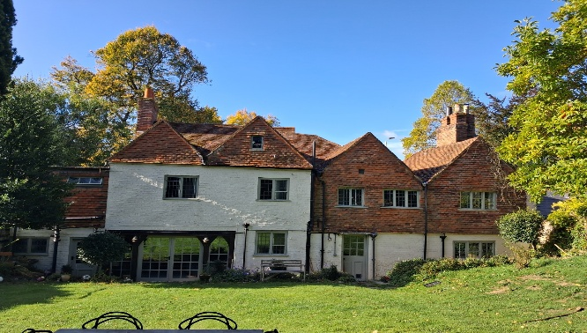

Rear view of house

As shown in the photo, there are tiles slipping and falling. This is caused damage to the basements window hood and is leaving the building open to the elements which may be causing weather damage.
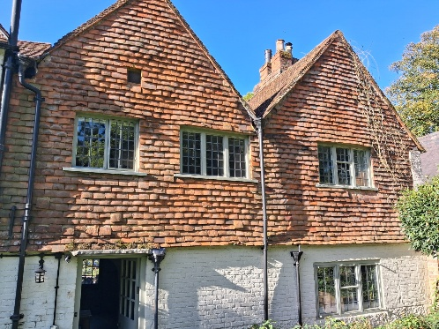
Photo of right side of rear elevation.

We propose to take all the tiles down, replace any rotten battens and replace all tiles, any replaced tiles will be like for like replacements and will be placed sympathetically to retain the aesthetic that the house currently offers.
Potential impacts on repairing hanging tiles include, changing tiles, modernisation, and design. We are not suggesting any modernisation as tiles are already on modern battens with nails, we are not requesting to change the design of aesthetic in anyway, we just want to repair the current tiles so that the area of safer for our children, the house is protected in a way that was originally intended and to preserve the beautiful traditional aesthetic of the house.
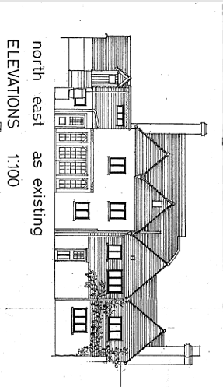
This method has always had a need for maintenance, it is typical that fixings fail due to decay or corrosion. Once tiles start slipping, battens can be exposed which can expose the frame to the elements leading to rot and structural damage. Replacing the tiles allows for replacement of these battens and fixings which helps preserve the structural integrity of the building while adhering to the heritage and conservation principles.
Due to the raised and missing tiles, our bat survey highlighted the potential for crevice dwelling bats and therefore we understand that our application would only be approved with the condition of further bat surveys starting in May 2026.
1 2 3 4 5
This rear elevation shows the 5 areas of hanging tiles as shown in photos above.

Rear elevation after the proposed works will remain with the same aesthetic but with no perished and falling tiles.

Section roof drawings
Existing and proposed

Impact of proposed works on significance
Considering the heritage impact of repairing this roof, we have reflected on the appearance and integrity of the building, the heritage status of the building and the implications of affecting the fabric of the building. In the repairs that we propose we feel that the authenticity and historical value of the house will remain the same and the repairs will mean that the structural integrity of the house is preserved.
Our proposed works will have no significant impact on the appearance of the building, the tiles will remain as handmade clay tiles of the same colour. Replacing and repairing the tiles may provide a well looked after appearance to a traditional aesthetic.
The conservation area is there to ensure that any changes respect the area’s unique character, our proposed repairs will have no impact on the house’s character and how it will present within the local area.
Implications to the fabric of the building are none but potentially minimal. There will be no harm caused to the timber roof structures, the addition of breathable felt and air vents will only add further protection to the existing fabric. The only tiles that will be replaced will be the ones that have perished and are not fit for repair.

