
DESIGN AND ACCESS STATEMENT FOR:

ERECTION OF 2 BED DETACHED BUNGALOW
110 NORCOT ROAD, TILEHURST, READING, RG30 6BT

To be read in conjunction with:

01 Existing Plans & Elevations & Location Plan
02 Proposed Plans & Elevations & Site Block Plan
03 Landscape Plan
04 Construction Site Plan
CMS Construction Method Statement

Planning Policies

Section 38(6) of the Planning and Compulsory Purchase Act 2004 requires that proposals be determined in accordance with the development plan unless material considerations indicate otherwise. Material considerations include relevant policies in the National Planning Policy framework (NPPF) - among them the 'presumption in favour of sustainable development'.
The following local and national planning policy and guidance is relevant to this application and/or is addressed in this document or attached documents listed above:
National Planning Policy Framework (2023)
The following NPPF chapters are the most relevant (others apply to a lesser extent):
2. Achieving sustainable development
4. Decision-making
5. Delivering a sufficient supply of homes
8. Promoting healthy and safe communities
9. Promoting sustainable transport
11. Making effective use of land
12. Achieving well-designed and beautiful places

Reading Borough Local Plan (2019)
CC1: Presumption in Favour of Sustainable Development
CC2: Sustainable Design and Construction
CC3: Adaptation to Climate Change
CC5: Waste Minimisation and Storage
CC6: Accessibility and the Intensity of Development
CC7: Design and the Public Realm
CC8: Safeguarding Amenity
CC9: Securing Infrastructure
EN12: Biodiversity and the Green Network
EN14: Trees, Hedges and Woodland
EN15: Air Quality
EN16: Pollution and Water Resources
H1: Provision of Housing
H2: Density and Mix
H3: Affordable Housing
H5: Standards for New Housing
H10: Private and Communal Outdoor Space
H11: Development of Private Residential Gardens
TR1: Achieving the Transport Strategy
TR3: Access, Traffic and Highway-Related Matters
TR5: Car and Cycle Parking and Electric Vehicle Charging

2
Location
Norcot Road lies centrally within the village of Tilehurst, close to a range of services and transport links including Main Bus Routes, and within walking distance to amenities such as Meadow Park Academy & Moorlands Primary Schools, Tilehurst Library, and Victoria Recreation Ground, Meadway Park & McIlroy Park. The area has a variety of Building typologies including Detached, Semi-detached, Terraced housing, and Bungalows of various ages.

Standards for New Housing

The minimum gross internal floor area for a Single Storey, 2 Bedroom (3 Bedspace) dwelling as set out in the Government’s Nationally Described Space Standard is 61sqm. The layout of the proposed dwelling complies with the above requirement.
The amenity space minimum specified is a min. of the gross Floor area of the proposed dwelling. The above criteria have been demonstrated within the Proposal (See Proposed Plan & Site Plan), with 62.36m2 Internal Area, and 62.74m2 amenity space for the proposed dwelling.

Access and Parking

Policy TR5 of the Reading Local Plan Guidance indicates that proposals should ensure the ‘appropriate level of car parking’, while the supplementary Parking Standards indicate that C3 Dwellinghouses (2 Bed) within Zone 3 should provide 1.5 Parking spaces.
The proposed dwelling will be provided with 2no. Designated Parking Spaces within the front curtilage (and 1no. 7kW Electric Vehicle charger), and secure cycle storage for 2 Bicycles positioned within the private rear Garden.

Design, Access, and Energy/Sustainability

- Design
The Proposal includes the Erection of a 2 Bedroom Bungalow with a modest form factor and a matching architectural style to the Existing Bungalow at 110 Norcot Road.

Due to the levels and sloping nature of the site, as well as the existing Cypress Leyland trees lining the road facing elevation (to be retained), the development will be only partially visible from the carriageway. The proposed form of the Roof & Building Envelope will ensure that there is no significant impact on the dwellings to the South of the proposal, with a proposed Ridge increase limited to 1.2m. The Windows & Doors throughout the development will be selected to maintain the style of the neighbouring and adjacent properties whilst providing energy efficiency and a sufficient level of Sound Insulation to the proposed dwelling.

- Sustainability
Policy CC3 of the Adopted plan sets out criteria for meeting Climate change. Compliance with policy TR5 (Secure Cycle Storage, & EV Charger) has been provided. Amongst other measures included in this scheme will be:
- Solar Photovoltaic Array provided to South East facing Elevation Roof
- Water efficient fittings to the Bathroom and Kitchen
- Thermal Insulation to reduce energy consumption (Refer to SAP)
- New Windows & Doors with min. double glazed units to improve energy efficiency

3
Residential Amenity

The Proposed layout features Window positions and openings positioned to prevent overlooking from habitable rooms within the dwelling, with high level windows proposed to the South East and North West facing (Neighbour facing) elevations.

Acoustic/Noise Impact Assessment

Whilst the development will be a significant distance from the carriageway of Norcot Road (>20m), and the existing Trees lining the front of the site, as well as the level difference will contribute to diffusion/reduction of noise, measures will be taken to mitigate the traffic noise and ensure an acceptable noise environment for occupants; The internal noise level within a dwelling is dependent on the level arriving at the external façade, the sound insulation properties of the dwelling, (wall, window, roof/ceiling construction) the volume of the room and any furnishings present.

BS 8233:2014 indicates typical Traffic noise levels expected from from busy roads (up to 50km/h traffic speed) as 58-68db, as well as guidelines for acceptable levels of noise (7.7.2 Internal Ambient Noise Levels for Dwellings, as below);

Table 4. Indoor Ambient Noise Levels for Dwellings

Activity | Location | 7:00 to 23:00 | 23:00 to 7:00
Resting | Living Room | 35dB LAeq,16 Hour | —
Dining | Dining Area | 40dB LAeq,16 Hour | —
Sleeping | Bedroom | 35dB LAeq,16 Hour | 30dB LAeq,8 Hour

Therefore sound insulation measures such as a Glazing specification of Double Glazed Units min. RTRA 25db (Value taken for 4mm pane, 6-16mm air gap, 4mm pane from Table 4 of BS 12758:2011), in addition to fully insulated Cavity Wall construction to the Front (Street facing) Elevation will ensure the building envelope meets the above criteria in mitigating external traffic noise and providing an acceptable sound environment to the dwelling.

4
Biodiversity/Ecological Impact Assessment

The proposal seeks to improve biodiversity within the curtilage of the site, with the proposed Planting scheme increasing the potential habitat for wildlife (see Landscape Plan).
Great crested Newts and other Protected species have not been identified within proximity to the site, however, Ecology surveys, if required, and details of mitigating measures are proposed to be dealt with at condition stage.

Flooding and Drainage

The location of the application site within Flood Zone 1 does not give rise to concerns in regards to flooding or drainage, as the site is not located within Flood Zone 2 or 3.
Existing surface water systems are already in place within the curtilage of the existing dwelling, and the proposal aims to improve upon these systems with increased surface water management (Soakaway) sufficient to accommodate the proposed Roof Area, as well as removal of existing Tarmac surfacing and replacement with permeable paving to the hard standing areas, as well as proposed planting and soft landscaping (See Landscape Plan). The Existing Foul system is also in place and a new connection from the proposed dwelling is planned.
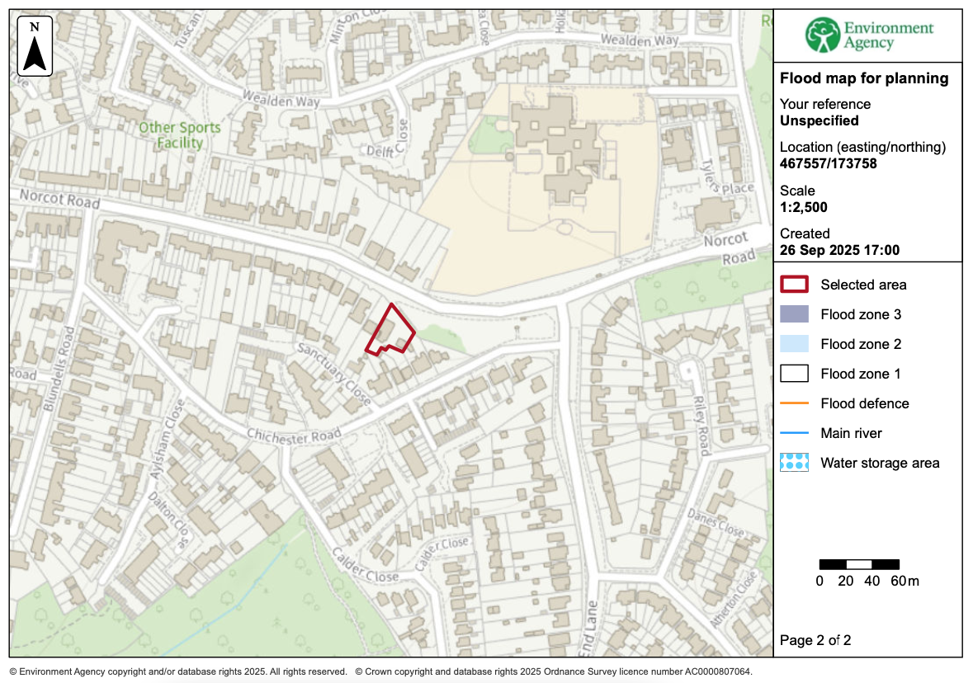

5
Transport Statement

The proximity of the site to local Bus Routes (including Reading Buses Purple 17 Route immediately adjacent to the site) offers good access to public transport systems. The provision of Parking spaces previously outlined (2 spaces), as well as the provision of EV Charging and secure cycle storage also offer improved access to sustainable transport methods.

Waste Management

Bin Storage positions and collection positions are indicated within the Proposed Site Plan.

Affordable Housing

Policy H3 of the Reading Borough Local Plan (Adopted November 2019) states the following:
‘on sites of 1 – 4 dwellings, a financial contribution will be made that will enable the equivalent of 10% of the housing to be provided as affordable housing elsewhere in the Borough.’

While the Affordable Housing Supplementary Planning Document (Adopted March 2021) chapter 7.7, states:

‘A typical Affordable Housing Statement for developments of less than 10 dwellings, where an off-site financial contribution is expected, should include the following information:
• the total number of all residential units;
• details of the Gross Development Value (GDV) of the whole development, based on two separate valuations by suitably qualified estate agents of the completed development; and
• the proposed level of financial contribution.’

Total number of Residential Units: 1
Gross Development Value (GDV): This information has not yet been finalised. However, it will be provided at the appropriate stage.

Proposed Level of Financial Contribution: As the above information has not yet been finalised, a calculation of contribution cannot yet be made; however, a financial contribution towards affordable housing in accordance with Affordable Housing Supplementary Planning Document and Policy H3 & CC9 will be made and the applicant formally agrees to this requirement.

Conclusion

The proposal makes a good use of the existing site, and would benefit the local area by providing new housing in a desirable and sustainable location, well related to key facilities and transport links, as well as providing a visually attractive and sustainable design which complements the immediately adjacent existing bungalow. Good quality and appropriately sized private amenity space will be provided in the form of Rear Garden and front curtilage, whilst the site is in a good location with very close access to various transport links and public amenity areas.

6.

