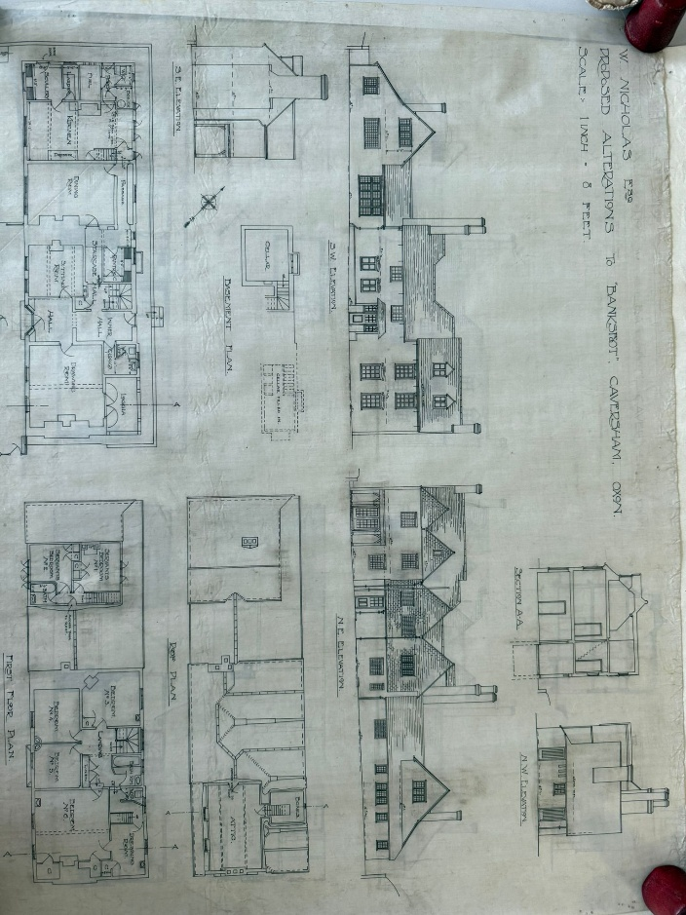
43 Church Rd, Historical Planning Applications

These drawings date back to early 1920’s when the current owner proposed some internal works and moved the front door to the front of the house and added a porch. Access was preciously obtained via what we now call the back door.
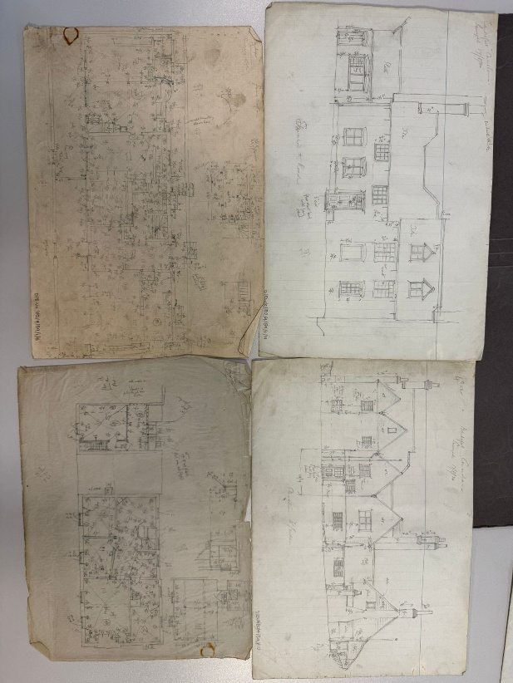

These were taken prior to the house being changed into 2 houses.

