NCP Kenavon Drive. Details on Condition 6.
Condition 6 states that:
‘Notwithstanding the layout plan hereby approved (Proposed layout plan, as received 04/06/2025), within 4 (four) weeks of the date this application is permitted, details of a pedestrian only entry/exit point opening onto Kenavon Drive shall be submitted for approval in writing by the Local Planning Authority. Details shall include measures to prevent vehicular use and a landscape management strategy to maintain suitable visibility. The entry/exit point shall be provided in full accordance with the subsequently approved details within 4 (four) weeks of written approval being given. Thereafter, the pedestrian entry/exit point opening shall permanently be kept free of any other obstructions, maintained in a good condition and kept open and available at all times for non-vehicular use to access and exit the car park for the lifetime of this permission.’
Here is an overview on the details
- Remove a section of vegetation, and angle Heras fencing to create a walkway. Heras Fencing will block people accessing the continued vegetation wall along the perimeter of the carpark.
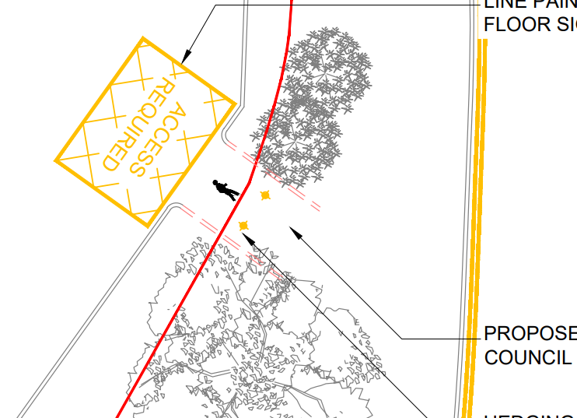
- The ground will be flattened and tarmac to provide a suitable walking surface.
- Hatching to be created on the NCP demise (Inside the carpark) to prevent cars blocking
- Bollards to be placed in the centre of the walkway preventing vehicles accessing although it is consider this would be unlikely due to existing curbs
- Solar Lamp to be added to the fencing in the centre of walkway.

It is noted that the boundary does cross the Council land. I have added some additional photos of the area below.

