TOWN AND COUNTRY PLANNING ACT 1990

Site Security Strategy

In respect of

Kenavon Drive
Forbury Park
Reading
RG1 3DH

On behalf of National Car Parks Limited

September 2025

LPA Ref: PL/25/0639

Aitchison Raffety
The Granary, Spring Hill Farm, Harborough Rd, Pitsford, Northampton NN6 9AA
Telephone 01604 880163

Prepared by
Nigel Ozier
BA (Hons) MRTPI

1 | Introduction | 3
2 | Site Context | 3
3 | Measures | 3
4 | Overall View | 6
5 | Monitoring | 8
CONTENTS

1. INTRODUCTION

  - This Site Security Strategy has been prepared to provide details required by Condition 5 imposed on planning permission PL/25/0639. Some of these details were explained prior to the determination of the application. Condition 5 states:

‘Within 4 (four) weeks of the date this application is permitted, a site security strategy shall be submitted in writing to the Local Planning Authority for approval. The site security strategy shall as a minimum include a formal surveillance strategy, with the provision of CCTV informed by an operational requirements study, and external lighting details. The subsequently approved measures by the Local Planning Authority, as contained within the Site Security Strategy, shall be implemented in full within 4 (four) weeks of written approval and shall be permanently retained and maintained thereafter for the lifetime of this permission.’

  - The Strategy covers the management aspect for the car parking area. It covers relevant matters on how NCP control the site use and visit the site on a regular basis. It considers any measures which will be implemented so that the parking area is appropriately managed.

2. SITE CONTEXT

2.1 The approved development comprises temporary use for public parking on vacant land. The provision of parking on this site has provided much needed spaces which have removed vehicles previously parking on the roadside and path and also spaces for hospital staff to use.

2.2 Planning permission was granted on the 25 July 2025. Limited change is required to the site. An application has also been submitted dealing with the details required on Conditions 2 and 3.

3. MEASURES

3.1 The following details form part of the site security strategy.

Boundary Treatment

3.2 All fences and hedges are marginally below 2 metres and cannot be easily climbed over. There is one main vehicle entry and exit point onsite which will remains as the main driveway entrance. A pedestrian entrance is also being provided (the site in its previous use did have gated pedestrian entrance close to the existing vehicle entrance). Anyone entering or exiting the site will have to use these points. There are no other accessible gaps or breaks in the boundary. The photograph below shows part of the boundary fencing.

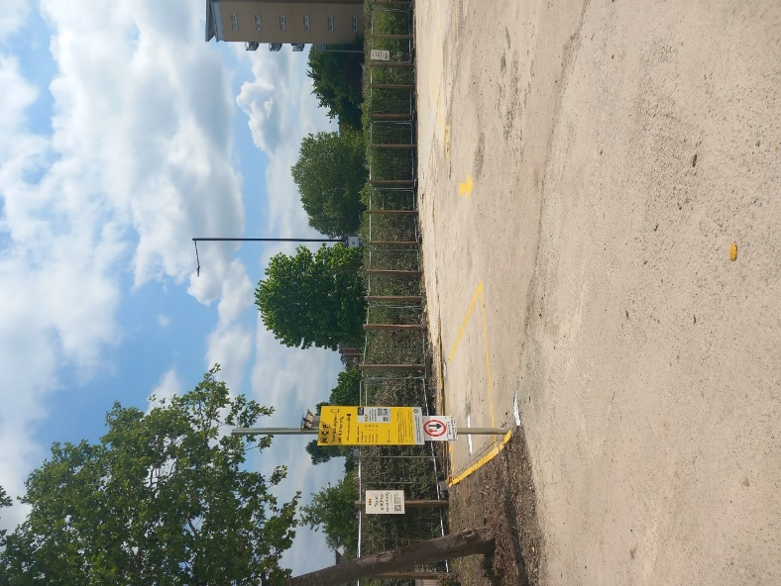

Barrier Details

3.3 The car park has 2 metre high, metal gates with a mesh finish fitted to the main entry point, although these are left open 24/7. It will not be possible to man the site 24 hours a day or have an opening and closing schedule.

CCTV Location

3.4 It is relevant that the site is overlooked by extensive developments of residential apartments including up to 6 stories high which provides significant security in itself. However, CCTV will also be provided as shown at the entrance to the site to note all those accessing the site and the vehicle registrations.

Lighting

3.5 Lighting is largely provided by the surrounding street lighting. NCP have also fitted movement sensor reactive solar lights to both ends of the car park which also assists in customers able to read the signage. The photograph below shows one of the lights around signage.

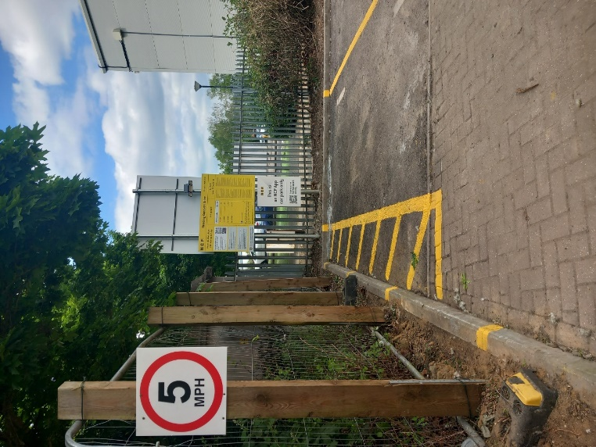

Site Monitoring

3.6 NCP provide physical visits on 5 days a week to maintain and patrol the site. All visits are conducted in NCP branded workwear and vehicles to provide a presence on the site. These visits are made at random times of the day so that a pattern cannot be formed.

4. OVERALL VIEW

4.1 National Car Parks operate numerous car parking sites throughout the UK and most are managed through CCTV and parking apps. The site at Kenavon Drive will be used for a temporary period and operated along the same lines as other car parks. The car park is proving already to be important in the area including the hospital and has not caused any problems to date. The CCTV provides sufficient information and regular visits are made to the site to identify any security issues.

5. MONITORING

5.1 The site is monitored regularly and any changes needed will be identified. It is unlikely that these will raise any material planning issues. Each car park is controlled by an area team who are able to ensure all matters are dealt with.

Northampton Office
The Granary, Spring Hill Farm,
Harborough Rd,
Pitsford,
Northampton
NN6 9AA

Aitchison Raffety (Commercial) Ltd, registered in England & Wales 03436430. Registered Office: Unit 4 Stokenchurch Business Park. Ibstone Road, Stokenchurch, HP14 3FE. Regulated by RICS.
Birmingham Office:
Edmund House, 12-22 Newhall Street,
Birmingham
B3 3AS

