Design & Access Statement
40 Yew Lane READING RG1 6DA
- Summary:
  - This Design and Access statement has been prepared by Erinn Melville, on behalf of Erinn and Adam Blything. It is to support listed building consent requestion to upgrading property-wide 13 single-glazed timber windows to double-glazed timber windows at 40 yew lane, and the replacement of blown double glazing roof light with like-for-like glazing.
  - All proposed changes mentioned throughout the planning application and this Design & Access statement are supported by interior and exterior photos with annotations / commentary.
- The Site and surrounding areas:
  - The application site is within Coley Park Farm, and more specifically the Grade II listed Barn at Coley Park farm, listed on 22 March 1957 with English Heritage building ID 39233.
  - The barn was built circa1619 and has Roman tiles on the roof. It was converted to housing, and the residents’ association incorporated in 1995.
  - The site is No. 40 Yew Lane a 3-bedroom house end of terrace.
  - The existing single-glazed windows are of no architectural merit, and do not add to the character of The Barn.
- Rationale for change
  - The existing single-glazed windows use 4mm float glass. The glass does not have any kite marks confirming the glass has not been toughened to safety glass standard. A couple of existing panes are cracked which also confirms this. The windows in the bedroom are below 800mm from the floor meaning they do not currently fit safety requirements for toughened glass.
  - There are a few points of softness and possible rot detected in the frames but overall condition of the exterior frames are in good condition which denotes regular maintenance and coating with exterior wood paints.
  - The Velux rooflight double glazed seal has blown which has lead to excessing misting and condensation such that visibility is very obscured and reduces the visual appeal of the property internally and externally.
  - None of the windows are the originals from the buildings initial purpose as a barn so only date back to the renovations in the late 1900s.
- Proposal
  - The alterations include fitting double glazed units into the existing wood frames. This will include the safe removal and disposal of existing 4mm float glass, cleaning out old putty and preparation of frames ready for glazing in units. The double-glazed units will be affixed with glazing sealant and will comprise of 4mm toughened glass both sides and will be a total unit depth of 14mm each. This will allow for new white oak 12mm square bead to be fitted to the frames to secure panels, the beading will be undercoated prior to fixing, beading will be affixed with 25mm Sherardized panel pins.
  - Two of the units for the bathroom will be fitted with privacy glass, as the bathroom is downstairs and faces onto a shared courtyard. The chosen privacy glass would be Pilkington's Optifloat Opal pattern glass (subject to approval) which is a translucent acid etched glass suitable for internal or external use and is a level 5 privacy glass and matches the neighbour’s bathroom windows on the opposite side of the courtyard.
  - The Velux window double glazing will also be removed and replaced with like for like double glazing panel into the existing frame.
  - The works would also include the replacement of the existing mismatched and broken window hardware (locks, handles and stays) with matching cast iron monkey tail hardware to enhance security and internal look, and repainting the timber frames with white exterior wood paint to ensure their condition is maintained.
  - The proposed replacements will be effectively identical given the existing timber frames will remain unaffected and/or condition improved where needed (same number of panels, lock types, painted white etc). The new double-glazing wooden windows would improve the energy efficiency of the property without altering the appearance of the and would continue to maintain the historic character of the building and remain in keeping with neighbouring properties.
- Access
  - There would be no change to access to the property.
- Conclusion
  - The proposed window changes to replace single glazing with double or repair existing double glazing, will improve the amenity of the property (both from the courtyard and street), prevent further deterioration of the existing windows, improve the energy performance of the property, improve the security rating of the property and will not detract from the architectural value or special character of the Barn.

Annex A – current window condition
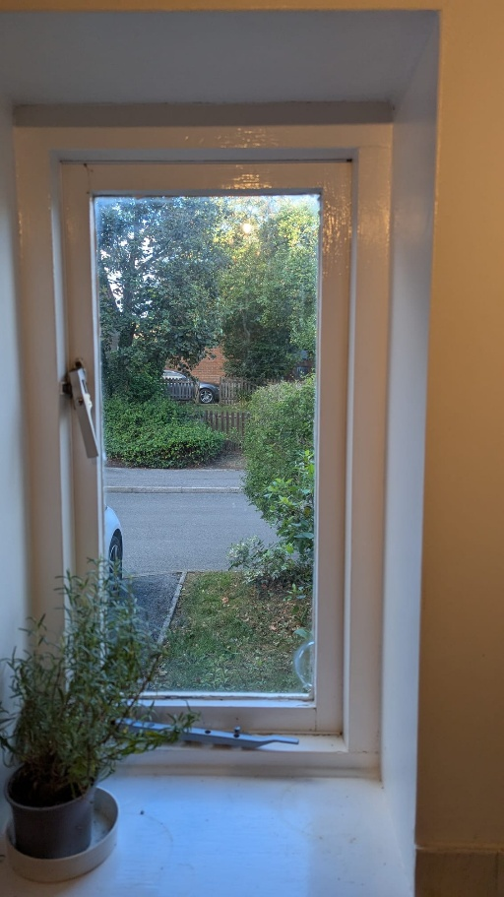
Photo 1. Kitchen Window with crack and broken hardware.
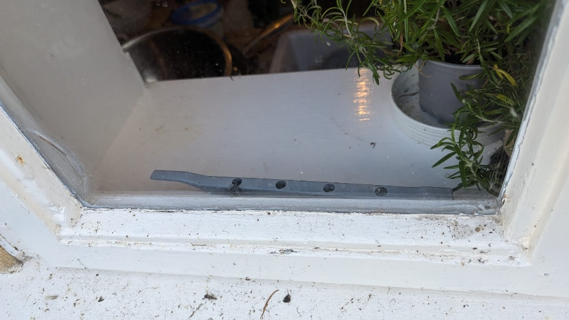
Photo 2. Condition of the timber frames which will be treated, filled and painted to enhance look and ensure maintenance. The existing beading would be replaced with thinner beading to allow for the thicker double glazed units but will look essentially the same as currently.
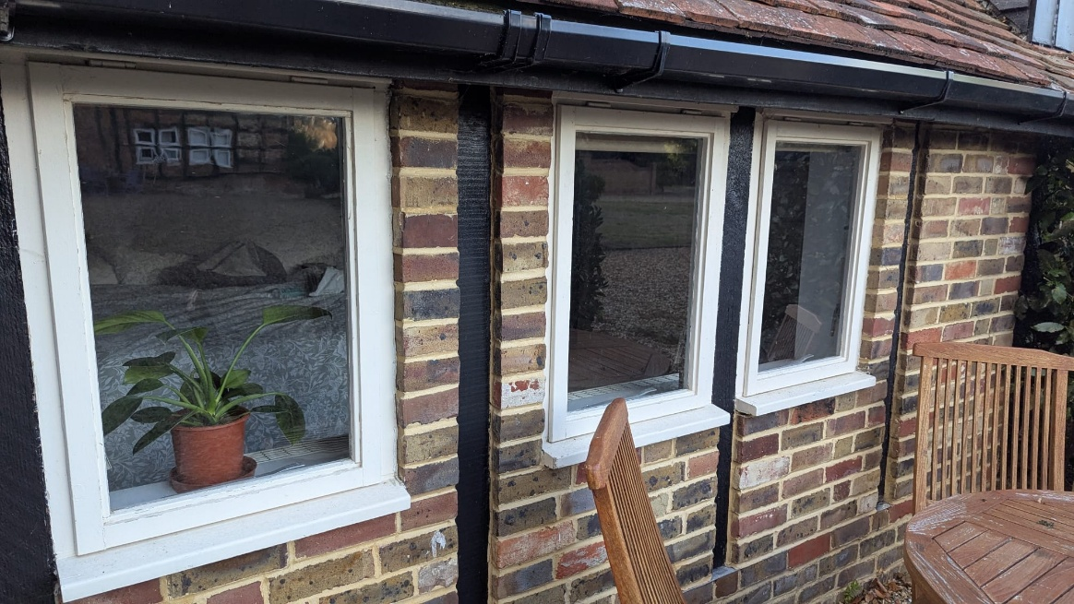
Photo 3. External view of the windows.
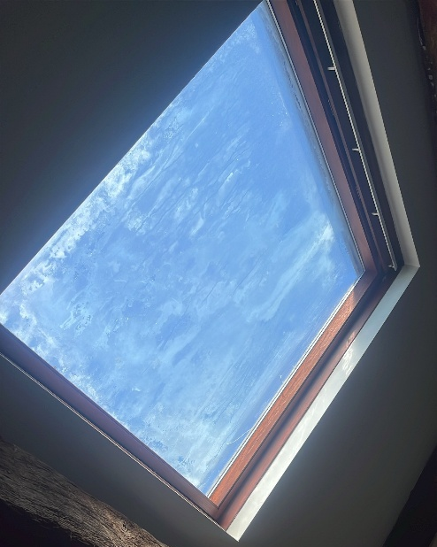
Photo 4. Skylight with blown double glazing with condensation and mould between the panes.

