Statement of Works
Planning Application Ref: PL/25/0197
Property Address: 5 The Brookmill, Reading, RG1 6DD
Condition Reference: 4
Date: 02/09/2025

1. Introduction
This Statement of Works is submitted in relation to planning application PL/25/0197, as required under Condition 4 of the Decision Notice. It sets out the methodology and approach for the repair, maintenance, and making good of the existing timber beams, with reference to the approved plans.

2. Existing Fabric
The building is a Grade II listed dwelling. The relevant structural elements involved in the proposed removal of the ensuite wall and bathroom fixtures:
Bedroom Beams:
- Timber beams running across the length of the room, directly through the wall to be removed
- Timber beam on ceiling visible at the top of the wall to be removed
- Exposed timber in west facing wall running underneath wall to be removed

En-suite Beams:
- Timber beam running across north facing wall above window at roof join
- Timber beam running up vaulted ceiling to wall to be removed
The beams are integral to the historic structure, some of which form part of the loadbearing framework of the dwelling.
Photographs of the existing beams and their context are provided in Appendix A.

3. Proposed Works

3.1 Inspection & Recording
The relationship of the stud wall to be removed to the adjacent beams, joists, and original fabric will be inspected and noted prior to any intervention.

3.2 Temporary Support
Before removal, any structural loads will be assessed. If required, temporary propping will be provided to ensure no undue strain is placed on the timber beams during dismantling.

3.3 Dismantling method
- The stud wall will be carefully dismantled by hand, working from top down. Mechanical cutting will be avoided in direct proximity to original timber members. Fixings, nails, and laths will be individually withdrawn rather than prised away, to prevent damage to adjoining beams.
- Where beams pass through the studwork, the timber framing will be removed around them without cutting, notching, or forcing.
- Bathroom tiling and plasterwork beneath will be removed as carefully as possible in relation to exposing currently hidden parts of beams 3 & 4:

3.4 Treatment of Beam Interfaces
- Any redundant fixing holes will be left undisturbed unless they present a risk of decay, in which case they will be filled with matching timber plugs.
- Beam surfaces will not be sanded or planed; original tool marks will be retained.

3.5 Making Good
Once the wall is removed, all exposed beams will be carefully inspected for signs of decay, insect attack, or historic alterations. All sound original material will be preserved and repairs will only be carried out where necessary for structural stability. If inspection reveals significant decay or structural failure beyond localised repair, a qualified conservation specialist or structural engineer will be appointed to assess the extent of decay and propose an appropriate repair strategy as part of a new Listed Building Consent application.

4. Conclusion
The proposed works follow established conservation principles and are designed to:
- Retain as much historic fabric as possible.
- Use like-for-like repair methods and materials.
- Ensure long-term stability and integrity of the structure.
The works will be undertaken in accordance with the approved plans PL/25/0197, and will preserve the special character of the building.

Appendices
Appendix A
Bedroom Beams:
- Timber beams running across the length of the room, directly through the wall to be removed
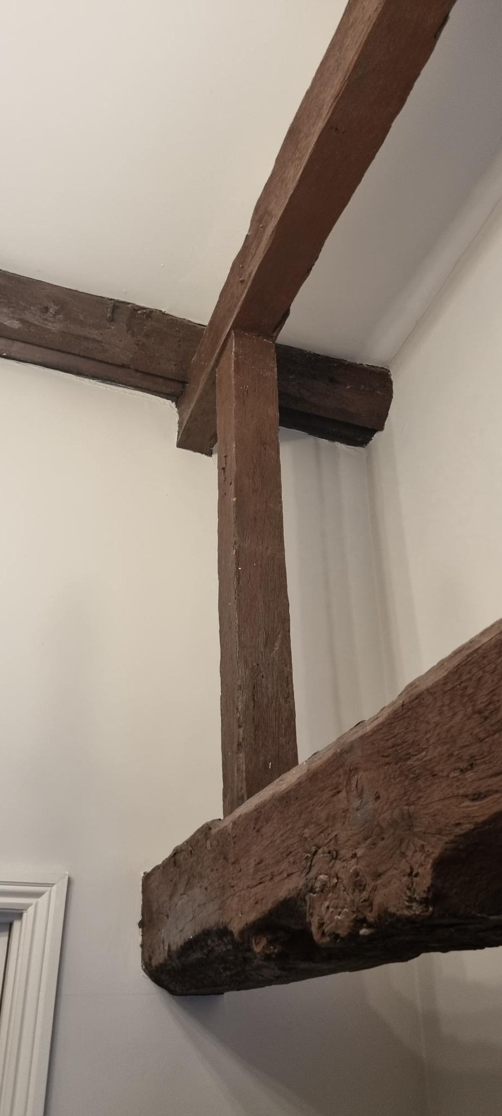

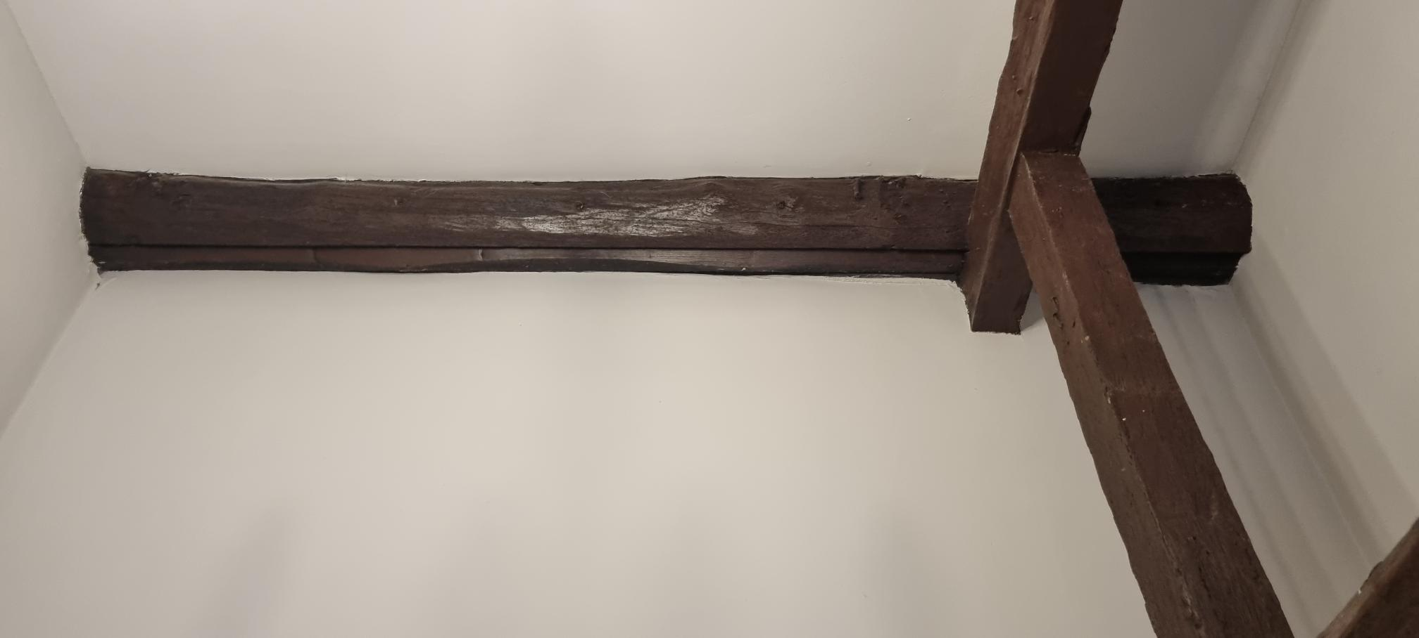
- Timber beam on ceiling visible at the top of the wall to be removed

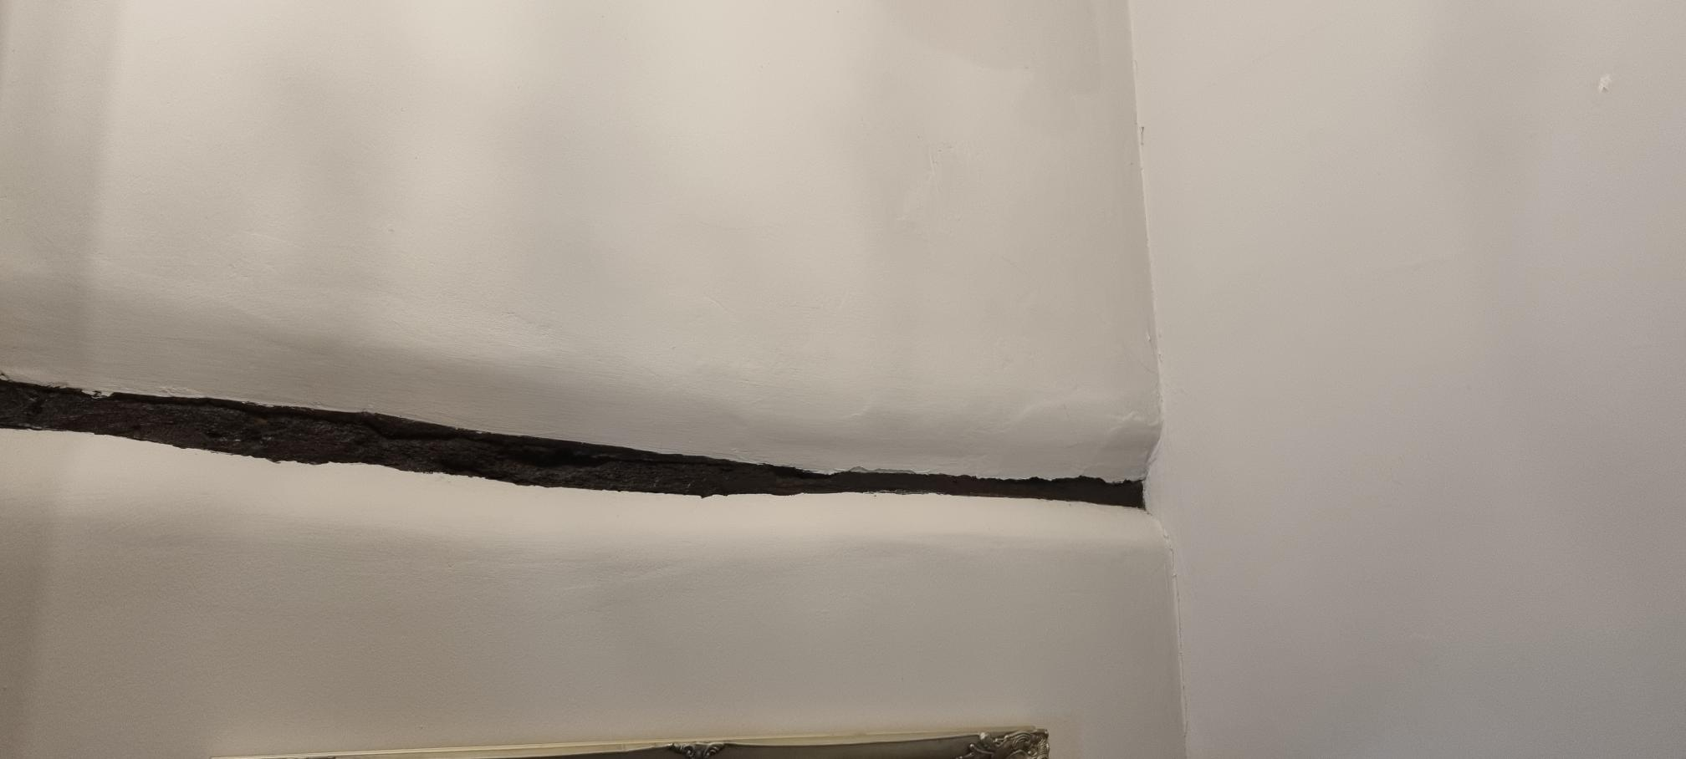

- Exposed timber in west facing wall

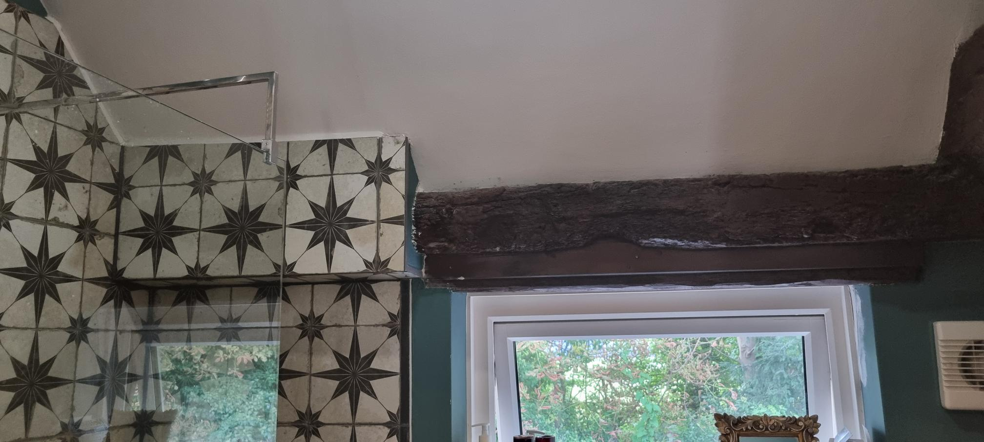
En-suite Beams:
- Timber beam running across north facing wall above window at roof join

- Timber beam running up vaulted ceiling to wall to be removed

