22/08/2025
Planning Application Ref: PL/25/1105
Officer: Gary Miles
Application Type: Prior approval Part 3 Class G: Retail or betting office or pay day
loan shop to mixed use
Address: 73-74 BROAD STREET, READING, RG1 2AF
Proposal: Application to determine if prior approval is required for a
proposed: Change of use from Commercial, Business and Service (Use Class E), or betting office or pay day loan shop to mixed use including up to two flats (Use Class C3) Town and Country Planning (General Permitted Development) (England) Order 2015 (as amended) - Schedule 2, Part 3, Class G

Application is for a change of use from Class E to Class C3 for 2 x 3 bedroom units on the second floor. The first and second floors will continue to be used for commercial use.

The site is located within the Reading Central Area and within Reading’s primary shopping area. The site is located within Zone 1 of the adopted Parking Standards and Design SPD which is an area at the very heart of Reading Borough, consisting primarily of retail and commercial office developments. This area is well served by rail and bus links and also contains the largest proportion of public car parking spaces.

The application will retain a retail element on the ground and basement level and the creation of 2 x 1 bedroom residential flats across the first, second and third floors.

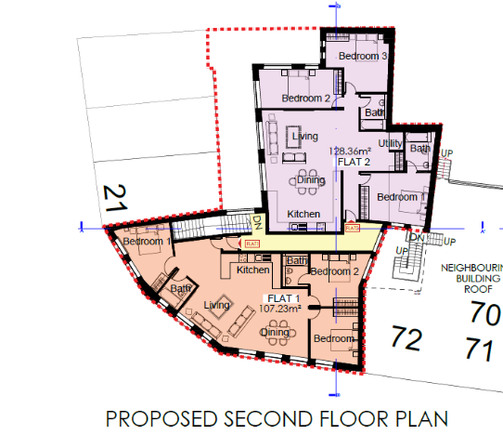

Due to the constraints of the site, there is no on-site parking available. The non-provision of parking is acceptable in this town centre location the surrounding road network all have parking restrictions preventing on-street parking, therefore, any overflow in parking would not affect follow of traffic on the classified road network. Cross Street does not fall within a Resident’s Permit Zone.

If this application is approved there should be an assumption that any future occupants of the proposed units will not be issued with resident or visitor parking permits which should be covered by the appropriate condition and informative, this will ensure that the development does not harm the existing amenities of the neighbouring residential properties by adding to the already high level of on street car parking in the area

In accordance with the Councils current standards, each residential unit would require 0.5 cycle storage spaces, however under GPD we would not comment on this.

The applicant should ensure that the refuse storage provisions comply with the Council’s Waste Management Guidance which is available to view online.

Considering the sustainability of the site, the proposed change of use is unlikely to have a significant impact on the trips and parking demand generated by the premise. On street parking in the vicinity of the site is either restricted or regulated and therefore any increase in parking demand would not be accommodated on street.

In principle there are no Transport objections to this application,

IF3 Highways
I13 Parking Permits

N. Hussain
Transport Development Control Advisor

