DELEGATED APPLICATION REPORT
WARD: Thames
APP. REF: PL/24/1669
SITE ADDRESS: 72 George Street, Reading, RG4 8DW
PROPOSAL: Erection of covered building
APPLICANT: Mr J. Stanley
RECEIVED DATE: 12 December 2024
CASE OFFICER: Matthew Harding

TARGET DATE: 25 July 2025

- SITE DESCRIPTION
The application site is located on the north side of Reading town centre, to the western side and accessed from George Street (B3345). Immediately to the west of the site lies Christchurch Meadows and Christchurch Meadows Pavilion. A single storey brick-built structure lies adjacent to the western site boundary and the proposed covered building. Along the western and southern site boundaries there is a line of Poplar trees growing in Christchurch Meadows. Beyond the Poplar trees is the vacant pavilion which faces away from the site.
The wider application site forms part of a commercial laundry operation that is stated has been operating on the site since 1935 and is based in the large red brick building on the site. A brick wall demarcates the northern and parts of the eastern boundaries of the site. The site is dominated by the main laundry building which faces directly onto George Street. There is access onto George Street both to the northern and southern parts of the site. There is staff car parking for some 20 cars in in the northern part of the site and the southern part of the site is used mainly for open storage, including some 70 trolleys of used linen awaiting processing.
The site lies within Flood Zones 2 and 3 and the Air Quality Management Area (AQMA). The site does not lie within a conservation area, is not subject of an Article 4 Direction, there are no protected trees on or adjacent to the application site and the buildings on and surrounding the site are not listed or locally listed.
Furthermore, The Thames Valley major landscape feature (Policy EN13) wraps around the application site, running alongside the rear (western) boundary with Christchurch Meadows and on the opposite side of George Street to the east, including Hill’s Meadow and King’s Meadow further to the east.
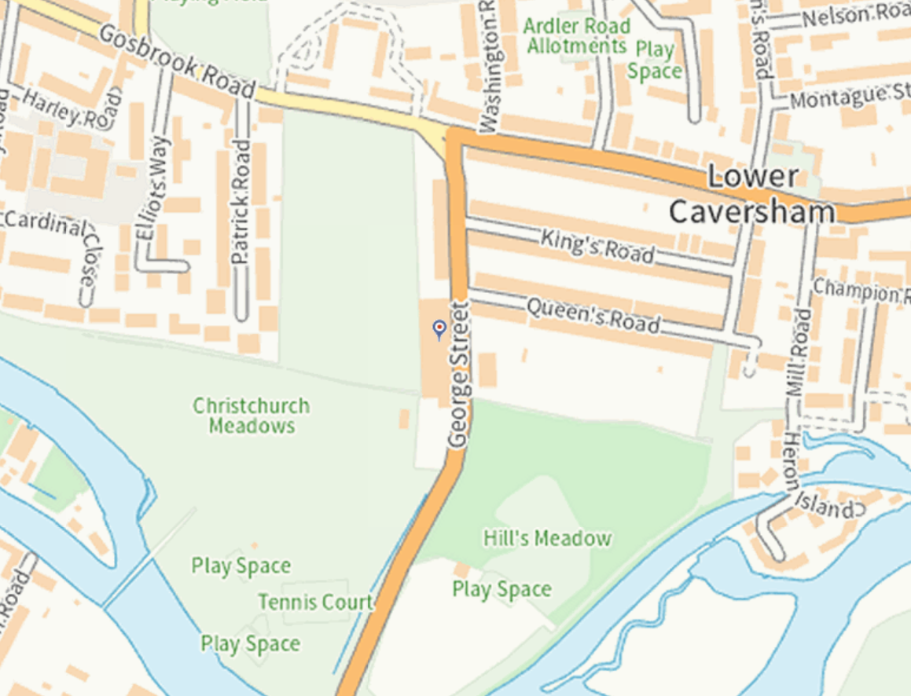
Figure 1: Location Plan
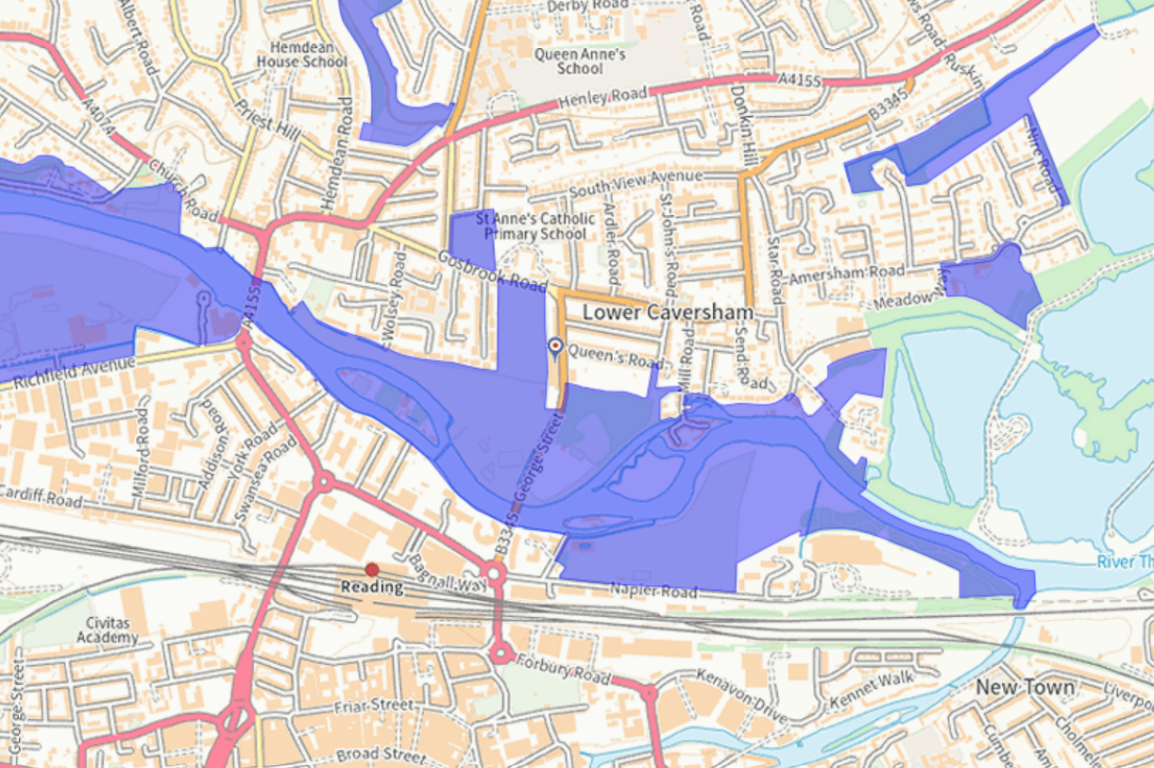
Major Landscape Feature (purple)
Application Site
Figure 2: Application Site and Major Landscape Features (Thames Valley)

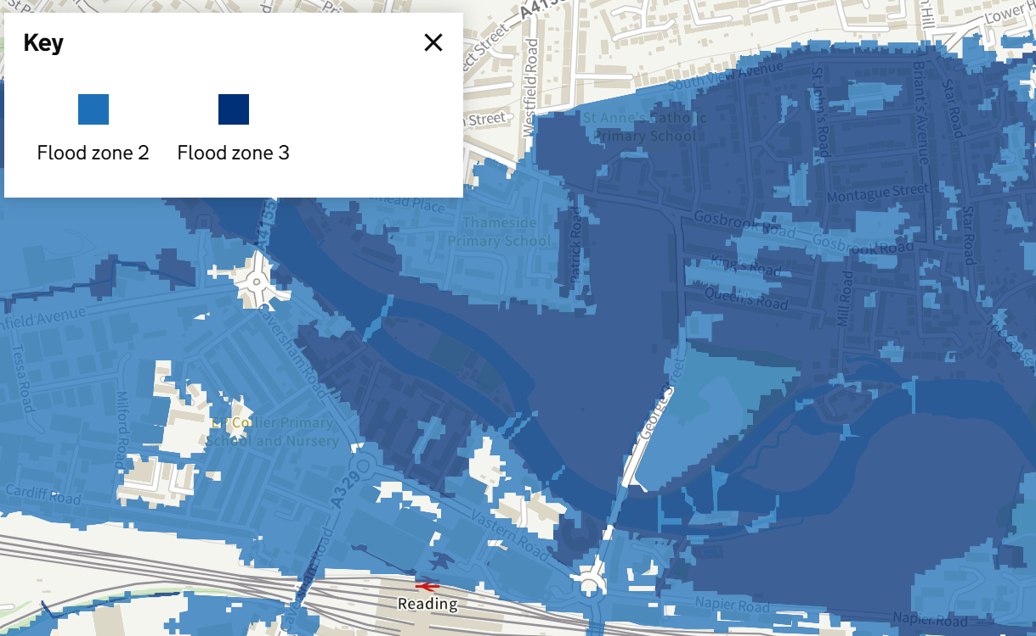
Application Site
Figure 3: Flood Zones
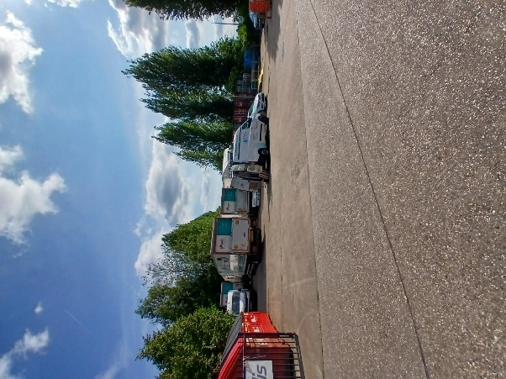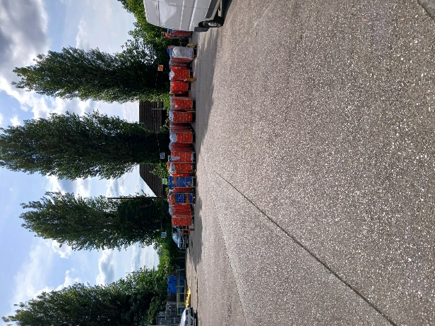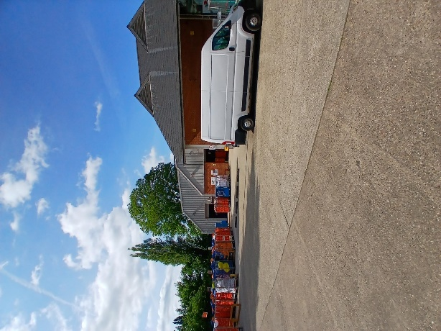
Figure 4: Site Photos – Laundry Building and Yard
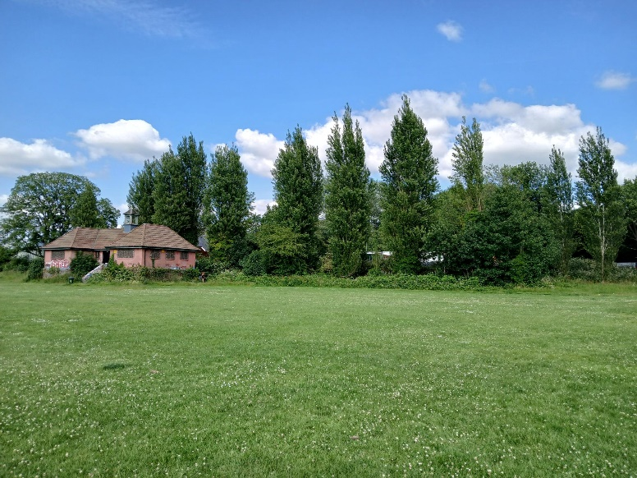
Figure 5: View from Christchurch Meadows towards application site (existing pavilion building left hand side)
- PROPOSAL
Planning permission is sought for the erection of a covered building, enclosed on three sides with an open frontage. The proposed building is shown positioned on the existing yard area serving the laundry building, with the building being a utilitarian metal-clad structure with steel uprights.
The building would extend to an overall height of 6.7 metres, width of 20 metres and depth of 10 metres, and have a footprint of 200 square metres. The building would bepositioned two metres away from the rear (western) boundary line with Christchurch Meadows.
The supporting documentation outlines that the purpose of the proposed building is as a shelter / storage for the incoming dirty linens prior to processing within the main laundry building from incoming delivery trucks.
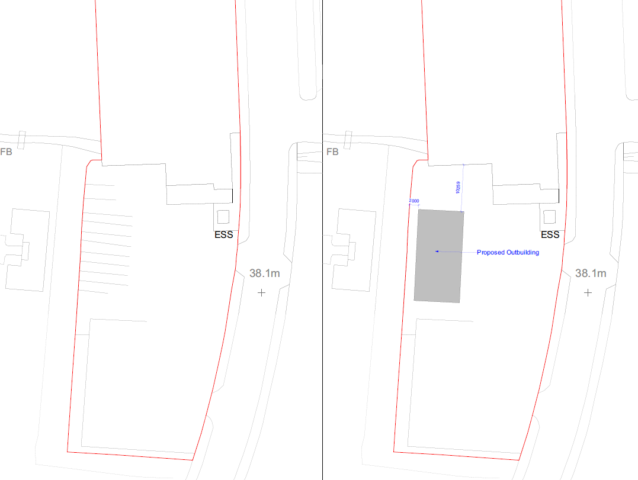
Figure 6: Existing and Proposed Block Plan
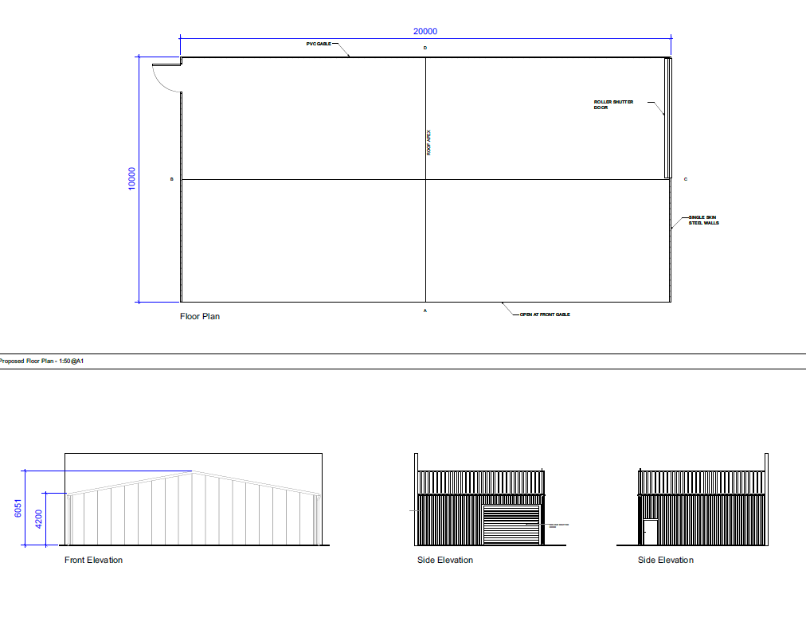
Figure 7: Proposed Building – Floor and Elevation Plans

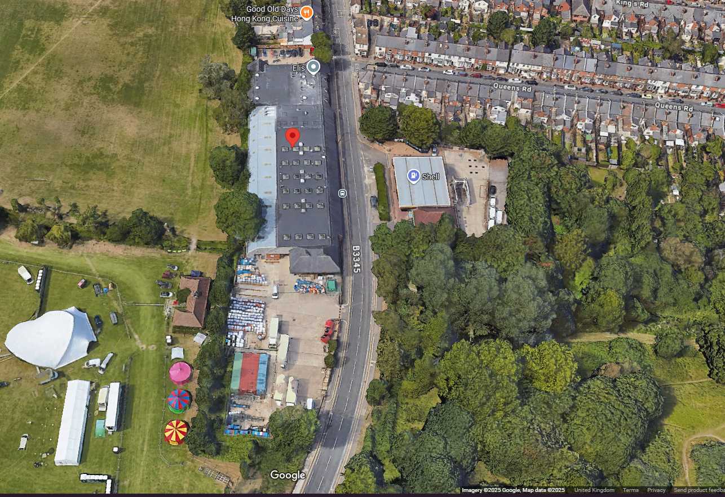

Information Submitted
The completed application form, including a written summary of the proposed development and the developer’s contact details.

Drawings and Documents ref.
- Application Form
- CIL Form (the development is chargeable at a nil rate)
- Covering Letter, reference: JO-687-LET-01-C, dated and received on 30 May 2025
- Design and Access / Supporting Planning Statement, prepared by Inception Planning, reference: 24-687-SPS-01 Version B, received on 21 May 2025
- Flood Risk Assessment, prepared by Geo Smart Information, reference: 82960R1, dated 12 September 2024, received on 21 May 2025.
- Arboricultural Development Report, prepared by Wood’s Tree Consultancy Ltd, dated 18 February 2025, received on 19 February 2025
- Site Location Plan, drawing number: PL-01 Rev. A, received on 12 December 2024
- Existing and Proposed Block Plans, drawing number: PL-02 Rev. C, received on 12 December 2024
- Proposed Plans and Elevations, drawing number: PL-03 Rev. B, received on 12 December 2024

- RELEVANT PLANNING HISTORY

- PL/88/0183 - Rebuilding laundry following substantial destruction by fire. Permitted 18/1/1989
- PL/04/1083 - Demolition existing buildings and erection 3 separate residential
- blocks varying in height from 2-5 stories to provide 1-, 2- and 3-bedroom flats
- Refused - 11/3/2005.
- PL/06/0250 - Demolition of existing building and erection of a 76 unit residential
- development composed in 4 separate blocks from 3-5 stories incorporating 8x 4 bed dwellings, 56 x 2 bed flats and 12 x 1 bed flats. Refused and Appeal Dismissed - 17/8/2006.
- PL/12/0294 - Erection of steel framed warehouse to rear of building. Permitted - 25/7/2012. Not implemented
- PL/13/0684 - Replacement detached warehouse and new single storey side extension (475 sq m.), following demolition of chimney and existing attached and detached buildings, improved boundary treatment to the western and southern boundaries with Christchurch Meadows and to the eastern boundary with George St. andnd provision of solar panels to the existing laundry roof. Permitted - 5/11/12013.
- PL/16/1137 - Non-material amendment to planning permission PL/13/0684 to include alterations in height / materials of fencing on south and west boundaries alterations to skylights and installation of 16 further skylights to extended buildings and alterations to doors. Agreed – 14/07/2016was .

- CONSULTEES
Environment Agency: We have two objections to this application due to the development being inappropriate to the flood zone and the absence of an acceptable Flood Risk Assessment (FRA). We recommend that planning permission is refused.
Natural Environment Team – RBC: No objection on tree grounds as the proposal offers minimal impact to the trees
Environmental Protection – RBC: No objection, subject to conditions.
Transport Strategy Team – RBC: No objection.

Third Party Comments:
A site notice was displayed on the application site on 11 June 2025. No letters of third-party representation have been received in connection with this application.

- LEGAL AND PLANNING POLICY CONTEXT
Section 38(6) of the Planning and Compulsory Purchase Act 2004 requires that proposals be determined in accordance with the development plan unless material considerations indicate otherwise. Material considerations include relevant policies in the National Planning Policy framework (NPPF) - among them the 'presumption in favour of sustainable development'. However, the NPPF does not change the statutory status of the development plan as the starting point for decision making (NPPF paragraph 12).
National Policy and Guidance
National Planning Policy Framework (NPPF)
National Planning Practice Guidance (PPG)

Reading Borough Local Plan (2019)
CC1: Presumption in Favour of Sustainable Development
CC2: Sustainable Design and Construction
CC7: Design and Public Realm
CC8: Safeguarding Amenity
EN7: Local Green Space and Public Open Space EN7Ca Christchurch Meadows and EN7Cc Hills Meadow.
EN13: Major Landscape Features and Areas of Outstanding Natural Beauty
EN14: Trees, Hedges and Woodland
EN15: Air Quality
EN18: Flooding and Drainage
TR3: Access, Traffic and Highway-Related Matters
TR5: Car and Cycle Parking and Electric Vehicle Charging

Supplementary Planning Documents (SPDs)
Revised Parking Standards and Design (2011)
Sustainable Design and Construction (2019)

Equality Act 2010
In determining this application, the Council is required to have regard to its obligations under the Equality Act 2010. However, there is no indication or evidence (including from consultation on the application) that the protected groups identified by the Act have or will have different needs, experiences, issues and priorities in relation to this planning application. Therefore, in terms of the key equalities protected characteristics it is considered there would be no significant adverse impacts because of the development.

- APPAISAL

Main issues:

Principle
Flooding: sequential considerations
Flooding: flood risk
Design and impact on the character of the area
(Other considerations)

Principle

Paragraph 85 of the NPPF sets out planning policies and decision should help create the conditions in which businesses can invest, expand and adapt, with significant weight placed on the need to support economic growth and productivity. In addition, Policy CC1 of the Reading Borough Local Plan supports the presumption in favour of sustainable development, unless application of policies in the NPPF that protect areas or assets of particular importance provides clear reason for refusing the development proposed or any adverse impacts in granting permission would significantly and demonstrably outweigh the benefits. Areas known to be at risk of flooding are protected areas for the purposes of the NPPF.
Policy EN13 expressly states planning permission will not be granted for any development that would detract from a Major Landscape Feature and Policy EN18 directs development to areas at lowest risk of flooding and where development in areas at risk of flooding is found to be necessary a proposal shall only be accepted where it will not reduce the capacity flood water capacity of the flood plain, impede the flow of floodwater or in any way increase the risks to life and property arising from flooding.
The application site relates to a commercial laundry operation, with an associated open yard area to the south of the main building that is used for the vehicle parking, manoeuvring and storage of laundry trolleys. The proposal seeks to erect a building, with an open frontage, to provide covered shelter for the laundry trolleys in support of the established commercial operations taking place on site. The proposal would support the existing business operation supported under Paragraph 85 of the NPPF. However, the site also resides on both Flood Zones 2 and 3 and is surrounded by a Major Landscape Feature. As such, the principle of development can only be supported if the proposal is found to be acceptable in terms of flood risk and landscape impact (and is suitable in all other respects). These aspects are considered in detail in the section below.
Flooding: sequential considerations
The application site lies within a Flood Zones 2 and 3 and therefore lies within an area at risk of flooding for the purposes of the NPPF and Policy EN18 of the Reading Borough Local Plan 2019. A Flood Risk Assessment (FRA) has been submitted in support of this application and the Environment Agency (EA) has reviewed and responded to the proposed development.
The FRA concludes the development would not increase the site’s vulnerability to flooding, as both the existing and proposed building for employment use being classified as “Less Vulnerable” (Annex 3 NPPF). However, there remains fluvial flooding risks with the site being within Flood Zone 3 (High Probability - 1:20 year flood risk) and remediation design recommendations have been made as part of the FRA. In consideration of the submitted FRA, the EA have raised concerns and an objection on two grounds.
The EA’s first objection is:
We object to the proposed development as it falls within a flood risk vulnerability category that is inappropriate to the Flood Zone in which the application site is located. The application is therefore contrary to the National Planning Policy Framework (NPPF) and planning practice guidance (PPG).
Reason 1 NPPF Annex 3 classifies development types according to their vulnerability to flood risk. PPG Table 2 provides guidance on which developments are incompatible with certain Flood Zones. This site lies within Flood Zone 3b functional floodplain, which is land defined by the PPG and your Strategic Flood Risk Assessment as having a high probability of flooding.
The development is classed as less vulnerable in accordance with Annex 3 of the NPPF. Table 2 of PPG makes it clear that this type of development is not compatible with this Flood Zone and therefore should not be permitted. The development is located within the 3.3% AEP, and as per reading Borough Council’s Level 1 Strategic Flood Risk Assessment, flood zone 3b (the functional floodplain) is defined as land having a 3.3% or greater annual probability of flooding. This proposal is also contrary to Policy EN18 in the Reading Borough Local Plan (adopted November 2019).
The EA have provided a comprehensive response to the proposal and has shown shortcomings in the submitted FRA and strong concerns that the proposal would increase the risk of flooding. As such, the development to contrary to paragraph 181 of the National Planning Policy Framework and Policy EN18 of the Reading Borough Local Plan 2019.

The NPPF (Planning and Flooding Risk) advises a sequential risk-based approach should be taken to individual applications in areas known to be at risk now or in future from any form of flooding, except in situations where a site-specific flood risk assessment demonstrates that no built development within the site boundary, including access or escape routes, land raising or other potentially vulnerable elements, would be located on an area that would be at risk of flooding from any source.

An FRA has been provided in support of this application, but this does not demonstrate the proposed built development would be in an area that would not be at risk of flooding from any source. The purpose of the sequential test is essentially policy-based, to steer new development to areas with the lowest risk of flooding from any source. Development should not be allocated or permitted if there are reasonably available sites appropriate for the proposed development in areas with a lower risk of flooding. The Local Plan strategic flood risk assessment will provide the basis for applying this test.

The proposed new building on the commercial laundry site does not come within the ‘minor development’ exemptions as set out by footnote 62 in the NPPF (page 50). Nor is the site allocated.

As set out within the PPG (paragraph 027 Reference ID: 7-027-20220825) the area to apply the sequential test will be defined by local circumstances. The proposed building is within a flood risk area (Flood Zones 2 and 3) and sequential testing of alternative sites should extend across the Borough, outside any flood risk areas and any other protected sites / areas.

No sequential test demonstrating there are no alterative preferable sites available has been undertaken within the application/FRA/planning statement and without such testing demonstrating otherwise, officers cannot conclude that there is not a preferable site for the proposed development outside a flood risk area. Therefore, proposed development fails to comply with Policy EN18, and the advice contained within the NPPF and should form a reason for refusal of the application.

Flooding: flood risk
The EA’s second objection is:
In the absence of an acceptable flood risk assessment (FRA) we object to this application and recommend that planning permission is refused.
Reason 2 The submitted FRA (Flood Risk Assessment, Report Reference 82960R1, Date 2024-09-12, Produced by GeoSmart Information Ltd.) does not comply with the requirements for site-specific flood risk assessments, as set out in paragraphs 20 to 21 of the Flood Risk and Coastal Change planning practice guidance and its site-specific flood risk assessment checklist. This proposal is also contrary to Policy EN18 in the Reading Borough Local Plan (adopted November 2019). The FRA does not therefore adequately assess the flood risks posed by the development. In particular, the FRA fails to:
- take the impacts of climate change into account;
- take a sequential approach and locate the most vulnerable development in the areas at lowest risk of flooding;
- consider whether flood risk will be increased in the surrounding area;
- demonstrate the development will not increase flood risk elsewhere;
  - it has not been demonstrated that the loss of floodplain storage within the 1% annual exceedance probability (AEP) flood extent with an appropriate allowance for climate change caused by the proposed development can be mitigated for;
- demonstrate that finished floor levels will be set above the 1% annual exceedance probability (AEP) flood level with an appropriate allowance for climate change. Consequently, there would be an unacceptable risk to the health and safety of the occupants in a flood event; and
- demonstrate the development will be appropriately flood resistant and resilient for its lifetime.
Officers agree that there are technical shortcomings with the FRA as identified above and that this should form a

- Drainage

In addition to flooding considerations, Policy EN18 of the Reading Borough Local Plan 2019 states that for small, non-major development schemes, sustainable drainage systems (SuDS) should be incorporated into the proposal where possible, with new developments in areas of flood risk should give priority to SuDS.

The supporting FRA outlines the potential use of a SuDS for the proposal development, although the submitted Planning Statement is silent on the matter. The installation of a SuDS system could be incorporated into the proposal and secured by way of a planning condition, despite the proposal being found to be unacceptable in other areas. As such, no objection is raised on drainage grounds.

Design and impact on the character of the area

The application site lies outside but adjacent to a public open space (Christchurch Meadows), opposite another (Hill’s Meadow) and surrounded by The Thames Valley .Major Landscape Feature, as can be seen on figure 2 above. Policy EN7 and EN13 of the Reading Borough Local Plan 2019 states planning permission will not be granted for any development that would erode the quality of existing open spaces through intensive adjacent development nor development that would detract from the character or appearance of a Major Landscape Feature.
The supporting text of Policy EN13 (paragraph 4.2.65) goes on to state that whilst Reading is primarily an urban area, it benefits from several natural features that have remained largely undeveloped and with Reading’s urban context the preservation of these features as backdrops is of particular importance. New development should seek to maintain and enhance the natural beauty and visual amenity of the identified major landscape feature.
The Thames Valley Major Landscape Feature effectively wraps around the application site, with the site excluded from it but extending up to and along the site’s side and rear boundaries and continuing eastwards on the opposite side of the road (George Street / B3345). The proposed building is positioned on the southern part of the site, within an existing hard surfaced parking / yard area of the site, with the existing laundry building and surrounding urban development to the north. It should be noted that although an industrial building, the main laundry building was substantially rebuilt following a fire in the late 1980s, and although industrial in nature, was built in a high-quality design including brick with contrasting brick detailing, Flemish bond, slate roof, arched details, iron rainwater goods, bracketed eaves.
The proposed building would be positioned along the site’s western boundary with the adjacent public open space (Christchurch Meadows), raised above the ground level of the public open space by approximately one metre. There is a line of Poplar trees and lower-level scrub vegetation along this boundary line, as can be seen in figure 5 above. The proposed building is proposed to be positioned to the rear of the existing single storey pavilion building on the Christchurch Meadows open space and would be sited behind (east of) the existing vegetation running along the boundary line. The existing pavilion building and vegetation would afford a degree of screening to the proposed building, more so in the summer months with the vegetation cover being largely deciduous in nature. However, the proposed building would be positioned on raised ground, as it is above the land levels of the adjoining public open space, extending to a height of over 6 metres AGL within the yard (6.7m), 4.2 metres to eaves, and extend to a width of 20 metres along the shared boundary line with the Christchurch Meadow public open space. It would be an industrial shed type structure, typically found on industrial estates or on farms and is of no design merit.
Given the above considerations, the proposal would have a differing impact on the Public Open Space, largely dependent on the season. The Natural Environment team advises that the proposal would benefit from additional soft landscaping and potentially the use of green walls / roof to improve the proposed building’s relationship to the neighbouring public open space and Major Landscape Feature. In this regard, the agent, on the applicant’s behalf, has provided a response outlining it would be possible for the building’s external elevations to be finished in a dark green colour, but additional planting would only be possible within the neighbouring site, with the landowner’s permission. As this landscaping would fall outside the boundaries of the application site and red line application boundary it is not considered a reasonable proposition that could be appropriately secured by way of a planning condition (ie. it is not within the applicant’s control, is not likely to be delivered and therefore fails the tests for a planning (Grampian-style) condition.).
The proposed building would be visible, in part, from the public open space and in parts of the Major Landscape Feature surrounding the application site, more so during the winter months. The building is considered to have some moderate impact on both the public open space and The Thames Valley Major Landscape Feature. However, the building has been sited carefully to be situated behind the existing pavilion building, the applicant has agreed to finish the building in a dark green colour and the building would be viewed in the context of the neighbouring significantly larger laundry building and surrounding urban development. As such, the extent to its harm on both the adjacent open spaces is considered to be moderate.

Policy CC7 of the Reading Borough Local Plan requires all development to be of a high design quality that maintains and enhances the character and appearance of the area of Reading it is located. This considers layout, landscape, scale, architectural detail and materials.

The application site lies at the junction between the urban area of Caversham (Lower Caversham) to the north and the open space comprising Christchurch Meadows and Hill’s Meadow to the east, south and west and wider and Reading urban area further to the south on the southern side of The River Thames.
The two closest buildings to the application site and proposed building are the existing laundry building, a large red-brick industrial building spanning the full width and much of the depth of the site, and the pavilion building to the west on the Christchurch Meadows open space. The laundry building fronts and runs alongside George Street. The pavilion building is a modest single storey brick building. Opposite the laundry building to the east is a petrol station (set in a landscaped setting and surrounded by trees) and beyond that and the laundry building, to the north, are a series of predominantly two storey traditional brick residential properties.
The proposal would see the introduction of a utilitarian building, with a streel frame and single sheet steel walls on three sides (rear and both sides). The front elevation is fully open to allow for easy access to delivery trucks picking up and depositing linen.
The proposed building has been designed for function and purpose. However, the building has not been designed to reflect the context, character and appearance of the local area, which essentially comprises traditional brick-built buildings. As such, the proposed building would not be of a high design quality that maintains and enhances the character and appearance of the area of Reading in which it is located. Neither would the proposal add to the overall quality of the area and provide an attractive addition, contrary to paragraph 135 of the NPPF.
6.4 Amenity considerations
Policy CC8 requires all development to not cause a detrimental impact on the living environment of existing residential properties or unacceptable living conditions for new residential properties. The proposed building is positioned away from the nearest residential property, with the closest residential building being over 100 metres away from the site. As such, the proposed development is not considered to cause a detrimental impact on the living environment of existing residential properties and accord with Policy CC8 of the Reading Borough Local Plan, together with the advice contained within the NPPF.
6.5 Highways and Parking
Policy TR3 sets out that considerations will be given to the effect on safety, congestion and the environment for proposals involving a new or altered access onto the transport network. In addition, Policy TR5 states “Development should provide car parking and cycle parking that is appropriate to the accessibility of locations within the Borough to sustainable transport facilities, particularly public transport.”

The Council’s Transport Strategy Team have reviewed the proposal and raised no objection, advising that the application proposal being for a further storage building on land that is presently used as a trolley “parking” area, there would be no change to the current operations and no intensification of use at the site because of the proposal. Also, the building would not generate any further employment on the site and no changes are proposed to the existing access, egress and manoeuvring on site. No further parking provision is required.
As such, the proposed development would not have an adverse effect on safety and, congestion nor would the proposal result in additional on-site parking demand / pressures above that of the existing situation. The proposal, therefore, accords with Policies TR3 and TR5 of the Reading Borough Local Plan 2019.
6.6 Ecology and Biodiversity Net Gain
Policy EN12 requires that development on all sites should not result in a net loss of biodiversity and geodiversity and should provide a net gain for biodiversity wherever possible. This application is also subject to mandatory biodiversity net gain (BNG) under Schedule 7A of the Town and Country Planning Act 1990.

The proposed building is to be positioned on an existing area of hardstanding away from the existing boundary planting. The proposal does not outline the need to remove any existing vegetation for its construction. The proposal would not result in a loss or net gain in the biodiversity value of the site. Owing to the proximity to the neighbouring open space, bat / bird boxes could potentially be installed on the building that would aid biodiversity. Such features could be secured by condition should the proposal have been found to be acceptable in all other respects.

In terms of BNG, the applicant has advised the proposal benefits from the BNG exemption in that the development is below the threshold. The exemption thresholds are as follows:

A development that does not impact a priority habitat and impacts less than:
- 25 square metres (5m by 5m) of on-site habitat
- 5 metres of on-site linear habitats such as hedgerows

The proposed development would not impact a priority habitat and would not impact any on-site habitat more than 25 square metres nor 5 metres or more of on-site linear habitats. As such, it is agreed that the proposal meets the BNG exemptions and is not required in this instance.

6.7 Sustainability

Policy CC2 (Sustainable Design and Construction) sets out that proposals for all minor non-residential developments or conversions to residential are required to meet the most up-to-date BREEAM ‘Very Good’ standards as a minimum. The supporting text of Policy CC2, paragraph 4.1.4 of the Local Plan recognises: “… some types of development, such as industrial uses, warehouses and schools might find it more difficult to meet these standards. In these cases, developments must demonstrate that the standard to be achieved is the highest possible for the development, and at a minimum meets the BREEAM ‘Very Good’ standard.”

As part of further supporting letter submitted as part of the application, dated 30 May 2025 (reference: JO-687-LET-01-C), there is a section entitled “Sustainability Statement”. This section outlines the proposed building materials, that the building is not for human occupation, no heating or air-conditioning is proposed, and the building would be mounted to the existing ground surface. No details are provided in relation to the building’s sustainable credentials, how it shall use energy, water, minerals, material and other natural resources appropriately and efficiently considering climate change. Nor that the development would meet the most up-to-date BREEAM ‘Very Good’ standard as a minimum. As such, the development fails to comply with Policy CC2 of the Reading Borough Local Plan 2019. There could have been design details however, that could enhanced the building in this regard, therefore overall, this is considered to be neutral in the planning balance.

6.8 Contaminated land / construction noise
The application site is positioned adjacent to the main laundry building, which is identified on the records held by the Council to be sited on contaminated land. The Council’s Environmental Protection Officer has reviewed the proposal and advised that as the development lies on the site of a laundry, which has the potential to have caused contaminated land there is a potential risk to future occupants / users of the site. As such, a condition has been recommended relating to unsuspected contamination were permission to be granted.
In addition, a condition has been recommended relating to hours of construction to ensure the construction operations do not have an adverse impact on the occupants of the surrounding noise sensitive properties.
Matters relating to contamination and construction noise, should the development have found to have been acceptable in all other respects, could also have been appropriately dealt with and controlled by way of planning conditions in accordance with Policy CC8 of the Reading Borough Local Plan 2019.

- CONCLUSION

The proposed development seeks the erection of a covered steel framed and steel-clad building to provide cover for linen trolleys in connection with the commercial laundry operations taking place on the site and whilst it would support the business, it would result in an increase in employment at the site (which would for instance be a benefit of the scheme in the planning balance). However, the building is comparatively large, has no redeeming design merit in a visually sensitive environment and moreover has not proven suitability in flooding terms.
The proposed development would erode the quality of the adjacent public open spaces and detract from the character and appearance of The Thames Valley Major Landscape Feature and is not considered to be of a high-quality design that would respect the context, character and appearance of the area.
The proposal has been found to increase the risk of flooding, with no sequential test having been undertaken to demonstrate there are not preferable, available and more suitable sites (within flood zone 1) available within the Borough. Therefore, the proposed development fails to comply with the relevant policies of the Reading Borough Local Plan and the advice contained within the NPPF.

On balance, whilst there are factors weighing in support of the proposal, principally supporting a local business operation and lack of environmental and transport concerns, the factors identified above are not considered to outweigh the issues identified with the proposal and hence the recommendation is to refuse the application.

- RECOMMENDATION

Refuse planning permission.

