tHE gRANARY
sPRING hILL oFFICE PARK
hARBOROUGH ROAD
pITSFORD
nORTHAMPTON
nn6 9aa

TEL 01604 880163
www.argroup.co.uk

Our Ref: 1388

Reading Borough Council
Planning Section
Civic Offices
Bridge Street
Reading
RG1 2LU

1 September 2025

Dear Sirs
PROPOSED CHANGE OF USE OF LAND FROM PRIVATE PARKING TO PUBLIC PARKING – 81 LONDON STREET, READING, RG1 4QA

I enclose on behalf of National Car Parks Limited an application for change of use to allow for public parking on land at 81, London Street, Reading.

The site comprises an existing parking area to the rear of the property with access from East Street. There will be no material changes to the site to accommodate the proposed use for public parking.

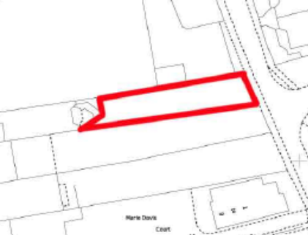
Site Location

It is acknowledged that the land lies within the Market Place Conservation Area with East Street providing the eastern boundary. In addition, No81 is a Grade II Listed Building and the details state that the listing relates to the street scape and group value in relation to London Street. The property was built around 1800 as a town house and has a large extension at the rear of the listed building built in the late 20th Century.

In terms of the proposed use for the existing parking area, there are no changes to the listed building or extension and there will be no impact on its setting. The proposed use will not affect the building nor the appearance of the car parking area as this is unchanged.

I have enclosed with the application, details of the site. Some 10 spaces will be open to public use with the remaining three spaces retained by the landlord.

Should you require any additional information, please do not hesitate to let me know.

Yours faithfully

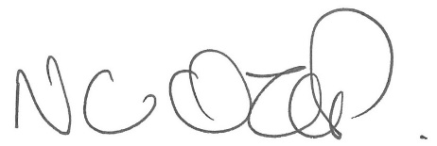

Nigel Ozier BA (Hons) MRTPI
Director – Planning and Development
Nigel.ozier@argroup.co.uk

