To: | Mr Keith Smith  The Studio, 17 Campbell Close, Grateley, Andover, Hampshire, United Kingdom, SP11 7DY | Application No: PL/24/1620  Application type: Full planning permission

Applicant: Mr Michael Coffey

Proposal: Change of use from commercial (with ancillary residential) to C3 residential use. Demolition of existing bungalow and erection of a 4 bed detached house and associated works and retrospective siting of 2 bed mobile home. (amended)

At: Riverview Manor (Formerly Cosy Kennels), Scours Lane, Tilehurst, Reading, RG30 6AX

The above application was WITHDRAWN by the applicant on .

Date: | 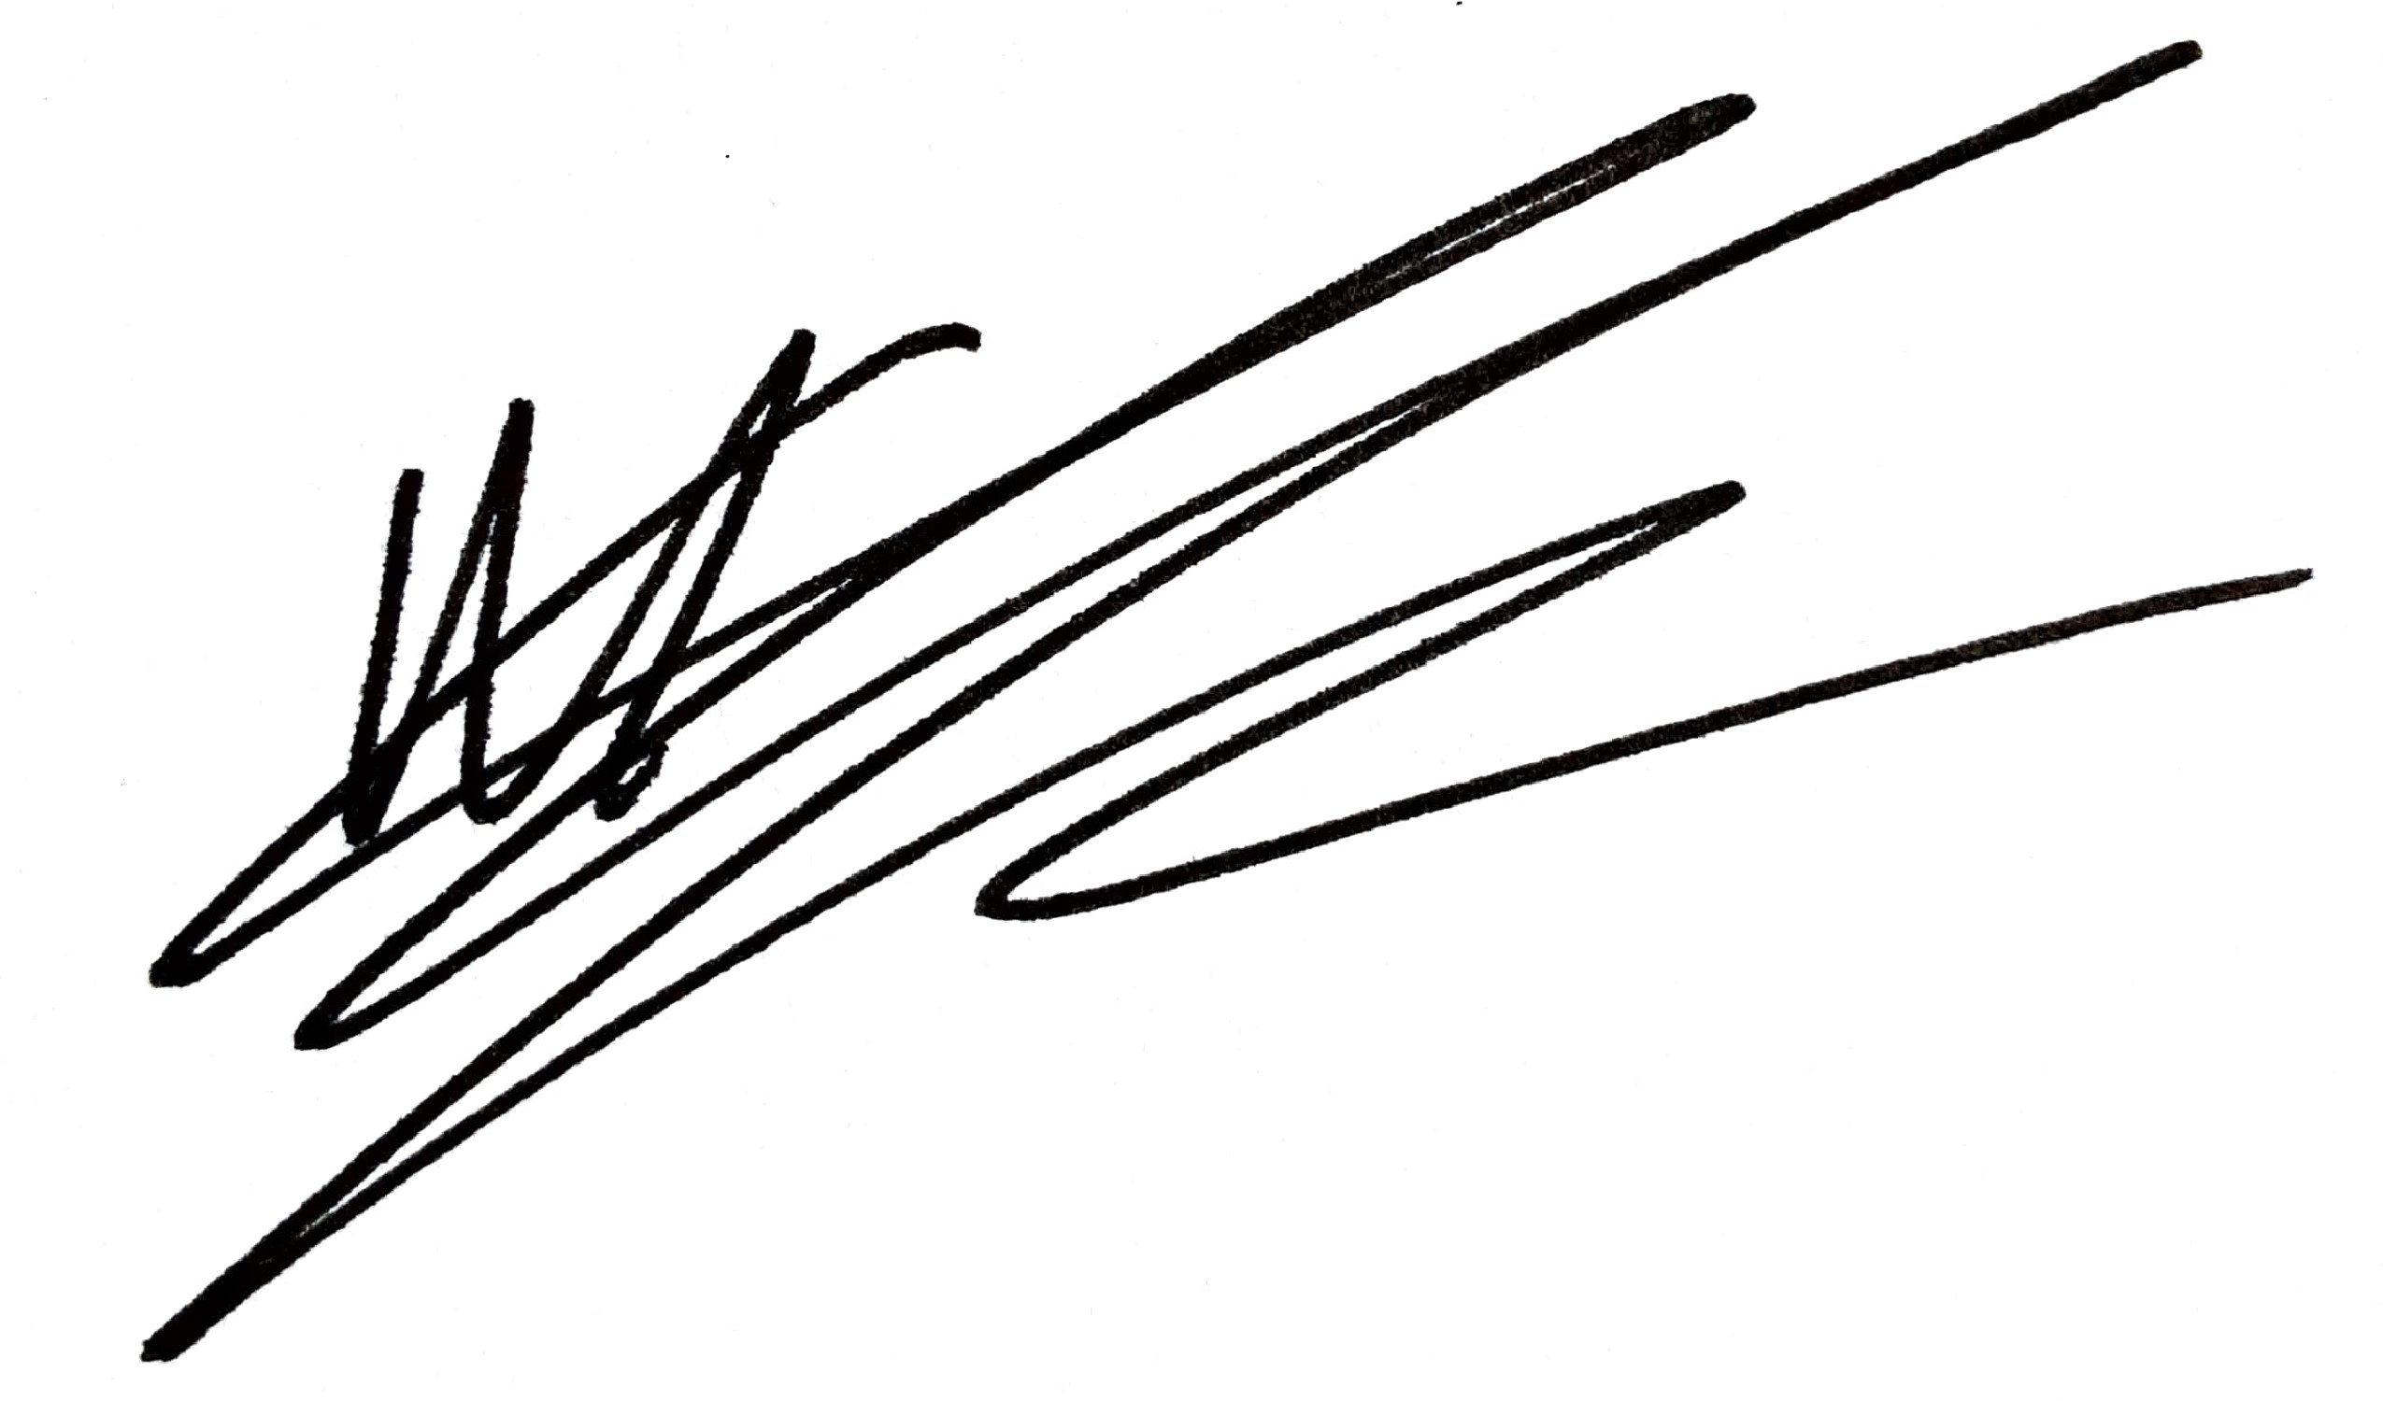
 | Acting Assistant Director, Planning, Transport & Public Protection

