108 Shinfield Road,
Reading,
RG2 7DE

Preliminary Roost Assessment
(Phase 1 Bat survey)

July 2025


Dr.Jonty Denton (Chartered Ecologist) FRES FLS MCIEEM CECol

Prepared by
Dr. Jonty Denton BSc (Hons) D(Phil) FRES, FLS, MCIEEM, CEcol
(Chartered Ecologist)
31 Thorn Lane, Four Marks, Hampshire, GU34 5BX
Phone: (01420) 565647 mobile: 07935594093
EXECUTIVE SUMMARY
Consultant Chartered Ecologist Dr.Jonty Denton FRES FLS MCIEEM CEcol was commissioned to undertake a Daytime Bat Assessment (Phase 1) of 108 Shinfield Rd, Reading, RG2 7DE in accordance with the Bat Conservation Trust Guidelines (Collins, 2023) on 27th July 2025.

There were no signs of historic bat activity in the house loft. However, there are gaps into the undertile spaces which crevice roosting bats could exploit. Therefore, the structure has low potential, and a Phase 2 bat survey is required.

INTRODUCTION
This report presents the results of a phase 1 bat survey at 108 Shinfield Road, Reading, Berks, RG2 7DE

Site Setting and Description
The property is large detached house situated to the west of Shinfield Road in Reading in a suburban setting in Berkshire (SU731712). The house dates to the early 20th Century and is orientated roughly east-west. Itis flanked by other detached properties with large gardens to the north and south with a woodland strip included in priority habitats inventory to the east with open sports fields beyond (see figure 1). bank. Therefore, the area has good foraging habitat for most bat species.
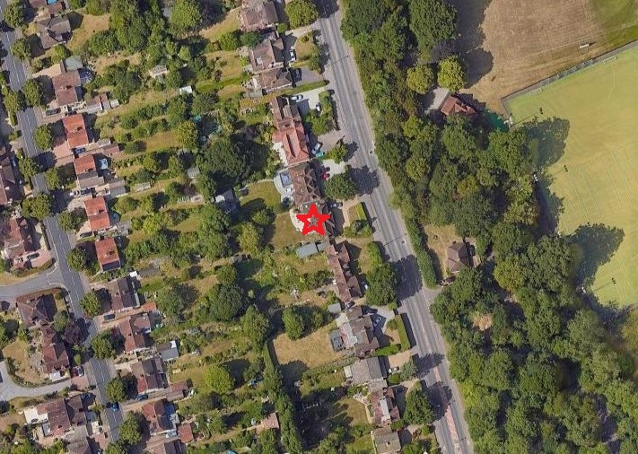
Figure 1. Site location (marked by red star). Courtesy of Google images

Phase 1 Bat Survey Methods
The Daytime Bat Assessment / Phase 1 Bat Survey was undertaken in accordance with the Bat Conservation Trust Guidelines (Collins, 2023).

The Phase 1 Bat Survey was carried out on the afternoon of the 27th July 2025, and comprised of a daytime walkover of the site, internally and externally, to record evidence of any protected bat species.

Details of the survey methods are given below.

The house was investigated externally to identify potential bat access/egress locations and roosting areas such as gaps or holes between roof tiles, fascias and soffits and to record direct evidence of bat presence such as droppings and urine staining. This was followed by a detailed investigation of all accessible internal spaces to record evidence of bat roosting activity such as droppings, feeding remains, live animals, corpses, urine staining and fur staining. The building was assessed as to its suitability for supporting roosting bats. The survey conformed to current Bat Conservation Trust guidelines (Collins 2023) Bat surveys for professional ecologists: Good practice guidelines 4th edition).
The details of the assessment criteria used to determine the ecological value of on-site attributes is outlined below. During the Phase 1 survey the assessment criteria are based on the potential for the site to support the species considered. However, in many cases Phase 2 surveys will be required to confirm presence /absence of any bat species and hence the importance of a population at the site, therefore the assessment of value should be considered as provisional.
Where possible, a provisional assessment of potential will be made although this may well require Phase 2 surveys to confirm status.

High Potential- High potential buildings are those that have features highly suitable for use by roosting bats, including gaps around soffits, hanging tiles, extensive roof spaces etc. High potential buildings are often, but not always, buildings of more historic construction. Further Phase 2 surveys will be required to confirm the presence/absence of bats.
Medium Potential- Medium potential buildings have a moderate number of features that may be utilised by bats for roosting, these may include loose fascias, roof spaces etc. Further Phase 2 surveys are likely to be required to confirm the presence/absence of bats.
Low Potential- Low potential buildings are those that provide limited bat roosting potential although some features that may be utilised by bats may be present. Further Phase 2 surveys are likely to be required to confirm the presence/absence of bats.
No/Negligible Potential – These are buildings that are extremely unlikely to support roosting bats due to the absence of suitable features. Further Phase 2 surveys are unlikely to be required for buildings with negligible potential.

Phase 1 Survey Timing and Weather Conditions
The Phase 1 bat survey was carried out on the morning of the 27th July 2025, which was calm and cloudy with 100% cloud cover, and an ambient temperature of approx. 18˚C.
Phase 1 Survey Equipment
During the Phase 1 survey the surveyor was equipped with 10 x 42 close focus binoculars and a high-powered torch.

RESULTS
Bats are fully protected under the Wildlife and Countryside Act 1981, as amended, and also receive additional protection via The Conservation of Species and Habitats Regulations (2017) from intentional killing and injury and from intentional damage, destruction or obstruction of access to a place of shelter. It is an offence to kill or injure a bat or interfere with any roosting or resting site. A bat roost is interpreted as "any structure or place used for shelter or protection" whether or not bats are present at the time or not. Barbastelle Bats, Bechstein’s Bat, Noctule, Soprano Pipistrelle, Brown Long-eared Bat, Greater Horseshoe Bat and Lesser Horseshoe Bat are also UK BAP Priority Species and SPI.

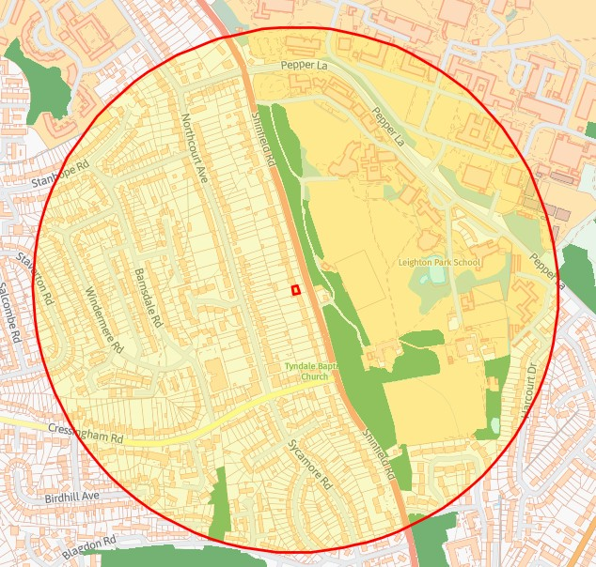
Figure 2. Priority habitats map. Courtesy of Magicmaps

According to the DEFRAs MagicMap, no EPS bat licence have been issued within 500m.

The house is a large, detached outbuilding is a brick-built two-storey structure with a hipped roof faced with clay tiles. There are a few potential openings into the undertile spaces (see figures 3-6).

The loft was accessed via a hatch on the landing. The roof is lined with softwood boarding (see figure 8). There was no sign of any bat activity within the loft which had extensive cobwebs in the upper third of the roof space.
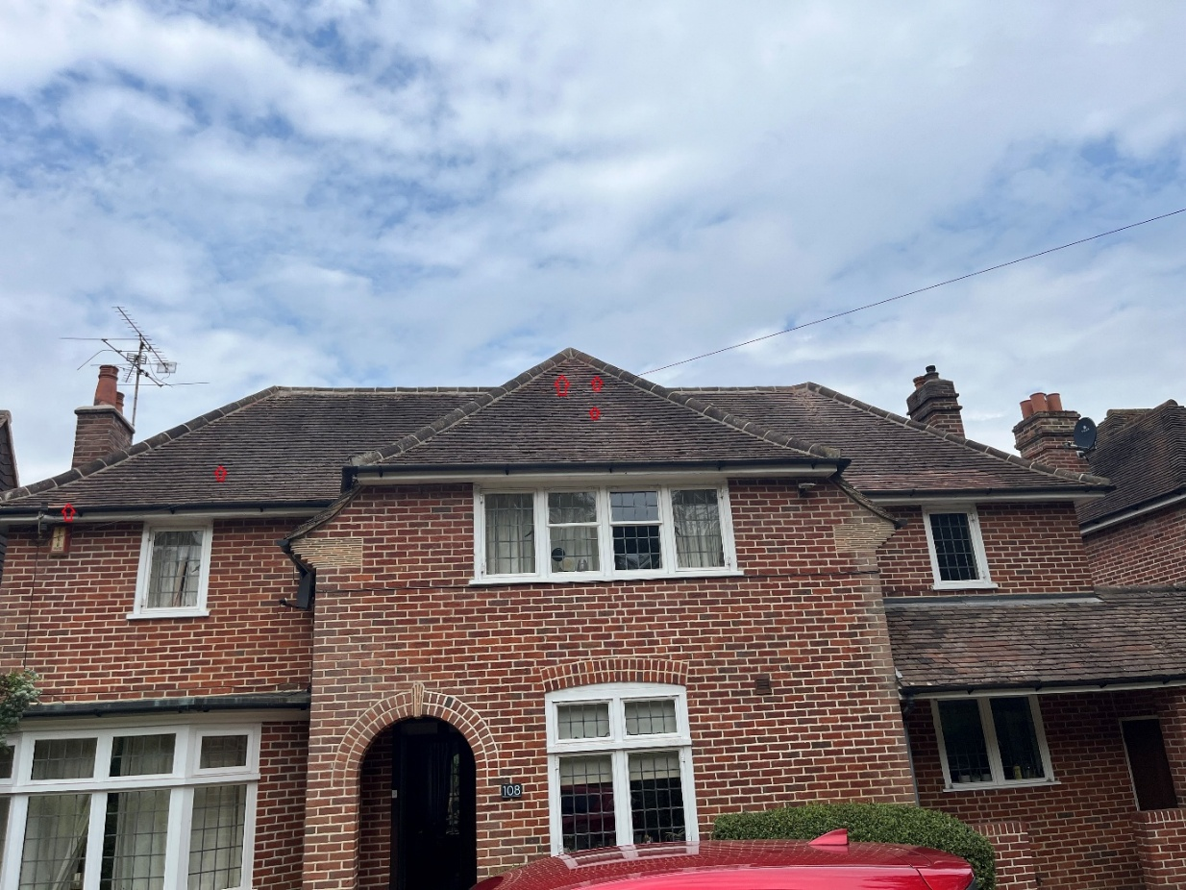
Figure 3. East elevations looking west: Red arrows indicate potential openings for crevice roosting bats.

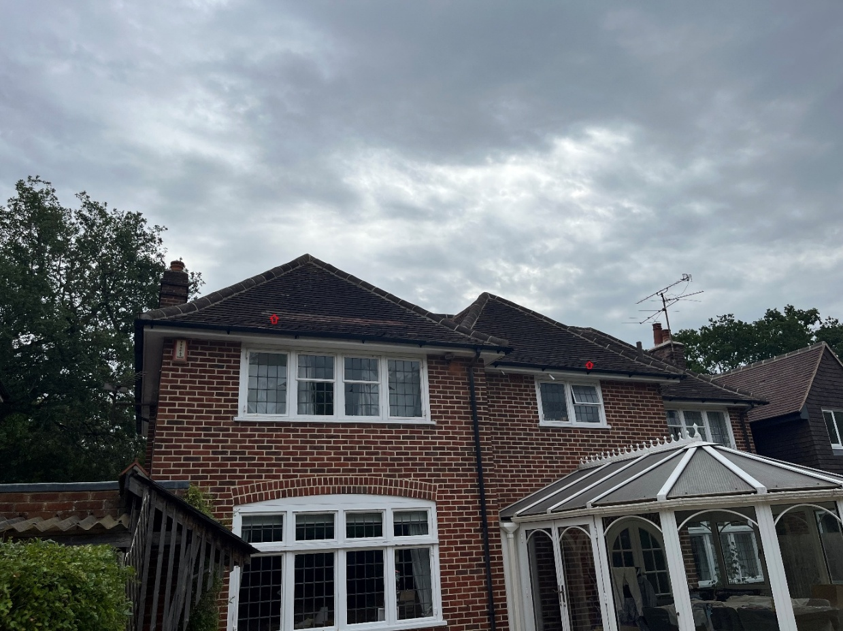
Figure 4. Western elevations looking east: Red arrows indicate potential openings for crevice roosting bats.
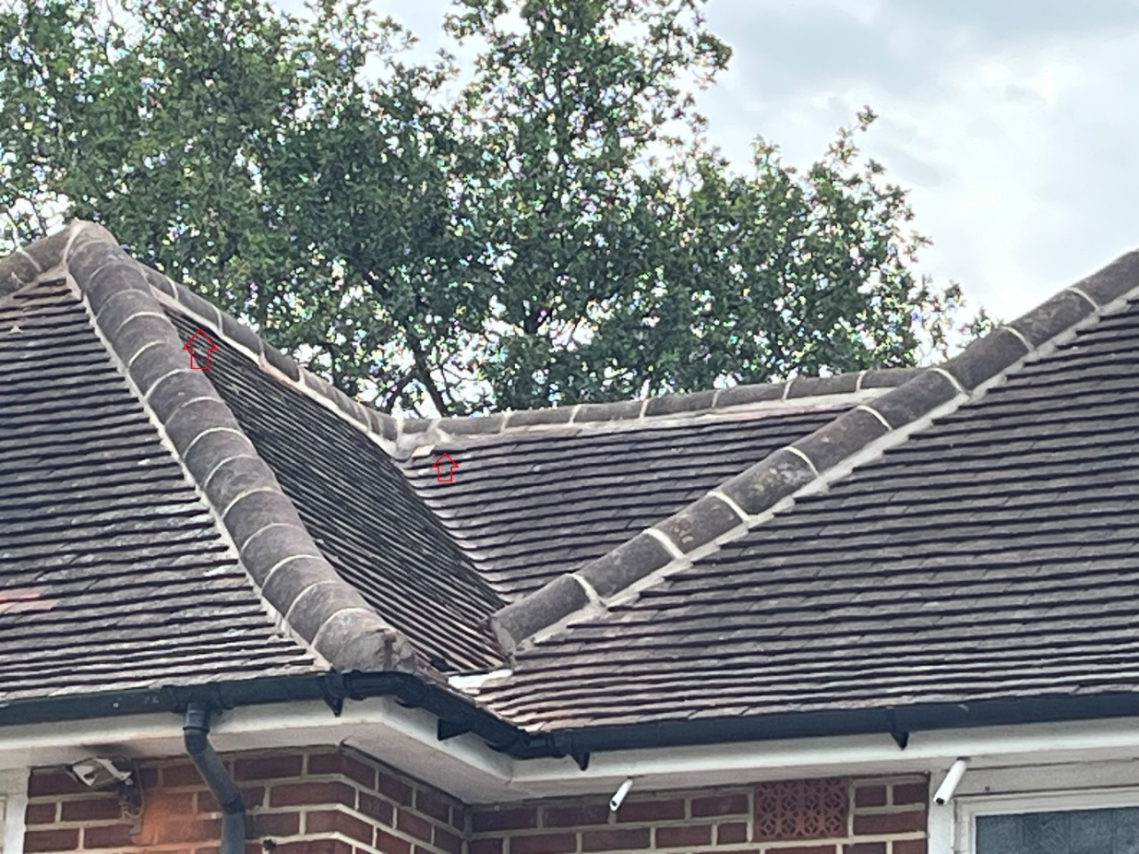
Figure 5. Detail of north valley looking northeast: Red arrows indicate potential openings for crevice roosting bats.

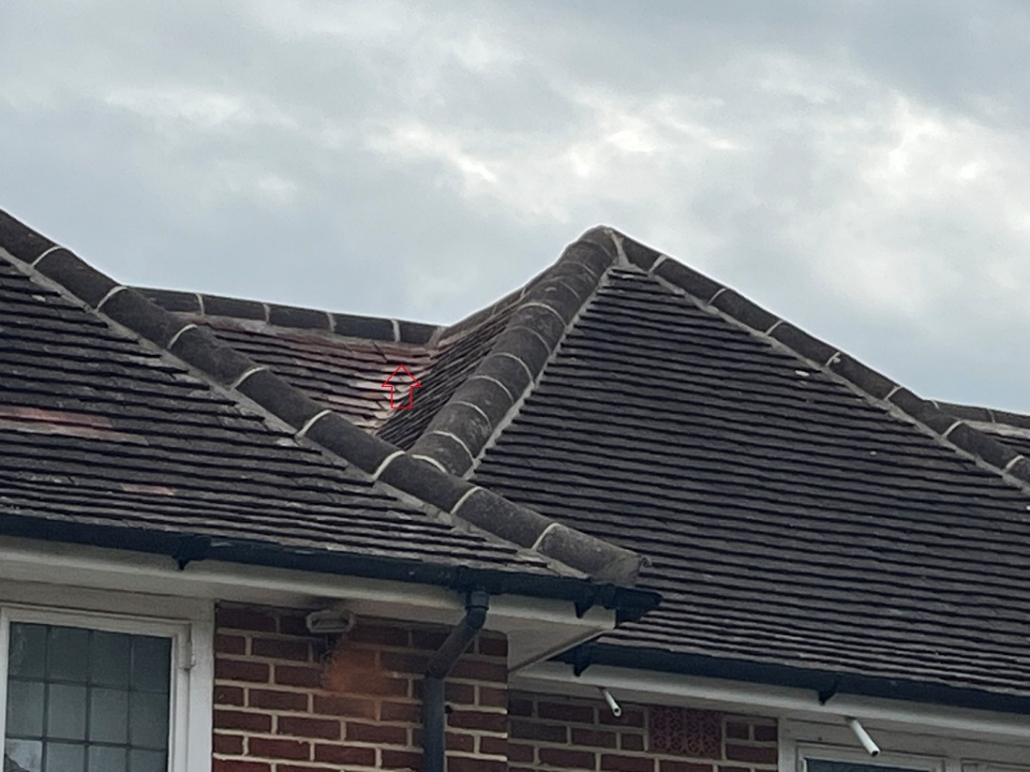
Figure 6. Detail of south valley looking southeast: Red arrows indicate potential openings for crevice roosting bats.

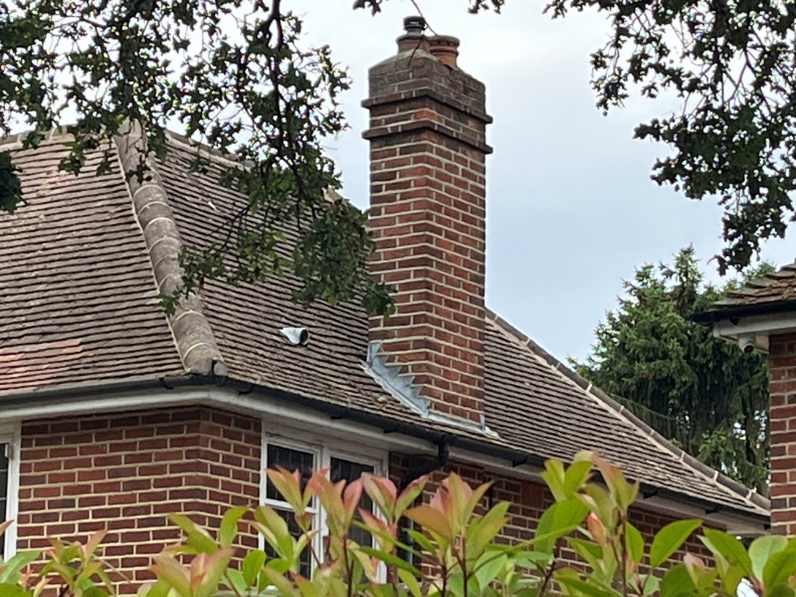
Figure 7. North elevation looking southwest

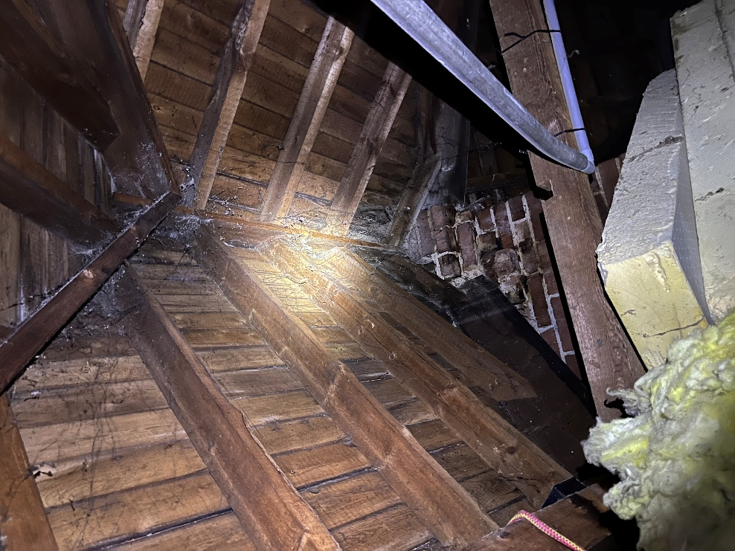
Figure 8. Interior of roof looking south

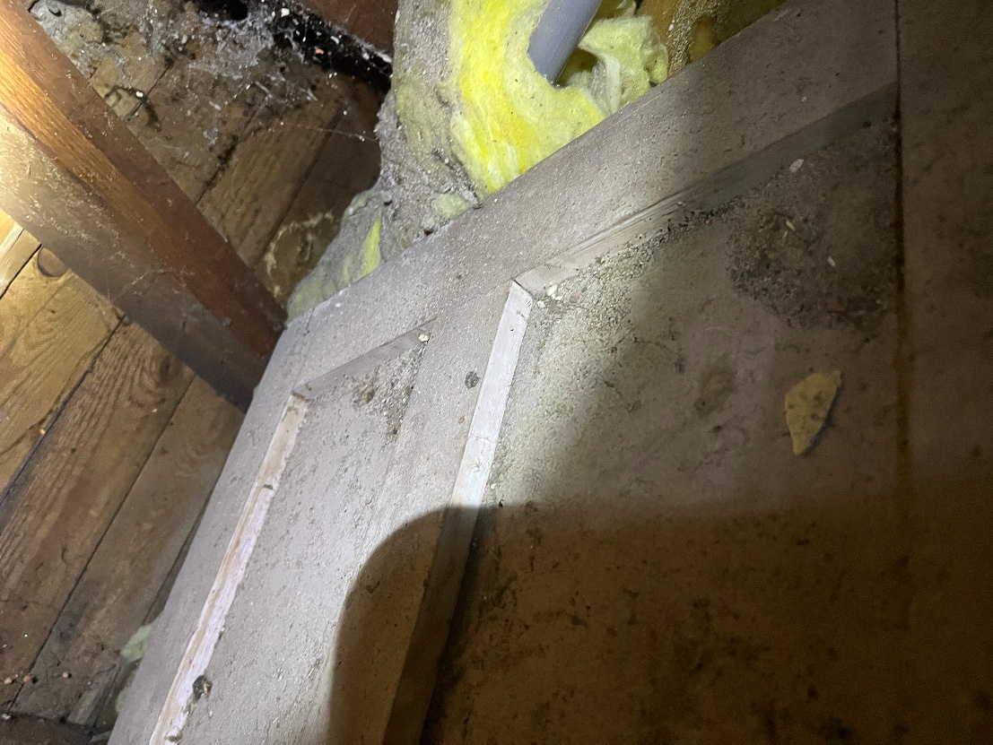
Figure 9. Loft floor near hatch
EVALUATION
There were no signs of historic bat activity in the house loft. However, there are gaps into the undertile spaces which crevice roosting bats could exploit. Therefore, the structure has low potential, and a Phase 2 bat survey is required.

This would entail the structure being surrounded by surveyors (two should suffice in this instance) such that all potential entrance/exit points are covered. The structure is then watched from either 15 minutes before sunset to 2 hours after or 2 hours before dawn to sunrise.
All emerging or re-entering bats are recorded along with their flight path, their species and the time of flight.
An emergence survey would identify:
- Whether bats are present in a structure, the species and number involved
- Entrance and exit points for the roost
- The type of roost
- Actions needed to be taken to ensure legal compliance

REFERENCES
Collins, J. (ed.) (2023) Bat Surveys for Professional Ecologists: Good Practice Guidelines (4th Edition). The Bat Conservation Trust, London

Reason, P.F. and Wray, S. (2023). UK Bat Mitigation Guidelines: a guide to impact assessment, mitigation and compensation for developments affecting bats. Chartered Institute of Ecology and Environmental Management, Ampfield.

INTERNET RESOURCES
Google Maps: www.maps.google.co.uk
Magic Interactive Map: www.magic.gov.uk

