108 Shinfield Road,
Reading,
RG2 7DE

PHASE 2 BAT EMERGENCE SURVEY
August 2025

Dr.Jonty Denton (Chartered Ecologist) FRES FLS MCIEEM CECol

Prepared by
Dr. Jonty Denton Bsc (Hons) D(Phil) FRES, FLS, MCIEEM, CEcol
(Chartered Ecologist)
31 Thorn Lane, Four Marks, Hampshire, GU34 5BX
Phone: (01420) 565647 mobile: 07935594093

SUMMARY
Dusk emergence survey wase carried out on evening of 5th August 2025. All potential openings were covered by the surveyors with Canon XA40 HD digital camcorders with IR illumination and EchotouchPro detectors employed to monitor and record bat activity.
No bats emerged from the property and activity was low with peak count of a single common pipistrelle.
No further surveys are recommended.

TIMING AND METHODS
Dusk emergence survey wase carried out on evening of 5th August 2025.. The evening was clear and very mild.
Canon XA40 HD digital camcorders with IR illumination were employed to cover all potential openings (see figure 1).
Survey commenced 30 minutes before sunset and continued until 90 minutes after sundown. EchotouchPro detectors were employed to monitor and record bat activity.
RESULTS
The night was suitable for bats with common pipistrelle active over rear garden.
No bats emerged from the property.
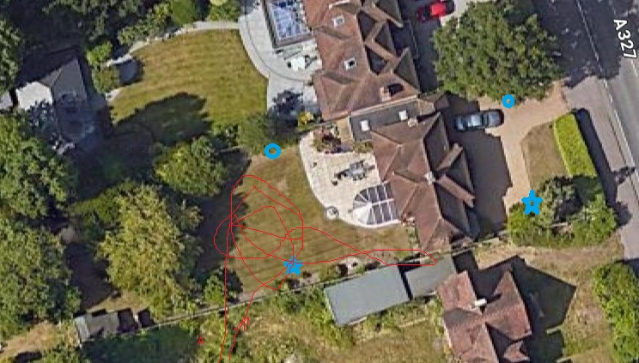
Figure 1. Surveyors and cameras (blue stars). Flightpaths (red line)
SPECIES ENCOUNTERED
Common Pipistrelle
One foraged more or less continuously throughout survey low over back garden (See figure 1)
One other was observed flying directly to woodland over road approximately 30m south of rear garden at 20.45pm

CONCLUSIONS
No bats emerged from the property and activity was very low.
No further surveys are recommended.
Bats are opportunistic and switch roosts frequently. The presence of a roosting bat in the adjacent property means it is not impossible that bats could switch to Beechcroft. If any bats are found during construction works, all work must stop immediately, and Natural England must be called. Additional information is available on the Bat Conservation Trust website at https://www.bats.org.uk/advice/imworking-on-a-building-with-bats/ive-found-a-bat-during-works.

New exterior lighting should be avoided, but if necessary for security purposes, then the latest updated lighting guidance note (GN08/23) should be followed. This is available at Guidance Note 8 Bats and Artificial Lighting | Institution of Lighting Professionals (theilp.org.uk) and supersedes all previous guidance.

APPENDIX 1. FIELD DATA
Project |  | Start time | 20.05 | Finish | 22.22 | Temperature | 17 C at start 16.3 C at finish
 |  | 5.8.25 |  | sunset | 20.42 | Weather  10% cloud beaufort 0
 | Bat passes heard
Station no. | Start time |  | No. | passes | comments
W | 20.44 | Common pipistrelle | 1 | 1 | Flew east at rooftop height from west across garden 30m to south of 108
W | 20.47 | Common pipistrelle | 1 | 5 | Flew in from south circling low over lawn to rear of property (see flightpath A on fig 1
W | 20.48-21.00 | Common pipistrelle | 1 | 50+ | Foraging low over lawn to rear of property (see flightpath A on fig 1
E,W | 21.01-03 | Common pipistrelle | 1 | 10+ | Briefly flew over to front garden returning to resume low circuits
W | 21.04-11 | Common pipistrelle | 1 | 30+ | Foraging low over lawn to rear of property (see flightpath A on fig 1
W | 21.13-20 | Common pipistrelle | 1 | 30+ | Foraging low over lawn to rear of property (see flightpath A on fig 1
W | 21.21-30 | Common pipistrelle | 1 | 30+ | Foraging low over lawn to rear of property (see flightpath A on fig 1
W | 21.31-40 | Common pipistrelle | 1 | 30+ | Foraging low over lawn to rear of property (see flightpath A on fig 1
W | 21.41-43 | Common pipistrelle | 1 | 30+ | Foraging low over lawn to rear of property (see flightpath A on fig 1
W | 21.45-55 | Common pipistrelle | 1 | 30+ | Foraging low over lawn to rear of property (see flightpath A on fig 1
W | 21.56-22.00 | Common pipistrelle | 1 | 30+ | Foraging low over lawn to rear of property (see flightpath A on fig 1
W | 22.04-22.12 | Common pipistrelle | 1 | 30+ | Foraging low over lawn to rear of property (see flightpath A on fig 1

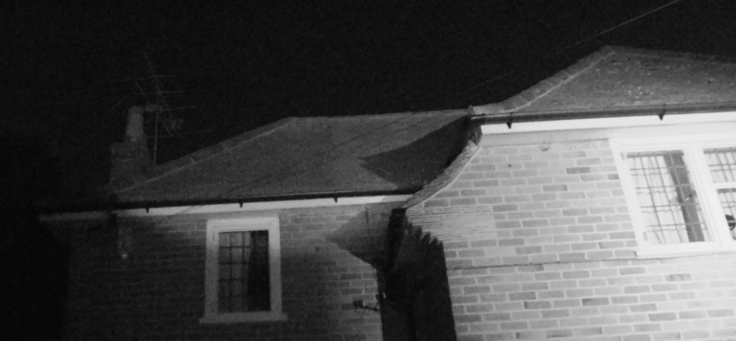
Figure 2. Southeast camera 1 dark sky 5.8.2025
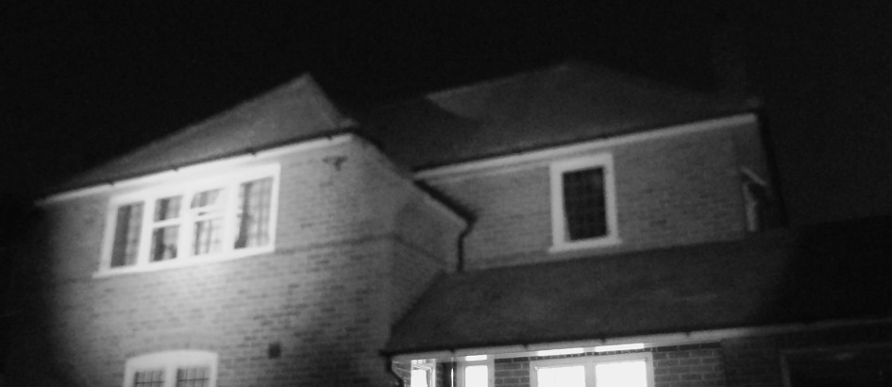
Figure 3. Southeast camera 2 dark sky 5.8.2025
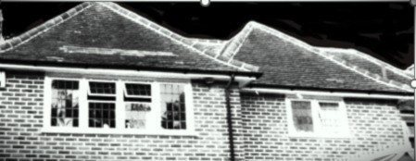
Figure 8. Northwest camera dark sky 3.8.2025

