Elevation Plan:
See below proposed elevation plan if No. 29 required a gas meter box located externally with copper outlet run. This will be similar acorss all first floor dwellings.
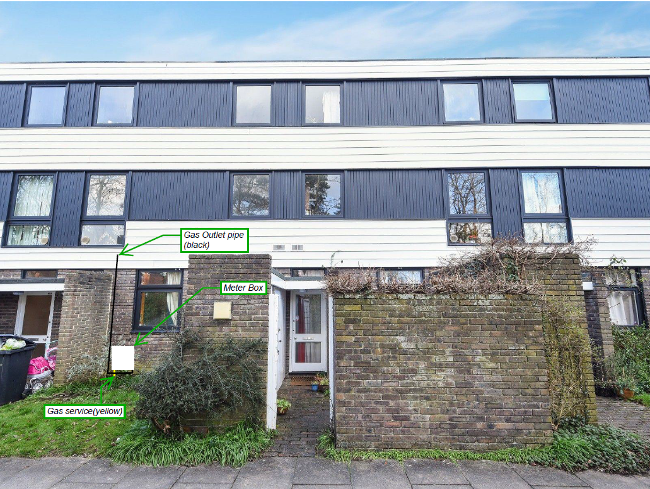

- We would run the gas service to the most inobtrusive location.
- Fix the meter box, connect the meter & test.
- In this situation we would run the outlet parallel to the brick wall, up to the required height, in this instance below the window to where the kitchen is, then into the building and make all final connections there.
- Test the outlet run and paint the pipework if required.

See below proposed elevation plan for ground floor dwellings. This is worst case scenario, as detailed in: “4. Submitted Documents - Service And Outlet Strategy”.
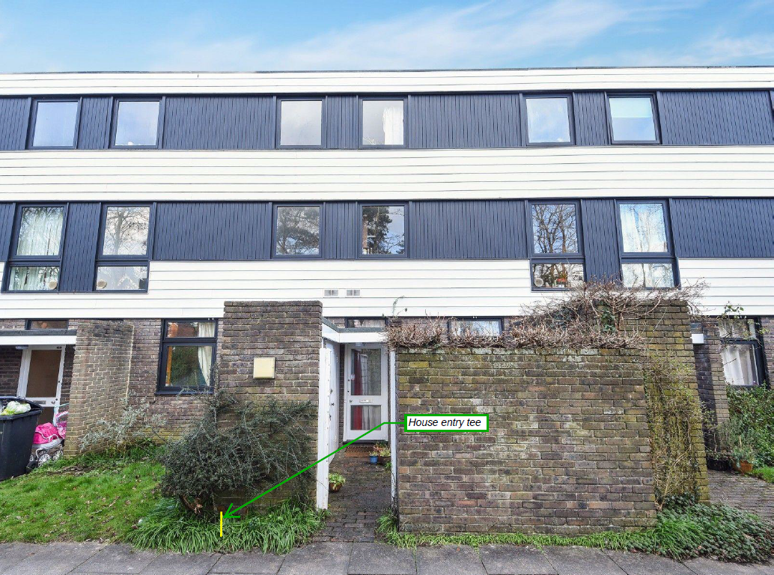

- We will attach a house entry tee onto the PE service and bring it low level outside meter box cupboards.
- We will drill through and make all final connections in the cupboards, so all pipework is out of sight.

