Service And Outlet Strategy:

After a walk around site, we managed to identify some properties that have already had their services renewed, new outlets run, and meter boxes positioned (findings below).

After investigation, our conclusion is the ground floor properties will be straight forward; we will first aim to push back the services to the original position, the outdoor storage cupboards. This will show no external changes. Failing that, we will use the same method as found at the site on a couple of occasions shown below. Where we use a low-level house entry tee and reconnect in the cupboards, showing as minimal pipework as possible.

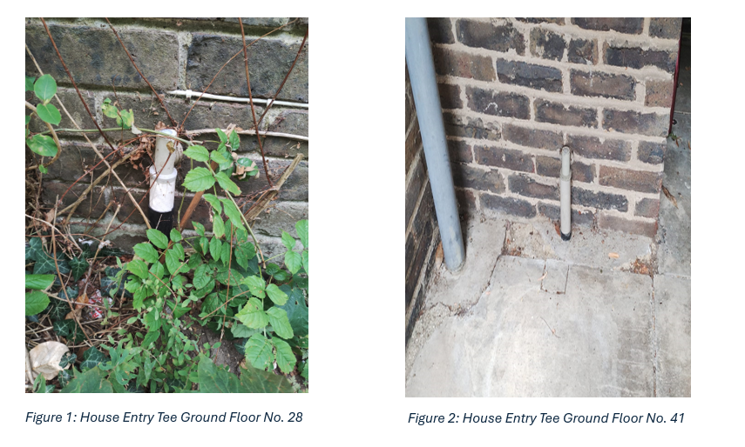

When it comes to the upper floors, again we will first aim to insert the service through the old steel service showing no visible external changes. This will always be our preferred method, but if we fail to do so, we will look to mirror the way it has been done at property 46. It is of our opinion and our specialist contractor, that any meter boxes we need to install, we can make it look more aesthetically pleasing than the one in situ currently (see photos below). We can do this by painting the pipework to blend in the background, e.g white paint if over facia boards, or black paint near drainage, and hiding the pipework where possible.

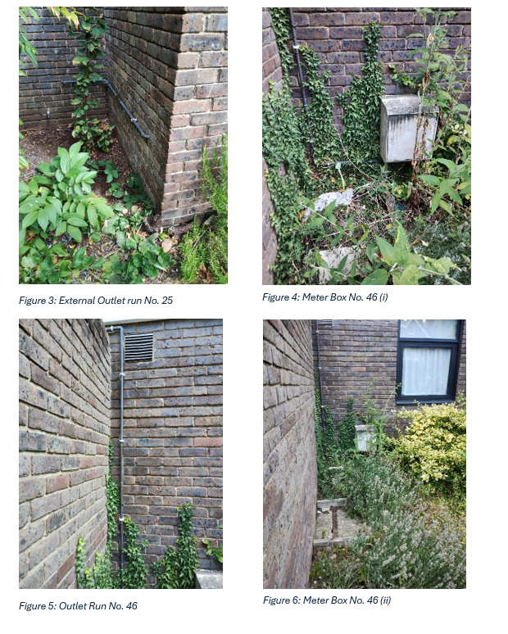

I would just like to reiterate, that we would always use our resources to achieve a result that everyone is happy with and we pride ourselves on that as a business.

