25/07/2025
Planning Application Ref: PL/25/0979
Officer: Gary Miles
Application Type: Householder planning permission
Address: 18 ROSEHILL PARK, EMMER GREEN, READING, RG4 8XE
Proposal: Alterations to access, first floor and single storey rear
extensions.

The application seeks to widen the existing vehicle crossing to facilitate a new parking layout. This will result in the partial loss of the boundary wall and grass verge located outside of the site. The grass verge area is part of the public highway and not in the ownership of the applicant.

The loss of an area of grass verge up to 8m2 is acceptable, however, if an area of between 8m2 and 15m2 of public highway /Council maintained grass verge is considered for removal, it will need to be replaced by a suitable permeable bituminous/tarmacadam material appropriate for use on the public highway and approved by the Council. This material will be applied to all of the crossing area to reduce the impact of surfacing a verge area. The Highways Team will need to be consulted, and a license obtained to undertake all works on the public highway, this includes the extension of a dropped crossing and removal of grass verge areas. It should be noted that the verge area should not be used for storage of plant or materials.

There is a utility cover located in the footway, this should be illustrated on plans in relation to the proposed extended vehicle crossing. The Highways Department will undertake a site visit and will advise the applicant if there will be a cost or in some instances if permission is needed from the utility company to lower the cover to prevent damage.

Submitted plans illustrate 3 parking spaces, which is in excess of the Councils current standards. No part of a vehicle is permitted to overhang the footway.

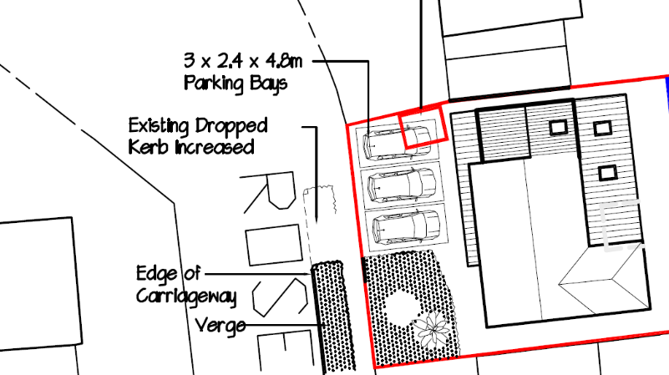

Water run-off from private property onto the public highway is not permitted. An appropriate method of drainage needs to be provided within the property curtilage including the use of suitable permeable surfacing materials.

Please ask the applicant to submit revised plans illustrating location of utility cover in relation to the extended vehicle crossing. I am happy to deal with this by way of condition.

DC1 VEHICLE PARKING (AS SPECIFIED)
DC4 VEHICULAR ACCESS (TO BE APPROVED)
IF3 Highways
I24 Do not damage the verge

N. Hussain
Transport Development Control Advisor

