READING TOWN HALL

Heritage Statement

9th July 2025

- Introduction
Section 7 of the Planning (Listed Buildings and Conservation Areas) Act 1990 states that “no person shall execute or cause to be executed any works for the demolition of a listed building or for its alteration or extension in any manner which would affect its character as a building of special architectural or historic interest, unless the works are authorised.”
This Heritage Statement has been prepared to inform like for like structural and fabric improvement works to the Town Hall.
No changes are proposed to be made to the structure and the works are intended to keep in observance of the Town Hall as a structure of architectural as well as historic interest.
- Proposal
The works proposed below are a result of:
The existing timber double fire door located on the rear fascia of the building has significantly deteriorated, with visible rot present on both leaves. In addition to the structural degradation, the door is allowing water ingress, which poses a risk of further damage and potential pest entry.
The proposed works involve the replacement of the existing timber door with a new metal double door. The new door will be of a like-for-like design, finished in the same grey colour as the existing, and will closely match the current appearance in terms of scale, form, and detailing. The intention is to ensure improved durability, weather resistance, and long-term protection, while maintaining the visual integrity of the building.
The door is situated on the rear elevation, as indicated on the accompanying plan drawing. The replacement will not introduce any additional visual or physical impact to the surrounding area.
The application site lies within the Market Place/London Street Conservation Area, and the Grade II* listed Reading Town Hall is located within this designation. While the proposal involves minor external alterations, the replacement door is designed to be sympathetic to the existing structure and its setting. As such, the proposal is considered to have a neutral impact on the character and appearance of the conservation area and does not affect the significance of the listed building.
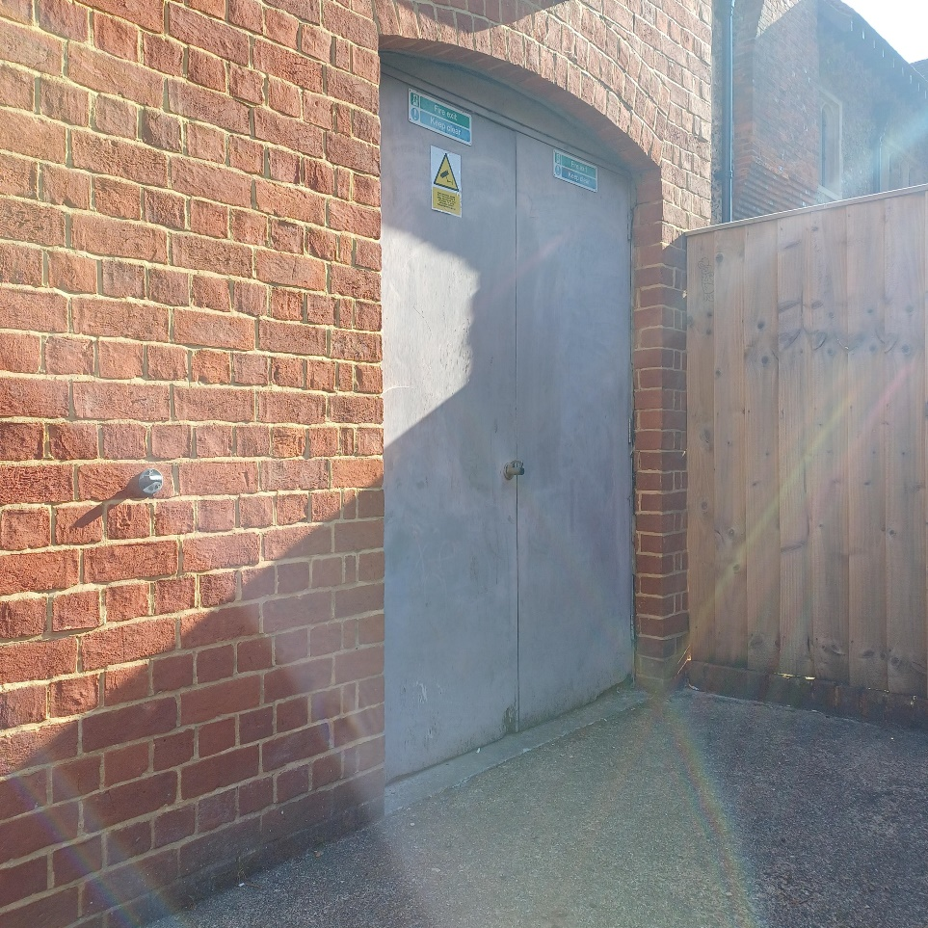
- Identifying the Heritage Asset
Reading Town Hall is a complex of interconnected civic buildings that have evolved over more than two centuries. The earliest part, the Victoria Hall (formerly the Small Town Hall), dates to 1785–86 and was designed by Charles Poulton. It was remodelled in 1863 by W.H. Woodman.
The main Town Hall building was constructed in phases:
- 1871–72: Designed by Alfred Waterhouse, a leading Victorian architect known for the Natural History Museum in London.
- 1879–82: Extended by Thomas Lainson.
- 1896–97: Further additions by John James Cooper and William Roland Howell.
The complex has served multiple civic functions, including a council chamber, concert halls, museum, register office, and formerly a library and art college. Restoration and modernisation works were carried out in the late 20th and early 21st centuries.

Significance of the Heritage Asset
Reading Town Hall is of high architectural and historic significance, as reflected in its Grade II* listing. Its significance can be summarised as follows:
- Architectural Value: The building showcases a rich blend of Victorian Gothic and classical styles, with high-quality materials, craftsmanship, and detailing. The work of Alfred Waterhouse is particularly notable.
- Historic Value: The Town Hall reflects Reading’s civic development and cultural aspirations from the late 18th century through the Victorian era and into the modern day.
- Communal Value: It remains a central civic and cultural venue, hosting concerts, exhibitions, and public events, and is a key part of Reading’s identity.
Conservation Considerations
As a Grade II* listed building, any alterations or maintenance must preserve its architectural and historical integrity. Works must comply with national heritage protection standards, and consultation with Reading Borough Council and Historic England is required for any significant changes.
- Conclusion
It is intended to carry out works that are sympathetic and in keeping with the original historic features of the Town Hall.
There are three policies of Reading Borough Local Plan – EN1, EN3 and EN6 which this application should comply with. The proposal would accord with these policies.
These works have been discussed with the Council’s Conservation officer and we hope as a result, should be approved.

Kye LOH
Clerk of Works
Property and Asset Management
Directorate of Economic Growth and Neighbourhood Services

Reading Borough Council
Civic Offices, Bridge Street
Reading, RG1 2LU

