DELEGATED APPLICATION REPORT
Ward:
App Ref: PL/24/1634 Householder planning permission
Address: 8 BYWORTH CLOSE, READING, RG2 8SH
Proposal: Single storey side and front extension
Applicant: Mr Daryl Davies
Received date: 09/12/2024
Target Decision date: 25/06/2025 (EXT)
Case Officer: Chukwudi Onwudinanti

- SITE DESCRIPTION
The site is a two-storey end of terrace dwelling on the western side of Byworth Close, among dwellings of similar style and size. It is in a predominantly residential area, sandwiched between Whitley Wood Lane and Greenfields Road.

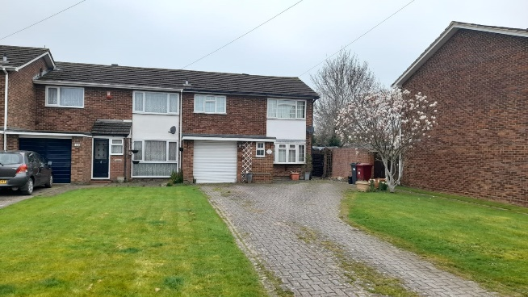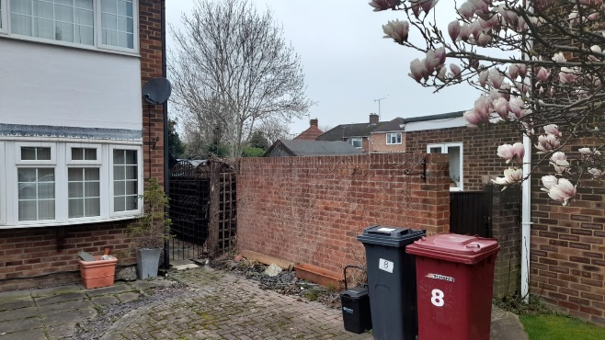

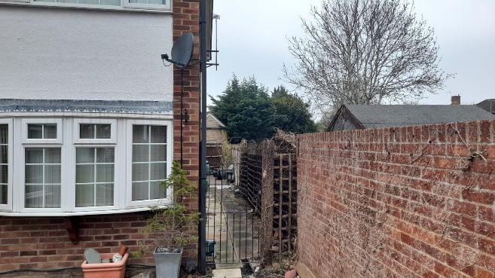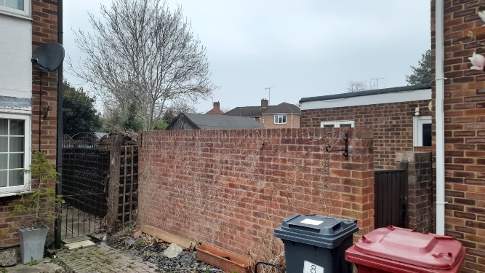

- PROPOSAL AND SUPPORTING INFORMATION
Single storey side and front extension measuring approximately 4.5m by 3.2m, effectively projecting the right side of the dwelling forward by approximately 1.4m beyond the furthest extent of the existing front building line.

Plans and documents
Location Plan received 9 Dec 2024
Site Plan received 26 June 2025
Drawing No C.01 – Existing Elevations dated Dec 2024 received 9 Dec 2024
Drawing No D.01 – Existing Plans dated Dec 2024 received 9 Dec 2024
Drawing No C.02 – Proposed Elevations dated 8 April 2025 received 8 April 2025
Drawing No D.02 – Proposed Plans dated 8 April 2025 received 8 April 2025

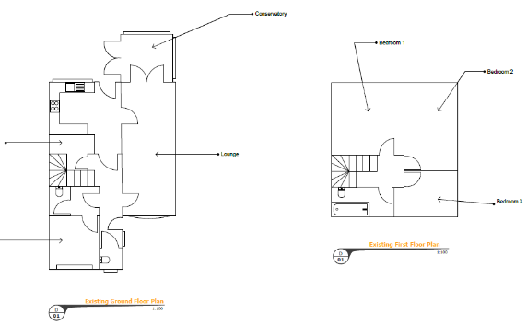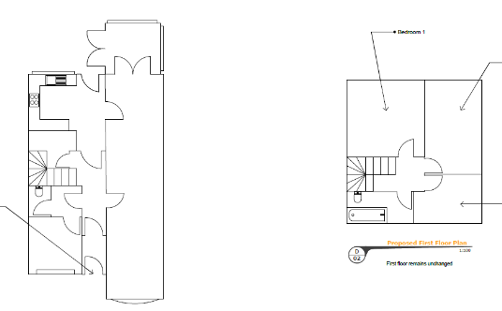
Existing and Proposed Plans
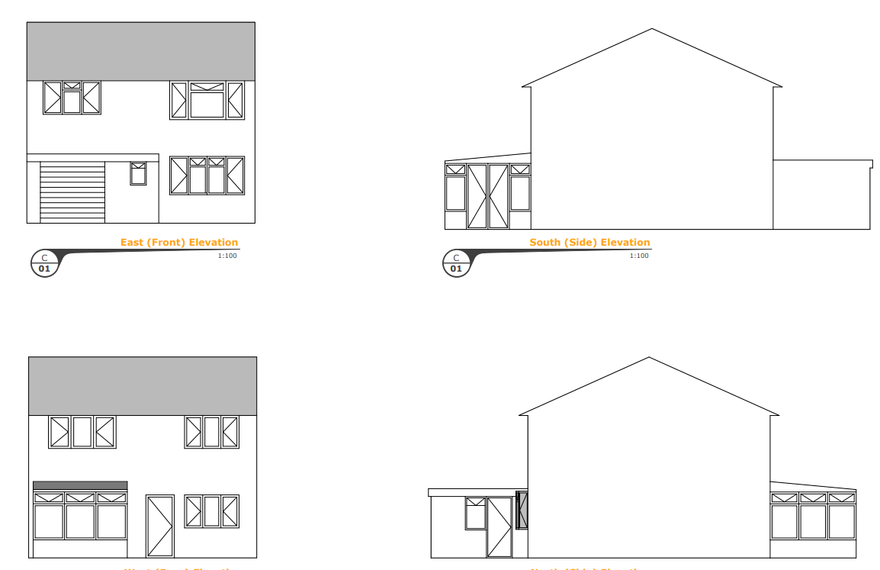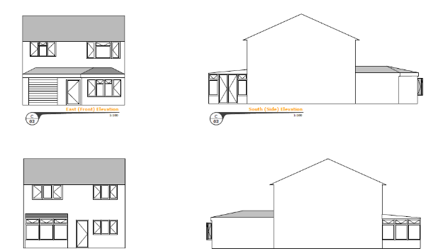
Existing and Proposed Elevations

- RELEVANT PLANNING HISTORY
None

- CONSULTATIONS
The following were consulted:
- Transport Development Control

Transport Comments
The proposed works do not change the existing parking or access arrangements, therefore there are no Transport objections to this application.

Discussions with agent.
The initial submission has been amended on the advice of the LPA, to remove the front porch aspect of the proposal.

- LEGAL AND PLANNING POLICY CONTEXT
Section 38(6) of the Planning and Compulsory Purchase Act 2004 requires that proposals be determined in accordance with the development plan unless material considerations indicate otherwise. Material considerations include relevant policies in the National Planning Policy framework (NPPF) - among them the 'presumption in favour of sustainable development'. The following local and national planning policy and guidance is relevant to this application:

National Policy
National Planning Policy Framework
National Planning Practice Guidance

Reading Borough Local Plan (2019)
CC7 (Design and the Public Realm)
CC8 (Safeguarding Amenity)
H9 (House Extensions and Ancillary Accommodation)
H10 (Private and Communal Outdoor Space)

SPD
Design Guide to House Extensions SPD 2021

- APPRAISAL
Character and Appearance
Policy H9 states that an extension to a house will be acceptable where it respects the character of the house in terms of scale, location, materials and design and respects the character and pattern of neighbouring properties and the street as a whole in terms of scale, location, materials and design, and any important existing building line. Policy CC7 also sets out relevant considerations for design.

The existing stagger to the front building line is with a projection to the left side. The proposed extension will alter the appearance by bringing the right-hand side of the building forward of the existing left-hand projection. However, this increase does not cause the frontline of the dwelling to go beyond the frontline of the overall terrace within which the application site sits, due to the stagger of buildings in the terrace and that the application site is located further from the highway than the rest of the terrace. The proposed height is 2.2m, ground to eaves.

Also, whilst this extension to the front alters the appearance of the existing dwelling it is not an alien feature within the terrace where other dwellings have a right-handed front projection.

The flat roofs will be altered to install hip roofs but these are considered to be an enhancement of the dwelling and not detrimental to its features.

It is considered, therefore, that no aspect of the alterations proposed here would have a detrimental impact on the character of the house in terms of scale, location, materials and design, as well as the pattern of neighbouring properties and the street scene.

Residential Amenity
Policy H9 states that an extension will be acceptable where it does not result in an overbearing impact on neighbours. Policy H10 seeks to ensure that the amenity of gardens and other outdoor areas are not compromised. Policy CC8 states an extension to a house will be acceptable where it will not cause a significant detrimental impact to the living environment of existing or new residential properties.

The front of the application site is currently ca 4.6m further back than the rear of no. 6 (within the next terrace group) and is separated by a ca 1.8m high boundary wall. The proposed extension would create a new blank wall of 4.5m depth and 2.2m height, but this would be set back from the existing boundary line. There is no existing window to a habitable room of no. 6 on direct sightline of the proposed extension and there are no side facing windows proposed. The limited height of the extension above the existing boundary wall would not create any significantly additional impact on the neighbours.

The usable garden space would also not be impinged by this development, so the amenity for the users would be preserved.

CONCLUSION
The proposed development has been assessed as set out above and is considered to be acceptable on that basis, subject to the following conditions.

- RECOMMENDATION: Grant
Recommended Conditions:
AP1: Approved Plans
TL1: Time Limit Standards
M1: Materials to Match Existing
PD2: No New Opening

