Planning Application Ref: PL/25/0691
Officer: Matthew Burns
Application Type: Outline planning permission: Some matters reserved
Address: Land West of Kidmore End Road, Oxfordshire, RG4 8SG
Proposal: Outline planning application for the development of up to 70 homes (including affordable housing), new vehicular access, associated parking and landscaping (all matters reserved except for access).
The site is located immediately to the north of the proposed residential development on the former golf club land within the Borough of Reading. This application is for a residential development of up to 70 homes with all matters reserved except for access. It is only the proposed access to the Site which lies within the administrative boundary of Reading Borough Council, the rest of the proposed development will be considered by South Oxfordshire District Council.

Outline planning, with matters reserved in respect of Appearance, was granted in March 2022 under ref. 211843 for the land within the Borough of Reading for the demolition of the existing clubhouse and the erection of a new 223 home residential scheme.

Vehicular access is to be taken from the southeast corner of the site via the permitted residential development to the south, to join Kidmore End Road. A secondary emergency access is provided towards the southwest corner of the site. Both the vehicular access and emergency access will tie into the approved internal road network currently under construction.

The application is supported by a Transport Assessment (TA) produced by SDP.

It is noted that the Transport Assessment (TA) has not made reference to Cross-Thames Travel as is referenced in the Reading Borough Local Transport Plan 4 (2024-40), Reading Transport Strategy 2040 dated June 2024. The TA must therefore be updated to reference what impacts the development would have on the delivery of a Cross-Thames Travel route.

To determine the total number of person trips from the proposed 70 additional residential homes, the previously agreed trip rates for application ref 211843 was applied.

Table 6.2 presents the number of trips by each mode of travel for a development of 70 homes.

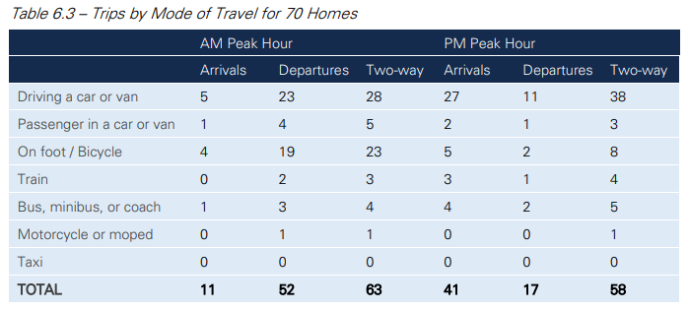
The assessment was cross referenced against the current version of the TRICS database (version 7.11.4) to compare the expected trip rates for the proposed development.
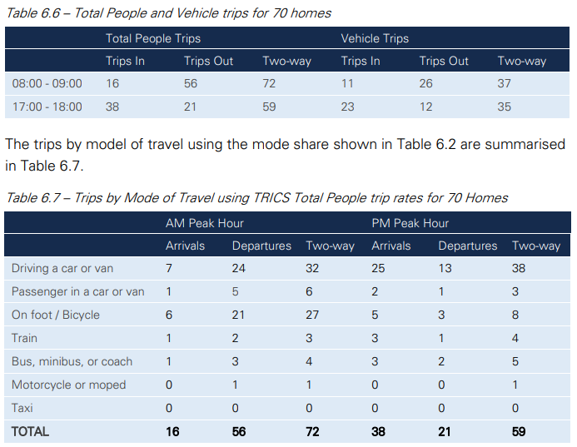
The predicted total number of vehicle trips in the peak hours shown in Tables 6.3 and 6.7 are similar in number, as are the vehicle trips predicted using the TRICS vehicle trip rates in Table 6.6. The highest vehicle trips have been used in the capacity analysis to present a robust calculation of the vehicle trips from the proposed development.
Traffic surveys were undertaken in March 2025 at the following junctions:
• Kidmore End Road / Chalgrove Way priority junction
• Kidmore End Road / Grove Road priority junction
• Peppard Road / Kidmore End Road priority junction
• Peppard Road / Buckingham Drive mini-roundabout
• Peppard Road / Kiln Road priority junction
• Kiln Road / Caversham Park Road priority junction

Junction capacity assessments have been undertaken at each of the junctions listed above to determine whether the proposed development traffic would have a significant impact on the operation of the junctions. The results of the junction assessments are presented in section 7 of the Transport Assessment.

However, it appears the junctions of Peppard Road / Kiln Road and Kiln Road / Caversham Park Road have been assessed separately using Picady software. Given the proximity of these junctions, it is considered that these junctions should be assessed together due to the interaction between the two junctions and the blocking which occurs. This approach was agreed and assessed as part of the 2022 application. The developer is therefore requested to undertake a further assessment linking the two junctions which should be submitted for review.

It should also be noted that the junction capacity assessment for the 2022 application deemed that these junctions exceeded the theoretical operating capacity and a junction improvement scheme was secured to mitigate the predicted increases by widening the junction entries. This mitigation has not yet been provided by the developer but must be included within any further assessment of this junction.

In addition, no junction capacity assessments have been undertaken for the Peppard Road / Prospect Street / Henley Road / Westfield Road signalised junction. The 2022 application determined that the signalised control junction operates above the maximum theoretical operating capacity and a contribution was sought to upgrade the junction. Whilst this application is for fewer residential houses, the impact of the additional development traffic proposed under this application is likely to worsen this and capacity assessments should be undertaken as part of this application.

The Chartered Institute of Highways and Transportation (CIHT), provides guidance on acceptable walking distances for various purposes, including commuting/school journeys, town centers, and general areas. Acceptable walking distances are typically between 800m and 2000m, depending on the context.

It is important that users of, and visitors to the development can make sustainable travel choices using non-car modes of Transport. It must be demonstrated that any new development enables and supports walking, cycling and the use of public transport.

Given that the site is an extension to the previously approved development, walking distances should be assessed to bus stops and local facilities from the furthest dwellings to ensure that any new development is sustainable and at a scale, density and intensity appropriate to that level of accessibility.

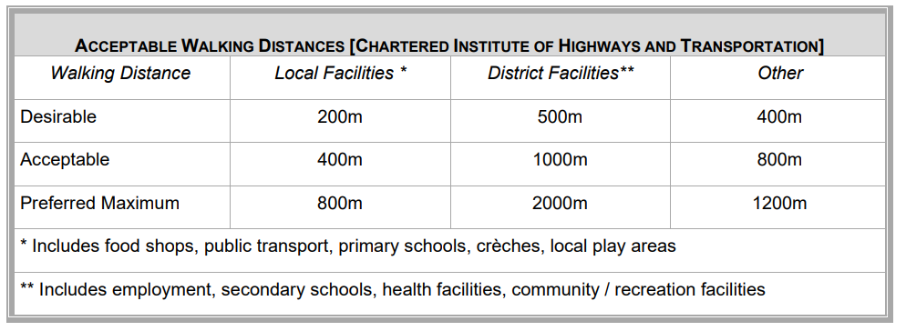
The developer is also required to supply an Active Travel England tool kit for the site.
It is noted that the proposed development intends to enhance pedestrian and cycle permeability between areas east and west of the site with the provision of active travel links to Kidmore End Road on the eastern boundary and Highdown Hill Road on the western boundary of the site. Given that the outline planning application considers access arrangements for the development, further plans should be submitted which clearly demonstrates how the proposed active travel links will connect onto the existing network. It should be noted that both Kidmore End Road and Highdown Hill Road have established hedge rows which will impact of visibility. Therefore, a detailed plan illustrating the footway/cycleway connections including visibility splays and gradients should be submitted for further review. The Natural Environment Officer should also be consulted on the loss of the hedgerow.

On other matters relating to footway connections, the illustrative masterplan shows a new footway connection extending into the eastern edge of the 2022 residential development currently under construction. However, it should be noted that the routing of this path appears to be through the approved attenuation basin. This should be reviewed.
Tracking diagrams are also required illustrating an 11.6m refuse vehicle navigating through the approved 2022 residential development, given that this is the size of the South Oxfordshire refuse vehicles.
It requested that the comments above are sent to South Oxfordshire District Council for review and the applicant is requested to address the points accordingly prior to determining this application.

- Insufficient information has been submitted with the planning application to enable the traffic and highways implications of the proposed development to be fully assessed. The Highway Authority objects to the development unless and until the information outlined above is supplied in respect of junction capacity assessments, and walking assessment is undertaken to ensure the development can make sustainable travel choices using non-car modes of Transport, as per Local Plan Policy TR1 & TR3.

Regards

Natalie Lucas
Transport Development Control Officer
Transport | Environment & Neighbourhood Services

