Existing materials and finishes:
The existing timber double fire door has deteriorated significantly, with rot present on both sides. Additionally, it is allowing water ingress, which may lead to potential pest entry.
To address these concerns, we propose replacing it with a new metal double door to ensure durability and improved protection.

Proposed materials and finishes:
The new door will be a like-for-like replacement, constructed in metal to ensure durability and compliance with fire safety requirements.

Please find attached a drawing indicating the location of the door, along with photos showing its current condition.
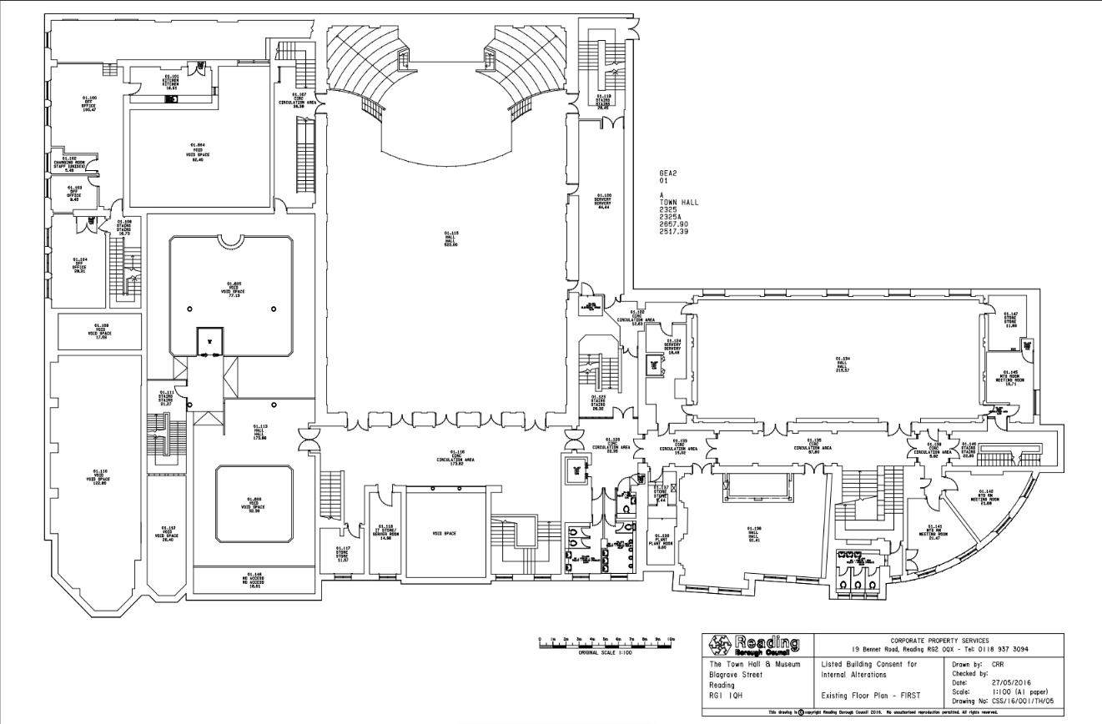
Present view of timber fire doors
