DELEGATED APPLICATION REPORT
Ward: Caversham
App Ref: PL/25/0559 Householder planning permission
Address: 28 CLONMEL CLOSE, CAVERSHAM, READING, RG4 5BF
Proposal: first floor side extension
Applicant: Ms Milena Kotwa and Mr Pierluigi Stanzione
Received date: 09/04/2025
Target Decision date: 06/06/2025
Case Officer: Gary Miles

- SITE DESCRIPTION

The application site is a semi-detached dwellinghouse located on the northern side of Clonmel Close, a residential street comprising of small blocks of terraced properties, constructed early 2000’s as part of a wider development. The property is constructed from red brick with tiled pitched roof, retains a small rear garden and benefits from a garage with additional off-street parking for 1 vehicle. The property has been subject to extensions and refurbishment. A block of terraced properties are located to the south, which side onto the host property. The property is not listed, nor in conservation area, however it is located within Flood Zone 3.

Site visit date: 1st May 2025

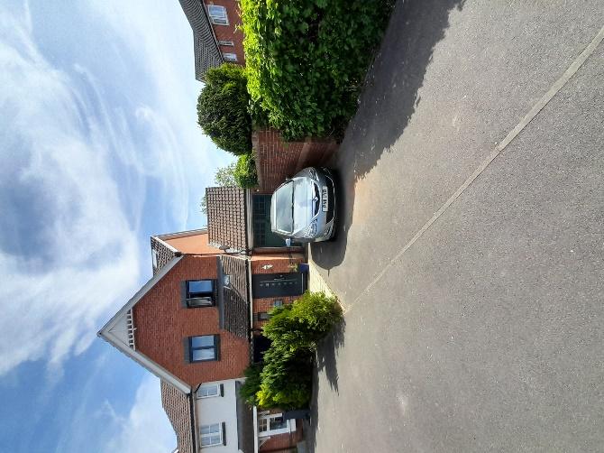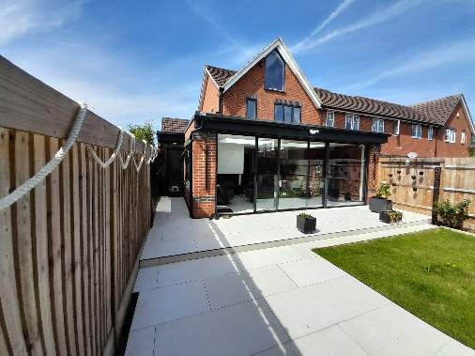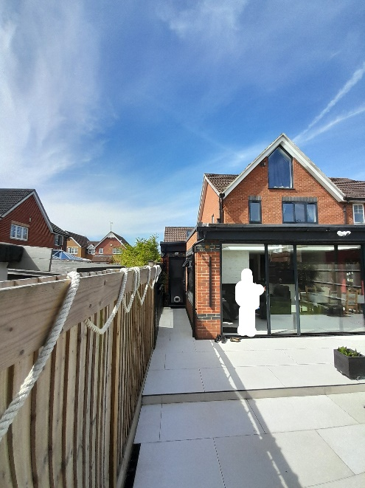
View of front elevation. Views of rear & side elevations with new additions, per previous permissions.

- PROPOSAL AND SUPPORTING INFORMATION

The proposal consists of a first-floor side extension above existing garage space to create a study. Narrow first floor extension along the depth of the property to create an additional toilet at first floor level. New window to front elevation, new window to rear elevation and additional solar panels to the front and rear roof slope. Internal alterations.

Plans and documents considered:

Application form, dated Apr 25
CIL form, dated Apr 25
Drawing no: 1246/31-Plans & Elevations as Existing, dated Feb 25
Drawing no: 1246/32-Plans & Elevations as Proposed, dated Feb 25
Drawing no: 1246/33/Revision A-Location and Block Plan, dated Apr 25 (superseded)
Drawing no: 1246/33/Revision B-Location and Block Plan, dated Apr 25
Flood Map for Planning-Reference 1246, dated Feb 19
Received by the Local Planning Authority 9th April 2025

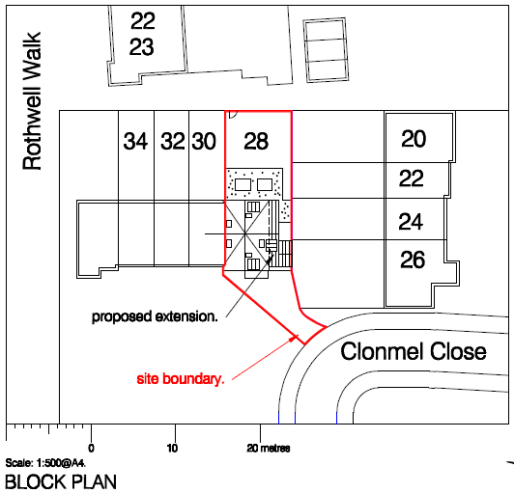

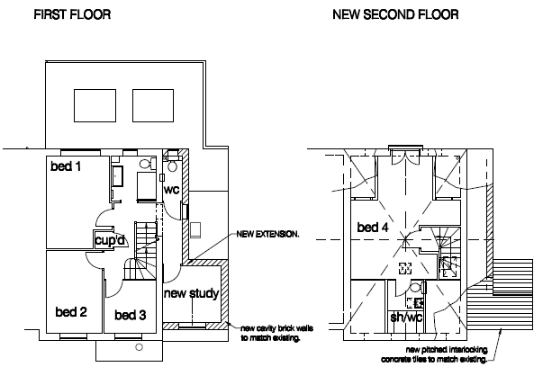
Proposed plans
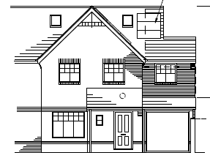

Proposed front elevation
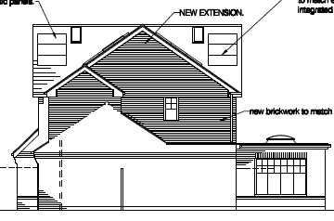
Proposed side elvation
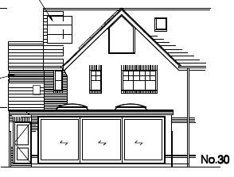
Proposed rear elevation

- RELEVANT PLANNING HISTORY

PL/22/1481/NMA - Non-material amendment to approved application 192051 for loft conversion and single-storey rear extensions, to include installation of rooflights to garage and east elevation, and alterations to rear fenestration – Approved 2022

PL/19/2051/HOU - Loft conversion and single-storey rear extensions (amended description) – Approved 2020

PL/19/1325/HOU - Two-storey side extension and single-storey rear extension – Refused 2019 – Appealed - Dismissed

PL/19/0113/HOU - First floor side extension and single storey rear extension (amended description) – Refused 2019 – Appealed – Dismissed

PL/99/00209/FUL - Demolition and removal of all engineering buildings and erection of 77 dwellings on site – Application Permitted 1999

- CONSULTATIONS

The following were consulted:

Internal

None.

External

The planning notice was installed on nearby street furniture of 1st May and left in place for a minimum of 21 days for the statutory public consultation period.

The following letters of representation have been:

- Neighbour | 26 CLONMEL CLOSE, READING | Object
- Neighbour | 2 CLONMEL CLOSE, READING | Object

Summary of comments:

The 2-storey side extension will be overbearing and look obtrusive to the view from neighbouring properties, negative impact on neighbouring properties which side on to the host property. Concerns of window overlooking – the feeling of being overlooked.

Overlooking from host property into neighbouring properties (outdoor amenity space and internal). Loss of privacy to side facing neighbours as result of side window being closer to the neighbouring boundary.

- EQUALITY ACT 2010

In determining this application, the Council is required to have regard to its obligations under the
Equality Act 2010. However, there is no indication or evidence (including from consultation other
application) that the protected groups identified by the Act have or will have different needs, experiences,
issues and priorities in relation to this particular planning application. Therefore, in terms of the key
equalities protected characteristics it is considered there would be no significant adverse impacts as a
result of the development.

- LEGAL AND PLANNING POLICY CONTEXT

Section 38(6) of the Planning and Compulsory Purchase Act 2004 requires that proposals be determined
in accordance with the development plan unless material considerations indicate otherwise. Material
considerations include relevant policies in the National Planning Policy framework (NPPF) - among them
the 'presumption in favour of sustainable development'. The following local and national planning policy
and guidance is relevant to this application:

National Policy
National Planning Policy Framework
National Planning Practice Guidance
H9 (House Extensions and Ancillary Accommodation)

Reading Borough Local Plan (2019)
CC7 (Design and the Public Realm)
CC8 (Safeguarding Amenity)

SPG/SPD
A Design Guide to House Extensions SPG

- APPRAISAL

Character and Appearance

Policy H9 states that an extension to a house will be acceptable where it respects the character
of the house in terms of scale, location, materials and design and respects the character and
pattern of neighbouring properties and the street as a whole in terms of scale, location,
materials and design, and any important existing building line. Policy CC7 also sets out relevant
considerations for design.

The study would extend the full width of the garage below, whilst the additional toilet is set back from the adjoining boundary. However, officers consider the proposed extension will be harmful to the existing streetscene due to its prominent positioning within Clonmel Close, on a corner and adjacent to neighbouring properties which have gardens side on to the host property. Officers consider the proposal to be bulky in appearance and out of scale with the host property (already being extended) and harmful to the pattern of properties.

The agent was advised that the proposal was harmful and requested to submit amended plans taking into account the points mentioned by officers. A deadline was given for amended plans to be submitted.

The agent confirmed the applicant does not wish to amend the design and wants the current application to proceed to decision, unchanged.

Officers consider the proposal fails to comply with policies H9 and CC7 of the Reading Borough Local Plan 2019.

Residential Amenity

Policy H9 states that an extension will be acceptable where it does not result in an overbearing
impact on neighbours. Policy H10 seeks to ensure that the amenity of gardens and other outdoor
areas are not compromised. Policy CC8 states an extension to a house will be acceptable where
it will not cause a significant detrimental impact to the living environment of existing or new
residential properties.

Officers consider the proposed extension is overbearing to neighbouring dwellings at 24 and 26 Clonmel Close which are arranged side on to and look directly at the side of the host property. The extension will appear bulky and feel intrusive at the rear of these properties. The new opening serving the newly created hallway is considered harmful to neighbouring residential amenity, the window is proposed to be be clear glazed rather than obscure glazed. The window is harmful to privacy of those neighbours to the south of the host property, the window gives the perception of being overlooked people will be seen passing the window and this is detrimental to the amenity of the neighbours to the south which side on to the host property. It is probably the proposed 2 storey extension will cause additional overshading due to its location and proximity to neighbours along the southern boundary.

Officers consider the proposal fails to comply with policies H9 and CC8 of the Reading Borough Local Plan 2019.

- CONCLUSION

The proposed development has been assessed and is unacceptable due to its bulkiness, scale and overly dominant form. The proposal is harmful to the privacy of neighbouring properties and fails to respect the existing property and pattern of neighbouring properties and wider streetscene.

It should be noted that no Pre-Application Advice were sought before submitting this application.

- RECOMMENDATION

REFUSE

