DELEGATED APPLICATION REPORT
Ward:
App Ref: PL/23/0645 Full planning permission
Address: Malvern Court,Reading
Proposal: New bin store
Applicant: Malvern House Estate Management Company Ltd
Received date: 11/05/2023
Target Decision date: 30/05/2025 (EXT)
Case Officer: Chukwudi Onwudinanti

- SITE DESCRIPTION

The site is on the approach of a cluster of blocks of flats on the eastern side of Malvern Court, North of Addington Road, opposite the Reading School.

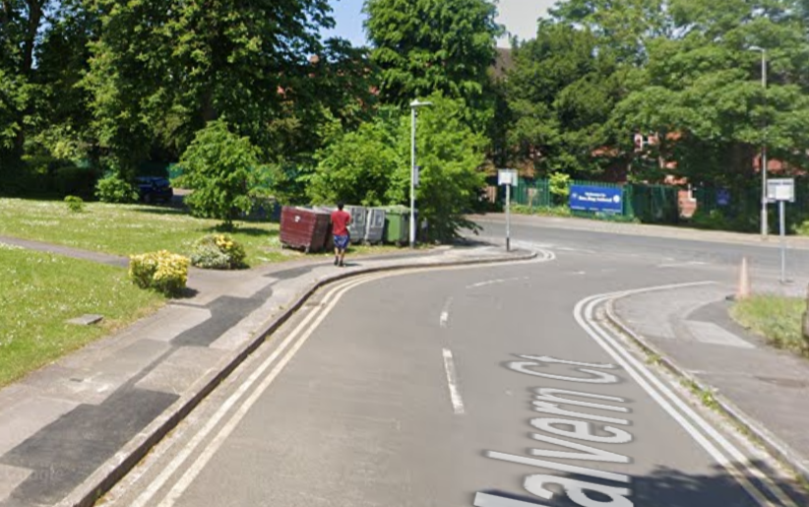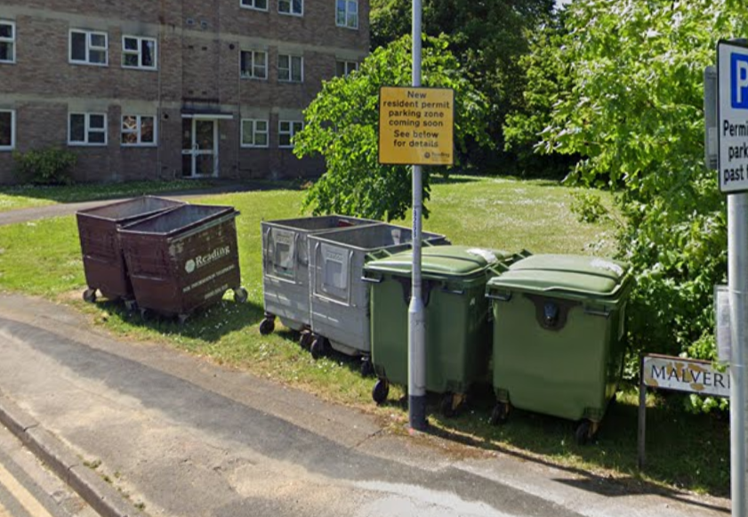

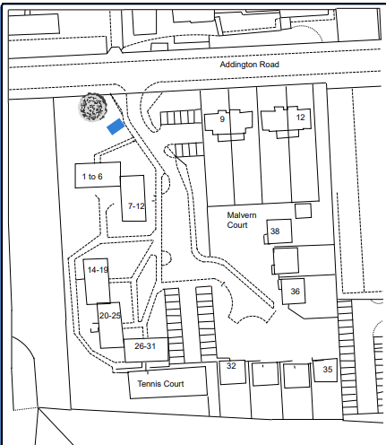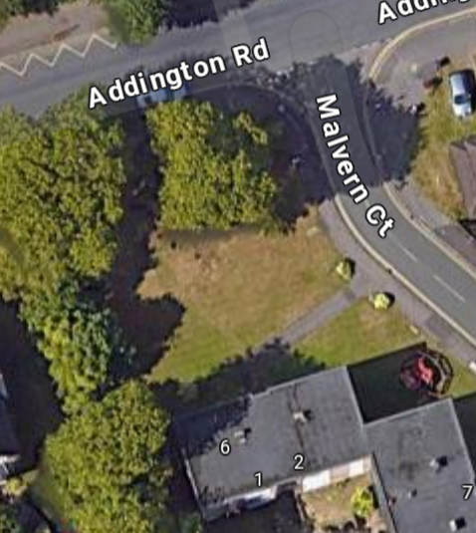
Google Photos

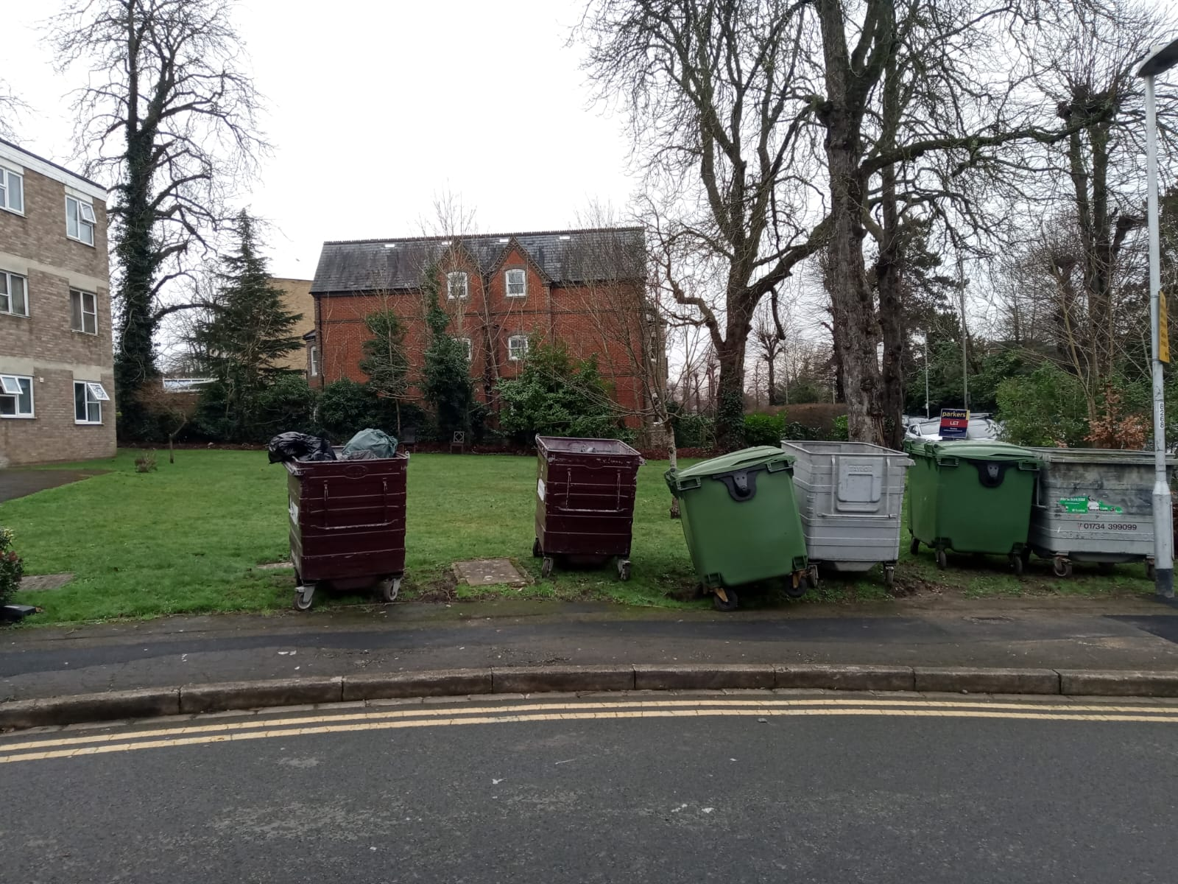
Site Photo

- PROPOSAL AND SUPPORTING INFORMATION
The proposal is for a bin store measuring 6m by 3.6m and 18m height.
Plans and Documents submitted dated 29/04/2025 received 30/04/2025

Drawing No 1001 Rev A - Elevations
Drawing No 801506 Rev C - Block Plan
Drawing No 1002 Rev A- Floor Plan

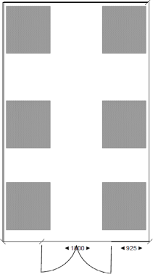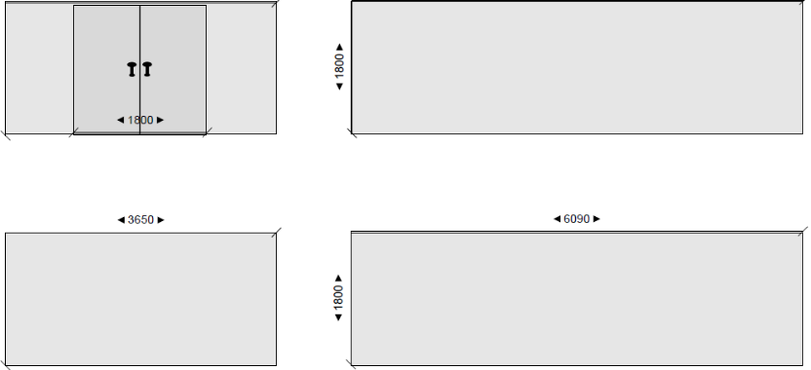
Proposed Plans and Elevations
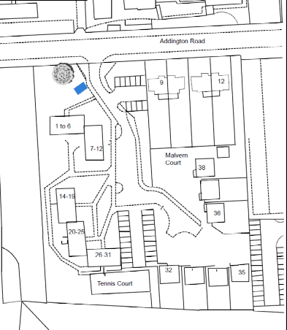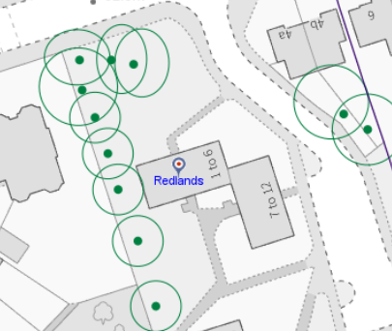
Block Plan/ TPOs

- RELEVANT PLANNING HISTORY
- PL/15/2074- Horse chestnut (T1 of application; T17 of TPO) – crown lift to 5m; remove overgrown basal growth -Permitted
- PL/19/1327- Trees overhanging Cadugan Place from Malvern Court T1 Maple - Crown lift over car park area only to provide approximately 5m clearance from - Permitted

- CONSULTATIONS

The following were consulted:
- Natural Environment

Transport Comments
The location of the proposed bin store should not detract from the character and the amenity of the street scene (this includes obstructing views of the high amenity tree).

Further comments from agent:

I believe that we recently received an email from Reading Council regarding the introduction of a new food waste bin, and they are planning to install one at Malvern Court.

In this case, if the new bin is installed, there is space for it to be kept in the bin shed, as per the submitted plans.

Site notice was displayed.

No letters of representation have been received.

- LEGAL AND PLANNING POLICY CONTEXT
Section 38(6) of the Planning and Compulsory Purchase Act 2004 requires that proposals be determined in accordance with the development plan unless material considerations indicate otherwise. Material considerations include relevant policies in the National Planning Policy framework (NPPF) - among them the 'presumption in favour of sustainable development'. The following local and national planning policy and guidance is relevant to this application:

National Policy
National Planning Policy Framework
National Planning Practice Guidance

Reading Borough Local Plan (2019)
CC7 (Design and the Public Realm)
CC8 (Safeguarding Amenity)
H9 (House Extensions and Ancillary Accommodation)
H10 (Private and Communal Outdoor Space)

SPD
Design Guide to House Extensions SPD 2021

- APPRAISAL

Character and Appearance, Residential Amenity and Tree Protection
Policy CC7 sets out relevant considerations for design, stating:

All development must be of high design quality that maintains and enhances the character and appearance of the area of Reading in which it is located.

Policy CC8 states:

Development will not cause a detrimental impact on the living environment of existing residential properties or unacceptable living conditions for new residential properties.

Policy EN14 states:

Individual trees, groups of trees, hedges and woodlands will be protected from damage or removal where they are of importance, and Reading’s vegetation cover will be extended. The quality of waterside vegetation will be maintained or enhanced.

The proposed bin store is to be sited roughly where the bins are currently placed and collected from. The original design has been amended to ensure that the bin store is not built on land that would interfere with the free movement of vehicles and pedestrians on the existing walkways and kerbs. The proposed structure would be sufficiently separated from the nearest tree but to ensure that the tree is protected during construction, conditions would be attached. The maximum height for the enclosure would be a maximum of 1.8m which is, consistent with the average height of a boundary fence, so is not considered to be detrimental to the outlook of the surrounding area. The materials proposed are of timber, similar to the materials used on everyday boundary fences (as submitted in additional documents with this application).

In principle, therefore, it is considered that the bin store would enhance the general outlook and amenity of the area and the residents. The bin store would provide an enclosure for the bins, mitigating the existing negative outlook caused by overflowing bins.

It is, therefore, recommended to be permitted, subject to conditions.

- CONCLUSION
The proposed development has been assessed as set out above and is considered to be acceptable on that basis, subject to the following conditions.

- RECOMMENDATION: Grant
Recommended Conditions:
Approved Plans
Time Limit Standards
Materials As Specified
Tree Protection

