
HERTIAGE STATEMENT AND ASSESSMENT OF SIGNIFICANCE TO SUPPORT THE LISTED BUILDING CONSENT APPLICATION FOR THE INSTALLATION OF LIGHTNING PROTECTION

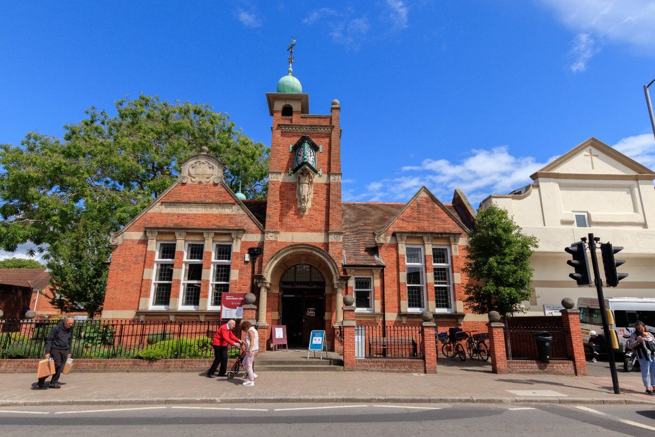

at
CAVERSHAM FREE PUBLIC LIBRARY
CHURCH STREET
READING
RG4 8AU
CONTENTS

1.0 Introduction

1.1Introduction

1.2 Purpose of the Heritage Statement

2.0 Section 1: The Heritage Asset

2.1

Nature of the Heritage Asset

2.2 Assessment of Significance

3.0 Section 2: Proposals Affecting the Heritage Asset

3.1

Proposed Works

3.2 Reasons and Justification

3.3 Assessment Impact

3.4 Mitigation

1.0 Introduction

1.1 Introduction
Listed building consent and planning permission approval is sought for the
Installation of a Lightning Protection System at Caversham Library in Caversham, Reading.
The proposed works are to help preserve the building in the event of a direct lightning strike to Caversham Library, a Grade II listed building.

1.2 Purpose of the Heritage Statement
The purpose of this Heritage Statement is to demonstrate a clear understanding of
the values that make Caversham Library culturally significant, and
then to communicate the appropriateness of the installation of a lightning protection system to ensure the longevity of the building without or minimising harm to this significance.
The Heritage Statement sets out the need and justification for the proposed installation and conservation works and explains why the particular type of lightning protection are
proposed. It explains why the faraday cage approach is considered the most appropriate to maintain the character and detail of the building.
The Heritage Statement will also outline how the proposed installation will contribute to the long-term sustainable conservation of the heritage assets and the mitigation measures adopted to remove the risk of potential harm to significance.

2.0 Section 1: The Heritage Asset

2.1 Nature of the Heritage Asset
Construction of Caversham Library began with the laying of the fountain stone on Saturday 23rd March 1907. William Bullivant Williams, the donor of the site, preformed the ceremony.
Caversham Library officially opened it doors on Wednesday 11th December . Viscount Valentia open the front doors with a silver key.
In the souvenir brochure of the opening ceremony, the library was described as being in ‘Free Renaissance’ style. The building itself is not symmetrical and found to be using different architectural styles.
The stone canopy over the entrance is borrowed from the Queen Anne style, and the pillars supporting it are borrowed from the classical architecture. The entrance doors with their round windows, are reminiscent of the Arts and Crafts movement, as is the tapering clock tower above, with the corner turret surmounted by a green copper ball and a weather-vane in the form of a swan. A second green copper ball sits on top of a ventilation turret.
On the official list of ‘listed buildings’ it is described as ‘sub-Voysey.’

Source: Roots and Branches by David Cliffe

2.2 Assessment of Significance
Caversham Library plays a key part in the History of Reading. As one of the first free libraries following the promise by Caversham Urban District Council to adopt the Public Libraries Act in 1905 and still serves the residents of Reading to this day.

3.0 Section 3: Proposal Affecting the Heritage Site

3.1 Proposed Works
The lightning protection system will consist of the following:
- Air termination network installed at appropriate high points of the roof and finials.
- Down conductors routed discreetly along building corners or other visually unobtrusive locations.
- Earth termination systems, safely buried and located to minimize visual and physical disruption.

3.2 Reasons and Justifications
The function of the lightning protection system is to intercept, conduct and disperse a lightning strike safely to earth. To protect the building's structure, electronic systems and the people around and within the building.

3.3 Assessment Impact
The aim is to keep the lightning protection system as discreet as possible as to not impact the appearance of Caversham Library.

3.4 Mitigation
The installation is proposed to mitigate the risk posed by lightning strikes, ensuring the safety of the building’s occupants and the protection of its infrastructure, particularly its electrical systems and archive materials.

