
Simon Dackombe
Strategic Planner

Property Services
HQ North – Fountain Court
The Boulevard
Kidlington
OXON
OX5 1NZ

07800 703316

15th May 2025

Dear Sir/Madam

DISCHARGE OF PLANNING CONDITION 3.
Erection of enclosure and associated gates around car park deck, atlantic house, THAMES VALLEY POLICE, READING POLICE BASE, ATLANTIC HOUSE, READING. RG2 0TD – PLANNING REFERENCE PL/25/0211

Please find enclosed details relating to the discharge of condition 3 relating to the above planning application. The condition states;

“No development shall be carried out relating to the approved fencing to the northern boundary of the car park (including demolition or preparatory works) until a schedule of tree protection and any associated tree works in accordance with the relevant recommendations of appropriate British Standards or other recognised Codes of Good Practice (to include BS5837:2012) for all existing trees that are not shown as being removed on the approved drawings, both within and adjacent to the site, has been submitted to and been approved in writing by the Local Planning Authority. The development shall not be carried out otherwise than in strict accordance with the approved schedule at all times thereafter.”

I trust the attached information is sufficient to discharge the condition. Should you require any further information or wish to visit the site please do not hesitate to get in touch.

Yours sincerely

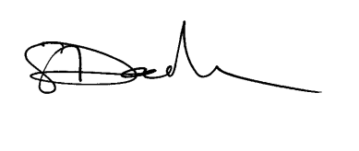

Simon Dackombe
Strategic Planner

