DELEGATED APPLICATION REPORT
Ward: Caversham Heights
App Ref: PL/25/0499 Non-Material Amendment
Address: 6 KELMSCOTT CLOSE, CAVERSHAM, READING, RG4 7DG
Proposal: Application for a Non-Material Amendment Following a Grant of Planning Permission PL/24/0839 to reduce the amount of unconverted garage space and increase the amount of habitable room for a Kitchen.
Applicant: Mr Will Frank-Gemmill
Received date: 28/03/2025
Target Decision date: 25/04/2025 Extension of Time agreed: 09/05/2025
Case Officer: Gary Miles

PROPOSAL AND SUPPORTING DOCUMENTATION

Application for a Non-Material Amendment following a grant of planning permission PL/24/0839 to reduce the amount of unconverted garage space and increase the amount of habitable room for a Kitchen. The remaining unconverted space will be too small for a car parking bay, however, there is sufficient space available for 3 off-road car parking bays in front of the property as shown on the proposed Block Plan.

Previously Approved Block & Elevation Plans under application PL/24/0839:

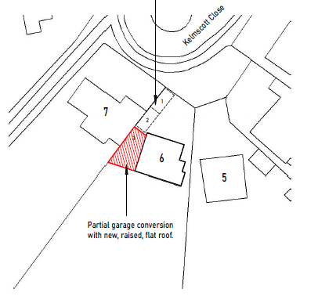

Approved Block Plan
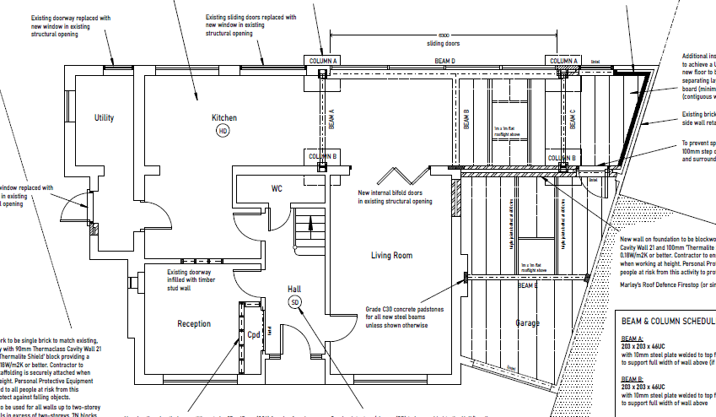

Approved Ground Floor Plan

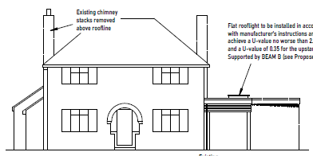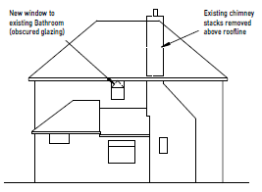

Approved Front Elevation Approved Side Elevation

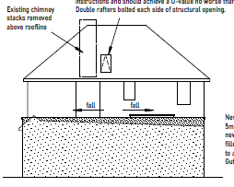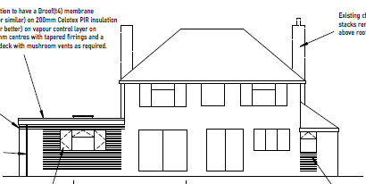

Approved Side Elevation Approved Rear Elevation
Drawing no: WFG-0724-01 Proposed Ground Floor Plan
Drawing no: WFG-0724-03 Proposed Elevations
Drawing no: WFG-0724-07 Block Plan

Amended Block and Elevation Plans Proposed under application PL/25/0499:

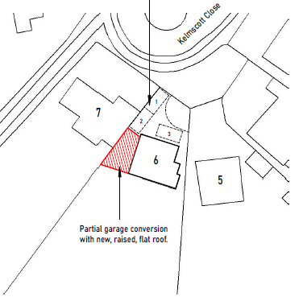

Proposed Block Plan

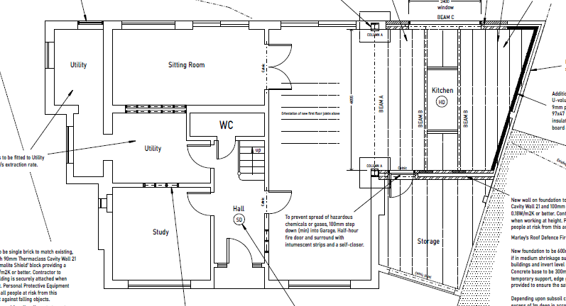

Proposed Ground Floor Plan

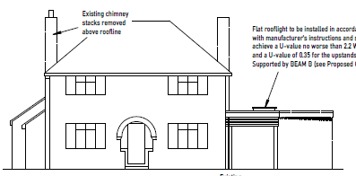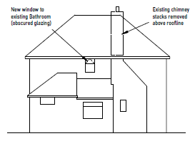

Proposed Front Elevation Proposed Side Elevation

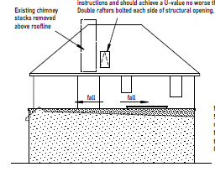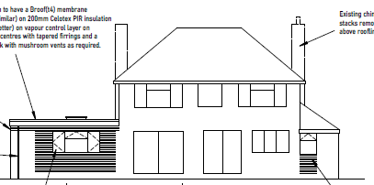

Proposed Side Elevation Proposed Rear Elevation

Drawing no: WFG-0724-01 Proposed Ground Floor Plan (revision D)
Drawing no: WFG-0724-03 Proposed Elevations (revision D)
Drawing no: WFG-0724-07 Block Plan (revision A)

CONSULTATIONS
Applications under S96A are not applications for planning permission, so are not covered by the publicity requirements as set out in the DMPO.

EQUALITY ACT 2010
In determining this application, the Council is required to have regard to its obligations under the Equality Act 2010. However, there is no indication or evidence (including from consultation on the application) that the protected groups identified by the Act have or will have different needs, experiences, issues and priorities in relation to this particular planning application. Therefore, in terms of the key equalities protected characteristics it is considered there would be no significant adverse impacts as a result of the development

RELEVANT PLANNING POLICY AND GUIDANCE
Whilst there is no statutory definition of what constitutes a ‘non-material’ amendment, Section 96A, part 2 of the Town and Country Planning Act 1990 (as amended) states that, "In deciding whether a change is material, a local planning authority must have regard to the effect of the change, together with any previous changes made under this section, on the planning permission as originally granted." The proposed amendments are assessed for materiality – not on the basis of their planning merits. Planning policies therefore do not apply.

ASSESSMENT
The proposed non-material amendment to application PL/24/0839 seeks to reduce the amount of unconverted garage space and increase the amount of habitable room for a Kitchen. The remaining unconverted space will be too small to accommodate a car, however, there is sufficient space available for 3 off-road car parking bays in front of the property as shown on the proposed Block Plan.

The changes proposed are not deemed to represent a material change to the original permission as the changes would not have a material impact on the design and character of the proposed rear extensions and single storey side extension to replace existing garage. It is not considered that this specific proposal raises any additional design concerns, over and above what has been considered appropriate previously.

The proposed alterations are not considered to alter the approved plans under application PL/24/0839 to the point that there may be planning concerns.

An informative is recommended which states that this permission relates only to the changes highlighted on the plans. Furthermore, it shall only be read in the context of the substantive permission and is bound by all conditions attached to that permission.

A further informative is recommended which states that in reaching this decision, the local planning authority is satisfied that the changes proposed by this application do not constitute material changes to the approved planning permission.

CONCLUSION
The proposed amendments have been concluded to not be harmful to the character or appearance of the site or its surroundings and would not have a detrimental impact on the original building or neighbouring properties.

As such the proposal is considered to be in accordance with policies CC7 and H9 of the Reading Borough Local Plan (2019) and the Councils Supplementary Planning Document “Design Guide to House Extensions” (2021).

RECOMMENDATION
Approve non-material amendment.

