30 April 2025 | 

Title | PLANNING APPLICATION REPORT
Ward | Norcot
Planning Application Reference: | PL/25/0471
Site Address: | 59 Honey End Lane, Reading
Proposed Development | Change of use from Class C3 dwellinghouse to C2 children’s home including alterations to front elevation, internal refurbishment and minor landscaping works
Report author | Richard Eatough
Applicant | Reading Borough Council
Deadline: | 30 May 2025
Recommendations | Grant planning permission, subject to conditions as follows:
Conditions | - TL1 standard three years for implementation  - AP1 approved plans  - M1 Matching materials (for front elevation works)  - No other use other than as a C2 childrens’ home  - Maximum of four residents  - DC1 Retention of front driveway for parking only  - DC5 Provision and retention of cycle parking  - No use of outbuilding as (a) bedroom(s) for staff or residents
Informatives | - Terms and conditions  - Positive and proactive  - Building Regulations approval required  - Environmental Protection Act 1990 requirements

- Executive summary
1.1 This report concerns the proposed change of use of this property, which is currently a C3 residential family home. There is a mix of uses in the area, although the predominant use is residential. The application proposal is to change the use of the building to a childrens’ home, to be operated by Brighter Futures for Children, which is part of the Council. The report explains that given the nature of the proposed use and the character of the area, the proposed use of the building and the site is considered to be acceptable and consequently, this report recommends the granting of planning permission.
- Introduction and site description
  - This is a full planning application for a change of use submitted by the Council and is therefore being reported to your meeting. The property is a recent acquisition by the Council and is currently vacant.

  - The application site contains a post-War, brick-built, detached house and its garden, situated on the west side of Honey End Lane. The house appears to have been extended twice, first via a single storey lean-to rear extension and then later by a two storey side extension (incorporating an integral garage). The site is largely flat, although there is a slight slope up in the rear garden beyond the patio, which is laid to lawn, and at the end of the garden (western end) is a large, wooden outbuilding, last used by the occupants as a games room. This part of Honey End Lane is largely residential, although nearby is Kings Prospect Academy (secondary school), Prospect Park, the Meadway Precinct and ASDA superstore and Prospect Park Hospital.

  - Below are the location plans and images of the application site and views from the road.
Location plan (not to scale)
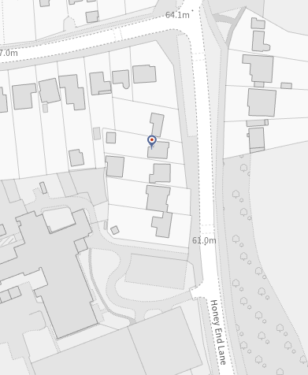
Front elevation
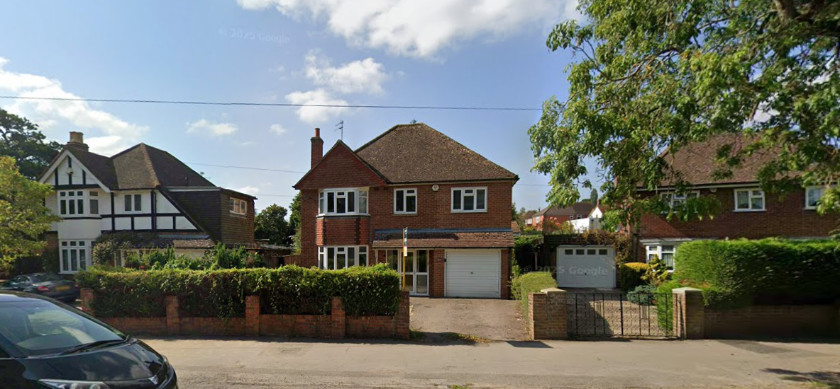

- The proposal

  - Full planning permission is sought to change the use from a C3 family dwelling into a C2 Childrens’ Home. The alterations to the house itself are comparatively minor and externally would be limited to conversion of the existing integral garage to a staff bedroom, including replacing the garage opening with a window. The property would also undergo minor internal reconfiguration and refurbishment, but the number of upstairs bedrooms would continue to be four. The rear garden and patio would be retained, a cycle store added and the existing outbuilding used as ancillary to the main building.

  - The proposed use would be very similar in nature to two other recent proposals reported to your meeting on 5 March (at 35 Alexandra Road and 134 Northumberland Avenue) except that 59 Honey End Lane would be used primarily as an ‘assessment centre’. This means that although the nature of the occupancy will be the same, the length of stay would tend to be shorter, as the children are to be housed here only usually for a matter of weeks before being placed in other accommodation, usually with foster families.

  - Documents submitted with the application include application form, planning statement, existing and proposed plans and elevations and a transport statement. The proposals have been subject to pre-application advice with officers before submission. This type of use attracts a nil charge under the Council’s adopted Community Infrastructure Levy (CIL) system.

- Planning history

00179 | Dwellinghouse with garage | Permission 22/10/1948
11739 | Extension | Permission 17/7/1964
23939 | Extension to garage and reroofing conservatory | Permission 20/12/1974
84/TP/0879 | Erection of two storey extension | Permission 27/11/1984

- Consultations

  - RBC Transport Strategy no objections, subject to conditions (discussed below)

RBC Environmental Protection no response at the time of writing, but any response received will be reported to your meeting.
  - Public consultation:

Site notices were displayed at the front of the property on Honey End Lane and on Cockney Hill. Letters were also hand-delivered to Nos. 57 and 61 Honey End Lane and 134 Cockney Hill. At the time of writing, there have been no responses, but any which are received will be reported to you. For information, the formal 21-day consultation period expires on 25 April, however any representations received up until your meeting will be reported and taken into consideration.

- Legal context

  - Section 38(6) of the Planning and Compulsory Purchase Act 2004 requires that proposals be determined in accordance with the development plan unless material considerations indicate otherwise. Material considerations include relevant policies in the National Planning Policy framework (NPPF) - among them the 'presumption in favour of sustainable development'. However, the NPPF does not change the statutory status of the development plan as the starting point for decision making (NPPF paragraph 12).

  - In this regard, the NPPF states that due weight should be given to the adopted policies of the Local Plan 2019 according to their degree of consistency with the NPPF (the closer the policies in the plan to the policies in the NPPF, the greater the weight that may be given).

  - Accordingly, the latest NPPF and the following development plan policies and supplementary planning guidance are relevant:

National Planning Policy Framework (December 2024)
Reading Borough Local Plan 2019 policies:
CC1 Presumption in Favour of Sustainable Development
CC6 Accessibility and the Intensity of Development
CC7 Design and the Public Realm
CC8 Safeguarding Amenity
H6 Accommodation for Vulnerable People
H7 Protecting the Existing Housing Stock
TR5 Car and Cycle Parking and Electric Vehicle Charging
OU1 New and Existing Community Facilities

Supplementary Planning Documents and other guidance

SPD: Revised Parking Standards and Design (2011)

Local Plan Update
6.4 The current version of the Local Plan (adopted in November 2019) turned five years old on Tuesday 5th November 2024. The Local Plan was reviewed in March 2023 and around half of the policies in the plan are considered still up to date. However, the rest need to be considered for updating to reflect changing circumstances and national policy. A consultation version of the draft update of the Local Plan was published on 6th November 2024.
6.5 Although there is a five-year period for carrying out a review of a plan after it is adopted, nothing in the NPPF or elsewhere says that policies automatically become “out of date” when they are five years old. It is a matter of planning judgement rather than legal fact whether a plan or policies within it are out-of-date. This will depend on whether they have been overtaken by things that have happened since the plan was adopted, either on the ground or through changes in national policy, for example.
6.6 Officer advice in respect of the Local Plan policies pertinent to these applications listed above is that they remain in accordance with national policy and that the objectives of those policies remains very similar in the draft updated Local Plan. Therefore, they can continue to be afforded weight in the determination of this planning application and are not considered to be ‘out of date’.

- Appraisal

  - The main considerations are:

  - Principle of Development
  - Impact on neighbour amenity (including disturbance and parking)

Principle of Development

  - The property was in use as a family dwelling until earlier this year, therefore the proposal involves a loss of a single family dwelling to another use. Dwellings, and in particular family-sized dwellings, are protected by Policy H7.

  - The Applicant’s planning statement explains the reason for the submission of a planning application as the need for the Council to provide childrens’ homes, to reduce the financial burden on the Council of these facilities being provided by the private sector. Although the use would be very similar to that of a house within the C3(b) dwelling houses (where up to six residents live together as a single household and receive care), Ofsted rules state that the Local Authority must apply for and secure a planning permission for it to be able to operate a C2 Childrens’ Home use. Hence, the applicant’s need to apply for and be granted planning permission for the change of use.

  - Officers advise that the proposed use should be broadly similar to the last family use of the property. The applicant’s planning statement explains that the current approach to providing childrens’ homes is different to older examples and large, institutional type buildings are no longer used. Instead, the model is for normal family houses to be used as far as possible, with the presence of a ‘family home’ indistinguishable within a residential street.

  - The Local Plan contains policies to protect the existing dwelling stock (H7), provide accommodation for vulnerable groups (H11) and to protect or improve community facilities (OU1). Whilst technically, a large family dwelling will be lost, overall, officers consider that in this instance, this is outweighed by the benefits of providing a childrens’ home and is in principle accepted. As is described further in the section below, the character of the use will be broadly similar and appropriate to the area. The proposal will also provide employment through the various support staff required (see below), which is a further benefit of the proposals.

Impact on neighbour amenity (including disturbance and parking)

  - The applicant’s planning statement provides a detailed description of the operation of the home. It would be a four bedroom children's home designed to provide a short-term home for up to four children, whilst they are being assess for suitability for onward accommodation of a more permanent nature. It would be managed by a registered manager with support and other staff during the day resulting in there being three to four staff on site at any one time. The planning statement sets out a usual daily schedule for the children which is quite structured. As well as support for the children as required, in other respects the property would largely operate as a ‘family-style’ home. Usually there would be one or more adults sleeping overnight in the home (via the new staff bedroom resulting from the garage conversion) and there would always be adults present. Shift patterns would not start before 7am or end after 10pm, which would minimise comings and goings at unsociable hours. There would be occasional visitors and use of the garden, patio and its outbuilding, as there would be with any usual family setting. The garden is presently in good condition and enclosed by a close-boarded fence. The current large outbuilding is in good condition and the applicant has advised that this would be retained and used for activities and perhaps staff use and meetings. However, due to possible disturbance to neighbours, officers advise that it is less suitable for use as overnight sleeping accommodation and a condition to preclude this is recommended. A response from the Environmental Protection (EP) Team is awaited, but given that it is a detached house and the overall spaciousness in this suburban location, the proposal is considered to be appropriate and strong concerns from the EP Team are not anticipated. As a precaution, a condition will ensure that no other use within the C2 use class is permitted, as other uses may have different impacts in terms of disturbance and traffic.

  - The site is well-located, being close to facilities at the Meadway Precinct District Centre, as well as being close to the town centre and accessible to bus routes on the Meadway and Bath Road. The Highway Authority advises that the Council’s parking standards SPD has no specific standards for this type of accommodation, and provision will be based on individual merits. It is advised that the proposal would not have a significant impact on the highway network. The site has space to park three vehicles in the front driveway, which can accommodation the maximum number of staff at any one time. Cycle parking for both staff and residents is shown in a new store in the rear. Conditions are recommended to supply and retain these parking facilities. A waste management condition is also recommended, however, officers advise that waste management is not expected to be an issue, as it would be the same/similar as the domestic situation and this condition is not considered to be necessary. Overall, in parking and transport terms, the use would be appropriate and acceptable in terms of policies CC6 and TR5 and the Council’s parking standards.

  - Subject to the response from the EP Team not raising substantial concerns that have not already been addressed by the case officer officers conclude that the proposed use would be similar to a C3 family home, so suitable in terms of the character of the area, and complies with Policy CC8.

Other matters

  - Externally, the infilling of the garage opening and installation of a window are considered to be minor and suitable works. A condition is recommended to require materials used to match, to comply with Policy CC7.

  - Officers have considered the extent to which the building would be accessible to all. There is a small step to the front door and only stair access to the first floor bedrooms and the bathroom and a further WC. Given that the use would function in much the same way as a family home and its similarity to its current use, it is accepted in this case that no intervention (e.g. lifts) would be appropriate. The ground floor staff areas are considered to be suitable in terms of Policy CC7. Separate Building Regulations approval is likely to be required and an informative is recommended.

  - Officers have considered to what extent adjusted or new emerging policies within the Partial Update of the Local Plan have relevance to this assessment and advise that the principal update in policy direction is proposed new Policy CC10: Health Impact Assessments (known as HIAs). This requires applications such as this, where accommodation for vulnerable groups is concerned, to look more widely at the health implications for the Borough. It should be noted that at the time of writing, HIAs are not a planning application validation requirement and officers are satisfied that the pertinent issues have been adequately addressed in the Appraisal above.

- Equality implications

  - Under the Equality Act 2010, Section 149, a public authority must, in the exercise of its functions, have due regard to the need to—
- eliminate discrimination, harassment, victimisation and any other conduct that is prohibited by or under this Act;
- advance equality of opportunity between persons who share a relevant protected characteristic and persons who do not share it;
- foster good relations between persons who share a relevant protected characteristic and persons who do not share it.

  - The key equalities protected characteristics include age, disability, sex, gender reassignment, marriage and civil partnership, pregnancy and maternity, race, religion or belief, sexual orientation. It is considered that there is no indication or evidence that the protected groups have or will have different needs, experiences, issues and priorities in relation to this particular application

- Conclusion & planning balance

  - As with all applications considered by the Local Planning Authority, the application is required to be determined in accordance with the development plan unless material considerations indicate otherwise, as per Section 38(6) of the Planning and Compulsory Purchase Act 2004.

  - Any harmful impacts of the proposed development are required to be weighed against the benefits in the context of national and local planning policies, as detailed in the appraisal above. Having gone through this process officers consider that the loss of present family dwelling is suitable, given the greater benefits to the Borough in terms of providing specialist residential accommodation for vulnerable children. The likelihood of neighbour disturbance is low and additional conditions to ensure this are recommended.
9.3 It is considered that officers have applied a suitable planning balance when reaching this conclusion. As such, this application is recommended for approval.
Site plan
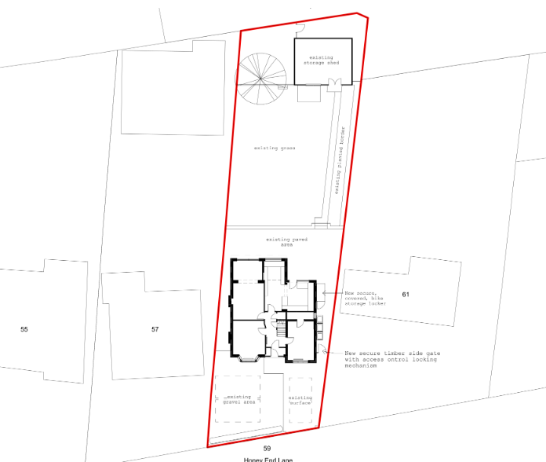
Proposed front elevation
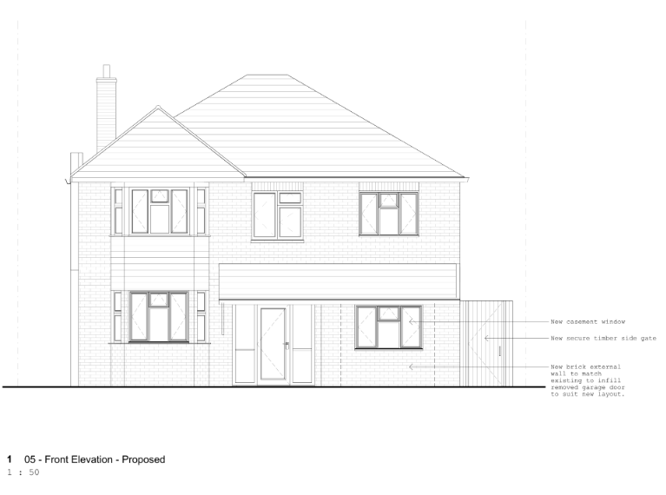

Proposed Ground Floor Plan
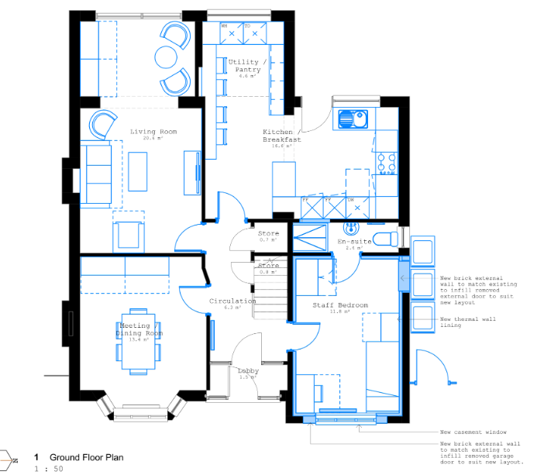
Proposed First Floor Plan
