TOWN AND COUNTRY PLANNING ACT 1990

PLANNING STATEMENT

Application for the Temporary Change of Use of Land to form a Public Car Park with associated equipment

Land at Unit C2, Forbury Park, Kenavon Drive, Reading,
RG1 3DH

Statement on behalf of
National Car Parks Limited

April 2025

XX DATE XX- V1

Aitchison Raffety
The Granary, Spring Hill Farm, Harborough Rd, Pitsford, Northampton NN6 9AA
Telephone 01604 880163

Prepared by
Nigel Ozier
BA (Hons) TP MRTPI

1 | Introduction | 3
2 | The Site and Surrounding Area | 3
3 | Planning History | 5
4 | Planning Policy | 5
5 | The Proposal | 7
6 | The Planning Case | 7
7 | Conclusions | 7
CONTENTS

1. INTRODUCTION

  - This Planning Statement has been prepared in support of a planning application for the temporary change of use of land at Kenavon Drive, Reading to be used as a public car park with associated access and equipment. Permission for up to 24 months is sought.

  - The purpose of this Statement is to review the planning history, prevailing planning policies and other material considerations that are relevant to the determination of the planning application and to present a case for granting planning permission.

2. THE SITE AND SURROUNDING AREA

2.1 The site is located on Kenavon Drive south of the Dacathlon retail building. The site is an open vacant area following the demolition of an office building and recent use by Berkeley Homes for parking. To the north and east of the site lies existing businesses and open car park area which have direct access from Kenavon Drive. South and south-east of the site lies residential development comprising 6 and 7 storey blocks of apartments.

2.2 The plan below shows the application site. It comprises and area of approximately 0.17ha. The application site is currently vacant but has previously been used as offices with access located at the rear of the former building in the north east corner of the site. This can be seen on the plan below and on the google image.

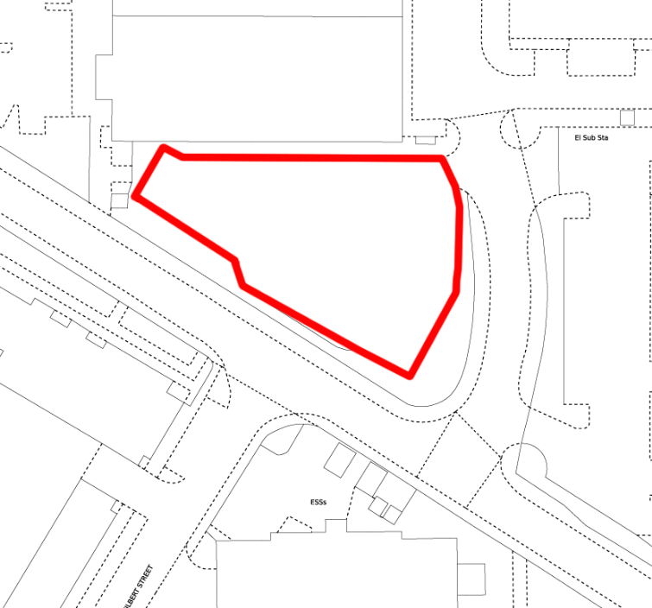
Site Plan

2.3 Additional car parking lies to the east of the site, again formerly in business use. There are a variety of uses in the area including business, retail and residential and there is clear evidence of a shortage of off street parking as shown in the photo below with cars needing to park on the side of Kenavon Drive.

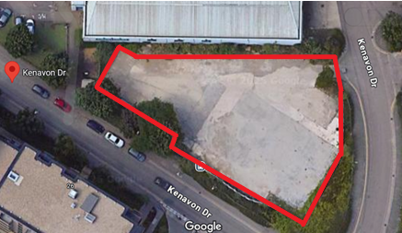
Google image

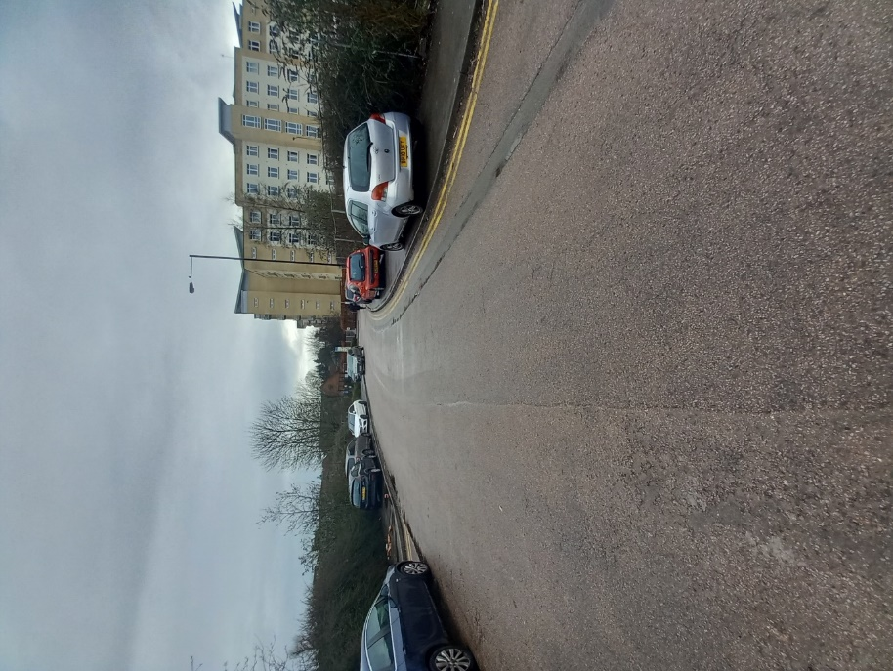
Parked cars on Kenavon Drive

2.4 The site is not within a conservation area and there are no technical designations that would restrict the proposed use. The site is part of Forbury Business Park and subject to specific proposals in the Local Plan which I refer to below. The use of the site as a temporary car park will not affect future proposals but will assist in relieving the shortage of off street public parking in this part of Kenavon Drive.
3. PLANNING HISTORY

3.1 There are no relevant planning applications relating to this site.

4. PLANNING POLICY

4.1 The starting point for assessing proposals is always the Development Plan. Section 38 (6) of the Planning and Compulsory Purchase Act 2004 which is relevant also in Wales states “if regard is to be had to the development plan for the purpose of any determination to be made under the Planning Acts, the determination must be made in accordance with the plan unless material considerations indicate otherwise.”

4.2 The relevant part of the Development Plan for this proposal is the Reading Local Plan which was adopted in 2019. The National Planning Policy Framework dated December 2024 is also relevant.

Reading Local Plan

4.3 The site lies within the area identified as the ‘East Side Major Opportunity Area.’ This is dealt with by Policy CR13: EAST SIDE MAJOR OPPORTUNITY AREA which states that

‘Development in the East Side Major Opportunity Area will: i) Provide a more defined urban environment than currently exists, of a medium to high density; ii) Contribute towards the provision of a new residential community at the eastern fringes of the central area. Development for education will be acceptable within the site; iii) Help facilitate greater pedestrian and cycle permeability, in particular east-west links through the area and links between development areas and the station, including improved crossings of the IDR and railway; iv) Safeguard land which is needed for mass rapid transit routes and stops; v) Conserve and enhance the listed buildings, scheduled ancient monument and historic garden in the area and their setting where possible; vi) Give careful consideration to the archaeological potential of the area and be supported by appropriate archaeological assessment which should inform the development; vii) Demonstrate that it is part of a comprehensive approach to its sub-area, which does not prevent neighbouring sites from fulfilling the aspirations of this policy, and which contributes towards the provision of policy requirements that benefit the whole area, such as open space; viii) Provide additional areas of open space where possible, particularly in the centre of the new community; ix) Maintain, improve and create new access along the north side of the River Kennet to the Kennet Mouth; and x) Give early consideration to the potential impact on water and wastewater infrastructure in conjunction with Thames Water, and make provision for upgrades where required.’

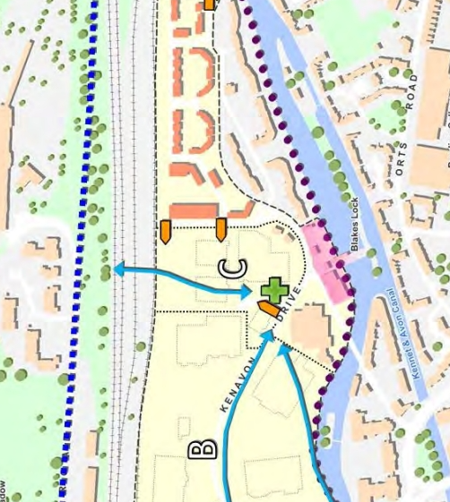

4.4 As shown in the Local Plan extract above, the application site lies within Area C and adjacent to the boundary with Area B. For Area B, the policy states

‘CR13b, FORBURY RETAIL PARK: This site would be the focus of the new residential community, and, alongside residential, additional retail, leisure and community uses at a scale to serve the Kenavon Drive area would be appropriate. It should include a new area of open space and enhance the frontage to the canal, including a buffer zone to the top of the canal bank to reflect its wildlife significance. Implementing this policy may involve complete redevelopment or using new additional development to improve the existing urban form of the area. Some parts of the site are likely to be implemented in the long term.’

4.5 For Area C, in which the site lies, the policy states

‘CR13c, KENAVON DRIVE & FORBURY BUSINESS PARK: This site would be largely residential in nature, although opportunities to create an area of open space close to the Kennet should be sought. Development will link into the newly opened pedestrian link under the railway to Napier Road.’

4.6 The proposed temporary use of the site for parking will not undermine the Local plan policies and the proposals for Forbury Business Park. The provision of additional parking spaces in the area will meet a clear need as shown in the above photograph. The temporary use will not be harmful to the character of the area which includes business uses, residential development and open car parking areas. Access to the site already exists and is acceptable for the proposed use.

5. THE PROPOSAL

5.1 The proposal relates to the land formerly used for employment and associated parking and is currently vacant. The land comprises approximately 0.17ha in area and will provide for 52 car parking spaces as shown on the submitted image.

5.2 Vehicular access is proposed directly off Kenavon Drive as shown in the site plan. The existing access will meet current standards for the proposed temporary car park.

6. THE PLANNING CASE

6.1 This section of the Planning Statement assesses the proposed development against the policies of the Local Development Plan and against all other relevant material considerations and sets out why temporary planning permission should be granted by the Council.

6.2 The starting point for assessing development proposals is the Development Plan, unless material planning considerations indicate otherwise.

Principle of development

6.3 The Application Site comprises an area of hardstanding formerly a site in business/office use. The site is fenced and separated from the adjacent development with direct access from Kenavon Drive.

6.4 The current proposal will have the same impact in terms of the character and scale of use as with adjoining areas used for car parking and the recent use of the site by Berkeley Homes. Vehicles will enter and leave the site spread over the day and the site is well located adjacent to both business uses and residential development. There will be no visual harm on the street scene. The temporary use for parking will not undermine the longer term opportunities for the site as identified in Policy CR13 of the Local Plan. The site is previously developed land, and the use as a public car park would use an area of hardstanding otherwise laying unused. The principle of the proposed temporary use is acceptable.

Access

6.5 The proposal will utilise an existing access. Given the previous use of the site and current uses in the area, there is no issue in terms of highway safety. The temporary use will not undermine the local plan proposals and accords with relevant national and local planning policies.
Edmund House, 12-22 Newhall Street,
Birmingham
B3 3AS

7. CONCLUSIONS

7.1 This Planning Statement has been prepared in support of a planning application for the temporary use of the land at Kenavon Drive for public car parking for up to 24 months.

7.2 It is considered that the proposal is de minimus with no material external changes occurring. The site operating as a public car park provides opportunities to help relieve parking shortage in the area. The principle of a temporary use is acceptable.

7.3 The relevant planning policies have been reviewed and for all the reasons set out in this Planning Statement the proposal accords with the Local Plan. The future proposals for this area will not be undermined.

Northampton Office
The Granary, Spring Hill Farm,
Harborough Rd,
Pitsford,
Northampton
NN6 9AA

Aitchison Raffety (Commercial) Ltd, registered in England & Wales 03436430. Registered Office: Unit 4 Stokenchurch Business Park. Ibstone Road, Stokenchurch, HP14 3FE. Regulated by RICS.
Birmingham Office:
Edmund House, 12-22 Newhall Street,
Birmingham
B3 3AS

