DELEGATED APPLICATION REPORT
Ward:
App Ref: PL/24/0587 Non-Material Amendment
Address: 8 Surley Row
Emmer Green
Reading
RG4 8LY
Proposal: Non-Material Amendment to application APP/EO345/D/12/217579611/01966/FUL permitted under appeal for changes to fenestration.
Applicant: Mr Andrew Boughton
Received date: 06/05/2024
Target Decision date: 25/05/2025(EXT)
Case Officer: Chukwudi Onwudinanti

- SITE DESCRIPTION
The site is a two-storey dwelling at the end of Surley Row, a dead-end road, north of reading between Caversham and Emmer Green and accessed off B481, Peppard Road/Buckingham Drive.

- PROPOSAL AND SUPPORTING INFORMATION
Non-Material Amendment to application APP/EO345/D/12/217579611/01966/FUL permitted under appeal for changes to fenestration.

Plans and Documents submitted.

Proposed Plans, Elevations & Section dated 6/04/2025 received 07/04/2025

Drawing No 1346.01 Rev C- Location and Block Plans

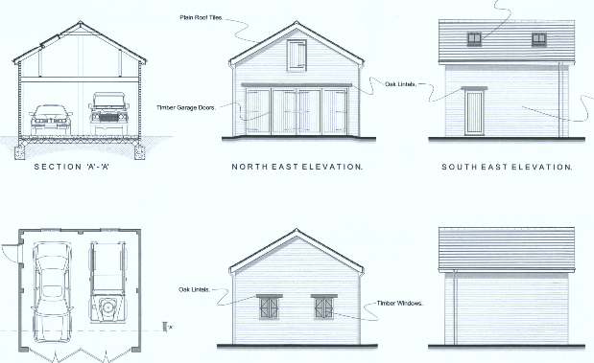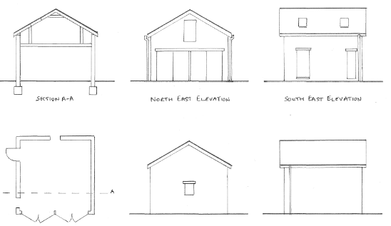

Plans/Elevations Approved in PL/11/0954 Plans/Elevations in NMA App.

- RELEVANT PLANNING HISTORY
PL/11/0954- Replacement garage and basement window and light well enlargement- Allowed on Appeal

- CONSULTATIONS

No consultations required.

- LEGAL AND PLANNING POLICY CONTEXT
Section 38(6) of the Planning and Compulsory Purchase Act 2004 requires that proposals be determined in accordance with the development plan unless material considerations indicate otherwise. Material considerations include relevant policies in the National Planning Policy framework (NPPF) - among them the 'presumption in favour of sustainable development'. The following local and national planning policy and guidance is relevant to this application:

National Policy
National Planning Policy Framework
National Planning Practice Guidance

Reading Borough Local Plan (2019)
CC7 (Design and the Public Realm)
CC8 (Safeguarding Amenity)
H10 (Private and Communal Outdoor Space)
EN3 (Enhancement of Conservation Areas)
EN4 (Locally Important Heritage Assets)

SPD
Design Guide to House Extensions SPD 2021

- APPRAISAL

If the Non-material Amendment is agreed, it would not grant a new planning permission. Rather it would form part of the extant permission, and the applicant would remain bound by all the conditions and obligations attached to that permission, except where amended by this NMA. Other than those sought to be amended by this NMA, no details or principles approved under the original permission can therefore be changed or amended by this application.

In this application, amendments are proposed to the fenestration on the proposed garage, with a net reduction in the openings/windows/doors proposed. What is proposed does not increase the overall size (footprint or height) of the proposed garage, therefore it has been considered that the amendments proposed in this application will have no material effect, within the context of the approval already conveyed in the Appeal Decision.

- CONCLUSION: Agree non material change.

