Applicant: Oriol Gaspa Rebull

Proposal: Removal and replacement of existing outbuilding

At: 33 DEANS FARM, CAVERSHAM, READING, RG4 5JZ

The above application was WITHDRAWN by the applicant on .

Date: | 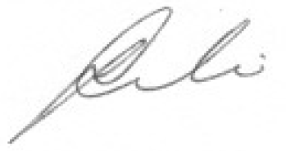
 | Assistant Director of Planning, Transport and Public Protection Services

