20 March 2025
Planning Application Ref: PL/25/0273
Officer: Anthony Scholes
Application Type: Full planning permission
Address: 23 CHURCH END LANE, TILEHURST, READING, RG30 4XA
Proposal: Construction of single storey 2 bed dwelling with parking and amenity space
This application proposes the erection of a1 x 2-bedroom dwelling on land adjacent to 23 Church End Lane.

The site is located in Zone 3, Secondary Core Area of the adopted Parking Standards and Design SPD. This zone is typically within 400m of a Reading Buses high frequency ‘Premier Route’ which provides high quality bus routes to the town centre and to major supermarkets and local centre facilities. In accordance with the adopted SPD, the development would be required to provide a parking provision of 1.5 spaces for the proposed 2 bedroom dwelling whilst maintaining the off-street parking provision for the existing dwelling.

Proposed site plan P22-042 Rev B illustrates that the existing access and driveway to the front of the 23 Church End Lane remains unchanged and provides a sufficient level of parking for the existing property.

The new dwelling will be provided with 1 parking space (Site Plan P22-042 Rev B) accessed via a newly created vehicle access point from Church End Lane this will result in the partial loss of the grass verge, (which is part of the public highway), that runs along the frontage of the site. The loss of an area of grass verge up to 8m2 is acceptable, however, if an area of between 8m2 and 15m2 of public highway /Council maintained grass verge is considered for removal, it will need to be replaced by a suitable permeable bituminous/tarmacadam material appropriate for use on the public highway and approved by the Council. This material will be applied to all of the crossing area to reduce the impact of surfacing a verge area. Visibility splays of 2.4m x 43m have not been provided for the new access, however I am happy these can be achieved.

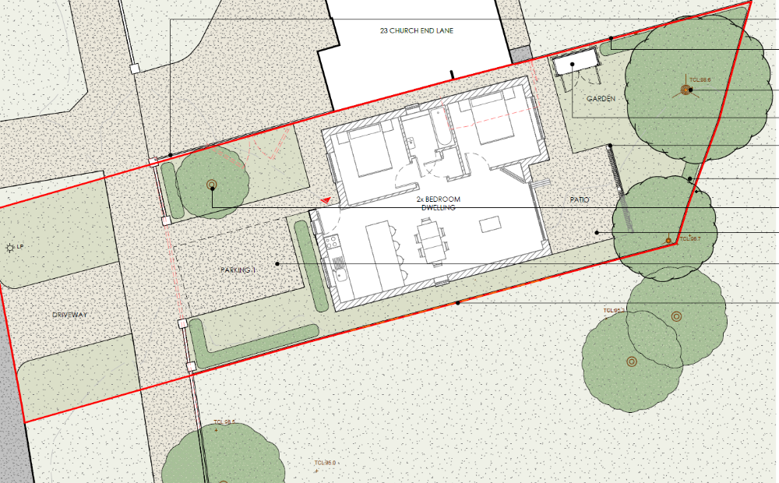

The Council’s Local Transport Plan 3 Strategy 2011 – 2026 includes policies for investing in new infrastructure to improve connections throughout and beyond Reading which include a network of publicly available Electric Vehicle (EV) charging points to encourage and enable low carbon or low energy travel choices for private and public transport. The Councils Local Plan was adopted in November 2019 and this includes a requirement at Policy TR5 for each new house to be provided with an electric charging point this will need to be illustrated on plans, however I am happy to deal with this by way of condition.

There is an existing lamp column on the verge in close proximity to the proposed access. this has been illustrated on the Block Plan and is over 1m away from the proposed access. The applicant should be advised that a licence must be obtained from the Council's Highways section before any works are carried-out on any footway, carriageway, verge, or other land forming part of the public highway. The Council’s Highways section will determine whether the lamp column will need to be relocated before the access is constructed.

In accordance with the adopted Parking Standards and Design SPD, a 2-bedroom development would be required to provide 2no cycle parking spaces. In a development of this nature this can be provided within an individual store such as a garden shed. This has been illustrated on plan and is deemed acceptable.

The applicant should ensure that the refuse storage provisions comply with the Council’s Waste Management Guidance which is available to view online. It is assumed that the refuse servicing will be the same as existing and kerb side collection will continue, however the bin strage and collection point should be illustrated on plans, I am appy to deal with this by way of condition.
A Construction Method statement will be required for this development.

Suggested conditions and informatives for this application:

C3 CONSTRUCTION METHOD STATEMENT (AS SPECIFIED)
DC1 VEHICLE PARKING (AS SPECIFIED)
DC3 VEHICULAR ACCESS (AS SPECIFIED)
DC5 CYCLE PARKING (AS SPECIFIED)
DC8 REFUSE AND RECYCLING (AS SPECIFIED)
DC24 EV CHARGING POINTS
IF3 Highways

N. Hussain
Transport Development Control Advisor

