DELEGATED APPLICATION REPORT
Ward: Whitley Ward
App Ref: PL/24/1662 Householder planning permission
Address: 6 WINCANTON ROAD, READING, RG2 8PB
Proposal: Proposed Outbuilding
Applicant: Mr Sukhpal Singh
Received date: 12/12/2024
Target Decision date: 13/03/2025 (EXT)
Case Officer: Chukwudi Onwudinanti

- SITE DESCRIPTION
The site is a semi-detached two storey dwelling on the southern side of Wincanton Road, within a line of similarly styled residential dwellings.

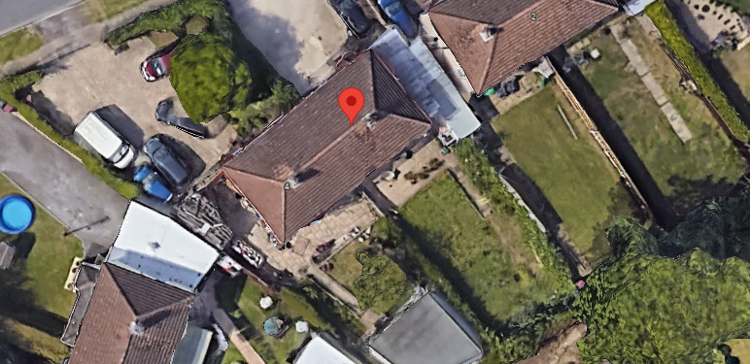
Google Photos showing rear garden

- PROPOSAL AND SUPPORTING INFORMATION
Proposed is an outbuilding measuring approximately 4.5m in depth by 7m in width, with an eave height of 2.5m.

Plans and Documents submitted dated 12/24 received 17/03/2025

Drawing No: P1594-01 – Location & Block Plan
Drawing No: P1594-02 – Proposed plans and Elevations

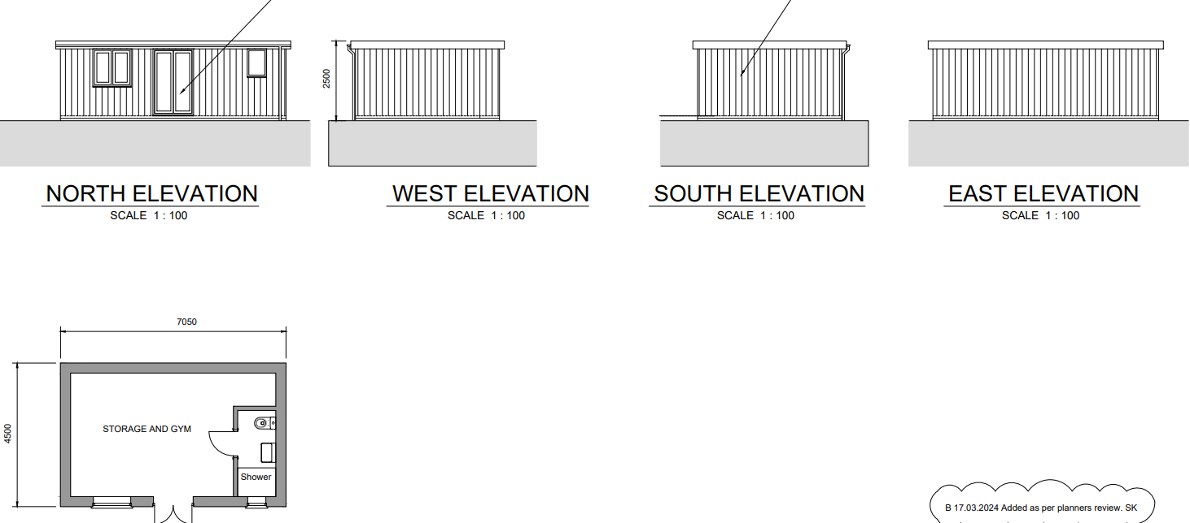

Proposed Plan/Elevations

- RELEVANT PLANNING HISTORY
None

- CONSULTATIONS

Site Notice was put up on 18/12/24.

No letters of representation have been received.

Discussion with agent
The agent was advised to reduce the depth and height of the original submission, as well as removing the side windows proposed. These revisions were agreed by the agents, and they complied with revised drawings.

Equality Act 2010:
In determining this application, the Council is required to have regard to its obligations under the Equality Act 2010. However, there is no indication or evidence (including from consultation on the application) that the protected groups identified by the Act have or will have different needs, experiences, issues and priorities in relation to this particular planning application. Therefore, in terms of the key equalities protected characteristics it is considered there would be no significant adverse impacts as a result of the development.

- LEGAL AND PLANNING POLICY CONTEXT
Section 38(6) of the Planning and Compulsory Purchase Act 2004 requires that proposals be determined in accordance with the development plan unless material considerations indicate otherwise. Material considerations include relevant policies in the National Planning Policy framework (NPPF) - among them the 'presumption in favour of sustainable development'. The following local and national planning policy and guidance is relevant to this application:

National Policy
National Planning Policy Framework
National Planning Practice Guidance

Reading Borough Local Plan (2019)
CC7 (Design and the Public Realm)
CC8 (Safeguarding Amenity)
H9 (House Extensions and Ancillary Accommodation)
H10 (Private and Communal Outdoor Space)

SPD
Design Guide to House Extensions SPD 2021

- APPRAISAL

Character and Appearance
Policy H9 states that an extension to a house will be acceptable where it respects the character of the house in terms of scale, location, materials and design and respects the character and pattern of neighbouring properties and the street as a whole in terms of scale, location, materials and design, and any important existing building line. Policy CC7 also sets out relevant considerations for design.

The proposed outbuilding will not cause significant changes to the character of the dwelling and will not significantly alter the appearance of the dwelling when viewed in the context of the street scene. In discussions with the agent, the size of the proposal has been reduced in footprint and height, such that the proposed outbuilding is not viewable from the street scene.

The alterations proposed therefore, are considered to be of acceptable scale and design, appropriately respectful to the scale, design and character of the proposal site and the neighbouring properties in close proximity.

Residential Amenity
Policy H9 states that an extension will be acceptable where it does not result in an overbearing impact on neighbours. Policy H10 seeks to ensure that the amenity of gardens and other outdoor areas are not compromised. Policy CC8 states an extension to a house will be acceptable where it will not cause a significant detrimental impact to the living environment of existing or new residential properties.

The proposed outbuilding as finally submitted is limited to a height of 2.5m which would in any case be permitted development. This limited height ensures that the blank wall visible to the adjoining property is significantly reduced in mass, especially when combined with the reduced depth of 4.5m. These reductions also mean that the encroachment on the rear garden is reduced by almost 14m², allowing for retainment of a large area for amenity.

Therefore, it is not considered that any aspect of this proposal will cause any negative residential amenity issues on the proposed address or the adjoining properties.

- CONCLUSION
The proposed development has been assessed as set out above and is considered to be acceptable on that basis, subject to the following conditions.

- RECOMMENDATION: Grant
Recommended Conditions:
Approved Plans
Time Limit Standards
Materials As Specified
Ancillary Use

