05 March 2025 | 

Title | PLANNING APPLICATION REPORT
Ward | Redlands
Planning Application Reference: | PL/25/0159
Site Address: | 35 Alexandra Road, Reading
Proposed Development | Use as Class C2 (Residential institution) including internal refurbishment and external landscape works
Report author | Richard Eatough
Applicant | Reading Borough Council
Deadline: | 27 March 2025
Recommendations | Grant planning permission, subject to conditions as follows:
Conditions | - TL1 standard three years for implementation  - AP1 approved plans  - No other use other than as a C2 childrens’ home  - Maximum of four residents  - Retention of front driveway for parking only  - Provision and retention of cycle parking  - No parking permits
Informatives | - Terms and conditions  - Positive and proactive  - Building Regulations approval required  - No parking permits  - Environmental Protection Act 1990 requirements  - Advice on maintaining features of the building within the Conservation Area.

- Executive summary
  - This report concerns the re-use/change of use of this property, which is identified as a Building of Townscape Merit (BTM) within the Alexandra Road Conservation Area. There is a mix of uses in the area. The building has formerly been in use as a childrens’ day nursery and most recently a home for Adults with Learning Difficulties (ALD). The application proposal is to change the use of the building to a childrens’ home, to be operated by Brighter Futures for Children, which is part of the Council. The report explains that given the nature of the proposed use and the character of the area, the proposed use of the building and the site is considered to be acceptable and consequently, this report recommends the granting of planning permission.

- Introduction and site description
  - This full planning application for a change of use is submitted by the Council and is therefore being reported to your meeting.
  - The application site features a Victorian detached double-fronted house and its garden, situated within the Alexandra Road Conservation Area. The building is largely original, except for a later small kitchen extension to the rear. There is a front drive area with two vehicular gateways and a central pedestrian gate set within wrought iron railings and a hedge behind. The site measures approximately 460 sq.m in area and is generally flat. Alexandra Road is notable for its avenue of street trees (Limes) and its Victorian buildings. The surrounding area of this part of Alexandra Road is predominantly residential, consisting of large houses, some flats including more modern flats at Marlow Court at the corner of Erleigh Road and the doctors’ surgery at 31 Alexandra Road.
  - Below is the location plans and images of the application site and views from the road.
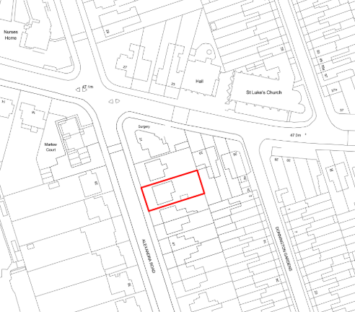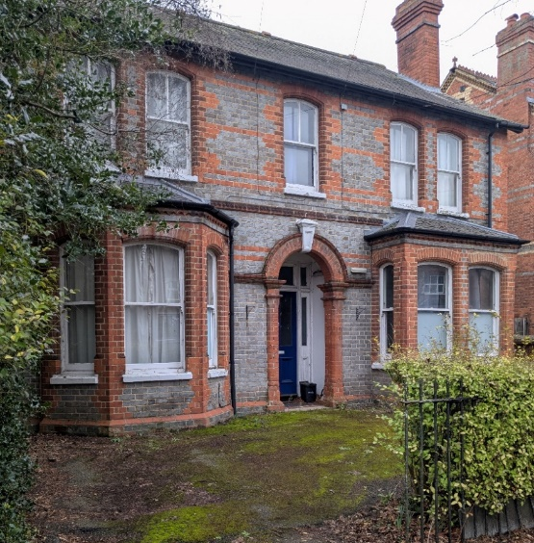
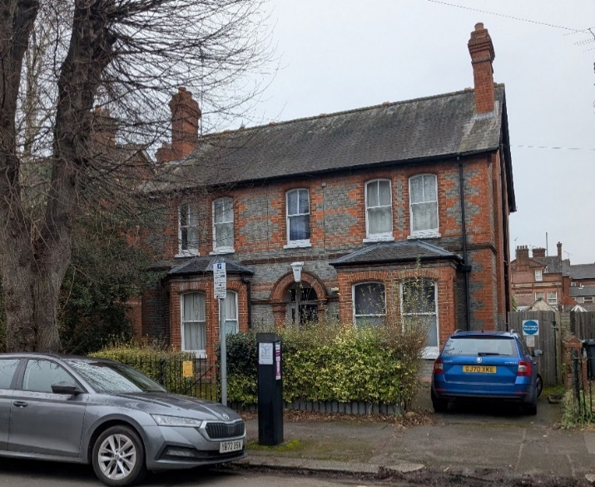

- The proposal
  - This planning application seeks a change of use of the property to a childrens’ home. Although the last use of the property appears to have been in a very similar use, the property has been vacant for almost two years and with the need for the applicant to gain a C2 planning permission (as explained in the Appraisal below), this application for planning permission has been considered necessary. With only very minor works, the application essentially consists of the change of use of the building only and no external works. The home would be used for four children, who would be supported at all times during the day and night by staff.
  - Documents submitted with the application include:
- Application forms
- Planning statement
- Existing and proposed floor plans and amended block plan

  - The proposals have been subject to pre-application advice with officers before submission. This type of use attracts a nil charge under the Council’s adopted Community Infrastructure Levy (CIL) system.
- Planning history
13857 Nursery School GRANTED 5/8/1966
23640 Change of use of first floor from living accommodation to day nursery (full) GRANTED 18/10/1974
PL/12/0340 Change of use from Day Nursery (D1) to a Dwelling House (C3b) for up to six residents receiving care and associated internal alterations and external repairs. GRANTED 1/5/2012 with s106 agreement (unilateral undertaking).
- Consultations
  - RBC Transport Strategy no objection, conditions recommended.
  - RBC Environmental Protection no objection.
  - Public consultation: site notices were displayed on site on Alexandra Road and Erleigh Road on 3 February 2025. No representations have been received at the time of writing but any which are received will be reported to your meeting.
- Legal context
  - Section 72 (1) of the Planning (Listed Buildings and Conservation Areas) Act 1990 requires the local planning authority in the exercise of its functions to pay special attention to the desirability of preserving or enhancing the character or appearance of a conservation area.
  - Section 38(6) of the Planning and Compulsory Purchase Act 2004 requires that proposals be determined in accordance with the development plan unless material considerations indicate otherwise. Material considerations include relevant policies in the National Planning Policy framework (NPPF) - among them the 'presumption in favour of sustainable development'. However, the NPPF does not change the statutory status of the development plan as the starting point for decision making (NPPF paragraph 12).
  - In this regard, the NPPF states that due weight should be given to the adopted policies of the Local Plan 2019 according to their degree of consistency with the NPPF (the closer the policies in the plan to the policies in the NPPF, the greater the weight that may be given).
  - Accordingly, the latest NPPF and the following development plan policies and supplementary planning guidance are relevant:
National Planning Policy Framework (December 2024)
Reading Borough Local Plan 2019 policies:
CC1 Presumption in Favour of Sustainable Development
CC6 Accessibility and the Intensity of Development
CC7 Design and the Public Realm
CC8 Safeguarding Amenity
EN1 Protection and Enhancement of the Historic Environment
H6 Accommodation for Vulnerable People
H7 Protecting the Existing Housing Stock
TR5 Car and Cycle Parking and Electric Vehicle Charging
OU1 New and Existing Community Facilities

Supplementary Planning Documents and other guidance

SPD: Revised Parking Standards and Design (2011)
Alexandra Road Conservation Area Appraisal (2005)

Local Plan Update

  - The current version of the Local Plan (adopted in November 2019) turned five years old on Tuesday 5th November 2024. The Local Plan was reviewed in March 2023 and around half of the policies in the plan are considered still up to date. However, the rest need to be considered for updating to reflect changing circumstances and national policy. A consultation version of the draft update of the Local Plan was published on 6th November 2024.

  - Although there is a five-year period for carrying out a review of a plan after it is adopted, nothing in the NPPF or elsewhere says that policies automatically become “out of date” when they are five years old. It is a matter of planning judgement rather than legal fact whether a plan or policies within it are out-of-date. This will depend on whether they have been overtaken by things that have happened since the plan was adopted, either on the ground or through changes in national policy, for example.

  - Officer advice in respect of the Local Plan policies pertinent to these applications listed above is that they remain in accordance with national policy and that the objectives of those policies remains very similar in the draft updated Local Plan. Therefore, they can continue to be afforded weight in the determination of this planning application and are not considered to be ‘out of date’.

- Appraisal
The main considerations are:
  - Principle of Development
  - Impact on neighbour amenity (including disturbance and parking)
  - Impact on heritage assets

Principle of Development

  - The property is likely to have originally been constructed as a family house, but since the 1960s (first partially, and later, completely) until about 2013, the property was in use as a childrens’ day nursery (a Class D1 use). Then with the granting of the planning permission in 2012, the property appears to have been in use in accordance with that planning permission, ie. as a C3(b) use, which is defined in the Use Classes Order as, “up to six people living together as a single household and receiving care”. The 2012 PAC report for that application notes the then proposed use as constituting up to six residents with learning disabilities, with one support worker on site during the day, with occasional overnight support provided. The residents were described as living ‘as a single household’ and sharing the communal facilities.

  - The Applicant’s planning statement explains the reason for the submission of a planning application. Following the vacancy period, the exact nature of the former use is/was not completely clear and moreover, Ofsted rules state that the Local Authority must apply for and secure a planning permission for it to be able to operate a C2 Childrens’ Home use. Hence, the applicant’s need to seek to formalise/regularise the operation with a change to a C2 use.

  - Officers advise that the proposed use would be broadly similar to the last use of the property, save that instead of adults being resident, it would be children. The applicant’s planning statement explains that the current approach to providing childrens’ homes is different to older examples and large, institutional type buildings are no longer used. Instead, the model is for normal family houses to be used as far as possible, with the presence of a ‘family home’ indistinguishable within a residential street.

  - The applicant advises that the former adult residents are rehoused in other family house situations within the Borough and they continue to receive daily care commensurate with their needs and in some cases, this will include overnight stays by staff. The applicant advises that there is sufficient accommodation, both Council-owned and in the private sector in the Borough, to provide this kind of care for these residents, meaning that this property is one which has been identified as surplus to Adult Care requirements.

  - The Local Plan contains policies to protect the existing dwelling stock (H7), provide accommodation for vulnerable groups (H11) and to protect or improve community facilities (OU1). Whilst the site has not been a family dwelling for very many years, its last use was a C3(b) use, ie. with an element of care. That planning permission did not prevent the site from potentially reverting to a C3 use. Both the last C3(b) use and the proposed use will provide an element of community use and provide residential accommodation and care for vulnerable groups. Overall, officers consider that in this instance, the technical loss of a dwelling is outweighed by the benefits of providing a childrens’ home and is in principle accepted. The proposal will also provide employment through the various support staff required (see below), which is a further benefit of the proposals.

Impact on neighbour amenity (including disturbance and parking)

  - The applicant’s planning statement provides a detailed description of the operation of the home. It would be a four bedroom children's home designed to provide stable long term homes (minimum usual length of stay would be nine months) for up to four children. It would be managed by a registered manager with support and other staff during the day resulting in there being three to four staff on site at any one time. The planning statement sets out a usual daily schedule for the children which is quite structured. As well as support for the children as required, in other respects the property would largely operate as a ‘family-style’ home. Usually there would be one or more adults sleeping overnight in the home and there would always be adults present. Shift patterns would not start before 7am or end after 10pm, which would minimise comings and goings at unsociable hours. There would be occasional visitors and use of the garden as there would be with any usual family setting. The garden is presently hardstanding and fully enclosed by Victorian walls of 1.8m-2.2m in height. This is proposed to be landscaped and the hard surface area reduced with lawn introduced. The area nearest the house is not proposed to be altered apart from a refurbished outside deck (approximately 7m x 5m). Overall, this would provide an improved area in a fairly usual domestic format and it would provide a suitable place for the residents and staff to enjoy.

  - The site is well located, being close to medical facilities and local shops nearby on Erleigh Road, as well as being close to the town centre. The site has space to park 2 vehicles in the front driveway and the Highway Authority considers that this would be sufficient for the use, however, the application proposal has not indicated cycle parking, which could be used by both staff and residents. This could be provided in the rear garden using the side access. In discussion with the applicant given the domestic setting and the Conservation Area location, it is agreed that the most appropriate solution would be a simple domestic garden shed, which should provide reasonable cycle security in the back garden, behind the side gate and details have been provided (see block plan below). The Highway Authority has also requested waste operations information, but as this would be acceptable just by moving bins from the back garden to present on the street on collection day, this is not considered to be necessary. Overall, in parking and transport terms, the use would be appropriate and acceptable in terms of policies CC6 and TR5 and the Council’s parking standards.

  - On the basis of the above discussion, given that the disturbance attributable to the proposed use would be similar to a C3 family home and would also be similar to the last use of the site as a home for adults with learning difficulties, the use is considered to be suitable in terms of the character of the area and complies with Policy CC8.

Impact on heritage assets

  - The application property is a handsome, double-fronted, brick-built and slate-roofed detached Victorian villa, built sometime between 1880-1900 and is similar in appearance to No. 33 to the immediate north, although the patterned brick details are different. It is a ‘Building of Townscape Merit’ (BTM) within the Conservation Area, meaning that it is a relatively unaltered historic building whose style detail and building materials provides the streetscape with interest and variety and makes a positive contribution to the special interest of the conservation area, which is characterised by varying styles of Victorian houses, both detached and semi-detached. Although not likely to achieve a Grade II Listing, the BTM indication means that if this building were outside of the Conservation Area, it would usually otherwise have merited adding to the Council’s Local List.
  - The property has been vacant since 2023 and requires refurbishment, which the proposed re-use will help to deliver. The original sliding sash windows require maintenance and advice to the applicant is that these should be conserved and repaired and not replaced as their replacement is likely to be considered ‘development’ requiring planning permission. This planning application does not involve any external changes to the building itself. Although the internal compartmentation/layout of this building is not a material consideration to this planning application, it is pleasing to note that the proposed layout is broadly sympathetic to the original layout of the house.

  - In summary, the impact of the proposal on heritage assets (ie. the conservation area and the building itself) is considered to be neutral/positive and complies with policies EN1 and EN4. An informative is recommended to advise of care for heritage asset.

Other issues
  - Officers have considered the extent to which the building would be accessible to all. There is a step to the front door and only stair access to the first floor bedrooms. The main bathroom to the house is on a half-landing, but this is an original arrangement. Given that the use would function in much the same way as a family home and its similarity to its former uses, it is considered that no intervention (e.g. lifts) would be appropriate. The ground floor staff areas are considered to be suitable in terms of Policy CC7. Separate Building Regulations approval is likely to be required and an informative is recommended.

  - Officers have considered to what extent adjusted or new emerging policies within the Partial Update of the Local Plan have relevance to this assessment and advise that the principal update in policy direction is proposed new Policy CC10: Health Impact Assessments (known as HIAs). This requires applications such as this, where accommodation for vulnerable groups is concerned, to look more widely at the health implications for the Borough. It should be noted that at the time of writing, HIAs are not a planning application validation requirement and officers are satisfied that the pertinent issues have been adequately addressed in the Appraisal above.
- Equality implications

  - Under the Equality Act 2010, Section 149, a public authority must, in the exercise of its functions, have due regard to the need to—
- eliminate discrimination, harassment, victimisation and any other conduct that is prohibited by or under this Act;
- advance equality of opportunity between persons who share a relevant protected characteristic and persons who do not share it;
- foster good relations between persons who share a relevant protected characteristic and persons who do not share it.

  - The key equalities protected characteristics include age, disability, sex, gender reassignment, marriage and civil partnership, pregnancy and maternity, race, religion or belief, sexual orientation. It is considered that there is no indication or evidence that the protected groups have or will have different needs, experiences, issues and priorities in relation to this particular application. Furthermore, the proposal would proactively provide accommodation for vulnerable groups (children) and the issue regarding accessibility has been discussed above.

- Conclusion & planning balance

9.1 As with all applications considered by the Local Planning Authority, the application is required to be determined in accordance with the development plan unless material considerations indicate otherwise, as per Section 38(6) of the Planning and Compulsory Purchase Act 2004.
9.2 Any harmful impacts of the proposed development are required to be weighed against the benefits in the context of national and local planning policies, as detailed in the appraisal above. Having gone through this process officers consider that the limited potential for disturbance are outweighed by the public benefits of providing accommodation for vulnerable children, providing employment and the use would provide a sympathetic re-use for this historic building and prevent it falling into disrepair.
9.3 It is considered that officers have applied a suitable planning balance when reaching this conclusion. As such, this application is recommended for approval.

Proposed Plans
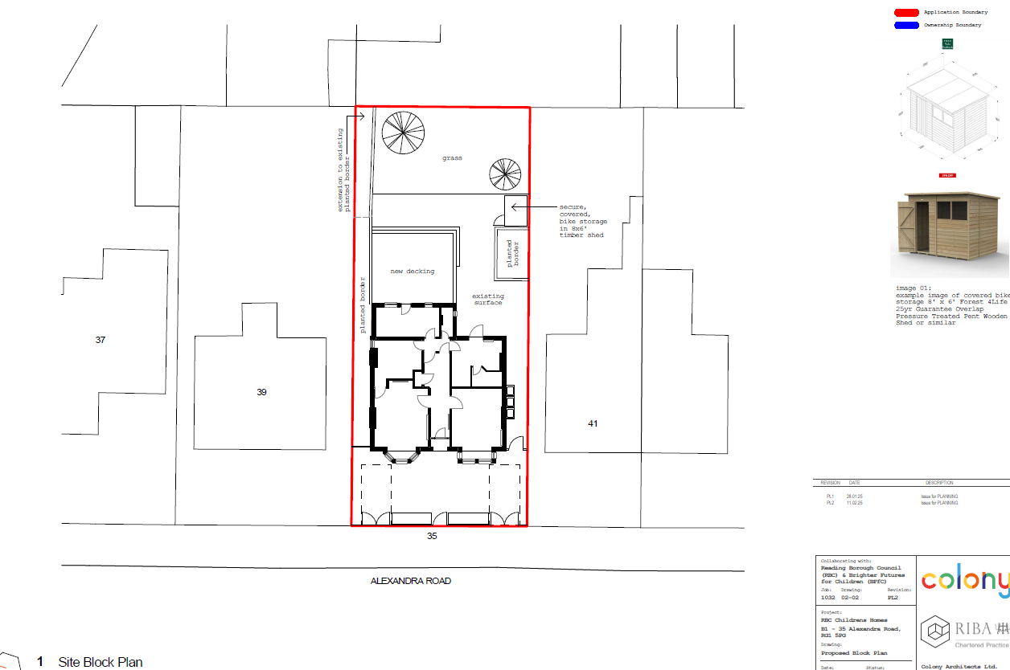
Block Plan
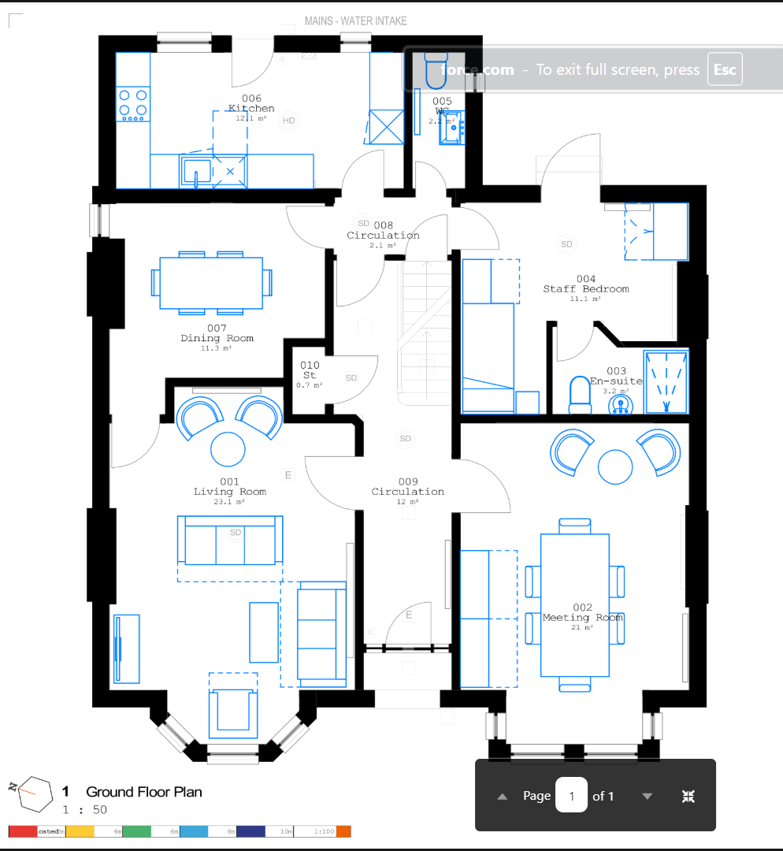

Ground floor

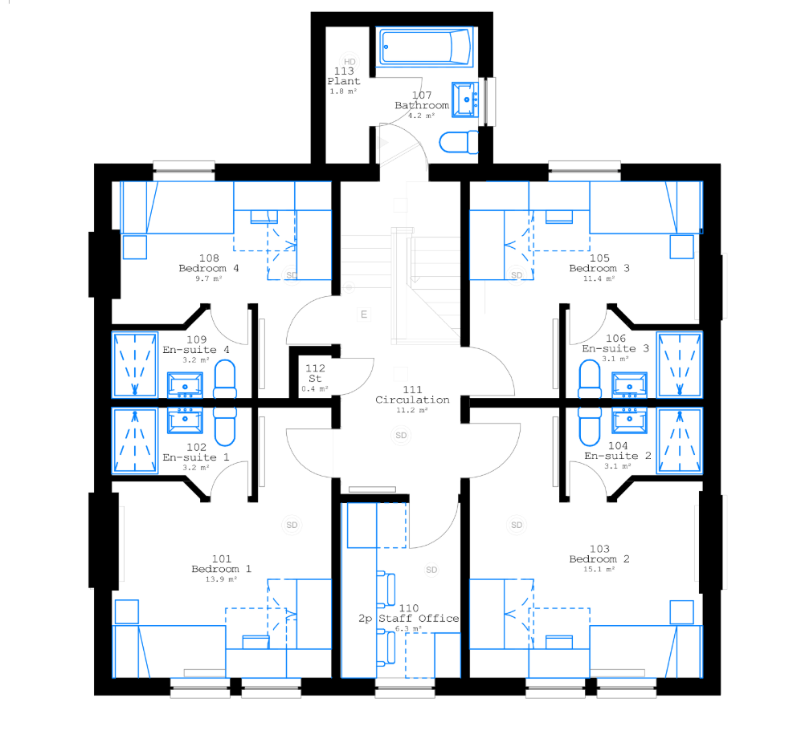
First floor

