05 March 2025 | 

Title | PLANNING APPLICATION REPORT
Ward | Katesgrove
Planning Application Reference: | PL/25/0160
Site Address: | 134 Northumberland Avenue, Reading
Proposed Development | Use as class C2 (Residential institution) including Internal refurbishment and external landscape works
Report author | Richard Eatough
Applicant | Reading Borough Council
Deadline: | 27 March 2025
Recommendations | Grant planning permission, subject to conditions as follows:
Conditions | - TL1 standard three years for implementation  - AP1 approved plans  - No other use other than as a C2 childrens’ home  - Maximum of two residents  - Retention of parking spaces for parking only  - Installation of noise suppression measures and retention thereafter
Informatives | - Terms and conditions  - Positive and proactive  - Building Regulations approval required  - Environmental Protection Act 1990 requirements

- Executive summary

  - This report concerns the re-use/change of use of an end-of-terrace (semi-detached) house on Northumberland Avenue in Whitley. The building has formerly been in use as a home for adults with learning difficulties. The application site is in an established residential area and the proposal is to change the use of the building to a childrens’ home, to be operated by Brighter Futures for Children, which is part of the Council. The report explains that given the nature of the proposed use and the character of the area, the use of the building and the site are considered to be suitable for the intended use and consequently, this report recommends the granting of planning permission.

- Introduction and site description

  - This application is submitted by the Council and is therefore being reported to your meeting.

  - The application site concerns a three bedroom, semi-detached property, the northernmost house in a terrace of three houses. There is a frontal drive area with room for three cars, a pedestrian path which slopes gently down to the front door and a side gate to the back garden. The site measures approximately 320 sq.m in area and slopes gently east to west, ie. down from the road. This area of Whitley is largely residential, although opposite the site is the Hexham Road Childrens Centre (under redevelopment and hoarded at this time) and to the southeast, Reading Girls’ School.

  - Below are images of the application site and view from the road.

Location plan (not to scale)
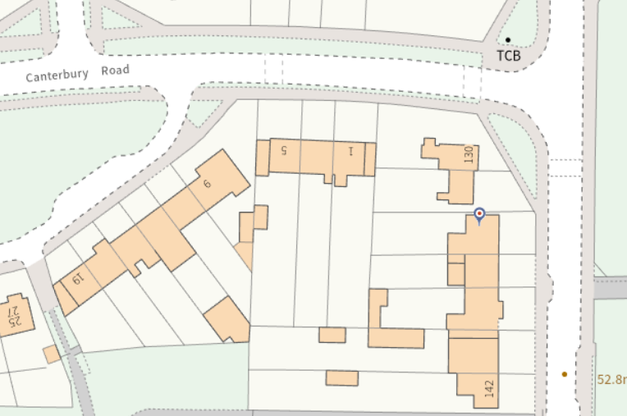
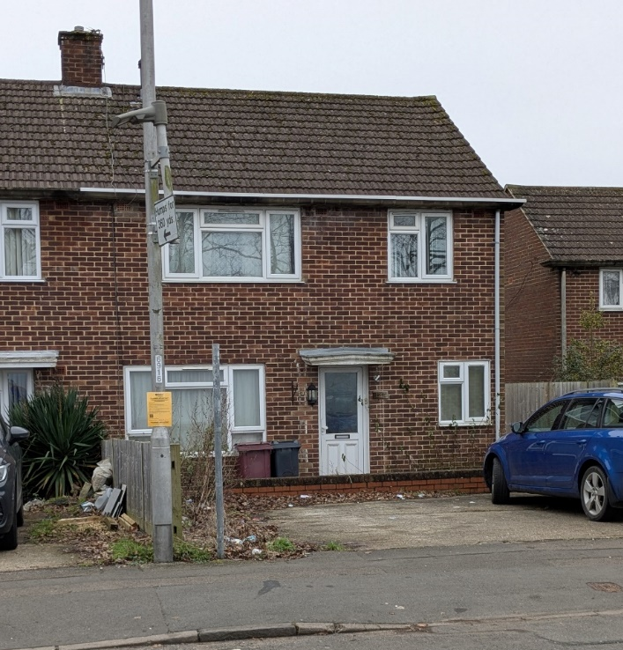

- The proposal

  - This planning application is for a change of use of the property to a childrens’ home. Although the last use of the property is likely to have been in a similar use, the property has been vacant since 2021 and with the need for the applicant to gain a C2 planning permission (as explained in the Appraisal below), this application for planning permission has been considered necessary. With only very minor works, the application essentially consists of the change of use of the building only and no external works. The home would normally be used to accommodate one child, who would be supported at all times during the day and night by staff.

  - Documents submitted with the application include:
- Application forms
- Planning statement
- Existing and proposed floor plans and block plan

  - The proposals have been subject to pre-application advice with officers before submission. This type of use attracts a nil charge under the Council’s adopted Community Infrastructure Levy (CIL) system.
- Planning history
None.
- Consultations

RBC Transport Strategy no objection, conditions recommended.
RBC Environmental Protection has sought further details on the method of noise attenuation in respect of the party wall with the neighbouring property.

Officer Note: the requested information was provided – see appraisal.

  - Public consultation: site notices were displayed on site on Northumberland Avenue and Canterbury Road on 3 February 2025. No representations have been received at the time of writing but any which are received will be reported to your meeting.

- Legal context

  - Section 38(6) of the Planning and Compulsory Purchase Act 2004 requires that proposals be determined in accordance with the development plan unless material considerations indicate otherwise. Material considerations include relevant policies in the National Planning Policy framework (NPPF) - among them the 'presumption in favour of sustainable development'. However, the NPPF does not change the statutory status of the development plan as the starting point for decision making (NPPF paragraph 12).

  - In this regard, the NPPF states that due weight should be given to the adopted policies of the Local Plan 2019 according to their degree of consistency with the NPPF (the closer the policies in the plan to the policies in the NPPF, the greater the weight that may be given).

  - Accordingly, the latest NPPF and the following development plan policies and supplementary planning guidance are relevant:

National Planning Policy Framework (December 2024)
Reading Borough Local Plan 2019 policies:
CC1 Presumption in Favour of Sustainable Development
CC6 Accessibility and the Intensity of Development
CC7 Design and the Public Realm
H6 Accommodation for Vulnerable People
H7 Protecting the Existing Housing Stock
TR5 Car and Cycle Parking and Electric Vehicle Charging
OU1 New and Existing Community Facilities

Supplementary Planning Documents and other guidance

SPD: Revised Parking Standards and Design (2011)

Local Plan Update

  - The current version of the Local Plan (adopted in November 2019) turned five years old on Tuesday 5th November 2024. The Local Plan was reviewed in March 2023 and around half of the policies in the plan are considered still up to date. However, the rest need to be considered for updating to reflect changing circumstances and national policy. A consultation version of the draft updated version of the Local Plan was published on 6th November 2024.

  - Although there is a five-year period for carrying out a review of a plan after it is adopted, nothing in the NPPF or elsewhere says that policies automatically become “out of date” when they are five years old. It is a matter of planning judgement rather than legal fact whether a plan or policies within it are out-of-date. This will depend on whether they have been overtaken by things that have happened since the plan was adopted, either on the ground or through changes in national policy, for example.

  - Officer advice in respect of the Local Plan policies pertinent to these applications listed above is that they remain in accordance with national policy and that the objectives of those policies remains very similar in the draft updated Local Plan. Therefore, they can continue to be afforded weight in the determination of this planning application and are not considered to be ‘out of date’.

- Appraisal

The main considerations are:
  - Principle of Development
  - Impact on neighbour amenity (including disturbance and parking)

Principle of Development

7.1 The property is likely to have originally been constructed as a family house, but then appears at some point approximately 20 years ago, the property appears to have been in use in Class C3(b) use, which is defined in the Use Classes Order as, “up to six people living together as a single household and receiving care”. The last resident left in 2021 and the property has been vacant since. The applicant advises that the property typically accommodated 3-4 residents who required extra needs and some of them were resident there for many years. They would have been supported by staff sleeping over as required. No authorisation of the C3b use was required because C3(a) to C3(b) is within the same use class, and therefore no material change of use would have occurred.
7.2 The Applicant’s planning statement explains the need for the submission of a planning application. Following the vacancy period, the exact nature of the former use is not completely clear and moreover, Ofsted rules state that the Local Authority must apply for and secure planning permission for it to be able to operate a C2 Childrens’ Home use.
  - The planning statement explains that the proposed occupation is primarily for solo children with complex needs, although if needed and appropriate, this would be extended to siblings or twins (ie. a maximum of two residents). There would be 2-3 staff on site at any one time during the day and one staff member sleeping over each night.

  - Officers advise that the proposed use would be broadly similar to the last use of the site, save that instead of adults being resident, it would be children, or more likely, one child. The applicant’s planning statement explains that the current approach to childrens’ homes is different to older examples and large, institutional type buildings are no longer used. Instead, the model is for normal family houses to be used as far as possible, with the presence of a ‘family home’ which is indistinguishable within a residential street.

  - The applicant advises that the former adult residents are housed in other family houses within the Borough and they continue to receive daily care commensurate with their needs and in some cases, this will include overnight stays by staff. The applicant advises that there is sufficient accommodation, both Council-owned and in the private sector in the borough to provide this kind of care for these residents, meaning that this property is one which has been identified as surplus to requirements.

  - The Local Plan contains policies to protect the housing stock (H7), provide accommodation for vulnerable groups (H11) and to protect or improve community facilities (OU1). Whilst the site has not been a family dwelling for very many years, its last use was a C3b use, ie. as residential with an element of care. Therefore, the site could at any time - without planning permission - have potentially lawfully reverted to a C3 dwellinghouse use, as they are in the same use class. Both the last use and the proposed use will provide an element of community use and provide residential accommodation and care for vulnerable groups. The provision of employment (staff required, see below) is also a positive benefit. Overall, officers consider that in this instance, the technical loss of a dwelling is outweighed by the benefits of providing a childrens’ home and in principle accepted.
Impact on neighbour amenity (including disturbance and parking)
  - The applicant’s planning statement provides a detailed description of the operation of the home. The previous arrangement appears to have had the three bedrooms upstairs and a fourth resident sleeping downstairs in the single storey rear extension, when required. The proposed plans indicate minor alterations to the layout of the house, such that the ground floor would be given over to communal and staff areas and the upstairs would be adjusted to accommodate two children’s bedrooms and a staff bedroom. It would be a two bedroom children's home designed to provide a stable long term home for up to two children. It would be managed by a registered manager with additional staff during the day with a structured daily schedule for the children providing support for the children as required. In other respects, the property would largely operate as a ‘family-style’ home. Shift patterns would not start before 7:00 AM or end after 10:00 PM usually with one or more adults sleeping overnight in the home and there would always be adults present. There would be occasional visitors. The minimum length of stay for children would normally be nine months.

  - The garden is overgrown so will need some work but would provide a suitable place for the residents to relax as it would be with any usual family. It is proposed to provide a decked area. It has been confirmed on amended plans that the combination of the gap to the boundary and the decking height (150mm) will prevent overlooking to neigbouring gardens from the decked area.
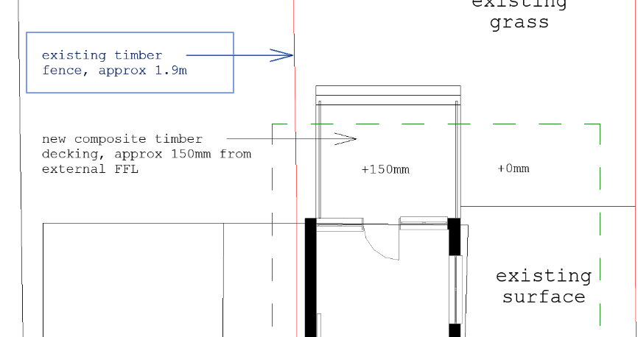 Decked area plan

  - Given that this is a semi-detached property and there is a party wall with the attached neighbouring family home, as a precaution, the application plans indicate that noise suppression would be provided. The Council’s Environmental Protection Officer’s comments requested details of the proposed sound attenuation measures referred to in the application submission. The applicant has confirmed that it is proposed to install acoustic wall lining on party walls in accordance with the manufacturer's details which includes acoustic insulation. There is a natural air cavity which is part of the designed system build up where the acoustic clips go, but this is included within the noise reduction factors. Typically either air separation, a solid build up, or a combination of the two help to reduce acoustics. The Council’s Environmental Protection Officer has confirmed that the response provided is acceptable. A condition is recommended to ensure the acoustic wall lining is installed.

  - The site is in a quite accessible location, being close to local shops nearby on Northumberland Avenue and bus routes. The site has the ability to park three vehicles in the front driveway and the Highway Authority considers that this would be sufficient for the use, however they have noted that the proposal has not indicated cycle parking and asked for a condition to require this. However, given the modest proposed occupancy of the property, this is not considered to be proportionate. The Highway Authority has also requested waste operations information, but as this would be acceptable just by moving bins from the back garden to present on the street on collection day, this is not considered to be necessary. Overall, in parking and transport terms, the use would be appropriate and acceptable in terms of policies CC6 and TR5 and the Council’s parking standards.

  - In this instance, given that the disturbance attributable to the proposed use would be similar to a C3 family home and would also be similar to the last use of the site as a home for adults with learning difficulties, the use is considered to be suitable in terms of Policy CC8.
Other issues
  - Officers have considered the extent to which the building would be accessible to all, but on the basis that this would function in much the same way as a family home and similar to its last use, it is considered that no intervention (e.g. lifts) would be appropriate. The ground floor staff areas are considered to be suitable in terms of Policy CC7. Separate Building Regulations approval is likely to be required and an informative is recommended.

  - Officers have also considered to what extent adjusted or new emerging policies within the Partial Update of the Local Plan have relevance to this assessment and advise that the principal update in policy direction is proposed new Policy CC10: Health Impact Assessments (known as HIAs). This requires applications such as this, where accommodation for vulnerable groups is concerned, to look more widely at the health implications for the Borough. It should be noted that at the time of writing, HIAs are not a planning application validation requirement and officers are satisfied that the pertinent issues have been adequately addressed in the Appraisal above.

- Equality implications

  - Under the Equality Act 2010, Section 149, a public authority must, in the exercise of its functions, have due regard to the need to—
- eliminate discrimination, harassment, victimisation and any other conduct that is prohibited by or under this Act;
- advance equality of opportunity between persons who share a relevant protected characteristic and persons who do not share it;
- foster good relations between persons who share a relevant protected characteristic and persons who do not share it.

  - The key equalities protected characteristics include age, disability, sex, gender reassignment, marriage and civil partnership, pregnancy and maternity, race, religion or belief, sexual orientation. It is considered that there is no indication or evidence that the protected groups have or will have different needs, experiences, issues and priorities in relation to this particular application. Furthermore, the proposal would proactively provide accommodation for vulnerable groups (children) and the issue regarding accessibility is discussed above.

- Conclusion & planning balance

9.1 As with all applications considered by the Local Planning Authority, the application is required to be determined in accordance with the development plan unless material considerations indicate otherwise, as per Section 38(6) of the Planning and Compulsory Purchase Act 2004.
9.2 Any harmful impacts of the proposed development are required to be weighed against the benefits in the context of national and local planning policies, as detailed in the appraisal above. Having gone through this process officers consider that the limited opportunities for disturbance are outweighed by the public benefits of providing accommodation for vulnerable children and the use would provide a sympathetic re-use for the building.
9.3 It is considered that officers have applied a suitable planning balance when reaching this conclusion. As such, this application is recommended for approval.

Proposed plans

Ground floor
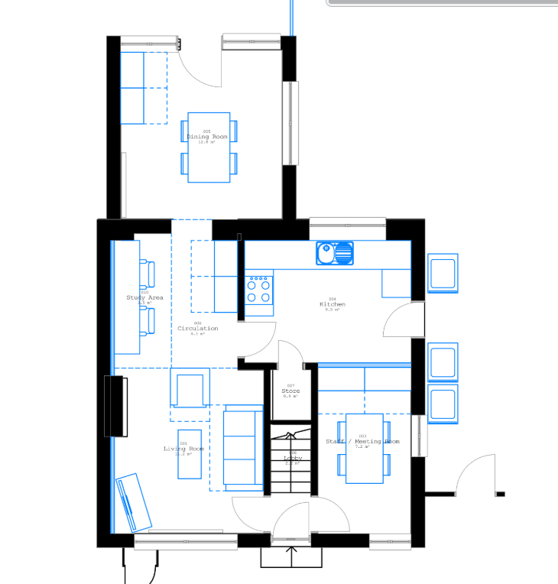
First Floor
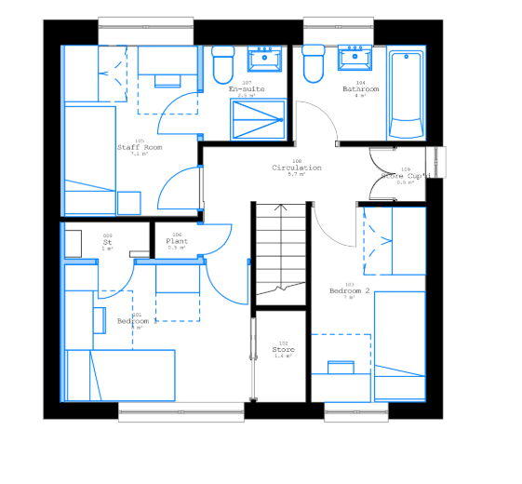
Block plan
