21/02/2521
Planning Application Ref: PL/25/0102
Officer: Anthony Scholes
Application Type: Full planning permission
Address: 1029 OXFORD ROAD, TILEHURST, READING
Proposal: Development of new building to provide 2no.1 bedroom and 6no. 2 bedroom flats along with the creation of 8 parking spaces and associated landscaping Following the demolition of the existing building.

The site is located within Zone 3 Secondary Core Area, of the Council’s adopted Parking Standards and Design SPD. Typically these areas are within 400m of a Reading Buses high frequency ‘Premier Route’, which provides high quality bus routes to and from Reading town centre and other local centre facilities. The A329 Oxford Road is one of the main routes into Reading from the west, therefore, any proposal needs to comply with the Council’s adopted Design Guidance for Residential Accesses on to Classified Roads.

The site currently comprises of a detached, two storey building which contains 4no Flats. This application seeks to demolish the existing building and construct a detached, two and a half storey building to accommodate 8no. flats:
- 2x 1-bedroom flats
- 6x 2-bedroom flats

In accordance with the adopted Parking SPD, the development would require the following parking provision.

Size of Units | No of units | Required Provision Per Unit | Proposed Provision
1 & 2 bed units | 8 | 12 | 8
Visitor 1 space per 4 units |  | 1 | 0
Total required |  | 13 | 8

The proposal will bring vehicles closer to the highway following the extension of hardstanding at the front if the property. 8 parking spaces are prosed which falls well below the required parking provision. Car parking standards have been produced taking into account the proximity to bus services and other public transport facilities, these standards have been used to undertake an assessment to the level of parking required.

Proposed Parking Layout: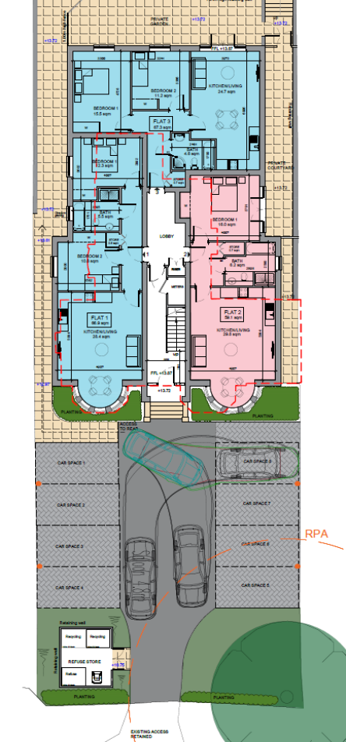
The applicant has referenced Census 2011 data to support the lower parking provision, however this relates to how people travel to work. For a lower provision to be considered car ownerships data for Tilehurst North would be required.

As a result of the increased hard standing, parking bays will be brought forward closer to the Highway. Tracking diagrams have been provided illustrating a vehicle driving in to and out of car parking space 8, however this has not been illustrated for parking spaces 4 and 5 which are located closer to the access and therefore manoeuvres would be more constrained. The applicant will need to provide tracking plans to show vehicles manoeuvring in and out of all of the parking bays and exiting the site in forward gear while another vehicle is waiting within the site. In addition to this 6m forecourt depths should be provided to allow easy access in and out of the parking bays which have not been provided.

There is no provision to turn on site should all the parking bays be occupied. A turning area should be provided within the site to enable delivery vehicles to enter and leave the site in forward gear given that the site is directly accessed from a major arterial road into and out Reading. However, I am concerned that this cannot be achieved within the boundaries of the site without reducing the parking provision.

Any proposals would need to comply with the Councils adopted design guidance for residential accesses on to classified roads. The applicant states that no changes to the existing access is proposed, however the access would need to be a minimum of 4.8m wide to facilitate two way access and egress from the site.

Given there will be an intensification of the access visibility splays of 2.4m x 90m will need to be illustrated on plans. Any proposals would need to comply with the Councils adopted design guidance for residential accesses on to classified roads.

A license will be required from the Highways Department to undertake all works on the public highway. All utility covers will need to be illustrated on plans.

Although not required under current standards it is noted that 4 x double point electric vehicle charging points (EVCP) have also been included within the parking layout to ensure that all flats have access to electric vehicle charging.

Cyle storage should be provided in accordance with the Councils current Parking Standards and Design SPD. Based on the mix of 1 and 2 bedroom units 0.5 cycle storage spaces would be required for each unit, this equates to a minimum of 4 secure and covered storage spaces, that should utilise Sheffield type stands. Submitted plan P0 5D identifies 8 cycle storage spaces located at the rear of the building in an accessible enclosed storage unit, this unit is deemed acceptable.

Bin storage area has been located adjacent to the access which would allow for kerb side collection which would be a similar arrangement for the existing use, however the Councils Waste and Refuse should be contacted to ensure the correct capacity and types of bins are provided for the number of units proposed.

The applicant has not demonstrated that all the Transport and Highway aspects of the development are appropriate, therefore a refusal is recommended.

Suggested Refusal:

The proposed layout fails to demonstrate that it complies with the Local Planning Authority’s standards in respect of vehicle parking. The proposed developnent would result in the intensification of the access. This could result in on-street parking/reversing movements on Oxford Road, adversely affecting road safety and the flow of traffic, and in conflict with local plan policies TR1 and TR3 of the Reading Local Plan 2019.

N.Hussain
Transport Development Control Advisor

