Caversham Place 1-49 tree work
Reference: PP-13731662

Front of Caversham place - T1,T2,T3,T4,T5,T6,T7
Rear of Caversham Place – T8,T9,T10,T11,T12,T13
Plan for works to be carried out:
We are looking for an approval to reduce the height of the trees at Caversham place by 50% reduction.
ALL 13 trees are extremely large and very close to the property, it is also over growing towards the road and covering street lights.
There is a concern for safety of the tree, branches falling and injuring residents or people passing by, we have had a branches fall of these trees and some being extremely large.

TREES LOCATION –
Caversham Place 1-49, Richfield Avenue, Reading, RG1 8BY

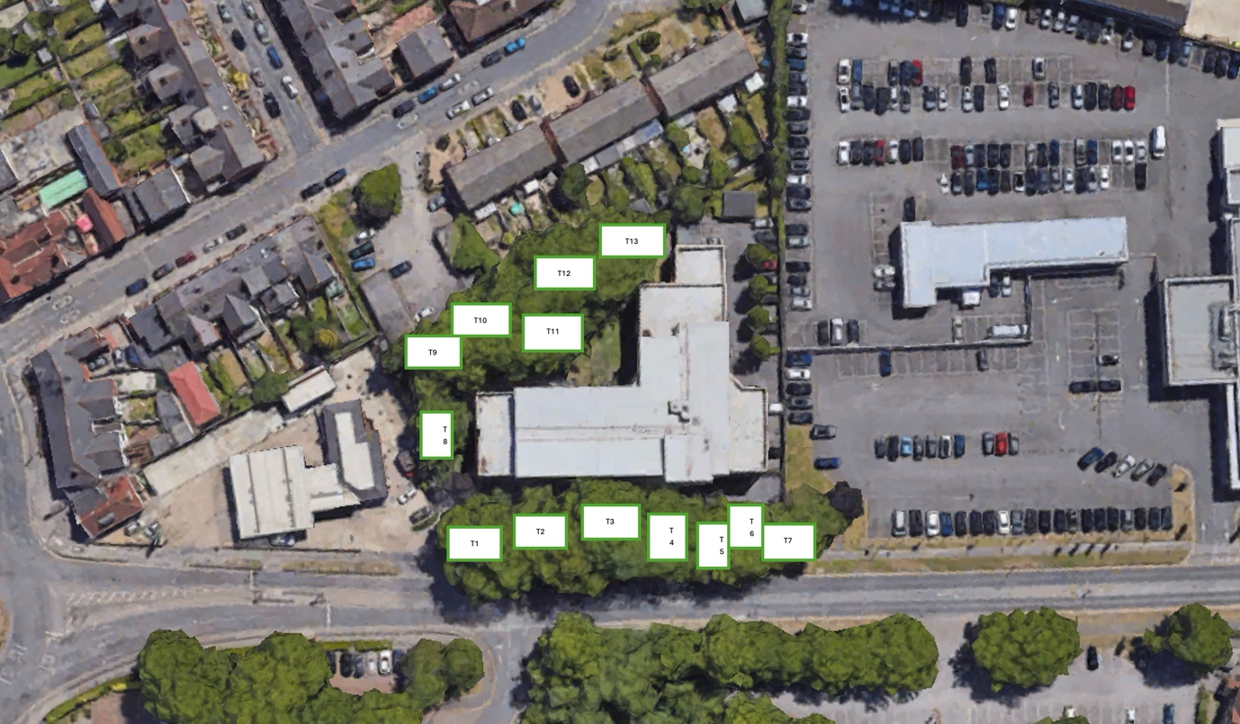

Front of Caversham place.
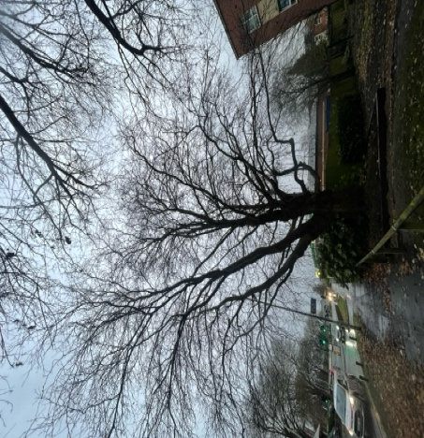
T1 – 50% RECUCTION

T2 – 50% RECUCTION

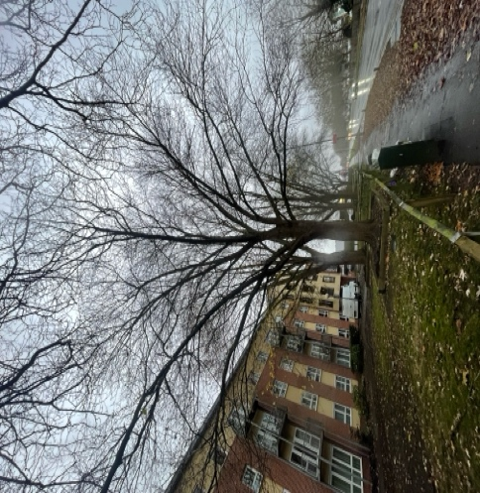

T3 – 50% RECUCTION
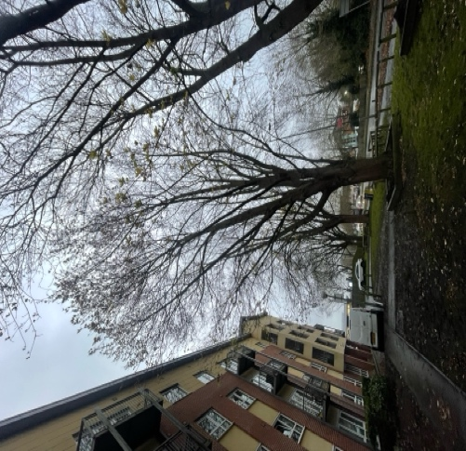

T4 – 50% RECUCTION
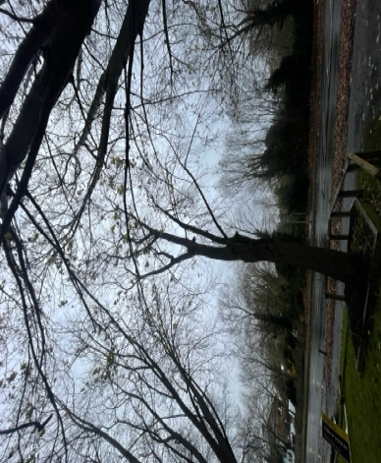

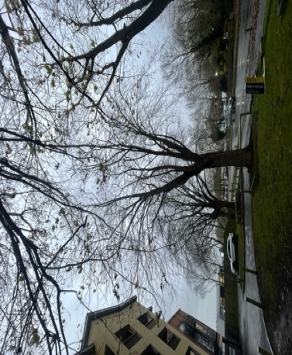
T5 – 50% RECUCTION

T6 – 50% RECUCTION
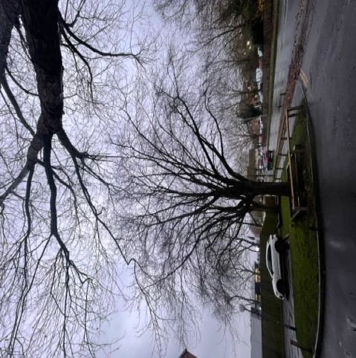

T7 – 50% RECUCTION

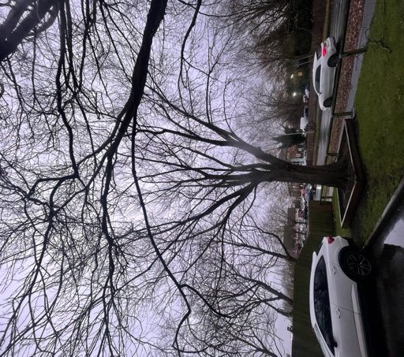

Rear of Caversham Place
T8 – 50% RECUCTION
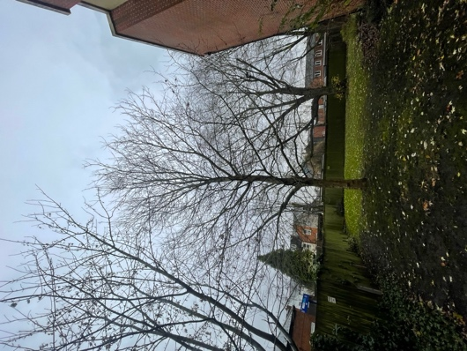

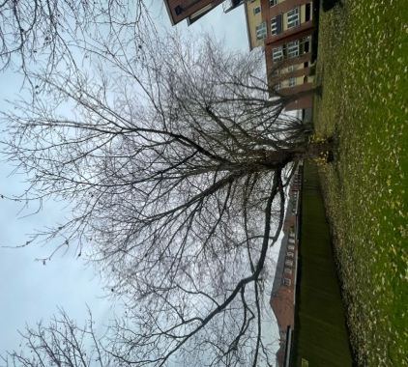
T9 – 50% RECUCTION

T10– 50% RECUCTION
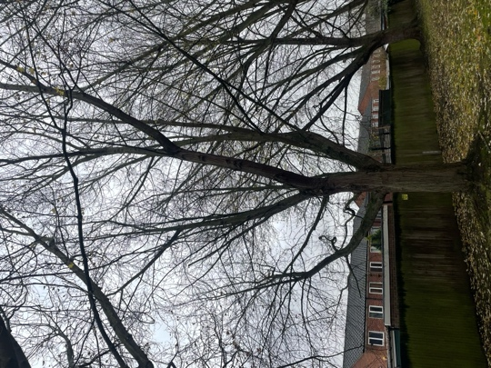

T11– 50% RECUCTION

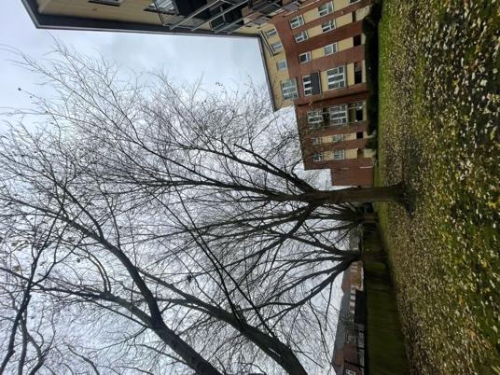
T12 – 50% RECUCTION

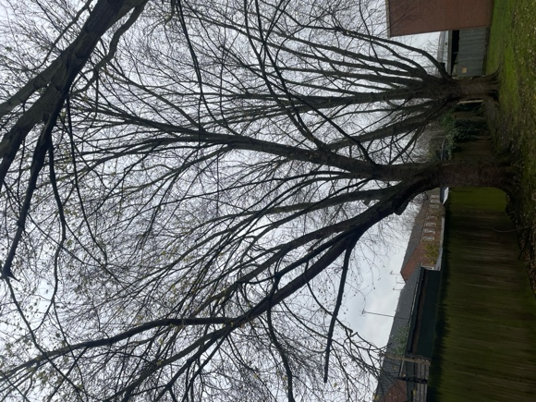
T13 – 50% RECUCTION

