PLANNING STATEMENT

in respect of a revised application for a proposed change of use from restaurant/café (formerly Class A3, now Class E(b)) to hot food take-away (Sui Generis), to the Use Classes Order (as amended).
168 Whitley Wood Road, Reading, RG2 8LQ
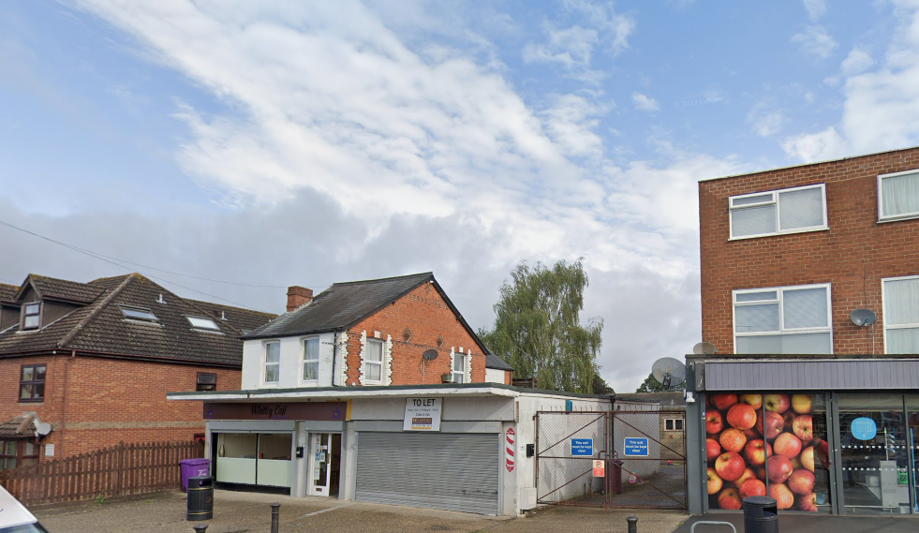

BACKGROUND

This application follows an earlier application in 2024 (Reading Borough Council – RBC) (REF:24/0462), which was withdrawn at the advice of the Case Officer and the local Ward Councillor. That application sought a variation of hours of an earlier Planning Permission (REF: Pl/18/1107) which itself was an application to change the previous Post Office here into the café, with ancillary take-away use.
So, the following documents have been provided to support this application, essentially for a hot food take-away, where consumption of that food is mostly off the premises (Use Class: Sui generis – “a class of its own”) by the Applicant, Zubair Qureshi:
- Ordnance Survey – Location Plan;
- Block Plan;
- Red Line existing and proposed floorplan;
- Updated Noise Impact Assessment (NIA) by Syntegra, May 2024.
- Planning Officers report into the original change of use from Post Office to Café.
So, we are submitting this planning application to Reading Borough Council to allow the introduction of a new hot food take-away here, to “allow flexibility” (as stated by Case Officer Anthony Scholes) and open between the hours of 7AM and 21.00PM. The updated NIA reflect this increase in hours.
SITE DETAILS

The application site is an L-shaped two storey building to the north of Whitley Wood Road, 60m west of the junction with Northumberland Avenue. The site is located within Whitley Wood Local Centre and forms part of an identified Key Frontage. The parade includes the Coop supermarket directly to the east of the site.
The building is mainly single storey, but also part two storey with residential uses on the first floor, however, the application in question relates to the ground floor of the building only, the exisitng commercial premises. The site was vacant from approximately 2017-2019 and received planning approval for café with ancillary takeaway in April 2019 (see Planning History below).
The current use is as a café (Class A3) with an ancillary takeaway (Class A5) function. The forward part of the premises comprises a seating area with the servery, kitchen, storage areas and bins to the front and rear. Forward of the building is located an area of hardstanding, used informally for vehicle parking. The surrounding area is comprised of a mix of commercial and residential uses.
PLANNING HISTORY

930144/OUT – Redevelopment to provide three storey building including a shop and four flats above – Refused 08/04/1993
960478/FUL – Change of use from Class A1 to restaurant with ancillary takeaway function (Class A3) – Refused 30/05/96 – Appeal ref: APP/QO315/A/96/270762 – Allowed 02/01/1997
020261/FUL – Alteration to shopfront to provide new external door entrance to 168b Whitley Wood Road – Permitted 04/03/2003
040828/FUL – Automatic entrance doors and fire escape – Permitted 29/06/2004 171045/FUL - Shop front alterations and various external alterations – Permitted 23/08/2017
171225/ ADV - Display of one internally illuminated fascia sign and one internally illuminated hanging sign to shop front and one non-illuminated panel sign at rear – Permitted 14/09/2017
181107/FUL - Change of use of ground floor from post office (Class A1) to cafe (Class A3) with ancillary take-away (Class A5) function – Permitted 01/04/2019
201257 - Notification of Prior Approval for a Change of Use from Retail, betting office or pay day loan shop or casino (Class A1 (shops) or Class A2 (financial and professional services)) to restaurant or cafe (Class A3). Prior Notification under Class C, Part 3 of Schedule 2 of the Town and Country Planning (General Permitted Development) Order 2015. – Application Withdrawn 15/09/2020
201288 - Certificate of Lawfulness for proposed conversion from post office retail to café –Application Returned 30/04/2022
201401 - Discharge of conditions 3 (odour assessment), 4 (noise assessment), 5 (deliveries and servicing) and 8 (litter management) of planning permission 181107/FUL – Split Decision 04/05/2022
PLANNING POLICY

The following local and national planning policy and guidance is relevant to this application:
National Planning Policy Framework (Amended December 2024)
Adopted Local Plan November 2019. Local Defined Shopping Centre; VITALITY AND VIABILITY OF SMALLER CENTRES
Sites and Detailed Policies Document (2012) Policy DM4 – Safeguarding Amenity

MATERIAL CONSIDERATIONS

CHANGE of USE:

This revised application stems really from advice provided by both the original Case Officer, Anthony Scholes and the local Ward Councillor Amjad Tarar. The current hours of 7am to 3pm are 8 hours a day and the proposed change to 7am to 9pm would, (as stated by Case Officer Anthony Scholes, in an email to Zubair):
“…allow more flexibility in the use of the business, should circumstances change and to avoid future variation applications.”
Policy DM4 of the Sites and Detailed Policies Document seeks to ensure that new development will not cause a significant detrimental impact to the living environment of existing or new residential properties in terms of noise, disturbance and smells. There are residential dwellings in close proximity to the application site and the existing use of the premises, however, an updated and detailed Noise Impact Assessment from Syntegra Consulting
The current opening hours of 7am to 3pm are insufficient for the applicant, as the nature of the new take-away use would operate most effectively within the evening hours serving evening passing customers. So, the Adopted Local Plan November 2019, includes Local Defined Shopping Centres:

RL3: VITALITY AND VIABILITY OF SMALLER CENTRES

a) Within the Key Frontages (identified on the Proposals Map), development involving a net loss of A1 retail or A2 financial and professional to other ‘centre uses’ will only be permitted where:

There would be no more than 3 consecutive units which are not in A1 or A2 retail use; and
The proportion of the total length of the Key Frontage within the centre that is in A1 or A2 use would exceed the relevant proportion below:

Caversham, Cemetery Junction, Tilehurst Triangle and Whitley District Centres; Christchurch Road, Coronation Square, Wensley Road and Whitley Wood Local Centres 60%
Emmer Green, The Meadway, Oxford Road West and Shinfield Road District Centres; Wokingham Road Major Local Centre;
Basingstoke Road North, Dee Park, Erleigh Road and Northumberland Avenue North Local Centres 50%
Whitley Street Major Local Centre 40%

b) Within district, major local and local centres, development will be permitted provided that:
- There would be no more than 2 consecutive A5 takeaways, and
- no more than 30% of the length of the Key Frontage would be in takeaway use;

So, in terms of Policy RL3, set out above, and we completely understand the need to ensure the “Vitality and viability of smaller centres” such as here at Whitley Wood Road, then the exisitng use is already a quasi “food use”, in the form of the café and we understand has a limited take-away element attached.

We note the Case Officers report into the previous change of use to Class A3 and part Class A5 (under the old Use Classes Order) concluded on the change of use at that time:

“An assessment of the Local Centre Key Frontage has been undertaken. The Key Frontage contains seven units, six of which fall within an A1 use with one A2 use. The proposed change of use does not therefore create more than three consecutive units not in A1 use and does not exceed the 60% limit. The change of use would also not create more than two consecutive A5 takeaway units. Subject to other policy considerations as below, the principle of the change of use is acceptable.”

Consequently, we will suggest this further change of use to take-away would also not push the non – retail % over and above the Local Centre Key frontage threshold, and should (subject to other usual planning considerations) be supported now.

RESIDENTIAL AMENITY

NOISE: Again, we would refer back to the 2018 planning officers report:
“A noise assessment and an assessment of odours have not been provided and it is not therefore possible to determine the likely impacts of the proposal. However, appropriate conditions can be applied to ensure that this information is supplied and agreed by the Local Planning Authority prior to the commencement of the use.
Noise would also be generated by deliveries and waste collection, and from patrons of the premises. It is therefore considered prudent to restrict the hours for deliveries, waste collection and the operation of the premises to protect the amenities of neighbouring owners and occupiers from the proposed development. Conditions are applied accordingly.”
So, since that application, the current application/applicant has provided a comprehensive Noise Impact Assessment from Syntegra Consulting, May 2024, which concludes:
The proposal is to extend the operating hours of the existing plant installation at the site to 0700hrs -2100hrs. The report assesses, through on-site noise measurements, the impact of the proposed plant on the surrounding noise sensitive receptors.
The results of the assessment have identified:
- The plant as proposed would achieve an initial rating of a low impact at most. However, the noise level generated would not achieve the requirements of the Local Authority.
  - Further mitigation measures have been suggested in order to achieve the requirements of the Local Authority:
Operating the extractor fan at a lower fan speed
Installing an acoustically attenuated duct termination for the extract fan
  - Subject to the installation of appropriate mitigation measures to achieve 4 dBA reduction in noise levels, the proposal will meet the requirement of the Local Authority.
Achievement of the target noise criteria will ensure compliance with the aims of the NPPF and the PPG in that it will avoid noise from giving rise to significant adverse impacts on health or quality of life on nearby noise sensitive receptors.
So, we assume the Environmental Health Officer will be consulted as part of this revised application, and clearly we would appreciate the opportunity to respond to any comments they may have, and re-consult with our own Consultants again, if necessary.
ODOURS and FUMES: It is understood the existing extractor system will be sufficient for the new take-away use, however again if the Environmental health Officer has any comments or concerns, we would be happy to respond.

PARKING:

Finally, as previously stated in the 2018 officers report;
“The site is located within Zone 3, Secondary Core Area of the Council’s Parking Standards and Design SPD. This zone is within 400m walking distance of a high frequency bus service. In accordance with the SPD, the proposed use would require an off-road parking provision of one space per 5sqm. The existing use requires a provision of one space per 40sqm. There is no formal off-road parking attributed to the premises. An area of hardstanding to the front of the premises is used informally for vehicle parking. In the consultation response received from Transport Development Control, concern was raised that the proposed use would generate a higher level of parking than the existing A1 use. The high level of on-street parking within the vicinity of the site was noted.
The site is located within Whitley Wood Local Centre and forms part of an identified Key Frontage. At the time of the officers site visit, the Key Frontage contained seven units including a Co-op supermarket, a betting shop and a pharmacy. Policy DM13 seeks to protect and enhance the network of district and local centres across the Borough. These centres ensure that services are provided close to people’s homes and provide a heart to Reading’s various communities. The policy seeks a diverse range of services within each centre, with a strong retail element maintained.
It is accepted that the proposal would reduce the number of A1 units within the local centre. However, all other units fall within A1 and A2 type uses. The introduction of an A3 use to the local centre is considered to diversify its appeal. It is expected that a significant proportion of the patrons to any of the existing units live within a short walk of the local centre. The local centre is also well served by high frequency bus routes. It is anticipated that a significant proportion of the future patrons of the proposed use already frequent the other facilities in the local centre. The proposed change of use is not therefore considered to substantial alter the number of trips and parking demand generated. On balance, it is considered that the proposal would not have a material detrimental impact on the functioning of the transport network in accordance with Policy DM12 of the Sites and Detailed Policies Document.
As detail of deliveries and servicing arrangements have not been provided with the application, appropriate conditions will be applied to ensure that this information is approved by the LPA prior to the commencement of the development.”
We would suggest the parking – highways generation with this take-away use might be lower, as the restaurant element would go, and therefore only local take-aways could generally be offered to local residents.
Consequently, we feel the traffic levels – demand would lower, and as stated above, there is also a good frequent bus service too. However, again we would be delighted to respond to the Transport Development Control Officers response, if necessary.

CONCLUSION:

This revised application, follows a recommendation by the Case Officer to withdraw a previous application in 2024, plus the promising support of the local Ward Councillor.
With the right conditions imposed and the updated Noise Impact Assessment, it is considered we can work with the Council in ensuring the right hours, noise and odour questions, parking and broader neighbours amenity can be maintained and protected. However, if there is anything further we need to respond to, amend, ad to or whatever, please call me:

Colin Tebb, BA(Hons), Btp. Planning Consultant.
Email: dorsethome@btinternet.com
TEL: 07824116423

