To: | Mr Peter Reime  Unit 1, The Hall, High St, Tetsworth, Tetsworth, United Kingdom, OX97AB | Application No: PL/24/1253  Application type: Full planning permission

Applicant: Mr Suhas Patil

Proposal: 2-storey attached 2-bed dwelling with private amenity to rear including associated frontage works for carparking and access following demolition of existing single storey side extension.

At: 44 BERKELEY AVENUE, READING, RG1 6JE

The above application was WITHDRAWN by the applicant on .

Date: | 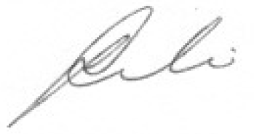
 | Assistant Director of Planning, Transport and Public Protection Services

