Dear Sir/Madam,
Reading Borough Council Planning, Reading Borough Council Civic Offices, Bridge Street, Reading, RG1 2LU 28/1/2025.

OGEA14357215
Title: – BT intends to install fixed line broadband electronic communications apparatus Outside 22 Pierces Hill, Tilehurst, Reading, Berkshire, Reading, RG31 6RB
Under the Electronic Communications Code (Conditions and restrictions) (Amendment) Regulations 2017, I hereby give you notice under Regulation 5 informing you of our intention to install 1 pole at the above location.
I enclose a copy of the plan indicating the approximate position for the proposed apparatus.
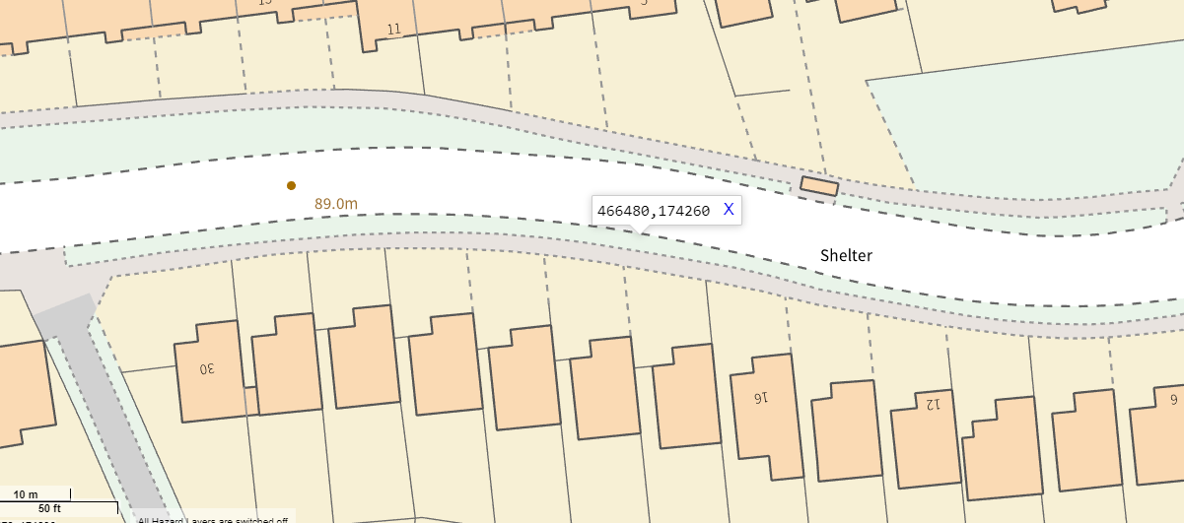
Approximate Grid ref: - 466480 174260
USRN: 31001023

Should you require further information about the above works, please do not hesitate to contact me.
Yours faithfully,

