READING BOROUGH COUNCIL CONSERVATION OFFICER
CONSULTATION COMMENTS FOR PL/24/1682
Request for observations by Reading Borough Council to Wokingham Borough Council on full application for proposed external and internal refurbishment, repairs and alterations consisting of replacement windows and doors; replacement roofs including new roof lights, cowls and lanterns; installation of solar panels; concrete repairs; full mechanical and electrical services upgrade; erection of two external staircases; new detached bin and bike store, and hard and soft landscape and accessibility improvements. For URS Building, Whiteknights Campus, Earley, RG6 6BW, Reading, By Reading Borough Council Conservation Officer, Burcu Can-Cetin, 31/01/2025
Please note – These comments are limited to the design and access statement and heritage statement only and do not include the assessment of all impacts (either positive or negative).
Relevant policies and legislation - National
From the point of view of the historic environment, the main statutory tests are set out within the Planning (Listed Buildings and Conservation Areas) Act 1990. Sections 16(2) and 66 require that special regard be given to the desirability of preserving listed buildings, their settings or any features of special architectural or historic interest which they possess.
National Planning Policy and Guidance
The NPPF outlines government policy, including its policy in respect of the historic environment. Chapter 16 of the NPPF (2024) 'Conserving and enhancing the historic environment' sets out the Government's high-level policies concerning heritage and sustainable development.
Paragraph 207 states, “In determining applications, local planning authorities should require an applicant to describe the significance of any heritage assets affected, including any contribution made by their setting. The level of detail should be proportionate to the assets’ importance and no more than sufficient to understand the potential impact of the proposal on their significance.” And Paragraph 208 says, “Local planning authorities should identify and assess the particular significance of any heritage asset that may be affected by a proposal (including by development affecting the setting of a heritage asset) taking account of the available evidence and any necessary expertise. They should take this into account when considering the impact of a proposal on a heritage asset, to avoid or minimise any conflict between the heritage asset’s conservation and any aspect of the proposal.”
Paragraph 212 of the NPPF requires that ‘When considering the impact of a proposed development on the significance of a designated heritage asset, great weight should be given to the asset’s conservation….’ And paragraph 213 says, ‘any harm to, or loss of, the significance of a designated heritage asset (from its alteration or destruction, or from development within its setting) should require clear and convincing justification’.
Paragraph 215 requires that ‘where a development proposal will lead to less than substantial harm to the significance of a designated heritage asset, this harm should be weighted against the public benefits of the proposal…’
National Planning Practice Guidance on Historic Environment provides context to the NPPF.

Other Guidance
Historic England Advice Note 2 – Making changes to Heritage Assets illustrates the application of policies set out in the NPPF in determining applications for Planning Permission and Listed Building Consent.
English Heritage’s “Conservation Principles” provides policy and guidance for the “sustainable
management of the historic environment”.
Historic England Listing Selection Guide – Education Buildings, 2017 provides a general conservation framework for university buildings to be protected as heritage assets.
Please consult with your conservation specialist for the local policies on heritage assets.

Significance Assessment
I noted that the subject Grade II listed building, URS Building, including the paved surface of Chancellors Way and raised edges of the ornamental pool, University of Reading, is located in a historic environment with many periods, the lands of Whitenight and Whiteknights Park, which was a large estate constituting a number of a Victorian building which were replaced with the university buildings after the WW2. Due to the large footprints of the education buildings and their positions creating a sense of a university campus, the legibility of the historic park is very limited. However, the environment in which the URS building forms a part still has a composition of historical layers, with the university buildings dominating. Within this environment, given the positions of the Victorian buildings and their arrangement with the university buildings and the scale of the proposed works to the URS building, I could conclude that, possibly, none of the settings of listed buildings, except for the URS, would be substantially impacted by the proposal (This needs to be checked on site). As such, the emphasis should be put on the impact on the significance of URS Building.

From the official listing description on URS Building, including the paved surface of Chancellors Way and raised edges of the ornamental pool, University of Reading, Earley - 1435127 | Historic England the following details are read:
“Reasons for Designation
The URS Building at Reading University, 1970-72 by HKPA, is listed at Grade II for the following principal reasons: * Architectural interest: the expressive use of structure to enclose space, which references traditional Japanese construction, and the playful exaggeration of the post and lintel joints, give the building drama, wit and virtuosity; * Planning interest: the practical, cost efficient, central corridor plan is innovatively re-imagined to bring natural light into the core of the building and to create a linear plan of dynamic cross section; * Architects: the building comes towards the end of HKPA’s impressive sequence of educational buildings; expressing elements of this important practice’s architectural philosophy while being an idiosyncratic and creative response to its brief.”
(…)
“Details
University faculty building, 1970-72, by Howell, Killick, Partridge and Amis, built for the Faculty of Urban and Regional Studies, including the College of Estate Management (CEM).
MATERIALS: the building is composed of an exposed reinforced concrete frame finished in ochre-coloured cement; the frame is infilled with pre-cast concrete cladding panels of brown Thames Valley aggregate, aluminium panels, and aluminium windows. The low-pitched roofs are also covered with aluminium sheet.
PLAN: the building forms the south side of an open space enclosed by Whiteknights House to the west, the Humanities & Social Studies Faculty to the north and the Library to the east. The building has a long, narrow, footprint, which runs broadly east to west; the north elevation faces out onto the open space. The building has four floors, plus a basement and a partial fifth floor with plant room over. The plan is centred on a 120m long top-lit spine, which forms the principal internal circulation space. Rooms, lecture theatres and teaching spaces, project irregularly out from the spine, and to the north they project over a wide double-height, brick-paved, pedestrian walkway known as Chancellor's Way.
The circulation spine takes the form of a double corridor sandwiching a central core of staircases, lobbies, lifts and light-wells. Lecture theatres and tutors' rooms are at first floor level with seminar and teaching rooms above. The ground floor is reserved for the printing and administration of the CEM’s postal courses. With the exception of a small ground-floor infill extension, alterations are limited to minor internal rearrangements of partitions, to subdivide, or open up, rooms in discrete areas of the building.
EXTERIOR: the building’s elevations are formed of irregular projections, braking up its length with vertical and horizontal cut-aways to bring daylight into the corridors. The exposed structural frame creates a strong bay rhythm, and the joints of post and beam are exaggeratedly-expressed, with the fork-ended beams resting on, or supporting, the shouldered ends of the columns, giving a playful emphasis to the building's rational construction.
The structure is made to work hard, with beams post-tensioned for large spans and cantilevers. The most dramatic projection is to the north, over Chancellor’s Way; the supporting structural columns forming a colonnade. The principal entrances, each of which gives access to a stair, are arranged along the north elevation, but the heavy modelling is a feature of both north and south elevations. The two end elevations to east and west give the appearance that the building has been sliced like a stick of rock, to reveal the cross-section of the structure. At both ends there are also projections – to the east a service tower, and to the west the central spine advances forward at first, second and third floor, projecting out over a square, ornamental, pool.
The building’s roofs are visible as shallow, mono-pitch gable ends from the east and west ends; built-in box gutters terminate in projecting spouts to carry water away from the building. The proportions and glazing pattern of the windows vary depending on the rooms they serve, and some are more architecturally expressed, forming shallow oriels.
Chancellor’s Way, which runs along the north elevation of the building, is paved with brown brick paviours. The route steps up near the building, forming a continuous shallow podium along its length. To the west, the paviours wrap round to side of the building and form a raised edge to the square pool beneath the projecting end of the building.
The building’s expressed structure is a typical feature of HKPA’s work, recalling their interest in oriental timber construction. However here, the trabeated post-and-lintel aesthetic is translated to reinforced concrete and amplified to a monumental scale, creating a distinctive and extrovert aesthetic. It is a didactic building, showing how structural loads are transmitted; this was appropriate given that Construction Management was amongst the courses taught here.
INTERIOR: the building’s structure is exposed internally as it is externally, with the beams tapering in depth and forking as the engineering requires. The top-lit stairwells and light-wells are enclosed in timber and glass screens, with fin-like vertical mullions, allowing light through the building, and creating a sense of structural transparency. The timber detailing is in HKPA’s consistent style and redolent of simple Japanese-inspired design. The wells have pitched glass lanterns over them, with the exception of one well, which is open to the sky. The dog-leg stairs are self-supporting, with balustrades of painted tubular steel and timber panel. Internal walls are of painted concrete block, and doors are mainly flush-panel or have two glazed panels, although a number are later replacements.
The two first-floor raked lecture theatres are double-height spaces, as is the printing room on the ground floor. Timber and glass screens, matching those used elsewhere, create a partition between the printing room and the offices at first and second floors, again, allowing light and views to travel through the space.
Pursuant to s.1 (5A) of the Planning (Listed Buildings and Conservation Areas) Act 1990 (‘the Act’) it is declared that internal, non-structural, party walls between adjacent rooms are not of special architectural or historic interest.”

In addition to the above description, the building's footprint appears to have been considerably preserved since its construction, as illustrated below (on the next page).
The linear form of the footprint follows the historic Chancellor's Way and incorporates it into the building design with a modernist approach, which is then reflected in the strong internal circulation inside the building.
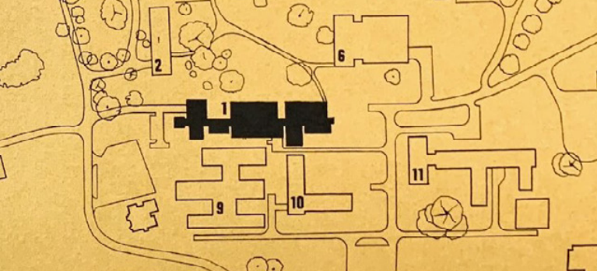
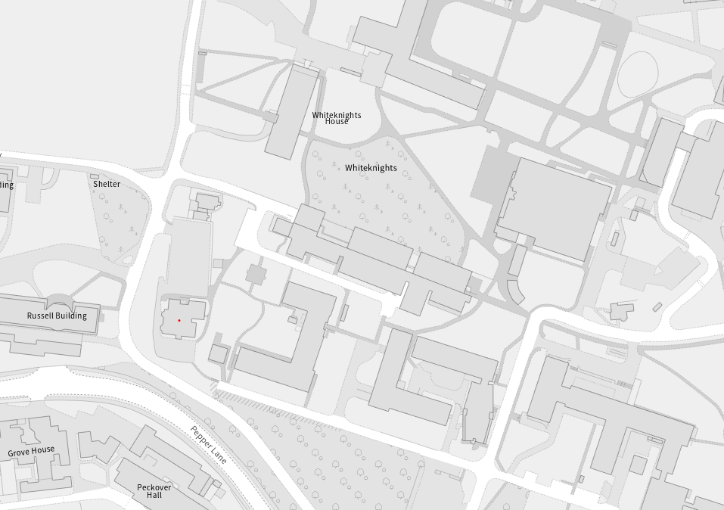

Impact Assessment
Without knowing the planning history and details about the external and internal alterations that have taken place, I am only able to make the following comments.
- I have reviewed the submitted heritage statement. I would argue that the term ‘neutral’ significance is not applicable to this building or any building. If the building has been altered very little, given its architectural composition as a whole, its authenticity is still there, and all original forms, spaces, construction system, architectural language, and detailing are legible, then it is a very strong statement for this 1970s building to have low and neutral significance in some parts.
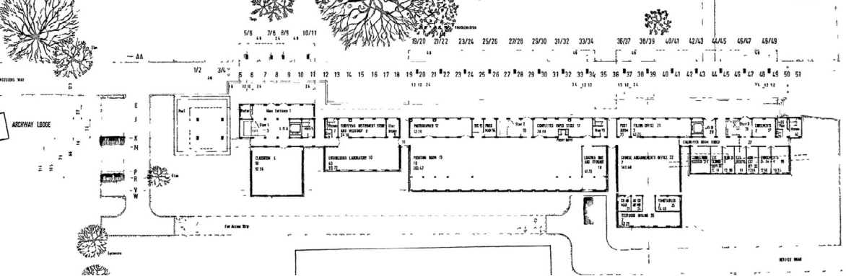
The above is the original ground floor plan (from the heritage statement). Compared with the existing plan, the circled area appears to be the most changed one. Therefore, it is hard to understand the rationale between the medium and low significance as the original plan is preserved for those areas.
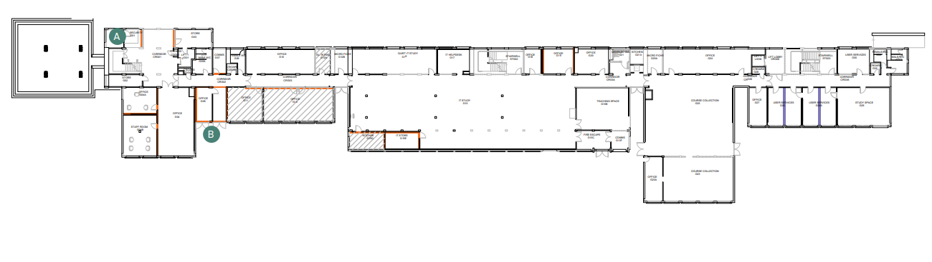
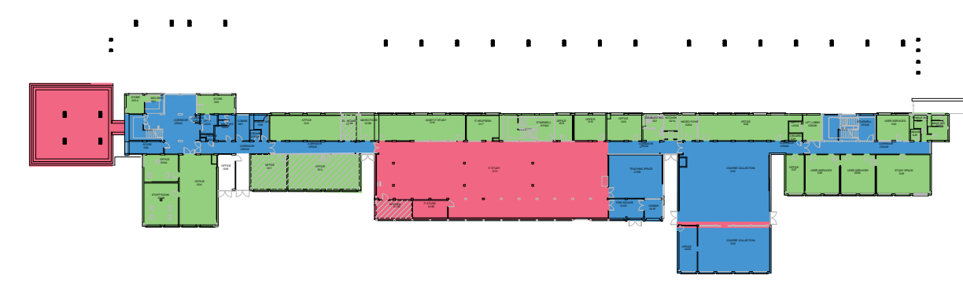
Similarly, I think the significance assessment on the floor plans needs to be revised. The internal spaces without alteration and others with alterations, for instance, on the first floor, are all indicated as low significance – green. Is this related to the non-structural partition walls, and are they not significant? That means the second-floor half of the building has some importance, which should not be the case. Defining partition walls not significant or not contributing to the special interest of the building does not mean that the spaces to the north do not form part within the significance of the building.
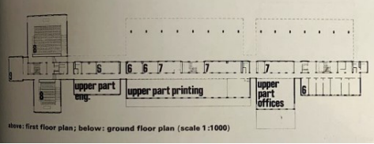
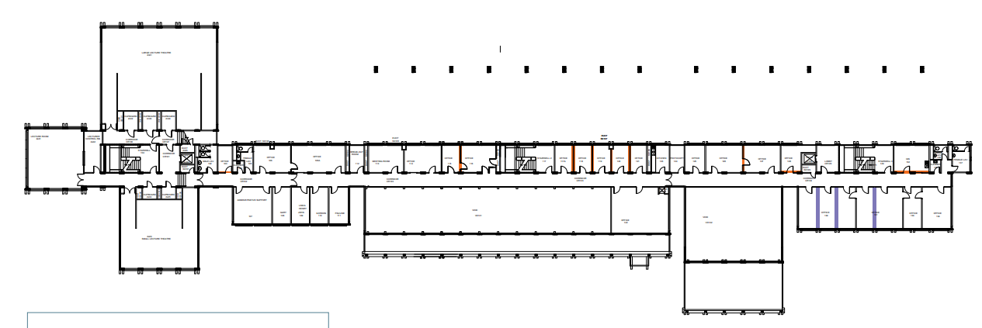
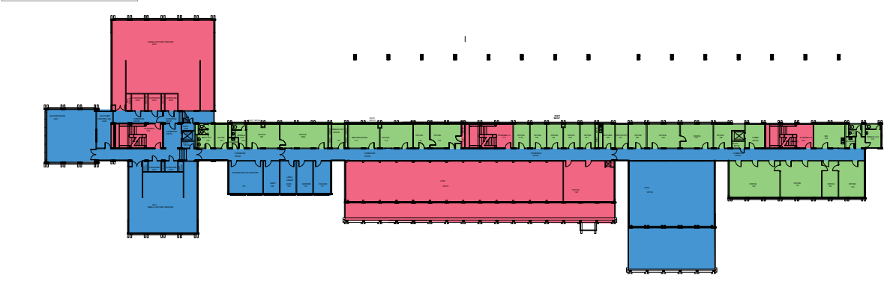
Original, existing plans and significance assessment for the second floor. The difference or relationship between significance and alteration is not clear.
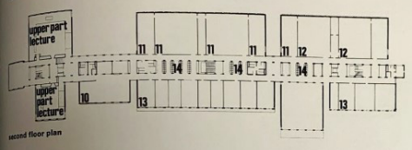
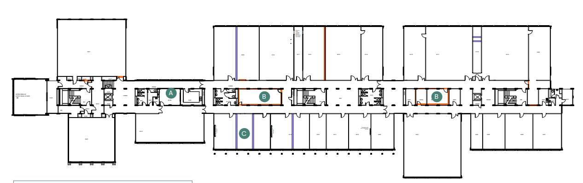
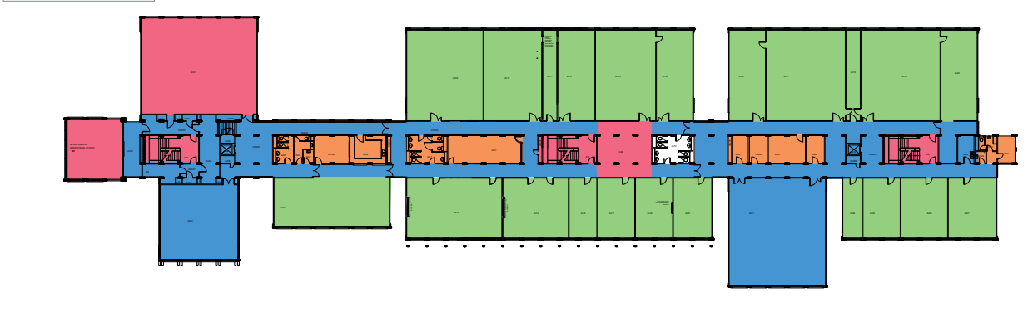
- The demolition strategy of the proposed works includes demolition of all partition walls. No matter whether the significance assessment concludes high, medium, or low, they are proposed to be treated the same. So, I assume none of the internal partition walls in the phase 1 is structural? Or is the colouring of the drawing below is wrong? Phase 2 says external fabric but it all blues are internal? Demolition Strategy states “Phase 1 works are currently underway, Phase 2 has recently obtained planning permission/listed building consent and this planning application represents Phase 3 of the building strategy.” I note that there is no space untouched by the proposed works; this could be an excessive intervention. However, I am unable to know the details. I assume there are already structural assessment and condition assessment for the listed building.
- On page 28, the design statement includes “Significant concrete & structural issues.” So, does the building need structural strengthening, or is it just an energy efficiency problem? If it is the latter one, I should remind that these should not be imposed on the architectural significance of the building.
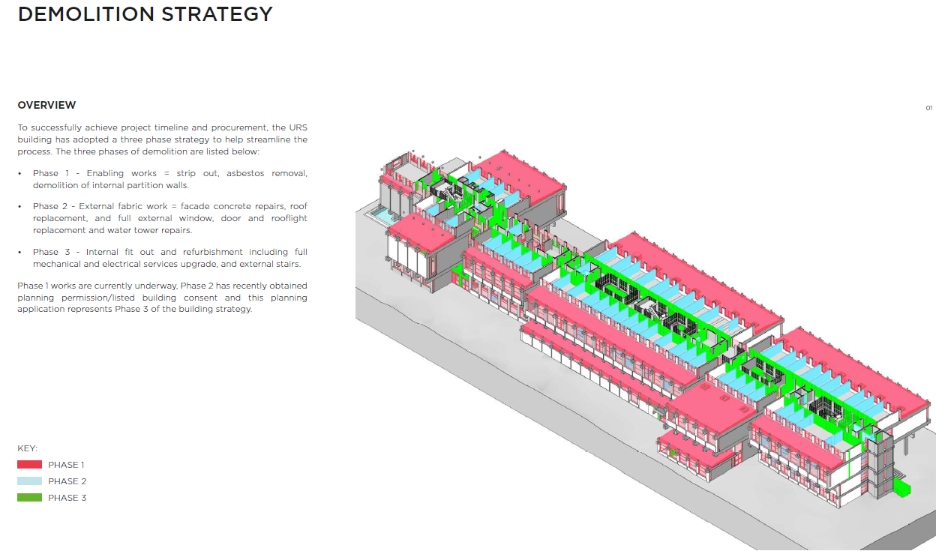
- Window replacement – needs to be further analysed as all windows appears to be proposed for replacement. Some would not have the original design because “The minimal horizontal transom to the sliding sash has not been replicated, as it is a secondary element in a strongly vertical pattern and its introduction would have no functional reasoning.” (page 33) I think there should be left some original windows, it is not a reason of being functional but the originality of the design and in line with the official description of the use of aluminium harmoniously in roof sheets, panels and windows and their integration. The details are important for listed buildings and leaving no original fenestration should not be the only option. The fact that the building is modern does not mean its original elements can easily be replicated or replaced. I think the windows should not be ‘composite’ either.
- Similarly, external doors would not have period features and introduce a common design to today’s buildings. The details and some significance would be lost due to the proposed works to the windows and doors. The new windows and doors would not be 1970’s design and material, would not reflect the period or technology of the listed building.
- I would leave the full roof replacement to the Wokingham Council’s officers.
- The proposed perforated metal roof deck would bring an alien use of metal not appearing light but bold statement. As the building is not an industrial one, I find it excessive and competing to the original concrete elements of the structure.
- The proposed mechanical ventilation would bring the same problem; when the ceilings of the structure are perceived, it would be read as an industrial use or purpose. Accoustic baffles could also create an imposing element from ceilings. Therefore, I’m not sure about these proposals either.
- I would like to add that, the works should be addressing an existing important problem for the life of the building and its structure and should resolve the existing problems of conservation. Works for only ‘insultation’ or due to the ‘likely issues’ cannot be justified on heritage grounds. Rooflight replacement, roof cowl replacements, and some other works when all come together, this would be no original part left on the roof, from the 1970s roof.
- Soffit refurbishments – which ones, what is the original material /timber, and what is the proposed one? These should be answered to make an assessment. All of them should not be replaced.
- Aluminium façade panels – Only positive work, without a question.
- Concrete repair – CARE registered engineer could be involved in defining the necessary structural works. A methodology for concrete repair should be well-defined by a specialist.

- Additional Stair – I note the only reason is to comply with the current fire regulations? Compared with the significance assessment, Options 4 and 5 appear to be the most suitable ones as they are either low or neutral significance areas. However, the design statement mentions the significant impact on the concrete structure. Option no 2 and 3 would touch and change the medium significance areas of the listed building. No. 2 appears to be the better option compared to the others, as the only problem is that it “does not access the fourth floor” (page 50 of the design statement). However, I see that Option 3, being the largest staircase, is proposed.

- Impact of the proposed stair (A) – this proposal would be higher than the height of the existing building and would bring a new circular form and solid appearance. This would be against the planning interest of the listed building: “the practical, cost efficient, central corridor plan is innovatively re-imagined to bring natural light into the core of the building and to create a linear plan of dynamic cross section” AND “ The plan is centred on a 120m long top-lit spine, which forms the principal internal circulation space. Rooms, lecture theatres and teaching spaces, project irregularly out from the spine, and to the north they project over a wide double-height, brick-paved, pedestrian walkway known as Chancellor's Way.”

- The proposed stair would act as an element that divides the building into two, competing with spaces projecting from the spine of the building on all floors, dominating. Due to its large external surface - the material difference would be so high that the principal design of bringing natural light would also be broken. Against the linear plan, it would be a vertical addition that does not integrate into the basic design principles of the building but contrasts. This could be applied but my concern is not only the new architecture to be added but the location and position of it as well. All staircases are located at the core of the existing building, enhancing and supporting the linearity. The circulation is linear, somehow hidden. That is why the (largest) recessed rear main entrance would not be read anymore. I would prefer a more transparent solution if this location were the final choice. If possible, rather than aluminium, maybe the use of large sheets of glass or large glazing could be an option.

- The second additional stair on the north façade would have less impact, although it would cover a considerable space on this elevation as it would be a linear element on the end of the plan, an extension of the circulation core. The appearance would be much better without intervening in the architectural rhythm of the external envelope.

- I am unable to provide a detailed analysis of the impacts of landscape proposals and other internal works.

To summarise, bearing in mind that I do not have full access to the submitted documents of the proposed works, pre-app discussions or planning history of the site/building, I would like to raise some concerns, some of which may not be applicable:

- The attention should be paid to the necessity of the proposed works and their justification from the heritage conservation angle. The building is 50 years old. Therefore, such a comprehensive refurbishment work could not be the only option. As previously stated, there are concerns about replacing original architectural elements with new ones with different appearance, not period features, leaving no original part except for the concrete structure.

- Therefore, there should be a powerful justification for the proposed works. The current and improved building performance could be presented. Is there any report showing the energy level and sustainability impacts of the proposed works? However, please be advised that this/energy efficiency improvement does not constitute a heritage benefit, and if all elements are replaced due to higher energy efficiency, there is no heritage benefit. All left is a building shell. There can be some environmental benefits for this building; however, if it were not listed, the same benefit would be gained again. Therefore, an obvious heritage benefit should be defined.

- The new services, PV panels, and other additions would all incur additional costs and affect the structure itself. Some may reduce the internal height, perception of space, and original atmosphere of the building.

- The harm of energy efficiency works would be considerable due to the reasons as I stated. There would not be almost any untouched surface except for the external walls. The solutions for the existing condition problems of the building are not clear enough. The concrete repairs are not explained sufficiently, and heritage benefits cannot be fully assessed.

- Additional harm is expected due to new stairs, altering external appearance-transparency, internal circulation principle, hierarchy of the spaces, and readability of the southern façade as a whole of the listed building.

- I am not sure whether the heritage benefits outweigh the harm to the appearance, built form, layout, original materials and elements, legibility of the circulation and façade organisation, etc.

