CONSERVATION

Memo
WITHOUT PREJUDICE
To: Marcelina Rejwerska
From: Buju (Burcu) Can Cetin, Conservation Officer
Date: 14/01/2025
Re: Conservation Officer response
Application Number: PL/24/1554 and PL/24/1556
Application Type: Full Planning Application and Listed Building Consent
Address: 35-37, St Marys Butts, Reading, RG1 2LS
Proposal: Proposed change of use of ground floor retail use to restaurant use and installation of kitchen extractor.

Summary
No objection – The proposed change of use would result in no substantial impact on the special interest of the Grade II listed building at 35-37 St Mary’s Butts, the settings of listed buildings within the immediate area of the application site, and the character and appearance of the St Mary’s Butts/Castle Street Conservation Area. However, the officers highly recommend reversing the negative impacts of the existing use on the legibility of the internal historic architectural features of the original fabric. The application could be an opportunity to enhance the significance of the listed building.

Relevant policies and legislation
From the point of view of the historic environment, the main statutory tests are set out within the Planning (Listed Buildings and Conservation Areas) Act 1990. Sections 16(2) and 66 require that special regard be given to the desirability of preserving listed buildings, their settings or any features of special architectural or historic interest which they possess.
Section 72(1) of the Planning (Listed Buildings and Conservation Areas) Act 1990 also requires the Council to pay special attention to the desirability of preserving or enhancing the character and appearance of designated Conservation Areas.
National Planning Policy and Guidance
The NPPF outlines government policy, including its policy in respect of the historic environment. Chapter 16 of the NPPF (2024) 'Conserving and enhancing the historic environment' sets out the Government's high-level policies concerning heritage and sustainable development.
Paragraph 207 states, “In determining applications, local planning authorities should require an applicant to describe the significance of any heritage assets affected, including any contribution made by their setting. The level of detail should be proportionate to the assets’ importance and no more than sufficient to understand the potential impact of the proposal on their significance.” And Paragraph 208 says, “Local planning authorities should identify and assess the particular significance of any heritage asset that may be affected by a proposal (including by development affecting the setting of a heritage asset) taking account of the available evidence and any necessary expertise. They should take this into account when considering the impact of a proposal on a heritage asset, to avoid or minimise any conflict between the heritage asset’s conservation and any aspect of the proposal.”
Paragraph 212 of the NPPF requires that ‘When considering the impact of a proposed development on the significance of a designated heritage asset, great weight should be given to the asset’s conservation….’ And paragraph 213 says, ‘any harm to, or loss of, the significance of a designated heritage asset (from its alteration or destruction, or from development within its setting) should require clear and convincing justification’.
Paragraph 215 requires that ‘where a development proposal will lead to less than substantial harm to the significance of a designated heritage asset, this harm should be weighted against the public benefits of the proposal…’
National Planning Practice Guidance on Historic Environment provides context to the NPPF.

Local Planning Policy and Guidance
Policy EN1 ‘Protection and enhancement of the historic environment’ of the Reading Borough Local Plan (2019) sets out the Council’s aspirations for the historic environment. The policy requires that all proposals to protect and, where possible, enhance the significance of heritage assets and their settings, historic character and local distinctiveness of the area in which they are located. It echoes the NPPF by stating, “Proposals should seek to avoid harm in the first instance. Any harm to or loss of a heritage asset should require clear and convincing justification, usually in the form of public benefits”.
Applications that affect listed buildings are expected not to have an adverse impact on the elements that contribute to their special architectural or historic interest, including their settings.
Applications which affect, or have the potential to affect, the significant features of heritage assets should be justified by a Heritage Statement.
Policy EN3 ‘Enhancement of conservation areas’ of the Reading Borough Local Plan (2019) requires that development proposals within Conservation Areas contribute positively to local character and distinctiveness. This policy further states “Positive consideration will be given to proposals which take opportunities to enhance the character of conservation areas. These may include:
- Reducing visual clutter caused by negative factors, such as poles and overhead wires, satellite dishes or unnecessary street furniture;
- Restoring original building features;
- Removing inappropriate additions or alterations to buildings;
- Protecting and encouraging the maintenance of green spaces and important trees, particularly where they are intrinsic to the history and character of the area;
- Improving signage and street furniture;
- Restoring or re-establishing appropriate paving, railings or walls;
- Sympathetic landscaping and planting;
- Improving or restoring green spaces, including front gardens, that are appropriate to the historic interest of a Conservation Area;
- Signage that reveals and promotes the Conservation Area and its boundaries;
- Interpretation panels to inform the public of the area’s historical significance.”

Policy EN6 ‘New development in a historic context’ also requires “New development will make a contribution to the historic character of the area by respecting and enhancing its architectural and visual qualities and considering how heritage considerations can influence the design of new development. When determining planning applications for new development, the following factors will be taken into consideration:
a. The positive contribution of the development to the existing historic townscape (scale, height, mass, proportion, plot size, street form, materials, significant vistas and views, and open space);
b. Sensitivity to historic context;
c. Reflection of borough-wide major heritage themes that contribute to local distinctiveness (e.g. patterned brickwork or former worker terraced housing);
d. Whether development promotes and/or improves access to previously undiscovered or neglected historic significance.”

St Mary’s Butts/Castle Street Conservation Area Appraisal is also a material consideration in determining applications for development.

Other Guidance
Historic England Advice Note 2 – Making changes to Heritage Assets illustrates the application of policies set out in the NPPF in determining applications for Planning Permission and Listed Building Consent.
English Heritage’s “Conservation Principles” provides policy and guidance for the “sustainable
management of the historic environment”.

Relevant heritage assets
The application site relates to the ground floor retail unit of a Grade II listed (with no. 1321885) two-storey urban vernacular building dating to the 16th / 17th century. Located as opposed to the Grade I listed Church of St Mary (listing no. 1113573), it lies within the Character Area 2 – St Mary’s Butts, where many other listed buildings in St Mary’s Butts/Castle Street Conservation Area are concentrated.
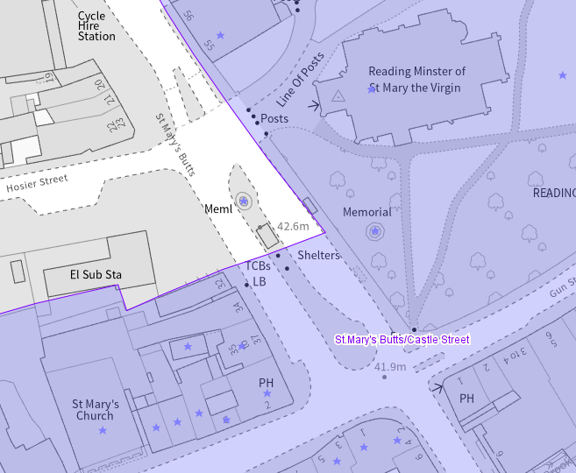
The application site (circled in red) and listed buildings (purple starred) within the conservation area (light purple)

Significance of heritage assets
The NPPF defines significance as the “value of a heritage asset to this and future generations because of its heritage interest.”

The interest may be architectural or historic, as set out in the Town and Country Planning (Listed Building and Conservation Areas) Act 1990 Section 1.

“Significance derives not only from a heritage asset’s physical presence, but also from its setting.” (NPPF, 2023)

Historic England assesses significance in a similar manner, referring to evidential, historic, aesthetic and communal values of a place.

The significance of the subject listed building relates to its continuous original mix use of commercial and residential, traditional timber construction system and substantial elements of the original fabric such as the jetty and gable roof with irregular profile, etc., and its constituting group with the same date listed buildings in Reading’s historic core.

The ‘Summary’, ‘Reasons for Designation’ and ‘Details’ of the official listing description are read below:
“Summary
A pair of buildings of C16 or C17 origin, remodelled in the C20.

Reasons for Designation
35, 36 and 37 St Mary’s Butts, Reading is listed at Grade II for the following principal reasons:

Architectural interest: * as an urban vernacular building of the C16 or C17 that retains a significant proportion of original fabric and important features such as the jetty and well-constructed timber frame.

Historic interest: * as an early post-medieval vernacular urban building which demonstrates the commercial and domestic occupation of English historic towns at that time.

Group value: * with the many listed buildings of the C16 and C17 in this particular part of Reading’s historic core, including The Horn Inn and others on Castle Street.

Details
A pair of buildings of C16 or C17 origin, remodelled in the C20.

MATERIALS: brick and timber frame, C20 brick glazed shop front on a brick plinth and plain tiled roof.

PLAN: the historic plan is obscured on the ground floor, having been opened up into one space to form a single shop unit, but both buildings would have had two rooms to each floor with back to back rear wings. There is a part-attic storey to the wings and a basement under most of the building.

EXTERIOR: two storeys with basement and part-attic. The principal front comprises a later C20 shop front on a brick plinth at the ground floor, with an off-centre late-C20 entrance door to the shop and an additional late-C20 door at the far left, leading to the offices of number 36 above. Number 37 has a bead-moulded jetty bresummer and jetty joists exposed at the soffit. There is no evidence of a jetty plate, presumably it was replaced by the later shopfront but it may be masked by the fascia. Above is close-studded timber framing, with midrails, an exposed wall plate and posts to each end of the jetty. There are two modern, two-light leaded casement windows probably not in the position of the original windows. Number 35 has an entirely late-C20 appearance, with modern shop front and a three-light window in a brick surround to the first floor. The eaves have been cut back slightly, but both 35 and 37 share a gable roof with irregular profile, covered in plain tiles.

To the rear, there are exposed sections of box framing, some rendered or clad with modern materials particularly at number 37. There is a substantial shouldered and truncated brick stack in red brick laid in English bond at the rear of number 35. Between the side elevation of number 35’s rear wing and The Horn Inn to the south is a part-covered passage; the exposed elevations reveal box framing with brick panels laid in stretcher bond, storey posts and a midrail. Some repaired brickwork is apparent, but there are also narrow handmade bricks. There are C20 openings at the rear and side elevations.

INTERIOR: the basement has brick paviours and exposed brick walls for the most part, although some are rendered or overpainted. The front wall is constructed from narrow, handmade, dark red bricks; the bond is irregular but appears to be a variant of English bond. An unusual curved passageway leads to the rear of number 35.

The ground floor has C20 features and finishes with round columns supporting the jetty of number 37. At the rear of number 35’s rear wing is an open fireplace with timber bresummer. It is unclear where the original stairs would have been but a narrow C20 stair leads from the far-left entrance door to the first floor (number 36) where tie beams in the ceiling mark the former cross-walls above number 35; the wall plate to the façade is over painted but evident, but the wall frames are not exposed. The cross-wall between numbers 35 and 37 is partly in situ; a substantial tie beam, wall post and a storey post remain and there are some exposed ceiling joists. The northernmost room has exposed, pegged timber framing of substantial scantling including a jowled storey post and a cranked corner brace at the north-east corner, jointed to a tie beam. Some of the wall framing is of lighter scantling, particularly to the front wall and is probably later in date but the wall plate and bottom of the common rafter roof structure is exposed. The cross wall to the south is similar in form with a substantial tie beam, close studding and straight bracing. This room has two C18 two-panel doors with ‘HL’ hinges. The door leading into the rear of number 35 has part of a moulded architrave remaining with a modern fillet.

The attic had no exposed historic fabric and the upper part of the roof structure was inaccessible.”

In addition, the St Mary’s Butts/Castle Street Conservation Area Appraisal recognises the subject building forming a positive contribution to the significance of the conservation area. It is emphasised by the appraisal that the main feature of the special interest of the conservation area is “Its position at the Saxon centre of Reading at a cross-roads of the main east-west and north-south routes through the town, just north of an original crossing point across the River Kennet, upon which river the town grew.”

Regarding the contribution of the subject property, the document states:
“Character Area 2: Features that make a positive contribution to the historic character and appearance of the conservation area:
- The traditional 16th century buildings at the southern end of St Mary’s Butts (numbers 35-37 St Mary’s Butts and “The Horn” adjoining them to the south), and at 57 St Mary’s Butts, the latter retaining its cobbled access and passageway and cobbles in front of the building; …”

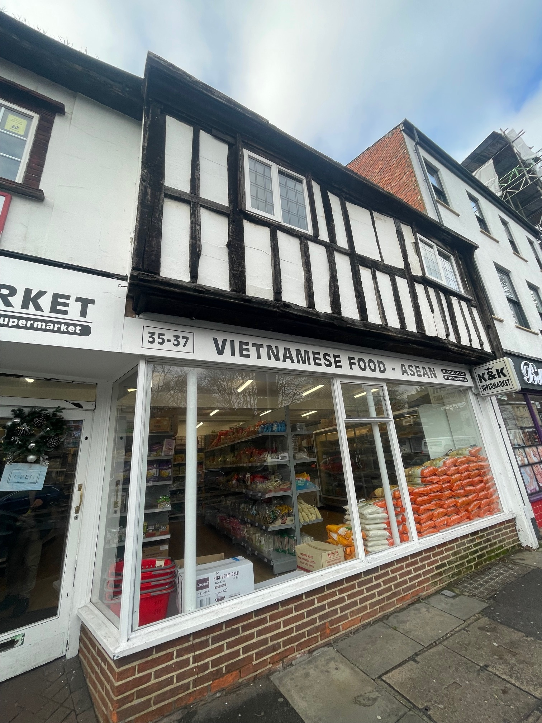
Photograph of the subject Grade II listed building (18/12/2024)

Impact of proposal upon heritage asset(s)
The application is for the change of use of the ground floor commercial unit from retail to a restaurant, which would require the installation of a kitchen extractor. The proposal would convert the existing storage/single-storey extension /late 20th-century building into a commercial kitchen by placing the new extract and air grill within the space of least significance. As such, the new kitchen would not substantially harm the listed building.

During the officers’ site visit, it was noted that most of the original internal elements were blocked by the existing shelving units. Therefore, it could be concluded that the existing use resulted in some harm to the legibility of the original features composing the significance of the historic fabric of the listed building. However, these appear to be reversible, and the current application(s) provides an opportunity.

Given that the only internal work proposed for the historic fabric is repainting the existing walls and ceilings of the unit and that most of the original elements mentioned by the official listing description are not visible, I would highly recommend that the agent and applicant consider revealing those features, some of which might be exposed ceiling joists and an open fireplace so that the proposal would have a good balance between original and new, as well as beneficial heritage impacts.

No works are proposed for the basement. No external works are proposed that no substantial impact would occur on the settings of listed buildings adjacent and/or within the immediate surroundings or the character and appearance of the conservation area.

Hence, the proposal would cause no additional harm to the significance of the listed building. However, it should consider reversing the harm of the existing use and improving the condition of the listed building.

Suggested condition(s)
During the works, if hidden historic features are revealed they should be retained in-situ. Works shall be halted in the relevant area of the building and the Local Planning Authority should be notified immediately.
REASON: To ensure that special regard is paid to protecting the special architectural and historic interest and integrity of the building under Section16 of the Planning (Listed Buildings and Conservation Areas) Act 1990.

Informative
The applicant is kindly reminded that the Local Planning Authority should be contacted if they want to carry out work on the listed building, which is not referred to in approved plans and documents. This includes:
* any extra work which is necessary after further assessments of the building's condition;
* stripping out or structural investigations; and
* any work needed to meet the building regulations or other forms of statutory control.
It is a criminal offence to carry out work on a listed building without our consent. Please
remind your client, consultants, contractors and subcontractors of the terms and conditions of
this consent.

Conservation response
No objections
No objections subject to conditions attached
Clarification required
Object

Contact details
Buju Can Cetin, Conservation Officer
Burcu.CanCetin@reading.gov.uk
0118 9373125

