Dear Sir/Madam,
Reading Borough Council
Planning, Reading Borough Council Civic Offices, Bridge Street, Reading, RG1 2LU
18/12/2024
Our ref:
OGEA16033353

Title:– BT intends to install fixed line broadband electronic communications apparatus Outside 10 ORMSBY STREET, READING RG1 7YR.
Under The Electronic Communications Code (Conditions and restrictions) (Amendment) Regulations 2017, I hereby give you notice under Regulation 5 informing you of our intention to install 1x9m medium pole at the above location.
I enclose a copy of the plan indicating the approximate position for the proposed apparatus.
Should you require further information about the above works, please do not hesitate to contact me.
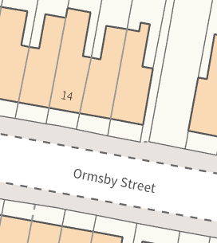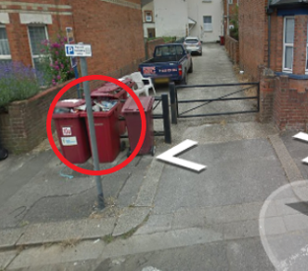
Approximate Grid ref:-
470311,173389
Yours faithfully,

