CONSERVATION OFFICER’S COMMENTS on PL/24/0590 for Replacement windows, replacement roofing and the provision of PV panels to the South facing roof slope
St Josephs College, 64 Upper Redlands Road, Reading, RG1 5JT
The subject building is a historic school building added to the Grade II listed building, Broad Oak, between 1910 and 1932, as seen on the OS Maps below. It should be noted that the school building, which has a direct functional relationship with Broad Oak, occupies a significant area within the listed curtilage. It has a grand, institutional appearance, typical of a school influenced by the Gothic revival style, with repetitive window patterns creating a rhythm across the façade along with decorative elements and vertical emphasis. Not only red brick construction with contrasting stone tops and cills but also the unique design of the windows itself, a complex multiple-hung timber awning type – as described within the submitted heritage statement – draws attention and highly contributes to the setting of the listed curtilage. As such, I agree with the heritage statement that the building has a medium level of significance.
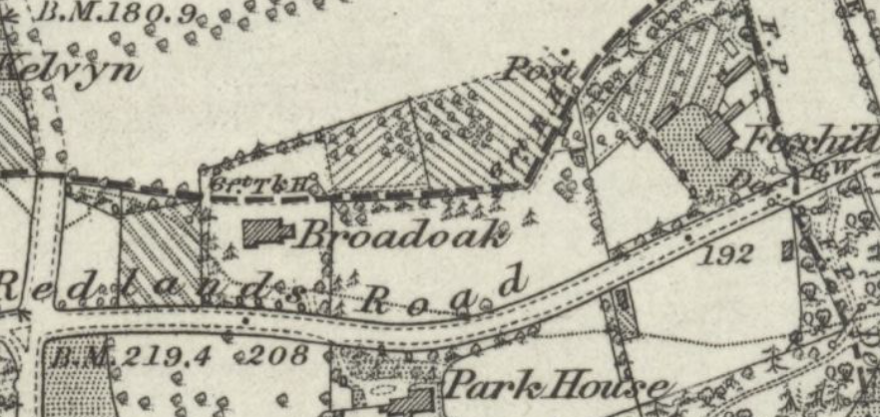
The OS Map dating 1872 to 1877 (published in 1883)

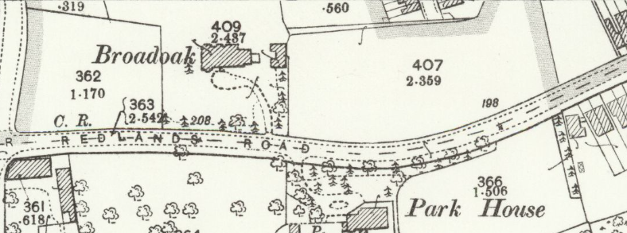
1898 (Published 1899)

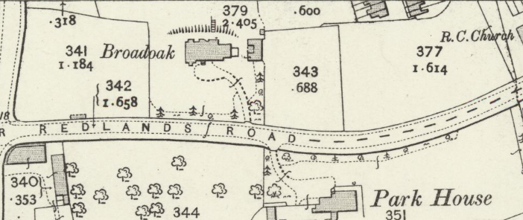
1910 (published in 1911)

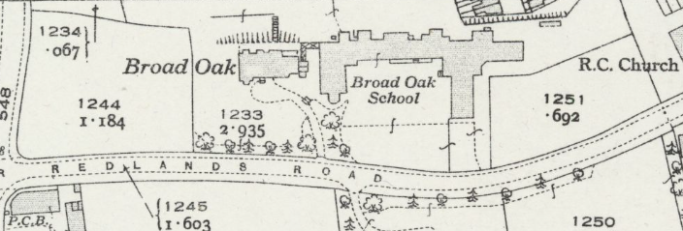
1932 to 1933 (1934)

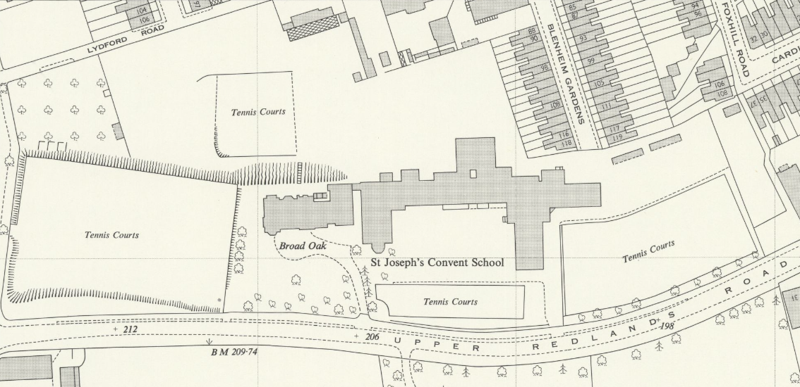
1957 (published in 1958)
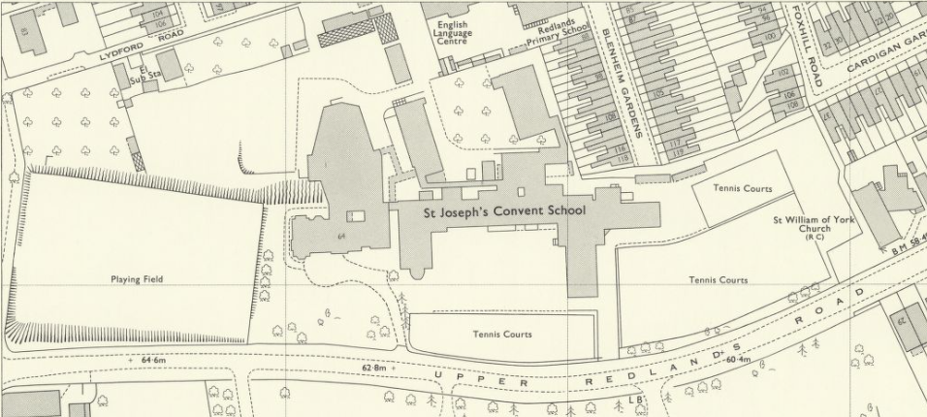
1970 (published in 1971)

In addition, the school building already has a considerable scale dominating the views; thanks to its architectural detailing, it is plainer and somehow monotonous, and it does not compete with the architectural characteristics of the listed building. However, it can be argued that it defines the main character/architectural style for the listed curtilage and wider setting, as illustrated by aerial views and a street view.
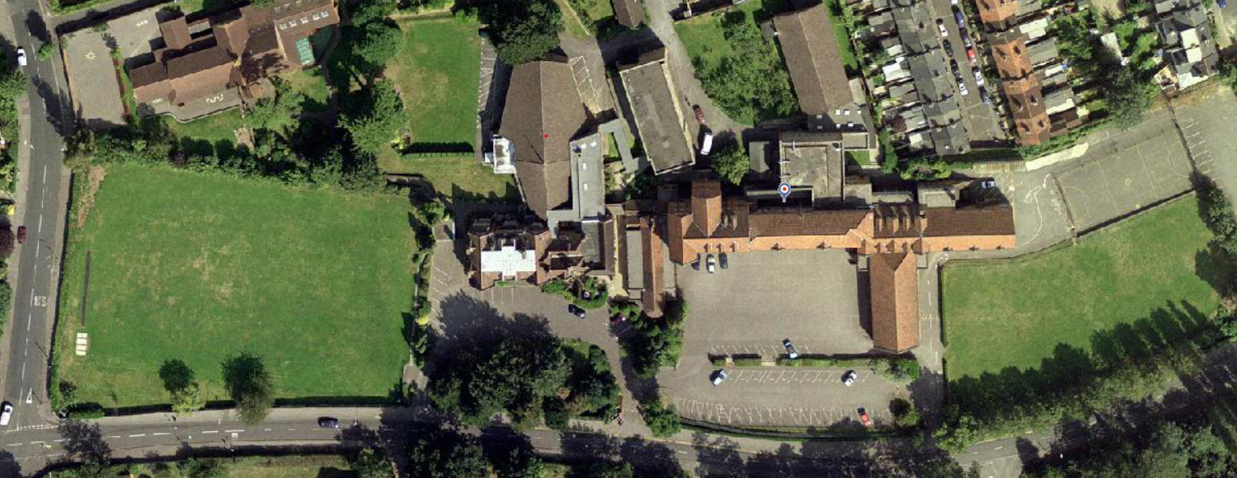
Aerial 2002 – Grade II listed Broad Oak is yellow circled and the historic school building is circled in red
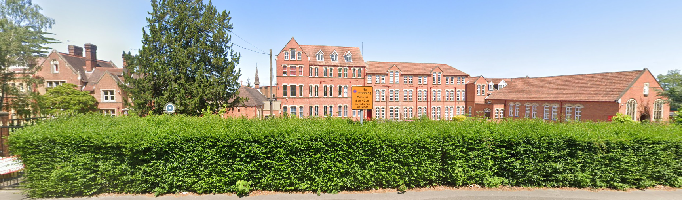
I noted that the proposed works are located to the eastern wing, the eastern end of the school building which is circled below.
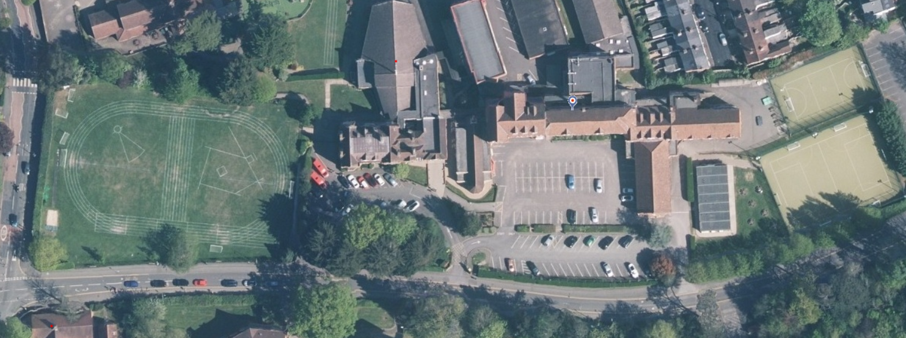
Aerial 2024
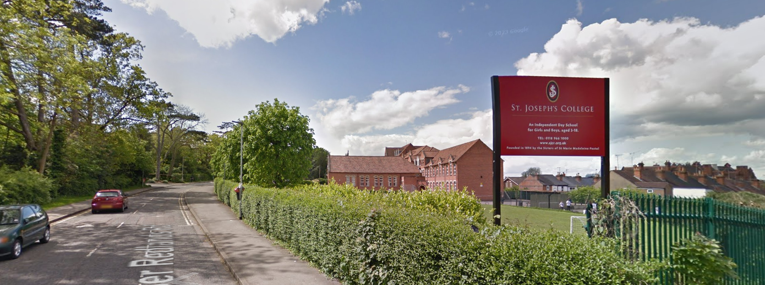
Google Street View, May 2014
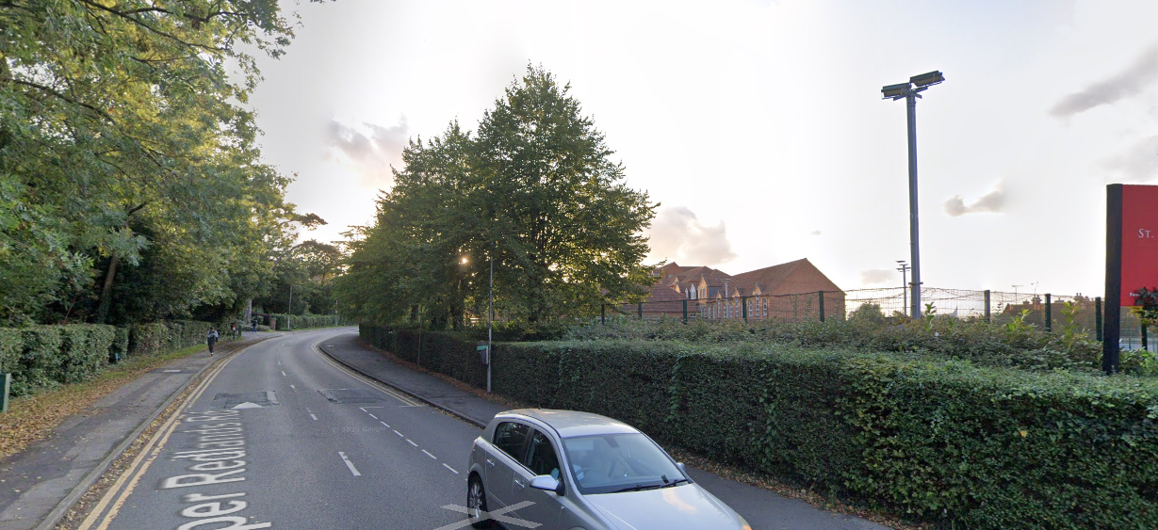
Google Street View, September 2023

I also noted that the submitted heritage statement says, “The early twentieth-century expansion of the school comprised three imposing brick ranges, which are distinguished by their consistency of form and architectural detail. They incorporate plain brick facades, but with highly regular and distinctive fenestration, incorporating multi-hung windows of unusual pattern, set within opening with decorative stone lintels.” (page 1)
The eastern wing is one of the three imposing brick ranges, and the provision of ‘all-black’ (as per submitted details) photovoltaic panels from the viewpoint of 2023 would be perceived as a building with a black/very dark-coloured roof slope that does not belong to the 90-100 years old school. It would not only distract from the features of the existing roof but also the whole/ integrated composition of the school building. Although I understand that the panels would be placed far away from the listed building and end of the school, they would still be highly visible from the public realm, resulting in a detrimental impact on the setting of the listed building and wider setting of the group of historic school buildings.
As Historic England states in its advice for traditional windows, “PVC-u is short for poly vinyl chloride un-plasticised, and these windows are assembled from factory-made components designed for rigidity, thermal performance, and ease of production. Their design, detailing and operation make them look different to traditional windows.” Therefore, after describing the existing traditional, highly unique windows as an important component of the significance of the listed curtilage/setting of the listed building, replacing them with cheap triple-glazed plastic windows would not be the expected from the conservation perspective and principles. Because there is not provided a detailed design of the proposed windows, it would not be possible to assess the impact of the new windows fully. However, it is known that for the original windows of high importance, it would not be easy to replicate the existing ones with the correct dimensions and design features using uPVC. Hence, I conclude that unsympathetic materials and design would adversely affect the character and special architectural and historic interest of the historic school building and the setting of the listed building.
The impact of insulation or any increased energy efficiency level would not outweigh the harm caused by the proposed PV panels and replacement upvc windows. I would highly recommend finding alternative locations for PV panels and considering timber windows.
In summary, the Council cannot accept the proposal on heritage grounds.
The reason for refusal: The proposed PV panels, by reason of their location, scale and colour, would dominate the roof of the eastern wing, detract from the appearance of the historic school building and be highly visible from the public realm, resulting in harm to the listed curtilage and setting of the listed building. The proposed replacement upvc windows, because of their unsympathetic design and materials, would also harm the historic and architectural character of the listed curtilage. The harm caused by the proposed development on the setting of the listed building would, therefore, be less than substantial harm at the moderate level. As the benefit of the energy efficiency measures would not outweigh this harm, the proposal would not meet the requirements of Policy EN1 of the Local Plan and Paragraph 215 of the NPPF (December 2024).

Burcu Can-Cetin, Conservation Officer, 17/12/2024

