DELEGATED APPLICATION REPORT
Ward: Church Ward
App Ref: PL/24/1168 Householder planning permission
Address: 64 CHAGFORD ROAD, READING, RG2 8AZ
Proposal: Part single part two storey rear extension, two storey side extension and front porch. Demolition of half existing outbuilding. (amended)
Applicant: Mr E Doci
Received date: 2024-09-05
Target Decision date: 2024-11-29 (EXT)
Case Officer: Huimin Chen

- SITE DESCRIPTION
The application site is a two storey semi-detached dwelling located to the south of Chagford Road. Along the road, there are large semi-detached properties and terraces of three houses.
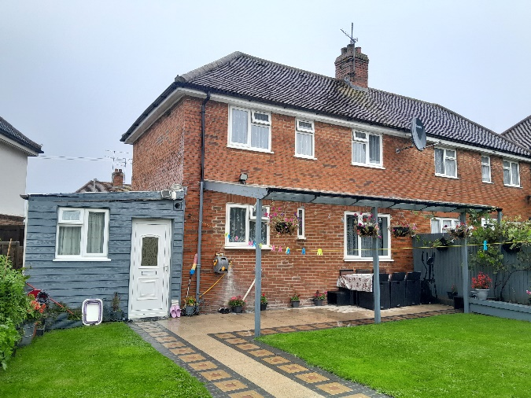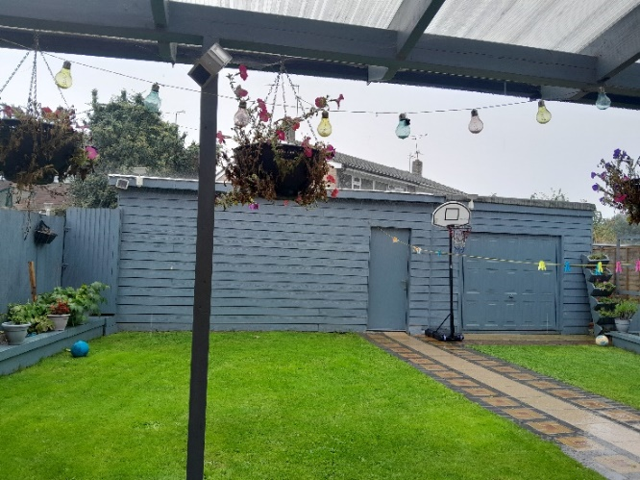
Fig 1. 64 Chagford Road. Site photo taken on 26/9/2024. Fig 2. 64 Chagford Road. Site photo taken on 26/9/2024.
- PROPOSAL AND SUPPORTING INFORMATION
The planning permission is sought for the construction of a part single part two storey rear extension and a two storey side extension with a pitched roof, as well as a front porch with hip roof. The existing rear pergola and side garage would be demolished to accommodate the proposed rear and side extensions, which project from the southern and western walls to a depth of approximately 3.5 m and 16 cm, respectively. The proposed single storey rear extension with a sloped roof and the installation of two roof lights would be adjacent to the 66 Chagford Road. One front-facing window would be installed on the first floor, and one west-facing door with two attached windows on each side would be added to the ground floor. The rear-facing windows and sliding door would be well arranged. The proposed spaces are intended to be used as a kitchen/dining area and bedrooms. The overall proposed extensions would be set down from the existing ridgeline and set further back from the frontage of the main building.
Regarding the proposed front porch, it would be built to dimensions of 1.19m*2.42m*3.74m (depth*length*maximum height), while the eaves height would be approximately 2.56m.
Following the completion of the proposed works associated with the main building, the usable private outdoor space would be insufficient considering the existing large scale garden outbuilding, contrary to policy H10 of the Reading Borough Local Plan 2019. Therefore, the proposal is to remove half of the existing garden outbuilding after the communication with the agent. Please note that there are no relevant applications related to the garden outbuilding, it is unclear what the status of the garden outbuilding is (i.e., whether it is lawful or not). Due to the lack of proposed elevations for the half-retained garden outbuilding, this application does not include it, and it would not be assessed. Relevant informatives would be included in the permission.
Following plans and email received further to the communication with the agent regarding the existing garden outbuilding:
- Drawing No. PL. 824.103 – Location plan, dated August 2024 and received 5th September 2024.
- Drawing No. PL.824.101.A – Existing plans, dated October 2024 and received 23rd October 2024.
- Drawing No. PL.824.105 – Visibility Splays (Block Plan)
- Drawing No. PL.824.102.C – Proposed plans, dated November 2024 and received 14th November 2024.
& an email from agent dated 25/10/2024 confirms that all proposed materials are to match those of the existing dwelling.

Existing Floor Plans and Elevations:
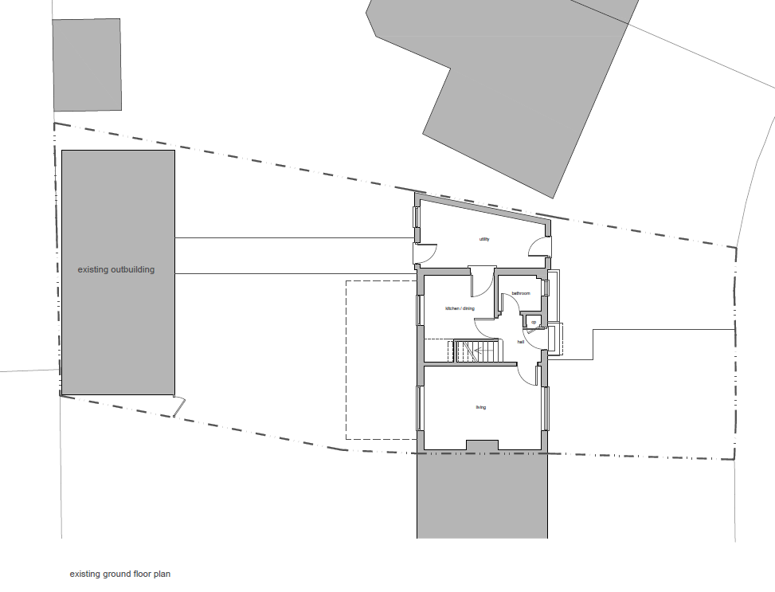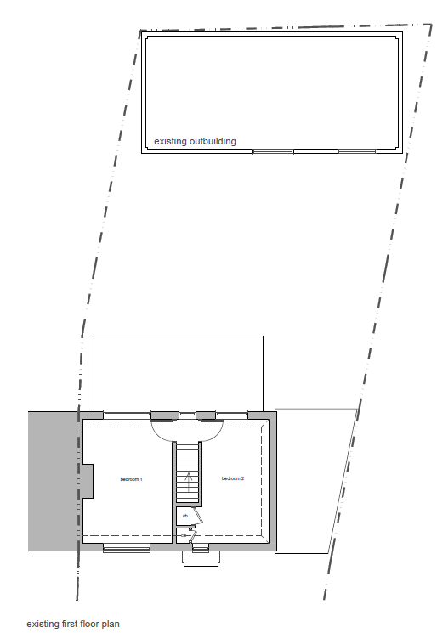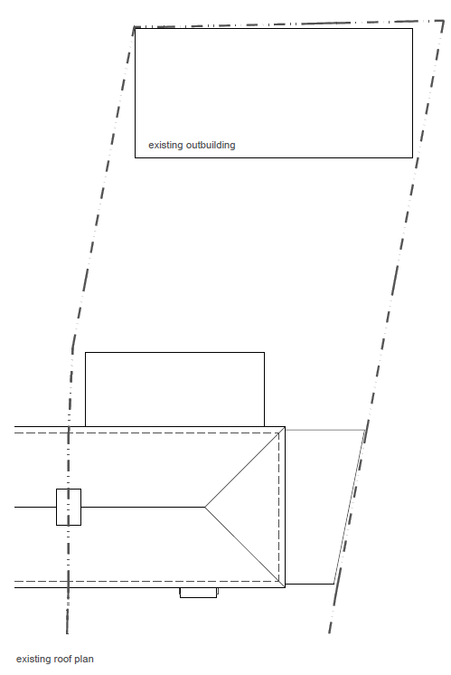
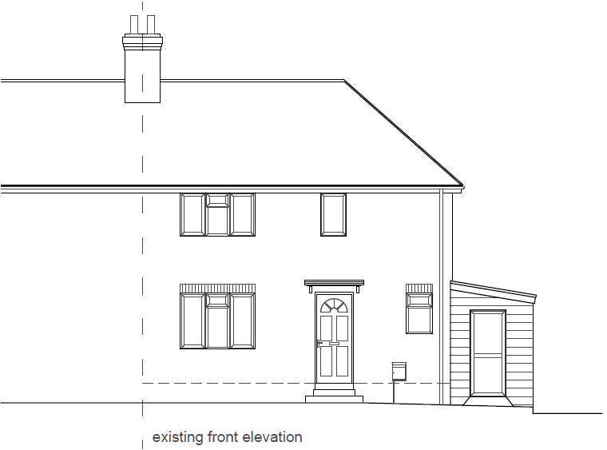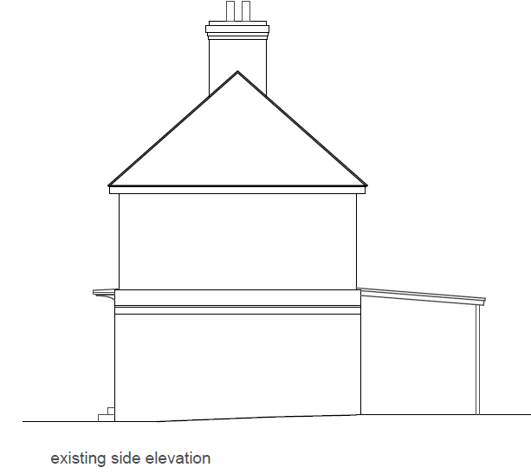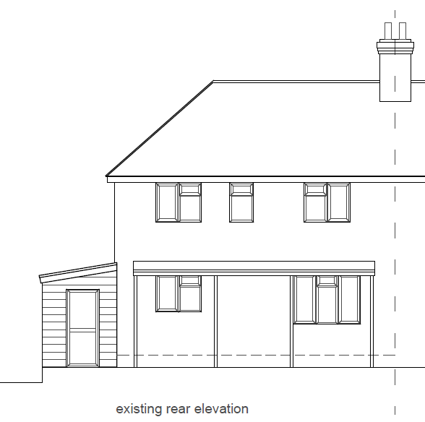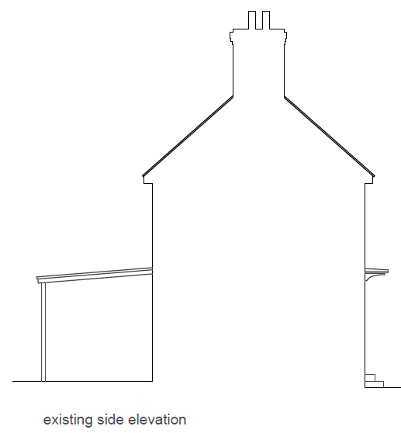

Proposed Floor Plans and Elevations:
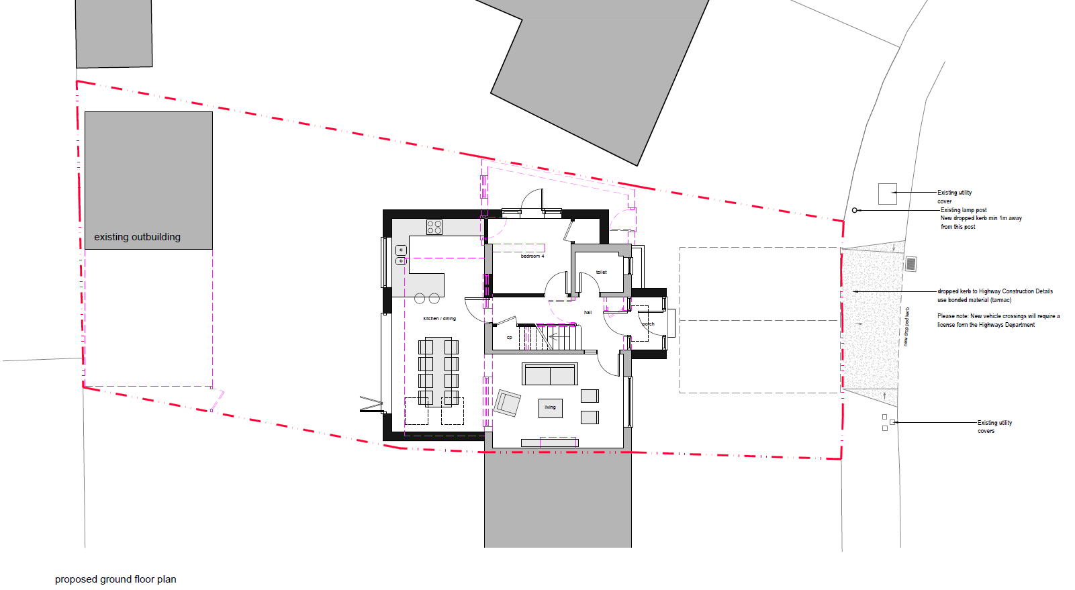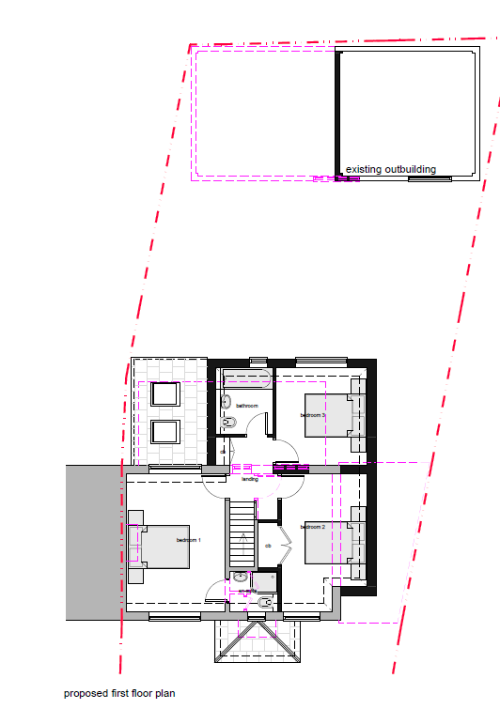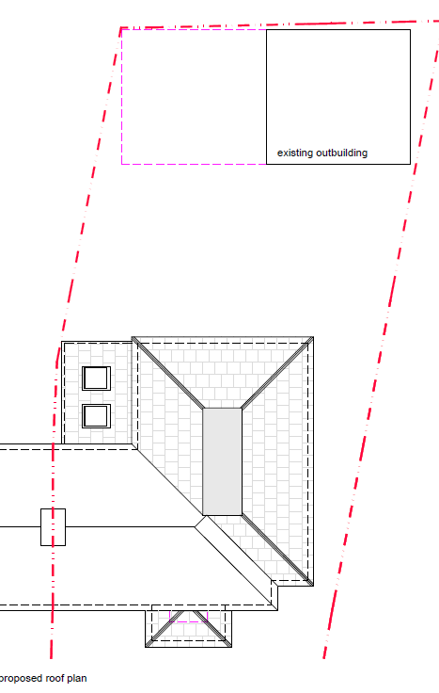
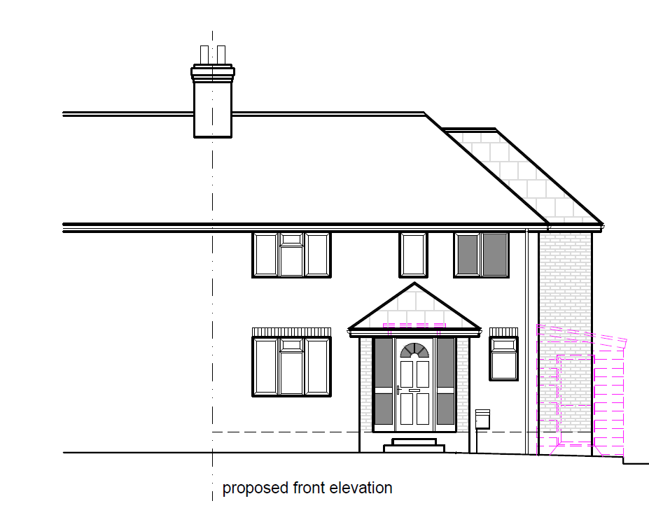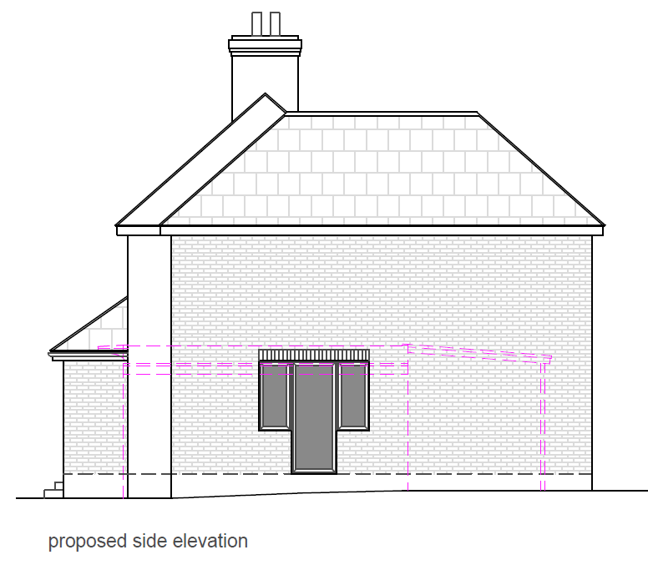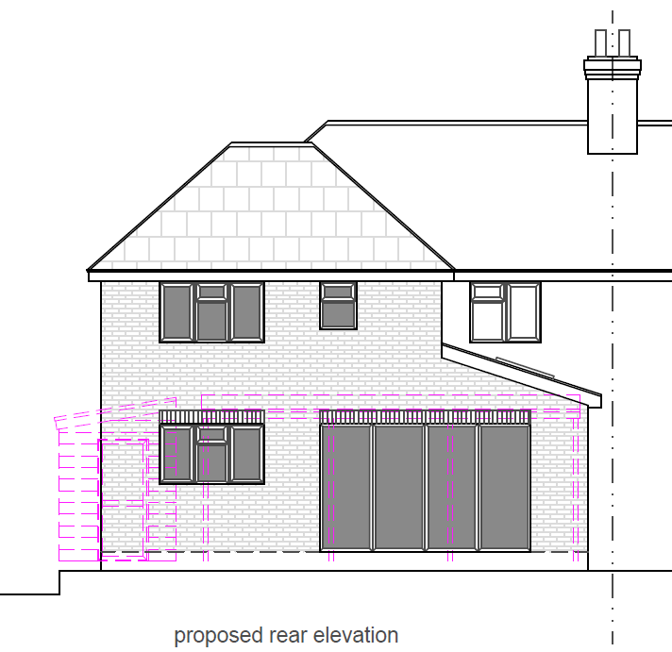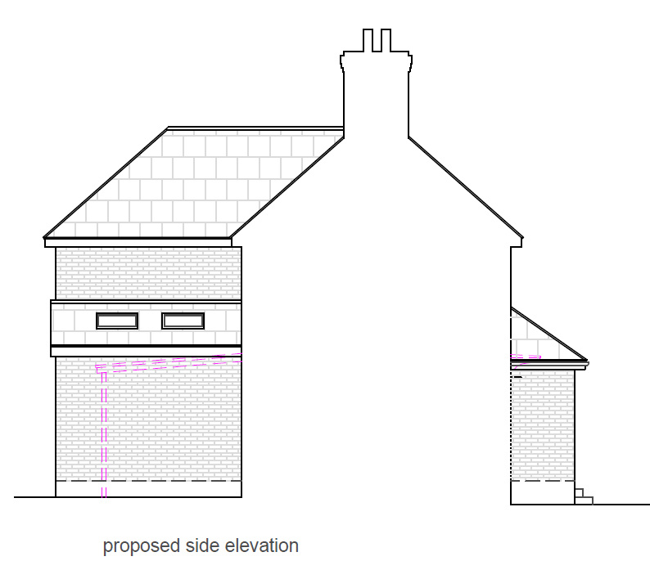
Relevant planning history:
None.
- CONSULTATIONS
Internal consultation:
Transport consultee: The submitted proposed site plan illustrates 2 off road parking spaces served via an existing dropped crossing, however site visit photos do not identify any existing vehicle crossing.
The proposed parking layout would not be achievable when accessed from the proposed location and width of the vehicle crossing. Revised layout required.
The introduction of a new vehicle crossing will require a license form the Highways Department, plans will need to identify the utility covers, drainage covers located on the footway and highway and the lamp column located on the property boundary. A minimum distance of 1m would be required between the dropped crossing and lamp column. Visibility splays of 2.4m x 43m will also need to be illustrated on plans.
The following addresses were consulted by letter:
- 11 Corinne Close, READING RG2 8AA
- 64 Chagford Road, READING, RG2 8AZ
- 62 Chagford Road, READING, RG2 8AZ
- 66 Chagford Road, READING, RG2 8AZ
- 15 Corinne Close, READING, RG2 8AA
No letters of representation have been received. The site notice was displayed for 21 days, and no comments were received.
- LEGAL AND PLANNING POLICY CONTEXT
Equality Act 2010:
In determining this application, the Council is required to have regard to its obligations under the Equality Act 2010. However, there is no indication or evidence (including from consultation on the application) that the protected groups identified by the Act have or will have different needs, experiences, issues and priorities in relation to this particular planning application. Therefore, in terms of the key equalities protected characteristics it is considered there would be no significant adverse impacts as a result of the development.
Section 38(6) of the Planning and Compulsory Purchase Act 2004 requires that proposals be determined in accordance with the development plan unless material considerations indicate otherwise. The Development Plan for Reading relevant to the application site comprises the Reading Local Plan (2019).
National Policy and Guidance
National Planning Policy Framework
National Planning Practice Guidance

Reading Borough Local Plan (2019)
CC7 (Design and the Public Realm)
CC8 (Safeguarding Amenity)
H9 (House Extensions and Ancillary Accommodation)
H10 (Private and Communal Outdoor Space)
TR3 (Access, Traffic and Highway-related Matters)
TR5 (Car and Cycle Parking and Electric Vehicle Changing)

SPD
Design Guide to House Extensions SPD (2021)
Parking Standards and Design Supplementary Planning Document (SPD) (2011)

- APPRAISAL
Character and Appearance
Policy H9 states that an extension to a house will be acceptable where it respects the character of the house in terms of scale, location, materials and design and respects the character and pattern of neighbouring properties and the street as a whole in terms of scale, location, materials and design, and any important existing building line. Policy CC7 also sets out relevant considerations for design.
The proposal is considered acceptable in terms of the size and scale, given that the proposed side extension only projects ca 16cm from the side wall and the depth of the rear extension is ca 3.5m, which is less than the recommended depth in the Design Guide to House Extensions 2021. The proposed front porch is also small in scale and maintains a reasonable distance from the highway. Moreover, considering the moderate scale, the set-down ridgeline and the set-back frontage of the proposed rear and side extensions, the proposal is considered proportionate and would not appear overbearing to the existing dwelling. The agent has confirmed that all proposed materials are to match those of the existing property, which would therefore respect the character and appearance of the existing dwelling and the local environment. The arrangement of windows and doors in relation to the host dwelling and adjoining properties is considered appropriate in terms of size, scale and placement, it respects the pattern of building frontages and would not detract from the street scene.
Residential Amenity
Policy H9 states that an extension will be acceptable where it does not result in an overbearing impact on neighbours. Policy H10 seeks to ensure that the amenity of gardens and other outdoor areas are not compromised. Policy CC8 states an extension to a house will be acceptable where it will not cause a significant detrimental impact to the living environment of existing or new residential properties.
There are no identified risks in terms of blocking light or being overbearing to the neighbouring properties, given design of the proposed part single storey rear extension and the reasonable gap from the shared boundary. Although two side windows are proposed for the western wall, they are not considered to raise privacy issues for No. 62 due to the ground-level nature of the area and the gap from the shared boundary.
The usable private outdoor space of the original proposal is less than the gross floor area of the dwelling to which it relates. Therefore, it is considered to have insufficient functional private outdoor space following the completion of the proposed extensions, especially considering the existing large-scale garden outbuilding. Following communication with the agent, half of the existing garden outbuilding would be demolished to address this issue, which complies with Policy H10 of the Reading Borough Local Plan 2019.
Parking:
Policy TR3 states that development will only be permitted where accesses and works to the highway comply with the adopted standards of the Transport Authority; Policy TR5 states that development should provide car parking and cycle parking that is appropriate to the accessibility of locations within the Borough to sustainable transport facilities, particularly public transport.
Drawing No. PL.824.102.C (Proposed plans) and 105 (Visibility Splay plans) have been received further to the communication with the agent to address all issues raised by the Transport team. The transport consultee can confirm that the proposed plans are acceptable and in compliance with Policies TR3 and TR5. Although the visibility splays have not been illustrated correctly, the acceptable splays can be achieved.
Please note a license will be required for the introduction of the new dropped crossing. Highways will determine if the distance from the lamp column is acceptable when they undertake a visit to the site and review the location of the gully. Conditions is recommended to secure the details.
Overall, the proposal is considered acceptable based on the reasons listed above.
- CONCLUSION
The proposed development has been assessed as set out above and is considered to be acceptable on that basis, subject to the following conditions.
- RECOMMENDATION
Approve with Conditions

Recommended Conditions:
Approved Plans
Time Limit
Materials (To Match)
No New Openings
Vehicular Access (As Specified)

