Officer: Thomas Bradfield
Planning Application Ref: PL/24/1155
Application Type: Full planning permission
Address: JOHN LEWIS CUSTOMER COLLECTION POINT, CROSSLAND ROAD, RG1 2HT
Proposal: Demolition of the existing building and redevelopment of the site comprising erection of a new building for up to 215 build to rent residential dwellings (Use Class C3) together with flexible commercial / community space (Use Class E/F1/F2), residents’ facilities, landscaping, public realm, amenity space, cycle parking and disabled car parking.

The site is located within the Zone 2, the primary core area but on the periphery of the central core area which lies at the heart of Reading Borough, consisting primarily of retail and commercial office developments with good transport hubs. The site is within walking distance to the Reading town Centre and Reading main train station.

The Site was previously used as a warehouse building with customer collection
facilities, ancillary car park and servicing area.

This application seeks to provide 215 residential dwellings comprising of:

1 Bed Units – 111
2 Bed Units – 92
3 Bed Units – 12
TOTAL 215

In accordance with the adopted Parking Standards and Design SPD the following parking and cycle provision would be required for the suggested mix of units:

Unit Type | Parking Standard per unit | Required Provision | Cycle standards per unit | Required Provison
1 bedroom Unit (111) | 1 | 111 | 0.5 | 55.5
2 Bedroom Unit (92) | 1 | 92 | 0.5 | 46
3 Bedroom Unit (12) | 1.5 | 18 | 1 | 12
TOTAL |  | 221 |  | 113.5

In addition to this visitor parking would also be required. The Design and Access and Planning Statement makes reference to this development being car free with the exception of 3 accessible parking bays located at the eastern end of Crossland Rd, near the main entrance.

iShare images identify the that the parking area proposed for accessible parking bays are located on public highway land as identified in the plans below:
Proposed Ground Floor Plan Parking I Share Extent of Public Highway
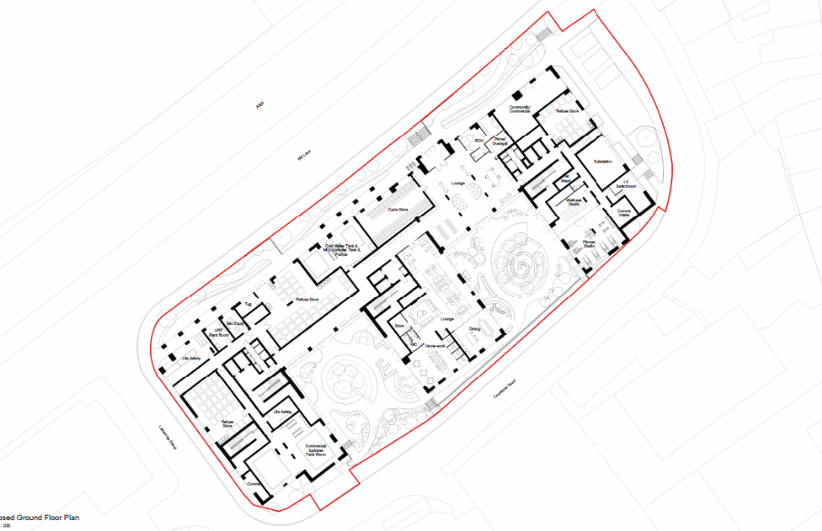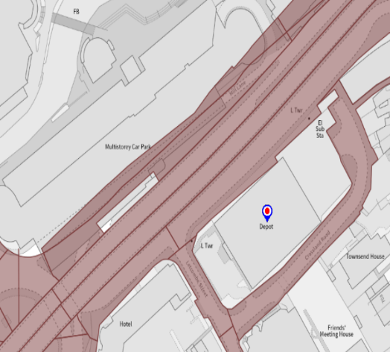

Any parking related to this development should be provided on site and not on any part of the public highway.

The loading facility as identified in the tracking diagram below is also located on the public highway.

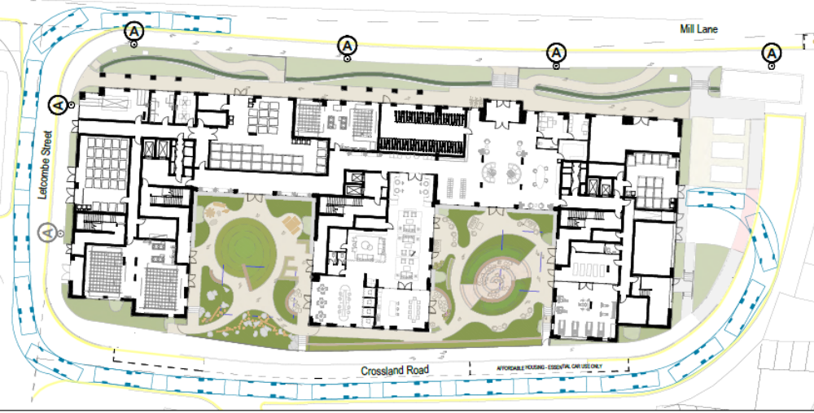

Given the locations of the 3 parking bays and loading bay are on highway land, these areas would potentially be available to use by the general public and not just for the occupants of the proposed dwellings. Parking would need to be contained within the site as would internal paths and landscaping. It is noted steps are also illustrated on plans located in the highway, these would need to be removed and suitable paths with appropriate gradients provided. As previously advised at the pre application stage the Councils mobility officer should be consulted. An over lay plan illustrating the extent of the site including accesses with the highway is required.

The Planning statement states that the existing access to the customer car park off Crossland Road is to be closed and the footway and kerb reinstated allowing for a longer parking bay. 4 x on street parking spaces are proposed along Crossland Rd for occupiers of the affordable housing. While we can accept the additional bays these cannot be allocated for the sole use of occupants of the proposed development and would be subject to the rules and condition of the Councils residential parking permit scheme which the prospective occupants would not be eligible to apply for. If the application is approved the appropriate conditions would be applied to ensure that the development does not harm the existing amenities of the neighbouring residential properties by adding to the already high level of on street car parking in the area.

A Car Club space is proposed to replace one existing pay and display parking on Mill Lane. This location is detached from the main residence is located, and therefore it would be more appropriate for the car club bay to be located on Crossland Rd where it would be more accessible for residents of the proposed development and closer to other residential areas in the area and better links to the wider road network. Revised plans required.

With regards to the relocation of the lighting columns. The submitted lighting document has been submitted to our consultants for review and therefore comments will be provided once review process has been completed.

Servicing, deliveries and refuse collection are to be made via the existing access point at the eastern end of the Site from Crossland Road and at the western end of the Site along Letcombe Street. Transport would not support any collections from Mill lane.

With regards to cycle parking, a communal cycle store is proposed at ground floor level providing 114 cycle parking spaces in the form josta style racks. In addition to this, three Sheffield stands are proposed to be located adjacent to the main building entrance to serve the flexible commercial/community space. Provision is in accordance with current standards and is deemed acceptable.

A CMS will be required for this development.

The principle of the development is acceptable given that the development will result in a decrease of vehicle movements in and out of the site, however unless the points made above are addressed the Highway Authority would object to the proposed development.

N.Hussain
Transport Development Control Advisor

