DELEGATED APPLICATION REPORT
Ward: Church Ward
App Ref: PL/24/1026 Householder planning permission
Address: 4 KINGSBRIDGE ROAD, READING, RG2 7RE
Proposal: Demolition of the garage, conservatory and erection of two storey side extension and single storey rear extension to convert the property into C4 HMO for 6 individuals. (Amended)
Applicant: Mr Davies Oyegbeta
Received date: 2024-08-08
Target Decision date: 2024-11-22 (EXT)
Case Officer: Huimin Chen

- SITE DESCRIPTION
The application site is a two storey semi-detached dwelling located to the south of the Kingsbridge Road. The surrounding area is consisting of large semi-detached and terraced properties. The property is not listed, nor does it fall within conservation area or under Article 4 Directions. Permitted development rights have not been removed.
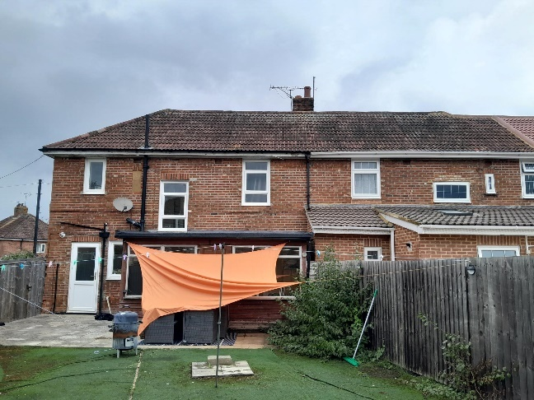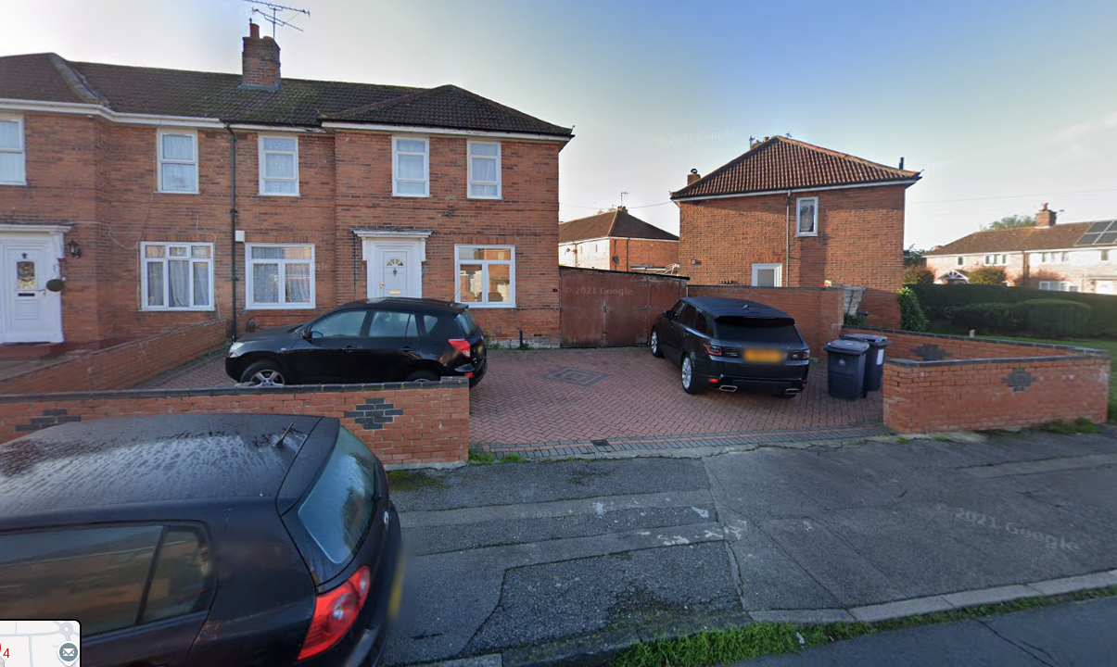
Fig 1: Rear of 4 Kingsbridge Rd, site photo taken by officer, 26/9/2024

Fig 2: Front of 4 Kingsbridge Rd, photo taken from Google Street View, 22/11/2024

- PROPOSAL AND SUPPORTING INFORMATION
Part of the original proposal was to convert the property into a large HMO for 7 individuals; however, the proposal faced many challenges in meeting Policy H8 (Residential Conversions) of the Reading Borough Local Plan 2019. Following communication with the agent, revised plans were subsequently submitted, seeking planning permission for the demolition of the garage and conservatory, and the erection of a two storey side extension and a single storey rear extension to convert the property into a C4 HMO for 6 individuals. The C4 use in itself would fall under permitted development rights.

The proposed two storey side extension would have a hipped roof, set back from the frontage, projecting ca 3.76m from the original side wall, which would align with the original wall and then follow the angled shared boundary as far as the existing rear building line. The proposed side development would measure 5.21m in eaves height (the same as the existing) and 7.24m in total height (lower than the existing). The proposed single storey rear extension would extend 4m in depth and feature a flat roof. The proposed western wall would be staggered, whilst the eastern wall would be straight and set off from the shared boundary with 6 Kingsbridge Road. All proposed materials would match those of the existing.

Further to the communications with the agent, following plans were submitted and under consideration:
- Drawing No. 100 – Location Plan received 8/8/2024.
- Drawing No. 102 – Existing Block Plan received 8/8/2024.
- Drawing No. 110 – Existing Floor Plans and Elevations received 8/8/2024.
- Drawing No. 101 Rev. A – Proposed Block Plan received 31/10/2024.
- Drawing No. 120 Rev. B – Proposed Floor Plans and Elevations received 18/11/2024.

Existing Floor Plans and Elevations: Proposed Floor Plans and Elevations:
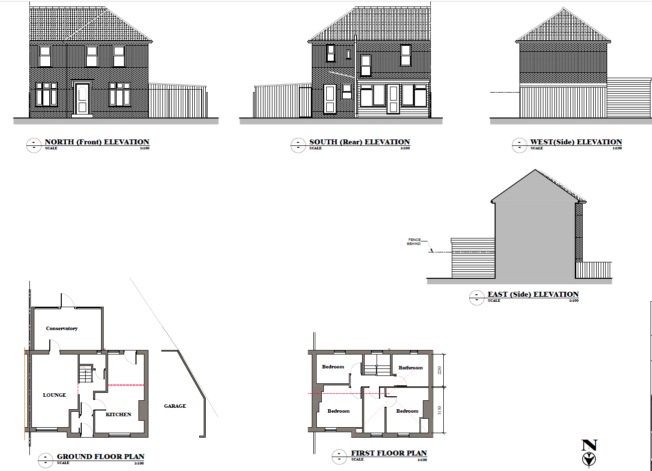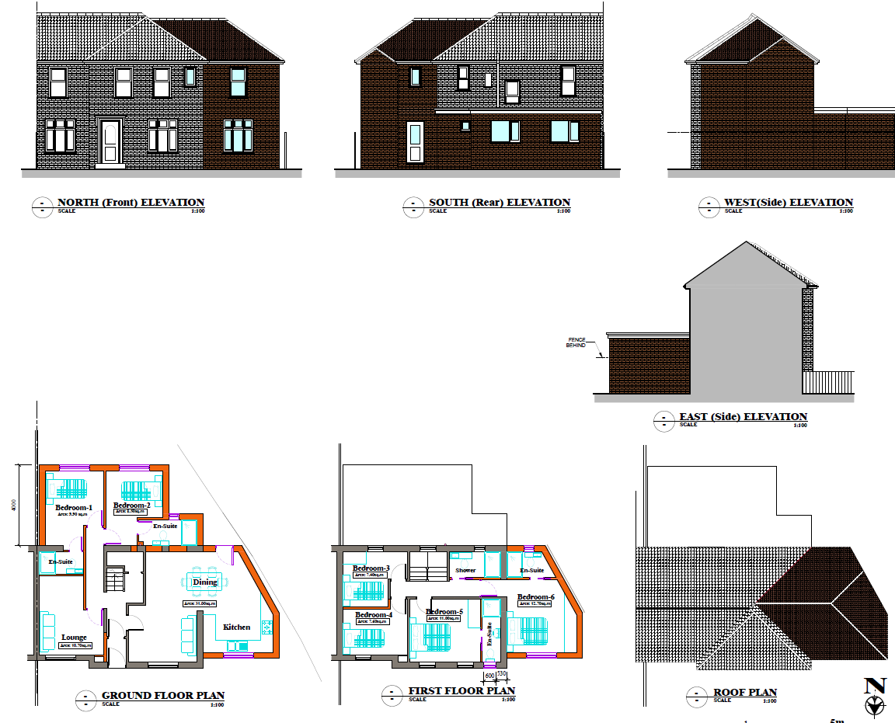
Relevant Planning History:
None.
- CONSULTATIONS
Internal Consultation:
- Transport Consultee Comments for original proposal:
Application seeks to extend the existing 4 bedroom dwelling into a 7 bedroom HMO following the demolition of the garage. In accordance with the Councils current Parking Standards and Design SPD each lettable room would require 0.25 parking spaces, this would equate to 2 off road parking spaces.

The property benefits from an area of hard standing currently used for parking served via an existing vehicle dropped crossing. 2 parking spaces are illustrated on plans which conforms to the current standards. However the Cycle storage for the HMO which should be provided at a ratio of 0.5 secure cycle storage spaces per room in the form of a Sheffield type stand within a covered lockable store ( Currently plans do not illustrate a covered storage area), would be blocked by the parked vehicles.

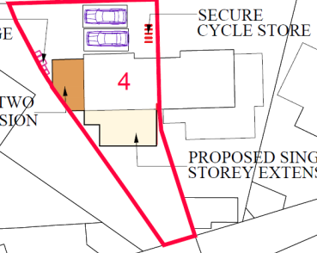

Revised plans required illustrating a revised layout that allows access to a covered storage area for the cycles.

Bin storage should comply with Manual for Streets and British Standard 5906: 2005 for Waste Management in Buildings and should be located no further than 15m from the access point of the site to avoid the stationing of service vehicles on the carriageway for excessive periods; it is assumed that kerb side collection will be undertaken as is the existing arrangement. It is recommended that the Councils Waste Management team be contacted to ensure the correct capacity of bins is provided for the proposed size of the HMO. Bins storage and collection area has been illustrated on plans and is deemed acceptable.

The following addresses were consulted by letter:
- 13 Brixham Road READING RG2 7RA
- 15 Brixham Road READING RG2 7RA
- 2 Kingsbridge Road READING RG2 7RE
- 4 Kingsbridge Road READING RG2 7RE
- 17 Brixham Road READING RG2 7RA
- 6 Kingsbridge Road READING RG2 7RE

No letters of representation have been received.

- LEGAL AND PLANNING POLICY CONTEXT
Equality Act 2010:
In determining this application, the Council is required to have regard to its obligations under the Equality Act 2010. However, there is no indication or evidence (including from consultation on the application) that the protected groups identified by the Act have or will have different needs, experiences, issues and priorities in relation to this particular planning application. Therefore, in terms of the key equalities protected characteristics it is considered there would be no significant adverse impacts as a result of the development.
Section 38(6) of the Planning and Compulsory Purchase Act 2004 requires that proposals be determined in accordance with the development plan unless material considerations indicate otherwise. Material considerations include relevant policies in the National Planning Policy framework (NPPF) - among them the 'presumption in favour of sustainable development'. The following local and national planning policy and guidance is relevant to this application:
National Policy
National Planning Policy Framework 2021
National Planning Guidance 2014 onwards

Reading Borough Local Plan (Adopted November 2019)
CC1: Presumption in Favour of Sustainable Development
CC2: Sustainable Design and Construction
CC5: Waste Minimisation and Storage
CC7: Design and the Public Realm
CC8: Safeguarding Amenity
H8: Residential Conversions
H9: House Extensions and Ancillary Accommodation
H10: Private and Communal Outdoor Space
TR5: Car and Cycle Parking and Electric Vehicle Charging

Supplementary Planning Documents
Design Guide to House Extensions SPD (2021)
Revised Parking Standards and Design (2011)
Residential Conversions (2023)
Sustainable Design and Construction SPD (2019)

- APPRAISAL
- Character and Appearance
- Residential Amenity
- Parking
- Residential Conversions

- Character and Appearance
Policy H9 states that an extension to a house will be acceptable where it respects the character of the house in terms of scale, location, materials and design and respects the character and pattern of neighbouring properties and the street as a whole in terms of scale, location, materials and design, and any important existing building line. Policy CC7 also sets out relevant considerations for design.
Even though the proposal is large in scale overall, the plot is capable of accommodating this size of development. Additionally, the proposed side extension would have a hipped roof, and all proposed materials would match those of the existing. The size, scale, and placement of windows and doors reflect the pattern and appearance of the host dwelling and adjoining properties. There are similar extensions in the vicinity, including the neighbouring property. Therefore, the proposal respects the character and appearance of the host dwelling and would not detract from the local environment. The proposed two storey side extension would be set back from the frontage and set down from the existing ridge line. The proposed ground floor would serve as a kitchen, forming a larger communal space. The proposed first floor side extension would serve as Bedroom 6. Therefore, it is considered subservient to the host dwelling.
- Residential Amenity
Policy H9 states that an extension will be acceptable where it does not result in an overbearing impact on neighbours. Policy H10 seeks to ensure that the amenity of gardens and other outdoor areas are not compromised. Policy CC8 states an extension to a house will be acceptable where it will not cause a significant detrimental impact to the living environment of existing or new residential properties.
There are no identified risks in terms of privacy or overbearing impact, given that there are no proposed side windows and the proposed set-off side walls. The application site and 2 Kingsbridge Road are at an angle, and the proposed two storey side extension would sit in a north-south orientation. The rear extension is only single storey. Therefore, the proposal is not considered to significantly block sunlight or daylight to the neighbouring properties. Outdoor space would be sufficient following the completion of the proposal.
- Parking:
The revised plan is to extend the existing 4-bedroom dwelling into a 6-bedroom HMO instead of 7-bedroom HMO, therefore, a parking spaces illustrated on plans would still comply with the Councils current Parking Standards and Design SPD.

Regarding the cycle storage, the revised plans illustrate 4 cycle spaces. The officer confirmed with the agent via email dated 18/11/2024 that the cycle storage area would be covered. Therefore, the proposed parking plans are considered acceptable based on the original comments provided by Transport consultee.

- Residential Conversions:
Policy H8 states that proposals to convert buildings for multiple occupation will be assessed against the impact on the amenity and character of the surrounding area, particularly in terms of intensification of activity, loss of privacy, loss of external amenity space, the provision and location of adequate on-site car parking and the treatment of bin storage areas and other related servicing.

Besides the proposed extensions, the revised proposal is to convert this 4-bedroom house into a C4 HMO for 6 individuals. Such a conversion would be permitted development in this instance, however as a submission under a full application the following has assessed this aspect of the proposal.
The proposal is considered to respect the physical character of the area in terms of scale, location, materials, and design, as well as the arrangement of doors, windows, and other principal architectural features, as mentioned in (i).
Additionally, the officer reviewed available information to establish the level of HMOs within a 50m radius. None were established and, therefore, single family housing would still remain the dominant form of dwelling in the vicinity of the application site, so there are no risks to having a mixed and sustainable community.
The Council’s SPD seeks to avoid layouts which locate living rooms, bathrooms and kitchens, next to, above, or below, proposed or neighbouring bedrooms. The layout largely achieves this with one bedroom above the kitchen and two above the kitchen and ensuite. However, this type of arrangement is not unusual even in a family house and is considered to be acceptable.
The bedrooms proposed for single occupancy are the following sizes: Bed 1 – 9.9sqm; 2 – 8.5sqm; 3 – 7.4sqm; 4 – 7.6sqm; 5 – 11sqm; 6 – 12.7sqm. All the proposed bedrooms are, therefore, acceptable in terms of size.
The SPD identifies that the amount of communal space considered appropriate in an HMO depends on the number and size of the bedrooms. The standard set out is for one communal room for every 4-6 bedrooms, depending on the size of the bedrooms. The scheme includes a kitchen, dining area, and lounge. The dining area and lounge could easily accommodate all residents. Therefore, the overall level of communal provision is considered acceptable.
The proposal includes the required general waste, recycling, and food bin storage within storage units at the front of the property, in an area close to the roadside where bins are collected. The level of noise and disturbance is unlikely to significantly affect the residents of adjoining properties, and any additional disturbance or nuisance is controlled by civil enforcement (police) and statutory nuisance legislation (Environmental Health). The HMO Management Plan informative would be included in the decision to provide further suggestions for the applicant.
As the permitted development rights have not been removed from the application site and Article 4 is not in place, the applicant could obtain a Certificate of Lawfulness for the change of use as well. The proposed change of use from C3 to C4 HMO for 6 individuals would comply with the conditions of Class L, Part 3, Schedule 2 of The Town and Country Planning (General Permitted Development) (England) Order 2015, which relates to ‘small HMOs to dwellinghouses and vice versa’. This fallback position is a material consideration.
- CONCLUSION
The proposed development has been assessed as set out above and is considered to be acceptable on that basis, subject to the following conditions.
- RECOMMENDATION
Recommended Conditions:
Approved Plans
Time Limit
Materials (To Match)
Use of Roof Restricted
Cycle Storage
Bin Storage
Communal Areas to be Retained

Informatives:
Terms and conditions
Proactive and Positive
HMO Management Plan

